Table 1: Ligand structural information and After single point and geometry optimization energy minimization calculations
Name of the inhibitor | Pubchem CID | Molecular formula  ( Molecular weight g/mol) | STRUCTURE (2D) | After Single point Energy | After Geometry Optimization minimizing energy
Andrographolide | 5318517 | C₂₀H₃₀O₅  (350.4) | 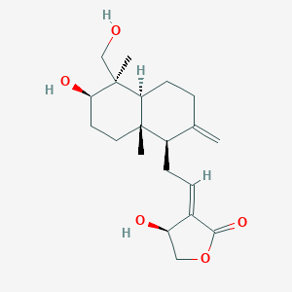 | 83.60  Kcal/mol | 43.22  Kcal/mol
Arctigenin | 64981 | C₂₁H₂₄O₆  (372.4) | 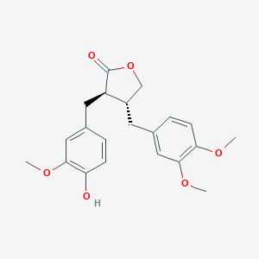 | 81.56  Kcal/mol | 49.26  Kcal/mol
Acanthoic acid | 9817887 | C₂₀H₃₀O₂  (302.5) | 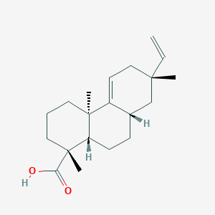 | 77.38  Kcal/mol | 37.14  Kcal/mol
Alpha pinene | 6654 | C₁₀H₁₆  (136.23) | 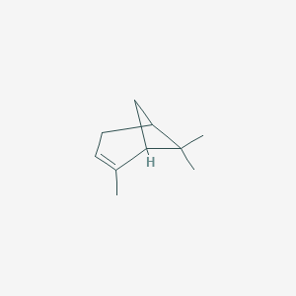 | 75.72  Kcal/mol | 59.29  Kcal/mol
Astaxanthin | 5281224 | C₄₀H₅₂O₄  (596.8) | 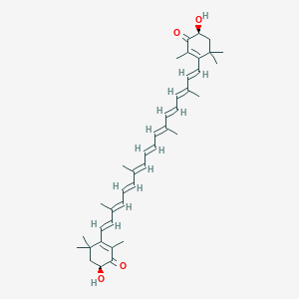 | 174.15  Kcal/mol | 40.71  Kcal/mol
Alpha solanine | 9549171 | C₄₅H₇₃NO₁₅  (868.1) | 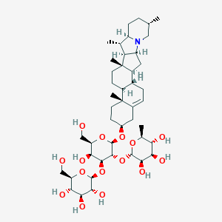 | 174.75  Kcal/mol | 96.90  Kcal/mol
Baicalin | 64982 | C₂₁H₁₈O₁₁  (446.4) | 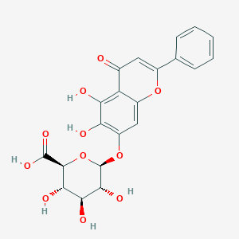 | 116.23  Kcal/mol | 22.71  Kcal/mol
Baicalein | 5281605 | C₁₅H₁₀O₅ (270.24) | 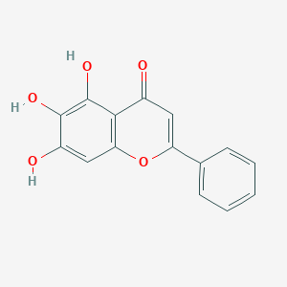 | 84.86  Kcal/mol | 30.62  Kcal/mol
Berberine | 2353 | C₂₀H₁₈NO₄+  (336.4) | 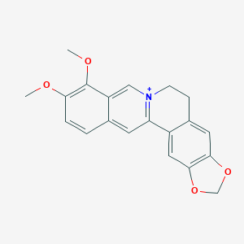 | 77.51  Kcal/mol | 28.71  Kcal/mol
Betanin | 12300103 | C₂₄H₂₆N₂O₁₃  (550.5) | 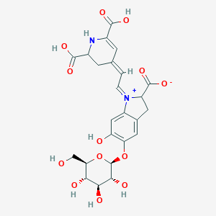 | 143.39  Kcal/mol | 31.49  Kcal/mol
Brusatol | 73432 | C₂₆H₃₂O₁₁  (520.5) | 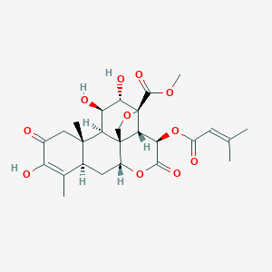 | 156.10  Kcal/mol | 55.88  Kcal/mol
Betulinic acid | 64971 | C₃₀H₄₈O₃  (456.7) | 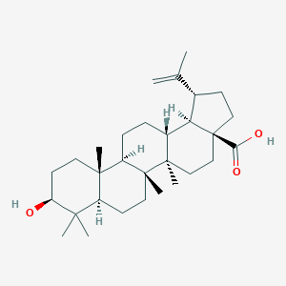 | 119.77  Kcal/mol | 84.95  Kcal/mol
Carnosol | 442009 | C₂₀H₂₆O₄  (330.4) | 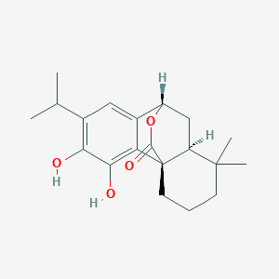 | 92.79  Kcal/mol | 61.67  Kcal/mol
Celastrol | 122724 | C₂₉H₃₈O₄  (450.6) | 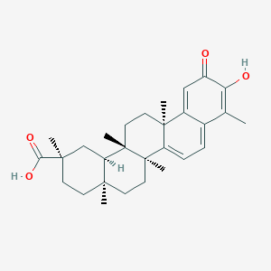 | 140.05  Kcal/mol | 94.62  Kcal/mol
Cairicoside I | 122230626 | C₆₅H₁₀₂O₂₆  (1299.5) | 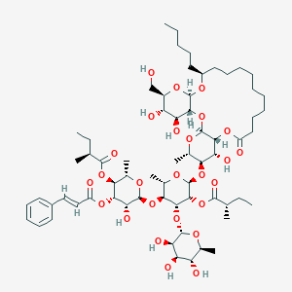 | 321.53  Kcal/mol | 86.50  Kcal/mol
Codonolactone | 155948 | C₁₅H₂₀O₃  (248.32) | 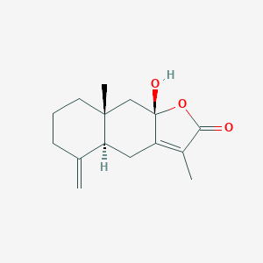 | 65.55  Kcal/mol | 30.4  Kcal/mol
Cordycepin | 6303 | C₁₀H₁₃N₅O₃  (251.24) | 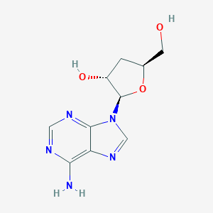 | 56.38  Kcal/mol | 28.73  Kcal/mol
Costunolide | 5281437 | C₁₅H₂₀O₂  (232.32) | 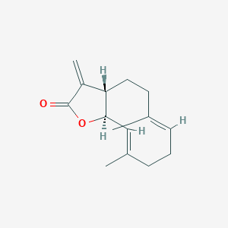 | 63.24  Kcal/mol | 17.16  Kcal/mol
Cryptotanshinone | 160254 | C₁₉H₂₀O₃  (296.4) | 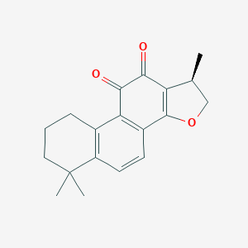 | 80.35  Kcal/mol | 25.30  Kcal/mol
Curcumin | 969516 | C₂₁H₂₀O₆  (368.4) | 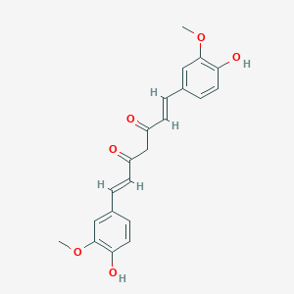 | 112.18  Kcal/mol | 10.98  Kcal/mol
Eupatolide | 5281460 | C₁₅H₂₀O₃  (248.32) | 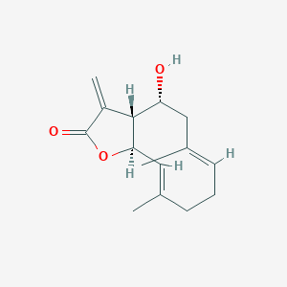 | 64.93  Kcal/mol | 18.60  Kcal/mol
Gallic acid | 370 | C₇H₆O₅  (170.12) | 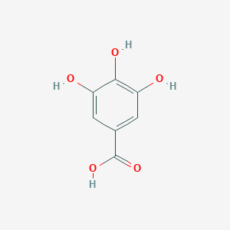 | 46.89  Kcal/mol | 5.58  Kcal/mol
Gambogic acid | 9852185 | C₃₈H₄₄O₈  (628.7) | 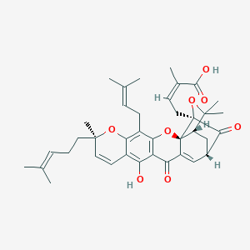 | 170.80  Kcal/mol | 44.92  Kcal/mol
Gedunin | 12004512 | C₂₈H₃₄O₇  (482.6) | 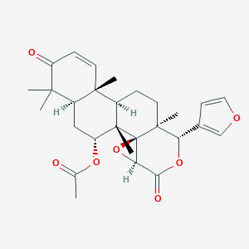 | 309.07  Kcal/mol | 225.87  Kcal/mol
Genistein | 5280961 | C₁₅H₁₀O₅  (270.24) | 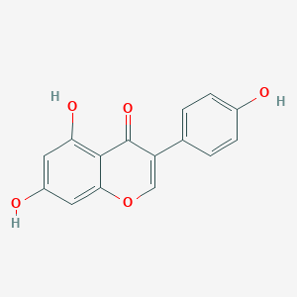 | 85.22  Kcal/mol | 37.07  Kcal/mol
Gentiopicroside | 88708 | C₁₆H₂₀O₉  (356.32) | 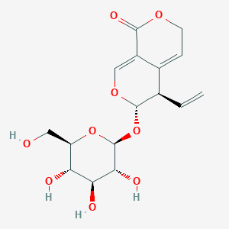 | 66.62  Kcal/mol | 18.62  Kcal/mol
Gigantol | 3085362 | C₁₆H₁₈O₄  (274.31) | 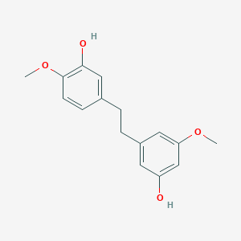 | 55.08  Kcal/mol | 7.44  Kcal/mol
Ginsenoside rb1 | 9898279 | C₅₄H₉₂O₂₃  (1109.3) | 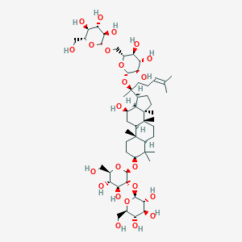 | 202.49  Kcal/mol | 95.76  Kcal/mol
Honokiol | 72303 | C₁₈H₁₈O₂  (266.3) | 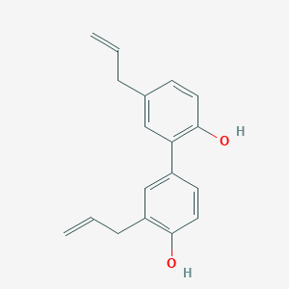 | 63.78  Kcal/mol | 28.46  Kcal/mol
Helenalin | 23205 | C₁₅H₁₈O₄  (262.30) | 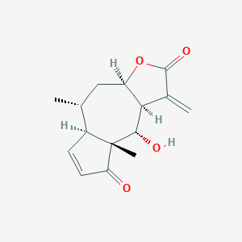 | 96.23  Kcal/mol | 46.14  Kcal/mol
Jatrophone | 5281373 | C₂₀H₂₄O₃  (312.4) | 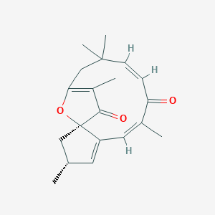 | 107.12  Kcal/mol | 33.06  Kcal/mol
Ligustrazine | 14296 | C₈H₁₂N₂  (136.19) | 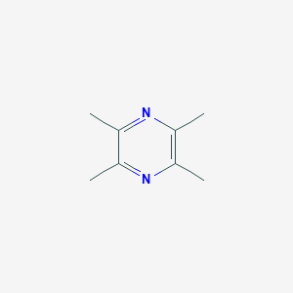 | 20.66  Kcal/mol | 1.87  Kcal/mol
Luteolin | 5280445 | C₁₅H₁₀O₆  (286.24) | 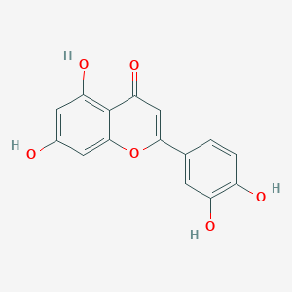 | 86.31  Kcal/mol | 13.75  Kcal/mol
Limonene | 22311 | C₁₀H₁₆  (136.23) | 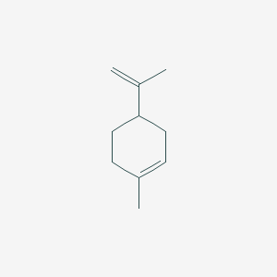 | 25.5  Kcal/mol | 12.84  Kcal/mol
Lycopene | 446925 | C₄₀H₅₆  (36.9) | 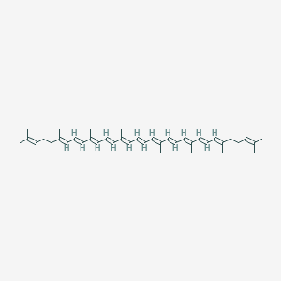 | 175.8  Kcal/mol | 38.98  Kcal/mol
Naringin | 442428 | C27H32O14  (580.5) | 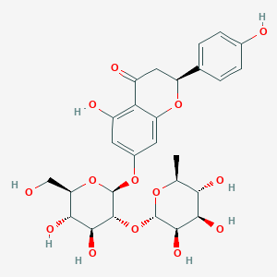 | 99.91  Kcal/mol | 33.08  Kcal/mol
Nimbolide | 12313376 | C₂₇H₃₀O₇  (466.5) | 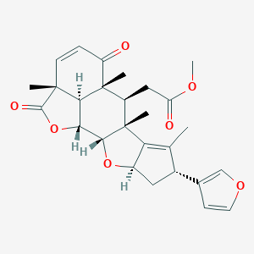 | 171.95  Kcal/mol | 96.88  Kcal/mol
Nitidine chloride | 25659 | C₂₁H₁₈ClNO₄  (383.8) | 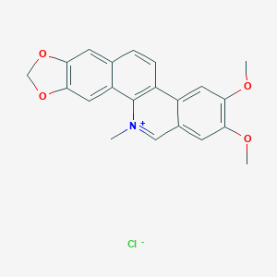 | 106.24  Kcal/mol | 31.38  Kcal/mol
Osthole | 10228 | C₁₅H₁₆O₃  (244.28) | 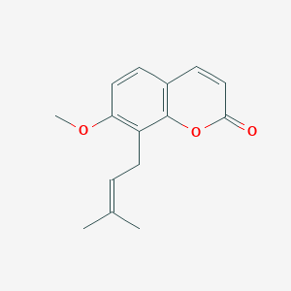 | 61.29  Kcal/mol | 8.65  Kcal/mol
Oxymatrine | 114850 | C₁₅H₂₄N₂O₂  (264.36) | 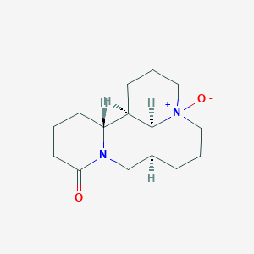 | 48.43  Kcal/mol | 28.91  Kcal/mol
Paeoniflorin | 442534 | C₂₃H₂₈O₁₁  (480.5) | 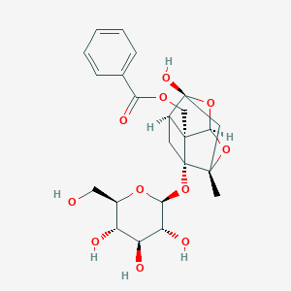 | 150.59  Kcal/mol | 87.94  Kcal/mol
Paeonol | 11092 | C₉H₁₀O₃  (166.17) | 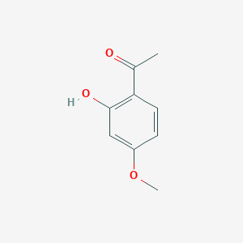 | 46.43  Kcal/mol | 8.50  Kcal/mol
Parthenolide | 7251185 | C₁₅H₂₀O₃  (248.32) | 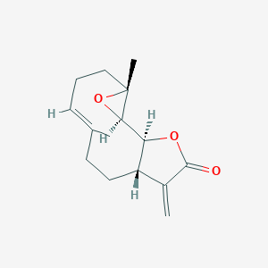 | 225.52  Kcal/mol | 177.95  Kcal/mol
Plectranthioc acid | 154731119 | C₃₀H₄₈O₃  (456.7) | 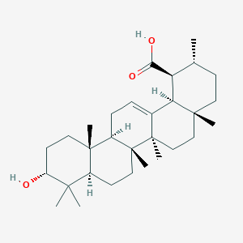 | 125.92  Kcal/mol | 95.95  Kcal/mol
Phoyunnanin E | 101380569 | C₃₀H₂₆O₅  (466.5) | 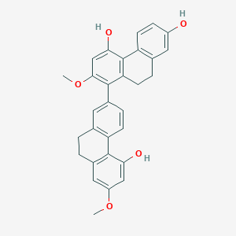 | 102.00  Kcal/mol | 26.41  Kcal/mol
Piperlogumine | 101380569 | C₃₀H₂₆O₅  (466.5) | 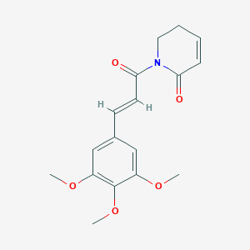 | 92.93  Kcal/mol | 18.36  Kcal/mol
Plumbagin | 10205 | C₁₁H₈O₃  (188.18) | 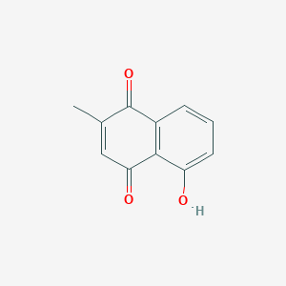 | 68.49  Kcal/mol | 8.15  Kcal/mol
Polyphyllin I | 11018329 | C₄₄H₇₀O₁₆  (855.0) | 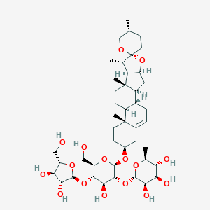 | 177.11  Kcal/mol | 97.87  Kcal/mol
Perillyl alcohol | 10819 | C₁₀H₁₆O  (152.23) | 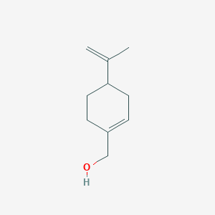 | 25.96  Kcal/mol | 13.50  Kcal/mol
Resveratrol | 445154 | C₁₄H₁₂O₃  (228.24) | 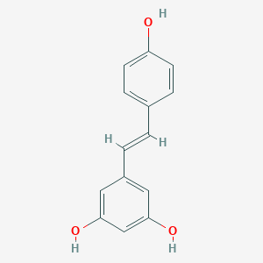 | 60.41  Kcal/mol | 10.75  Kcal/mol
Salvianolic acid A | 5281793 | C₂₆H₂₂O₁₀  (494.4) | 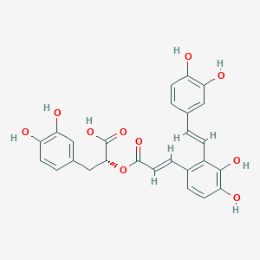 | 141.70  Kcal/mol | 13.73  Kcal/mol
Sulforaphane | 5350 | C₆H₁₁NOS₂  (177.3) | 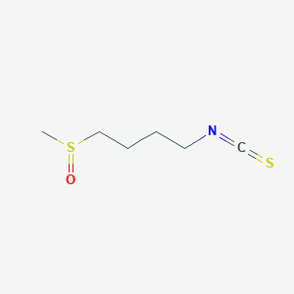 | 270.60  Kcal/mol | 3.35  Kcal/mol
Tanshinone IIA | 164676 | C₁₉H₁₈O₃  (294.3) | 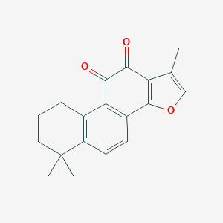 | 86.22  Kcal/mol | 31.05  Kcal/mol
Triptolide | 107985 | C₂₀H₂₄O₆  (360.4) | 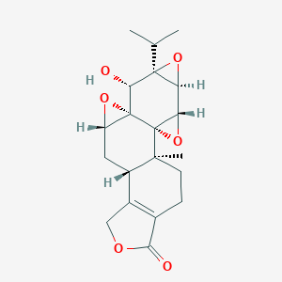 | 559.67  Kcal/mol | 497.19  Kcal/mol
Ursolic acid | 64945 | C₃₀H₄₈O₃  (456.7) | 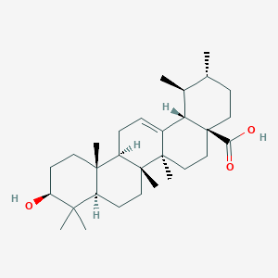 | 113.94  Kcal/mol | 82.21  Kcal/mol
Withaferin A | 265237 | C₂₈H₃₈O6  (470.6) | 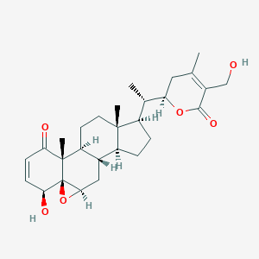 | 273.16  Kcal/mol | 210.199  Kcal/mol

Table 2: MolDock score, rerank score, interaction, torsions and hbond energy of the docked compounds with N protein.
Name of the inhibitor | MolDock Score,  kcal/mol | Rerank Score,  kcal/mol | Interaction energy,  kcal/mol | Torsion angle,  kcal/mol | H-Bond,  kcal/mol
Andrographolide | -107.944 | -82.44 | -122.4 | 3 | -10.89
Arctigenin | -110.939 | -80.25 | -113.42 | 7 | -9.58
Acanthoic acid | -80.68 | -51.46 | -90.72 | 2 | -4.05
Alpha pinene | -49.54 | -15.53 | -62.36 | 0 | 0
Astaxanthin | -133.88 | -107.55 | -180.85 | 19 | -10.16
Alpha solanine | -159.99 | -71.77 | -172.51 | 8 | -17.11
Baicalin | -105.37 | -102.20 | -148.59 | 4 | -18.27
Baicalein | -75.30 | -72.39 | -98.96 | 1 | -13.12
Berberine | -117.98 | -57.97 | -123.15 | 2 | -2.6
Betanin | -160.78 | -121.14 | -169.77 | 8 | -19.8
Brusatol | -122.35 | -99.60 | -124.69 | 6 | -13.01
Betulinic acid | -105.32 | -63.60 | -109.40 | 2 | -5.28
Carnosol | -64.60 | -36.71 | -82.93 | 1 | -10.86
Celastrol | -100.725 | -28.27 | -121.27 | 1 | -9.25
Cairicoside I | -285.68 | -36.03 | -245.10 | 24 | -16.8
Codonolactone | -77.74 | -63.24 | -79.63 | 0 | -8.29
Cordycepin | -90.37 | -76.89 | -97.15 | 2 | -10.49
Costunolide | -92.71 | -57.96 | -76.99 | 0 | -2.4
Cryptotanshinone | -102.47 | -47.45 | -108.00 | 0 | -4.66
Curcumin | -133.59 | -96.70 | -122.56 | 10 | -11.79
Eupatolide | -92.12 | -56.51 | -79.39 | 0 | -9.15
Gallic acid | -79.03 | -69.79 | -86.67 | 1 | -13.41
Gambogic acid | -164.94 | -102.58 | -147.09 | 11 | -8.5
Gedunin | -119.97 | -94.78 | -121.98 | 3 | -5.06
Genistein | -68.14 | -55.04 | -93.55 | 1 | -11.26
Gentiopicroside | -109.99 | -94.47 | -129.60 | 4 | -11.85
Gigantol | -112.45 | -87.08 | -111.03 | 5 | -6.4
Ginsenoside rb1 | -172.65 | -114.14 | -183.54 | 11 | -18.50
Honokiol | -82.89 | -50.03 | -88.17 | 5 | -7.4
Helenalin | -101.44 | -44.15 | -94.11 | 0 | -6.9
Jatrophone | -107.70 | -64.89 | -85.10 | 0 | -3.46
Ligustrazine | -45.03 | -43.16 | -54.79 | 0 | -3.39
Luteolin | -100.55 | -81.30 | -108.48 | 1 | -12.02
Limonene | -54.03 | -47.23 | -59.15 | 1 | 0
Lycopene | -150.00 | -98.54 | -149.19 | 29 | 0
Naringin | -145.45 | -122.25 | -171.67 | 6 | -23.82
Nimbolide | -127.16 | -90.66 | -116.72 | 4 | -12.05
Nitidine chloride | -122.18 | -99.14 | -124.62 | 2 | -3.86
Osthole | -91.72 | -70.25 | -95.01 | 4 | -3.9
Oxymatrine | -67.72 | -64.05 | -86.77 | 0 | -3.48
Paeoniflorin | -114.76 | -90.24 | -132.29 | 3 | -19.32
Paeonol | -71.70 | -51.20 | -72.66 | 2 | -7.3
Parthenolide | -101.17 | -70.32 | -85.69 | 0 | -5.0
Plectranthioc acid | -78.65 | -7.22 | -95.51 | 1 | -6.36
Phoyunnanin E | -130.07 | -66.91 | -144.87 | 3 | -10.75
Piperlogumine | -105.33 | -81.94 | -11.20 | 6 | -6.46
Plumbagin | -67.63 | -59.66 | -78.48 | 0 | -5.9
Polyphyllin I | -166.78 | -53.30 | -202.25 | 8 | -18.28
Perillyl alcohol | -57.33 | -49.25 | -64.05 | 2 | -5.0
Resveratrol | -102.06 | -85.28 | -105.42 | 2 | -7.9
Salvianolic acid A | -143.71 | -102.69 | -120.18 | 9 | -23.26
Sulforaphane | -69.60 | -56.81 | -69.23 | 6 | -7.6
Tanshinone IIA | -91.01 | -66.16 | -96.79 | 0 | -3.9
Triptolide | -108.18 | -69.07 | -116.04 | 1 | -6.75
Ursolic acid | -111.21 | -63.80 | -115.39 | 1 | -6.12
Withaferin A | -108.41 | -84.51 | -125.63 | 3 | -10.33

Table 3: MolDock score, rerank score, interaction, torsions and hbond energy of the docked compounds with RdRp protein.
Name of the inhibitor | MolDock Score,  kcal/mol | Rerank Score,  kcal/mol | Interaction energy,  kcal/mol | Torsion angle,  kcal/mol | H-Bond,  kcal/mol
Andrographolide | -78.57 | -41.04 | -96.44 | 1 | -9.08
Arctigenin | -103.39 | -58.12 | -108.45 | 7 | -6.7
Acanthoic acid | -82.50 | -71.41 | -94.94 | 2 | -4.8
Alpha pinene | -52.19 | -45.34 | -65.00 | 0 | 0
Astaxanthin | -141.71 | -89.26 | -154.64 | 19 | -8.09
Alpha solanine | -151.07 | -54.29 | -192.94 | 8 | -16.47
Baicalin | -83.51 | -88.97 | -124.67 | 4 | -11.9
Baicalein | -69.25 | -64.81 | -93.50 | 1 | -10.31
Berberine | -92.68 | -63.35 | -97.33 | 2 | -4.5
Betanin | -156.39 | -124.42 | -161.15 | 8 | -17.11
Brusatol | -123.40 | -20.73 | -116.28 | 6 | -8.82
Betulinic acid | -97.43 | -21.71 | -109.25 | 2 | -4.05
Carnosol | -65.30 | -54.71 | -83.73 | 1 | -8.58
Celastrol | -80.87 | -66.33 | -100.83 | 1 | -10.03
CairicosideI | -201.55 | -38.06 | -187.12 | 24 | -7.29
Codonolactone | -74.66 | -60.57 | -76.58 | 0 | -6.24
Cordycepin | -86.39 | -70.50 | -90.72 | 2 | -9.16
Costunolide | -97.27 | -72.13 | -81.55 | 0 | -2.5
Cryptotanshinone | -84.58 | -69.34 | -84.71 | 0 | -2.0
Curcumin | -139.05 | -84.62 | -119.16 | 10 | -1.36
Eupatolide | -87.92 | -64.60 | -75.19 | 0 | -4.9
Gallic acid | -57.60 | -32.54 | -64.72 | 1 | -13.04
Gambogic acid | -164.15 | -96.60 | -141.70 | 11 | -10.46
Gedunin | -112.33 | -83.70 | -113.51 | 3 | -3.6
Genistein | -70.18 | -70.39 | -98.21 | 1 | -9.02
Gentiopicroside | -89.50 | -56.30 | -106.50 | 4 | -20.08
Gigantol | -94.75 | -72.94 | -104.39 | 5 | -7.08
Ginsenoside rb1 | -147.04 | -112.25 | -175.82 | 11 | -19.13
Honokiol | -82.84 | -72.23 | -90.51 | 5 | -7.00
Helenalin | -98.80 | -76.76 | -91.48 | 0 | -8.0
Jatrophone | -104.69 | -72.77 | -82.09 | 0 | -4.74
Ligustrazine | -49.03 | -44.10 | -58.79 | 0 | -2.5
Luteolin | -99.88 | -72.35 | -96.76 | 1 | -10.15
Limonene | -53.51 | -45.84 | -58.64 | 1 | 0
Lycopene | -159.57 | -77.27 | -131.20 | 29 | 0
Naringin | -134.00 | -94.96 | -152.97 | 6 | -18.25
Nimbolide | -138.56 | -102.70 | -136.41 | 4 | -15.61
Nitidine chloride | -106.14 | -76.65 | -101.11 | 2 | -5.19
Osthole | -80.39 | -55.40 | -84.35 | 4 | -5.30
Oxymatrine | -66.42 | -62.34 | -85.47 | 0 | -2.0
Paeoniflorin | -104.34 | -79.60 | -120.53 | 3 | -13.28
Paeonol | -61.62 | -52.00 | -62.32 | 2 | -8.1
Parthenolide | -93.43 | -67.25 | -77.96 | 0 | -5.0
Plectranthioc acid | -95.26 | -77.56 | -108.66 | 1 | -4.7
Phoyunnanin E | -125.92 | -56.65 | -134.39 | 3 | -11.57
Piperlogumine | -107.52 | -82.01 | -109.57 | 6 | -9.30
Plumbagin | -55.15 | -51.81 | -65.99 | 0 | -5.5
Polyphyllin I | -140.21 | -103.76 | -161.01 | 8 | -18.45
Perillyl alcohol | -53.41 | -43.87 | -64.93 | 2 | -3.0
Resveratrol | -93.44 | -64.43 | -96.54 | 2 | -6.3
Salvianolic acid A | -150.83 | -100.05 | -126.55 | 9 | -11.02
Sulforaphane | -65.40 | -49.94 | -65.87 | 6 | -8.17
Tanshinone IIA | -85.99 | -54.53 | -91.76 | 0 | -3.5
Triptolide | -97.82 | -76.40 | -105.53 | 1 | -5.27
Ursolic acid | -110.67 | -60.04 | -116.76 | 1 | -6.0
Withaferin A | -105.21 | -83.42 | -118.83 | 3 | -7.40

Table 4: Amino acid residues around active site and docked against N protein
Name of the Inhibitor | Amino acid residues around active site | Ligand binding amino acids
Alpha solanine | Asp129A, Lys62B, Glu68B, Lys128A, Asp64B, Arg89A, Glu119A, Pro118A, Asn154D, Ile131B, Ile132B, Trp132B, Trp133B, Ala126B, Gly125B, Asn127B, His146D, Ile147D, Trp53D, Asn78D, Asn151A, Asn49A, Asn155D, Thr50A | Arg89A, Asn127B, Asn155D, Gly125B, Asn78D, Asn49A, Ile131B
Baicalin | Trp109B, Lys66B, Lue65B, Asp64B, Ile132B, Arg90B, Gly130B, Ile131B, Trp133B, Asn49A, Asp129B,Lys128B, Asn154B, Asn151D, Asn127B, Asn155B, Arg150D, Trp53B, Thr149D | Asn151D, Thr149D, Asn127B, Asn155D, Asn154D, Gly130B, Asp129B, Asp64B
Betanin | Trp133B, Lys128B, Asn127B, Trp53D, Asn78D, Asn49A, Thr50A, Ala51A, Arg89A, Ala91A, Arg90A, Thr92A, Lys66B, Glu63B, Pro169B, Lys170B | Asn127B, Arg89A, Arg90A, Thr92A, Glu63B, Lys66B
Cairicoside I | Trp53D, Ile147D, Ile158D, Asn78D, Asn155D, Asn154D, Asn127B, Asn151A, Thr50A, Pro118A, Tyr112A, Ser52A, Ala51A, Gly125B, Ile131B, Trp133B, Ile132B, Arp69B, The67B, Pro68B, Val159C, Tyr110A, Asp64B, Trp109B, Lue65B, The67B | Asn49A, Asn127B, Asn154D, Asn78D, Thr50A, Pro68B, Lys66B
Ginsenoside rb1 | Arg108A, Arg93A, Thr92A, Ana91A, Tyr110A, Ser52A, Tyr112A, Ala51A, Arg89A, Thr50A, Tro118A, Asn49A, Lys66B, Asn155D, Asn154D, Asn151D, Asn127B, Gly125B, Trp133B, Ile132B, Ile131B, Lys128B, Ala126B, Thr149D, Asn151D, Arg150D, Trp53D | Asn155D, Asn151D, Thr149D, Asn127B, Asn49A, Lys128B, Ile131B, Thr50A, Tyr112A
Naringin | Arg90A, Arg89A, Thr92A, Tyr110A, Tyr112A, Ser52A, Pro118A, Glu63B, Ala51A, Thr50A, Asn49A, Lys66B, Trp153B, Ile132B, Phe67B | Trp133B, Thr50A, Thr92A, Glu63B, Lys66B, Arg89A, Ser52A, Tyr122A
Paeoniflorin | Trp53D, Asn155D, Thr50A, Asn49A, Asn127B, Asp129B, Lys128B, Ala126B, Gly125B, Gly130B, Tle131B, Trp133B, Lys66B | Asn127B,Thr50A, Ile131B, Ala126B, Lys128B, ASN 49A
Polyphyllin I | Thr50D, Thr149D, Gly148D, Tle147D, Trp53D, Asn51D, Asn155D, Asn154D, Asp129D, lys128D, Asn127B, gly130B, Thr50A, Ala51A, Lys66B, Pro152A, Asn49A, Ile132B, Trp133B, Phe67B, Pro68B, Arg69B, Gln161C | Arg69B, Trp133B, Phe67B
Salvianolic acid A | Tyr112A, Arg89A, Pro118A, Thr50A, Asn154D, Asn155D, Trp53D, Asn127B, Asn49A, Lys66B, Asp64B, Lys128B, Asp129B, Ile131B, Gly130B, Arg90B | Asn49A, Thr50A, Arg89A, Gly130B, Asp129B, Ile131B, Lys128B, Asn127B, Tyr112A

Table 5: Amino acid residues around active site and docked against RdRp protein
Name of the Inhibitor | Amino acid residues around active site | Ligand binding amino acids
Alpha solanine | Val557A, Ser682A, Lys545A, Thr556A, Arg555A, Asp62A, Asp760A, Asp452A, Arg624A, Cys622A, Arg553A, Tyr455A, Lys551A, Lys621A, Pro620A, Lys798A, Tyr619A, Ala554A | Lys621A, Cys622A, Tyr619A, Asp760A, Asp623A
Betanin | Lys545A, Lys500A, Val557A, Gly683A, Thr556A, Ser685A, Ala554A, Asp452A, Arg553A, Tyr455A, Lys621A, Arg624A, Asp623A, Asn691A, Ser759A, Thr687A, Ala688A, Ser759A, Lys545A | Ala688A, Thr556A, Arg624A, Arg555A, Asp452A, Lys621A, Asp623A, Lys545A
Gentiopicroside | Tyr619A, Cys622A, Pro620A, Lys621A, Tyr458A, Asp623A, Arg624A, Tyr455A, Tyr458A, Arg553A, Asp452A, Ala554A, Arg555A, Tyr556A | Tyr619A, Cys622A, Asp623A, Lys621A, Arg555A, Ala554A
Ginsenoside rb1 | Ala688A, Thr687A, Ser759A, Asn691A, Asp760A, Ser682A, Asp623A, Tyr619A, Cys622A, Arg555A, Thr556A, Asp618A, Pro620A, Lys621A, Asp452A, Ala554A, Tyr455A, Lys798A, Arg553A | Lys798A, Asp618A, Arg555A, Asp452A, Ala554A, Lys621A, Arg553A, Asp760A, Ser759A
Naringin | Ala550A, Ser549A, Lys551A, Ala554A, Arg555A, Arg553A, Asp452A, Thr556A, Tyr455A, Arg624A, Lys621A, Ser682A, Asp623A, Cys622A, Thr687A, Asn691A | ASN 691A, Arg624 A, Thr556A, Lys621A, Cys622A, Asp623A
Polyphyllin I | Thr556A, Ala554A, Asp452A, Ser682A, Thr687A, Arg553A, Tyr455A, Arg624A, Asp623A, Ser759A, Leu758A, Asp760A, Cys622A, Lys798A, Pro620A, Asp648A, Tyr619A, Lys798A, Lys551A | Asp623A, Thr556A, Arg555A, Ala554A, Asp452A, Ser759A, Lys798A
Cairicoside I | Lys500A, Ala685A, Asp684A, Gly683A, Ala558A, Val557A, Ser682A, Thr687A, Ala688A, Ser759A, Leu758A, Asp761A, Cys813A, Ser814A, Asp760A, Tyr619A, Lys545A, Asp623A, Cys622A, Thr556A, Arg624A, Asp452A, Tyr455A, Arg553A, Lys621A, Pro620A, | Asp684A, Asp761A, Asp760A, Lys545A, Lys621A, Arg624A, Ser628A

Table 6. Pharmacokinetic properties of top-scoring ligands.
Property | Model Name | Alpha solanine | Betanin | Cairicoside I | Ginsenoside rb1 | Naringin | Polyphyllin I | Unit
Absorption | Water solubility | -3.021 | -2.86 | -2.89 | -2.834 | -2.91 | -3.34 | log mol/L
 | Caco2 permeability | -0.623 | -0.95 | 0.114 | -1.385 | -0.65 | -0.779 | log Papp in 10–6 cm/s
 | Intestinal absorption(Human) | 16.89 | 0 | 37.32 | 0 | 25.79 | 51.19 | %Absorbed
 | Skin Permeability | -2.73 | -2.73 | -2.73 | -2.735 | -2.73 | -2.73 | log Kp
Distribution | VDss(Human) | -0.279 | -1.70 | 0.541 | -0.62 | 0.61 | -0.304 | log l/kg
 | Fraction unbound(Human) | 0.537 | 0.60 | 0.306 | 0.4 | 0.15 | 0.417 | Fu
 | BBB permeability | -1.719 | -1.63 | -3.89 | -2.65 | -1.6 | -1.85 | log BB
 | CNS permeability | -4.74 | -4.93 | -4.92 | -6.25 | -4.77 | -4.51 | logPS
Metabolism | CYP2D6 substrate | No | No | No | No | No | No | Yes/No
 | CYP3A4 substrate | Yes | No | Yes | No | No | Yes
 | CYP1A2 inhibitor | No | No | No | No | No | No
 | CYP2C19 inhibitor | No | No | No | No | No | No
 | CYP2C9 inhibitor | No | No | No | No | No | No
 | CYP2D6 inhibitor | No | No | No | No | No | No
 | CYP3A4 inhibitor | No | No | No | No | No | No
Excretion | Total clearance | -0.373 | 0.216 | 0.701 | 0.539 | 0.318 | 0.365 | log ml/min/kg
 | Renal OCT2 substrate | No | No | No | No | No | No | Yes/No
Toxicity | AMES toxicity | No | No | No | No | No | No
 | Max. tolerated dose(Human) | -2.677 | 0.678 | -0.267 | -0.62 | 0.43 | -3.05 | log mg/kg/day
 | hERG I inhibitor | No | No | No | No | No | No | Yes/No
 | Oral rat acute toxicity(LD50) | 3.08 | 2.471 | 2.545 | 2.659 | 2.49 | 3.10 | Mol/kg
 | Oral rat chronic toxicity(LOAEL) | 2.81 | 3.652 | 2.124 | 4.00 | 4.20 | 2.91 | log mg/kg_bw/day
 | Hepatotoxicity | Yes | Yes | Yes | No | No | No | Yes/No
 | Skin sensitization | No | No | No | No | No | No
 | T.pyriformis toxicity | 0.285 | 0.285 | 0.285 | 0.285 | 0.285 | 0.285 | log µg/L
 | Minnow toxicity | 9.83 | 8.49 | 10.56 | 11.70 | 6.04 | 8.87 | log µg/L
Drug likeness | Lipinski | No | No | No | No | No | No | Yes/No
Bioactivity Score | GPCR ligand | -2.38 | 0.25 | -3.90 | -3.73 | 0.11 | -2.22
 | Ion channel modulator | -3.42 | -0.21 | -3.95 | -3.82 | -0.40 | -3.32
 | Kinase inhibitor | -3.44 | -0.48 | -3.96 | -3.85 | -0.24 | -3.33
 | Nuclear receptor ligand | -3.13 | -0.20 | -3.95 | -3.79 | -0.04 | -3.06
 | Protease inhibitor | -1.82 | 0.11 | -3.86 | -3.67 | -0.09 | -1.17
 | Enzyme inhibitor | -2.61 | 0.36 | -3.89 | -3.68 | 0.24 | -2.25

