Supporting Information

Title
A Supramolecular Heat-Pump: an Electrochemical Cooling System Utilizing the Enthalpy Change of a Host–Guest Interaction

Author name
Fumitoshi Matoba,¹ Teppei Yamada,² and Nobuo Kimizuka^{1, 3}

¹ Chemistry and Biochemistry Course, Department of Applied Chemistry, Graduate School of Engineering, Kyushu University, Motooka 744, Nishi-ku, Fukuoka 819-0395, Japan.
² Department of Chemistry, Graduate School of Science, The University of Tokyo, 7-3-1 Hongo, Bunkyo-ku, Tokyo 113-0033, Japan
³ Center for Molecular Systems(CMS), Kyushu University
E-mail: teppei@chem.s.u-tokyo.ac.jp
Keywords: Electrochemical Peltier effect | Host-guest chemistry | Cyclodextrin

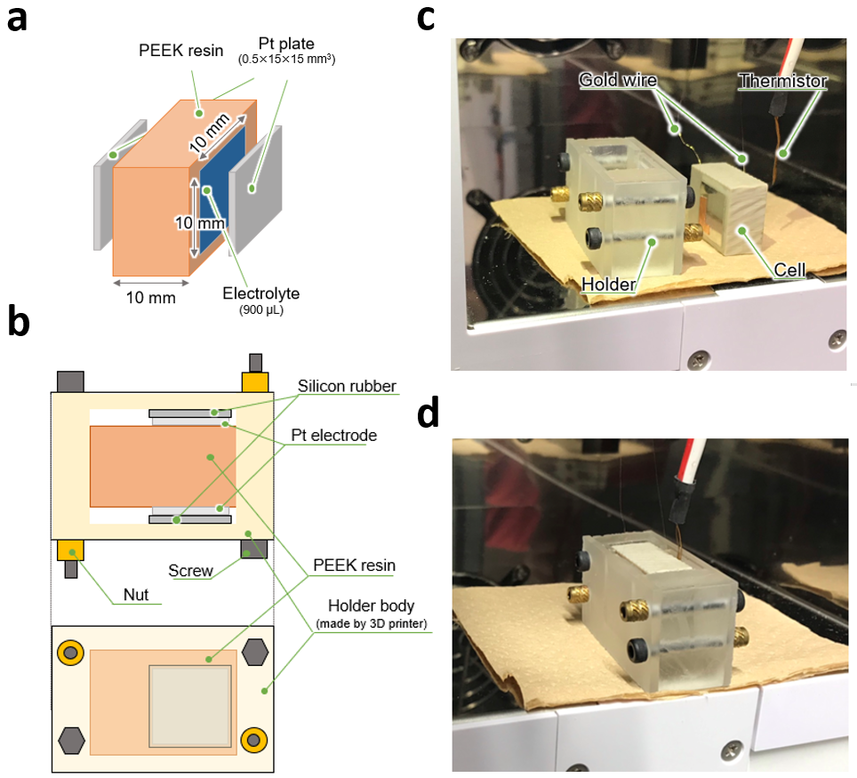
Figure S1. The measurement cell. (a) An illustration of the cell. (b)Top (upper) and cross-sectional (lower) illustration of the cell that is attached to the holder. (c) A photograph of the cell and holder. (d) A photograph of the cell that is attached to the holder.

Derivation of equation for evaluating the electrochemical Peltier effect
Equation (5) in the main text is derived from the modification of Boudeville’s equation^{[2]}.
We assumed that a single electrode reaction happens when an electric current is applied.
$$Ox+ne^{-}⇄Red$$
and also we assumed that
(i) Three kinds of heat effects happen when an electric current is applied to an electrolyte.
(a) heat absorption or desorption derived from redox reaction
(b) Joule heat
(c) Heat conduction
(ii) The amount of Joule heat generated at oxidation and reduction is equivalent and is independent of time.
(iii) Π value is not depending on temperature or the amount of current.
The thermal power absorbed at the interface of electrolyte and electrode q_{ox}(J s^{–1})and q_{red} (J s^{–1}) are expressed as Eqn (S1) and (S2), where q_{ox} and q_{red} denote the thermal power involving anodic and cathodic reaction, respectively.
$$\begin{aligned}q_{ox}=-\frac{Π}{nF}\left|I\right|-aRI^{2}+K∆T\#(S1)\end{aligned}$$
$$\begin{aligned}q_{red}=\frac{Π}{nF}\left|I\right|-aRI^{2}-K∆T\#(S2)\end{aligned}$$
where n is the number of electrons in the redox reaction, F is Faraday’s constant (C mol^{–1}), Π is electrochemical Peltier coefficient (J mol^{–1}), I is the current (A), R is electric resistance (Ω), and a is the ratio of Joule heat generated at the electrode to the total Joule heat. K is the thermal conductance (W K^{–1}), and ΔT is the temperature difference between two electrodes (K), and
$$\begin{aligned}K=κ\frac{S_{a}}{L}\#\left(S3\right)\end{aligned}$$
$$\begin{aligned}∆T =T_{ox}(t)-T_{red}(t)\#\left(S4\right)\end{aligned}$$
where κ is thermal conductivity (W K^{–1}m^{–1}), S_{a} is the space of electrode(m²), L is the distance between electrodes (m). T_{ox}(t) and T_{red}(t) are the temperatures of anode and cathode after t seconds’ current input.
The relational expression between T_{ox}(t) and T_{red}(t) is established as
$$\begin{aligned}\frac{T_{ox}\left(t\right)+T_{red}\left(t\right)}{2}=T_{0}+\frac{aRI^{2}}{C}t\#\left(S5\right)\end{aligned}$$
where T₀ =T_{ox}(0) = T_{red}(0) is the electrode temperature when no current is input, C is apparent heat capacity (J K^{–1}), which is the ratio of the amount of heat generated at the interface of electrolyte and electrode to actual temperature change.
Eqn (S5) gives
$$\begin{aligned}T_{ox}\left(t\right)=2T_{0}+\frac{2aRI^{2}}{C}t-T_{red}\left(t\right)\#\left(S6\right)\end{aligned}$$
or
$$\begin{aligned}T_{red}\left(t\right)=2T_{0}+\frac{2aRI^{2}}{C}t-T_{ox}\left(t\right)\#\left(S7\right)\end{aligned}$$
By using C, T_{ox}(t), and T_{red}(t), q_{ox} and q_{red} can be expressed as
$$\begin{aligned}q_{ox}=-C\frac{dT_{ox}\left(t\right)}{dt}\#\left(S8\right)\end{aligned}$$
$$\begin{aligned}q_{red}=-C\frac{dT_{red}\left(t\right)}{dt}\#\left(S9\right)\end{aligned}$$
First, we calculate T_{ox}(t). From Eqn (S1), (S7), and (S8), we obtain
$$\begin{aligned}\frac{dT_{ox}\left(t\right)}{dt}=-\frac{2K}{C}T_{ox}+\frac{2aRI^{2}K}{C^{2}}t+(\frac{Π}{nFC}\left|I\right|+\frac{aRI^{2}}{C}+\frac{2K}{C}T_{0})\#\left(S10\right)\end{aligned}$$
By solving Eqn (S10), we obtain
$$\begin{aligned}T_{ox}\left(t\right)=\frac{aRI^{2}}{C}t+\left(T_{ox}\left(0\right)-T_{0}-\frac{Π}{2nFK}\left|I\right|\right)e^{-\frac{2K}{C}t}+T_{0}+\frac{Π}{2nFK}\left|I\right|\#(S11\end{aligned})$$
T_{red}(t) can be obtained in the same way as T_{ox}(t). From Eqn (S2), (S6), and (S9), we obtain
$\begin{aligned}T_{red}\left(t\right)=\frac{aRI^{2}}{C}t+\left(T_{red}\left(0\right)-T_{0}+\frac{Π}{2nFK}\left|I\right|\right)e^{-\frac{2K}{C}t}+T_{0}-\frac{Π}{2nFK}\left|I\right|\#(S12)\end{aligned}$By subtracting Eqn (S12) from Eqn (S11) to eliminate the effect of Joule heating, we obtain
$$\begin{aligned}T_{ox}\left(t\right)-T_{red}\left(t\right)=\left(T_{ox}\left(0\right)-T_{red}\left(0\right)-\frac{Π}{nFK}\left|I\right|\right)e^{-\frac{2K}{C}t}+\frac{Π}{nFK}\left|I\right|\#(S13)\end{aligned}$$
when thermal conduction can be neglected, K is approximated to be zero. In this situation, Eqn (S13) can be rewritten as
$$\begin{aligned}T_{ox}\left(t\right)-T_{red}\left(t\right)=\frac{2Π}{nFC}\left|I\right|t+\left\{T_{ox}\left(0\right)-T_{red}\left(0\right)\right\} \#(S14)\end{aligned}$$
Eqn(S14) is the same as Eqn (5) in the main text. Eqn (S14) indicates that, when current is input and thermal conduction is negligible, the temperature difference between two electrodes shows a linear relationship against t. As the slope is proportional to Π, Π can be calculated by the slope of Eqn (S14).

Determination of dissociation rate constant of host–guest interaction from cyclic voltammetry
To obtain an insight into the kinetics of host–guest interaction in the EPE system, the dissociation rate constant was determined by cyclic voltammetry (CV) at fast scan rates. First, the equation for evaluating the dissociation rate constant is derived. The equation has already been shown elsewhere^{[3]}, although the derivation is not shown.
When a host is added to the electrolyte, host–guest interaction occurs. When an oxidant is selectively captured to the host, the equilibrium between the host (Host) and oxidant (Ox) is expressed below:
Host + Ox ⇄ Host–Ox (S15)
The association constant (K_{as}) and the total concentration of oxidant are expressed below:
K_{as} = C_{HO}/(C_{H} C_{O}) (S16)
C_{O}* = C_{O} + C_{HO} (S17)
where C_{H}, C_{O}, C_{HO} are the concentration of a host, oxidant, and inclusion complex, respectively. C_{O}* is the total concentration of oxidant in the electrolyte. The association constant can also be expressed as the ratio of the rate constant of association (k₊) and dissociation (k₋).
$$\begin{aligned}K_{as}=\frac{k_{+}}{k_{-}}\#\left(S18\right)\end{aligned}$$
The dissociation rate constant can be obtained by considering a steady state where the concentration does not change depending on time. At the steady-state, the current value does not change, hence a plateau of the reduction current can be observed. For the deviation, we assumed that
- Oxidants in inclusion complex cannot show electrochemical activity
- The electrochemical process is based on the CE mechanism (dissociation of oxidant following electrochemical reduction)
- the concentration of the host is much larger than that of guest
- the dissociation process is slower than the electron transfer one, hence the dissociation is the rate-limiting step at a fast scan rate
The diffusion equation for an oxidant is expressed below:
$$\begin{aligned}\frac{∂C_{O}}{∂t}=D_{O}\frac{∂^{2}C_{O}}{∂x^{2}}+k_{-}C_{HO}-k_{+}C_{H}C_{O}\#\left(S19\right)\end{aligned}$$
where D_{O} is the diffusion coefficient of oxidant. The first term of the right side of Eqn (S19) is derived from Fick’s second law of diffusion. The second and third terms mean the generated and consumed oxidants by the host–guest interactions, respectively.
When it is at the steady-state, the concentration of oxidants does not depend on time, hence $∂C_{0}/∂t=0$.
From Eqn (S16), k₊ = K_{as} × k₋. From Eqn (S17), C_{HO} = C_{O}* − C_{O}. When the concentration of the host is much larger than that of oxidant, C_{H} ≈C_{H}*. Therefore, Eqn (S19) can be rewritten as
$$\begin{aligned}\frac{∂^{2}C_{O}}{∂x^{2}}=\frac{k_{-}\left(1+K_{as}C_{H}^{*}\right)}{D_{O}}\left(C_{O}-\frac{C_{O}^{*}}{1+K_{as}C_{H}^{*}}\right)\#\left(S20\right)\end{aligned}$$
Since C_{O}*/(1+K_{as}C_{H}*) is constant, Eqn (S20) is equal to
$$\begin{aligned}\frac{∂^{2}}{∂x^{2}}\left(C_{O}-\frac{C_{O}^{*}}{1+K_{as}C_{H}^{*}}\right)=\frac{k_{-}(1+K_{as}C_{H}^{*})}{D_{O}}\left(C_{O}-\frac{C_{O}^{*}}{1+K_{as}C_{H}^{*}}\right)\#\left(S21\right)\end{aligned}$$
By solving Eqn (S21), we can obtain
$$\begin{aligned}C_{O}-\frac{C_{O}^{*}}{1+K_{as}C_{H}^{*}}=X exp(\sqrt{a}x)+Y exp(-\sqrt{a}x)\#\left(S22\right)\end{aligned}$$
where X and Y are constant, and
$$\begin{aligned}a=\frac{k_{-}\left(1+K_{as}C_{H}^{*}\right)}{D_{O}}\#\left(S23\right)\end{aligned}$$
Since almost all oxidants (guests) form inclusion complex at the bulk, C_{O} → 0 at x → ∞. Therefore, X = 0. Hence, Eqn (S22) is
$$\begin{aligned}C_{O}=\frac{C_{O}^{*}}{1+K_{as}C_{H}^{*}}+Y exp(-\sqrt{a}x)\#\left(S24\right)\end{aligned}$$
Since x = 0 is corresponding to the cathode where reduction reaction occurs, C_{O} = 0 at x = 0 regardless of time. Hence, Y = −C_{O}*/(1+K_{as}C_{H}*). Therefore, we obtain
$$\begin{aligned}C_{O}=\frac{C_{O}^{*}}{1+K_{as}C_{H}^{*}}\left\{1-\exp\left(-\sqrt{\frac{k_{-}\left(1+K_{as}C_{H}^{*}\right)}{D_{O}}}x\right)\right\}\#\left(S25\right)\end{aligned}$$
At the steady-state, the current value is determined by the diffusion of the oxidant. Hence
$$\begin{aligned}I=nFAD_{O}{\left(\frac{∂C_{O}}{∂x}\right)}_{x=0}\#\left(S26\right)\end{aligned}$$
where n is the number of electrons, F is the Faraday constant, and A is the surface area of the working electrode. From Eqn (S25) and (S26), we can obtain
$$\begin{aligned}I=nFAC_{O}^{*}\sqrt{\frac{k_{-}D_{0}}{1+K_{as}C_{H}^{*}}}\#\left(S27\right)\end{aligned}$$
Especially, when $K_{as}C_{H}^{*} ≫ 1$, we can approximate that $1+K_{as}C_{H}^{*}≈K_{as}C_{H}^{*}$. Hence
$$\begin{aligned}I=nFAC_{O}^{*}\sqrt{\frac{k_{-}D_{0}}{K_{as}C_{H}^{*}}}\#\left(S28\right)\end{aligned}$$
Next, by applying Eqn (S28), the dissociation rate constant of α-CD from I₃⁻ was determined. We assume that the cathodic reaction consists of the dissociation of the inclusion complex and the following reduction of I₃⁻.
α-CD–I₃⁻ → α-CD + I₃–
I₃⁻ + 2 e⁻ → 3 I⁻
As shown in Fig. S2 (a), plateau current was observed at each scan rate. The current value is larger at a larger scan rate, which we considered is due to the non-Faradaic charging current that is proportional to the scan rate. Hence this effect was omitted by calculating the current value at 0 V s⁻¹ (0.001 A) by extrapolation (Fig. S2 (b)). Based on Eqn (S28), the dissociation rate constant (k₋) at 25 °C was evaluated as 8.6×10⁵ s⁻¹ (Table S1). It is to note that precipitation was observed after the measurements, and the actual concentration of oxidant (C_{O}*) in the electrolyte is lower than 1 mM. Therefore, we consider that the real k– value is higher than 8.6×10⁵ s⁻¹ that is estimated from this experiment.
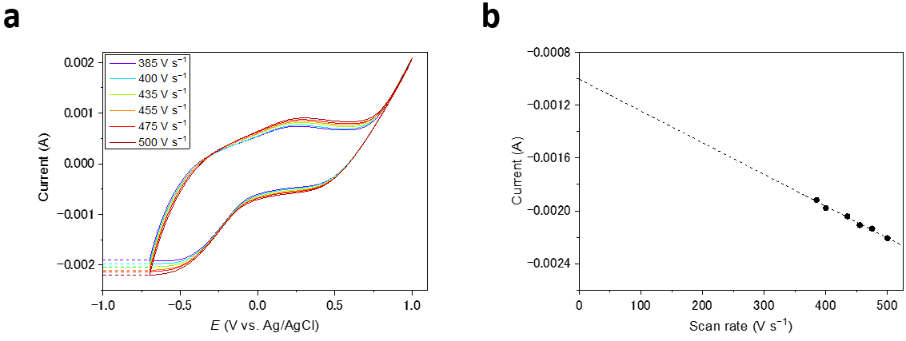
Figure S2. (a) Cyclic voltammetry at fast scan rates. (b) extrapolation of the steady-state current value. The steady-state current value at 0 V s⁻¹ (0.001 A) was used for determining the dissociation rate constant. The electrolyte is [KI] = 4 mM, [KI₃] = 1 mM, [α-CD] = 10 mM, and [KNO₃] = 100 mM.

Table S1. Determination of dissociation rate constant. The diffusion coefficient and association constant are taken from previous papers.
I (A) | A (m²) | C_{O}* (mol m⁻³) | D_{O} (m² s⁻¹)^{[4]} | C_{H}* (mol m⁻³) | K_{as} (m³ mol⁻¹)^{[5]} | k₋ (s⁻¹)
0.0010 | 7.1×10⁻⁶ | 1.0 | 1.0×10⁻⁹ | 1.0×10 | 160 | 8.6×10⁵

The maximum temperature difference and figure of merit for electrochemical Peltier refrigeration
Here we explain the figure of merit for electrochemical Peltier refrigeration.
The thermal power absorbed at the interface of electrolyte and electrode of the cold side q_{c} (J s^{–1}) is expressed as Eqn (S29). When heat is absorbed on the cold side, q_{c} has a positive sign.
$$\begin{aligned}q_{c}=\frac{Π}{nF}\left|I\right|-aRI^{2}-K∆T \#\left(S29\right)\end{aligned}$$
where electrochemical Peltier coefficient (Π) is the amount of heat transferred between electrodes per 1 mole of reactants and can be expressed as
$$\begin{aligned}Π=nFTS_{e}\#\left(S30\right)\end{aligned}$$
where S_{e} is the Seebeck coefficient. For simplicity, we assume that Π and S_{e} have a positive sign in this derivation. From Eqn (S29) and (S30), we obtain
$$\begin{aligned}q_{c}= S_{e}T_{c}I-aRI^{2}-KΔT\#\left(S31\right)\end{aligned}$$
When the direct electrical current was applied to the cell, the temperature difference (ΔT) is generated between electrodes, and q_{c} finally becomes zero. Assuming q_{c} = 0, ΔT is considered as a quadratic function of electrical current in Eqn (S31), and the electrical current value where ΔT becomes the maximum can be obtained. ΔT has the maximum value (ΔT_{max}) at
$$\begin{aligned}I=I_{m}=\frac{S_{e}T_{c}}{2aR}\#\left(S32\right)\end{aligned}$$
to be
$$\begin{aligned}{ΔT}_{max}=\frac{1}{4a}\frac{σS_{e}^{2}}{κ}T_{c}^{2}=\frac{1}{4a}ZT_{c}^{2}\#\left(S33\right)\end{aligned}$$
where σ is the electrical conductivity (S m⁻¹). When a = 1/2, ΔT_{max} = 1/2 ZT_{c}², which is consistent with ΔT_{max} of conventional solid-state Peltier cooling device^{[6]}. From Ohm’s law, Eqn(32) is equal to V = S_{e}T_{c} when a = 1/2. Since ΔT_{max} is proportional to the Z, Z can be regarded as the figure of merit for the electrochemical cooling system. It should be noted that Z is also the figure of merit for thermo-electrochemical cell (thermocell)^{[7]}, which is the inverse application of electrochemical Peltier refrigeration. Eqn (S33) indicates that ΔT_{max} is high when the electrolyte has high electrical conductivity, low thermal conductivity, and a large Seebeck coefficient (or large electrochemical Peltier coefficient).

Table S2 summarizes the calculated ΔT_{max} values for the aqueous electrolyte in this work. The values of Seebeck coefficients are taken from the previous paper^{[5]}.

Table S2. The maximum temperature values for the electrolyte used in this work. Each ΔT_{max} value is calculated based on Eqn (S33). For the calculation, ionic conductivity was used instead of electrical conductivity. a is assumed to be 1/2 and the cold side temperature (T_{c}) is assumed to be 298.15 K.
[α-CD] | σ  (mS cm⁻¹) | S_{e}  (mV K⁻¹)^{[5]} | κ  (W m⁻¹ K⁻¹) | Z = σS_{e}²/κ  (K⁻¹) | ΔT_{max}  (mK)
0 mM | 1.53 | 0.86 | 0.58 | 2.0 × 10⁻⁷ | 8.7
4 mM | 1.41 | 1.45 | 0.58 | 5.1 × 10⁻⁷ | 23

Relationship between the electrical current and electrochemical Peltier coefficient (Π)
In the Eqn (S14), it is assumed that the electrochemical Peltier coefficient is constant regardless of temperature or current value. However, the electrochemical Peltier coefficient is generally termed as the amount absorbed or desorbed during the redox reaction of a reversible process. Hence, the dependence of Π on the current was investigated. Square wave current was applied to the cell and T_{ox}(t)–T_{red}(t) value was plotted against t at various currents based on the average temperature of 4999 cycles (Fig S3-S6). In most cases, T_{ox}(t)–T_{red}(t) value changed linearly against t, which indicates that the Π value is independent of time or temperature. 2Π/nFC values were calculated for each current according to Eqn S(14) and plotted against the current (Fig. S7). From the figure, the 2Π/nFC is almost constant when the current does not exceed 0.15 mA (Fig. S3 (a)-(e) and Fig. S5 (a)-(b)), electrochemical Peltier coefficient does not depend on the current value at least when the current value is not more than 0.15 mA. In the presence of α-CD, the change of the average temperature seems rather be exponential at a higher current than 0.15 mA (Figure S5(c)-(e)). Because the thermal conductivity can be neglected (Table S2), this non-lineality can be attributed to the place of the host–guest interaction that is gradually apart from the electrode over time.

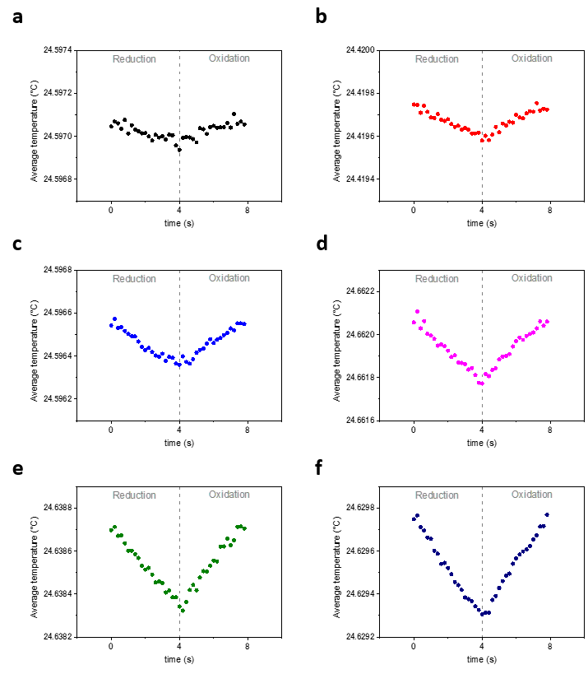
Figure S3. Results of the electrochemical Peltier measurement of an aqueous solution containing KI (10 mM) and KI₃ (2.5 mM). The average temperature of an electrode at various currents. The oxidation and reduction cycles were repeated 4999 times, and the temperature was averaged. The magnitude of currents are (a) 0.10 mA (b) 0.15 mA (c) 0.20 mA (d) 0.30 mA (e) 0.40 mA (f) 0.50 mA.

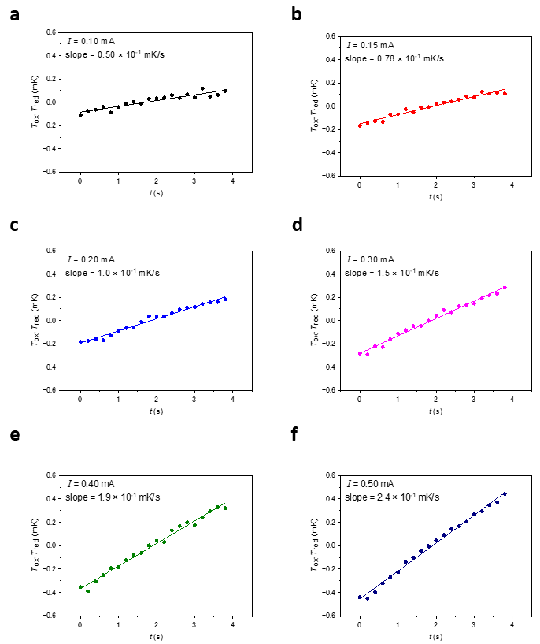
Figure S4. Relationship between T_{ox}(t)–T_{red}(t) of Fig. S3 and t at various current values.

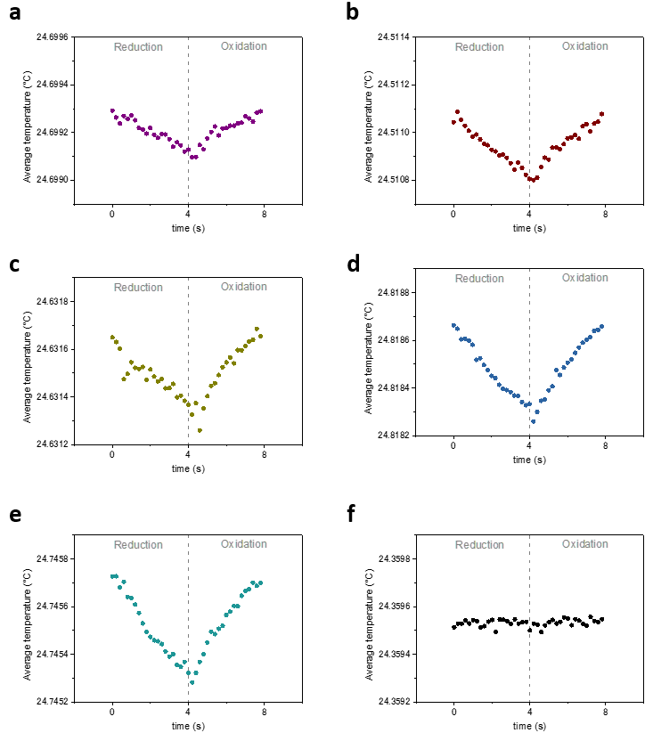
Figure S5. Results of the electrochemical Peltier measurement of an aqueous solution containing KI (10 mM) and KI₃ (2.5 mM), and α-CD (4 mM). The average temperature of an electrode at various currents. The oxidation and reduction cycles were repeated 4999 times, and the temperature was averaged. The magnitude of currents are (a) 0.10 mA (b) 0.15 mA (c) 0.20 mA (d) 0.25 mA (e) 0.30 mA (f) 0 mA (no current input).

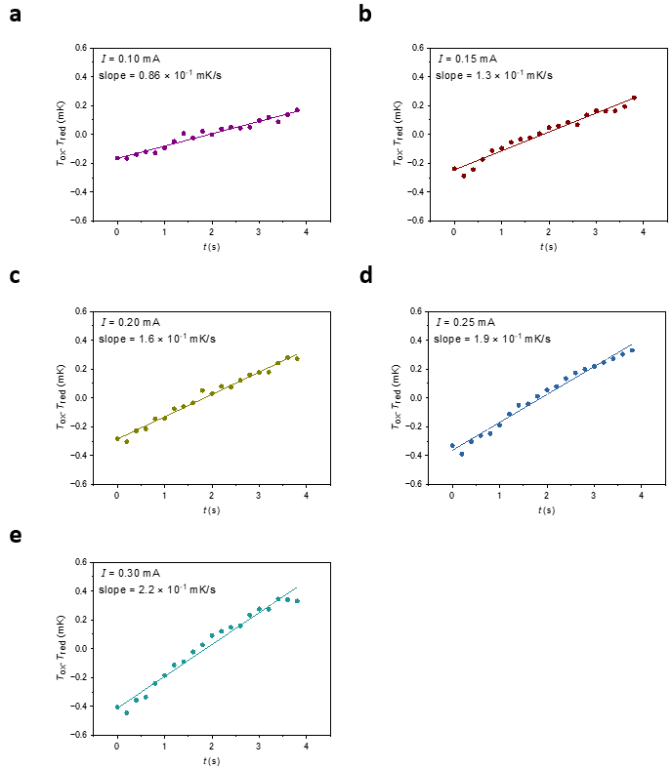
Figure S6. Relationship between T_{ox}(t)–T_{red}(t) of Fig. S5 and t at various current values.

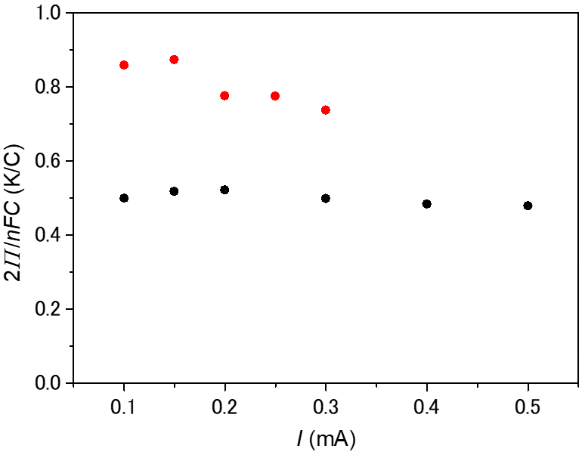

Figure S7. The dependency of 2Π/nFC values at various currents (black) without and (red) with 4 mM of α-CD. 2Π/nFC values were calculated from the slope of T_{ox}(t)-T_{red}(t) plot (Fig. S4. and Fig. S6.).

References
[1] P. F. Salazar, S. T. Stephens, A. H. Kazim, J. M. Pringle, B. A. Cola, J. Mater. Chem. A 2014, 2, 20676–20682.
[2] P. Boudeville, A. Tallec, Thermochim. Acta 1988, 126, 221–234.
[3] Seitaikinoukanrenkagakujikkenhou, Kagaku-Dojin P, 2003.
[4] E. A. Hogge, M. B. Kraichman, J. Am. Chem. Soc. 1954, 76, 1431–1433.
[5] H. Zhou, T. Yamada, N. Kimizuka, J. Am. Chem. Soc. 2016, 138, 10502–10507.
[6] J. Mao, G. Chen, Z. Ren, Nat. Mater. 2020, DOI 10.1038/s41563-020-00852-w.
[7] M. F. Dupont, D. R. MacFarlane, J. M. Pringle, Chem. Commun. 2017, 53, 6288–6302.

