SUPPLEMENTARY MATERIAL
Table S1 Hospitalisations (WHO score >=4) by SARS-CoV-2 lineage and age
 |  | ChAdOx1 nCoV-19 |  | Control
 |  | 18-55 years | 56 years + | 18-55 years | 56 years +
Secondary cases  (> 21 days after dose 1, < 15 days after dose 2) | Undetermined/no swab | 0 | 0 | 2 | 2
 | B.1.1.33 | 0 | 0 | 0 | 1
 | P.1 | 0 | 0 | 1 | 0
Primary cases  >= 15 days after dose 2 | Undetermined/no swab | 1 | 0 | 10 | 1
 | B.1.1.28 | 0 | 0 | 2 | 2
 | P.1 | 0 | 0 | 1 | 0
 | P.2 | 0 | 0 | 2 | 0

Table S2 Viral load from swabs (IU/mL)
Lineage | N | Median | Lower Quartile | Upper Quartile | Minimum | Maximum
All swabs
B.1.1.28 | 78 | 10421194 | 3076815 | 134118446 | 45720 | 3719734679
P.2 | 234 | 17495255 | 1129066 | 201985761 | 0 | 6030847082
P.1 | 178 | 80814649 | 5753668 | 526356323 | 480 | 18347259144
B.1.1.33 | 15 | 1341412 | 332255 | 13548956 | 61164 | 1408401265
Undetermined | 135 | 117320 | 1882 | 63948286 | 0 | 3921994942
Cases included in efficacy analysis
B.1.1.28 | 49 | 13565118 | 3433272 | 239472398 | 45720 | 3719734679
P.2 | 153 | 16383823 | 1129066 | 208670379 | 0 | 6030847082
P.1 | 18 | 28082673 | 1018799 | 371165029 | 98181 | 1988535214
B.1.1.33 | 9 | 4209409 | 414335 | 11311270 | 332255 | 1408401265
Undetermined | 71 | 2728762 | 2481 | 129539823 | 0 | 3921994942
Wilcoxon rank sum test comparing cases included in primary efficacy analysis with excluded cases, p=0.27.
Kruskal-Wallis test comparing viral load across lineages in all participants with swabs, p=0.0002.

Table S3 Days between illness onset and swabbing for NAAT testing
Lineage | N | Median | Lower Quartile | Upper Quartile
Known lineage
B.1.1.28 | 76 | 4 | 2.5 | 6
B.1.1.33 | 15 | 4 | 2 | 6
P.1 | 109 | 4 | 3 | 5
P.2 | 238 | 4 | 3 | 6
Other B.1 lineage | 19 | 3 | 2 | 6
Undetermined | 49 | 8 | 6 | 12
Undetermined lineage – Not P.1 or P.2 | 79 | 5 | 2 | 6

RNA extraction and viral load quantification.
For 96% of the sample set (650/676 samples, 516/518 of efficacy cohort), RNA was extracted from primary samples shipped at –80°C from participating sites in Brazil to the University of Oxford. The remaining samples were shipped as pre-extracted RNA. SARS-CoV-2 viral RNA was extracted from swab samples using the Quick-DNA/RNA Viral kit (Zymo Research): 200 µL of sample was mixed with 200 µL of DNA/RNA shield, before being extracted according to the manufacturer’s spin column protocol. RNA was eluted in 50 µL of DNAse/RNAse-free water and frozen at -80°C. SARS-CoV-2 RNA was quantified by real-time polymerase chain reaction (RT-PCR) using the CDC N1 oligonucleotide set (https://www.cdc.gov/coronavirus/2019-ncov/lab/rt-pcr-panel-primer-probes.html) and the Quantitect Probe RT-PCR kit (QIAGEN) in a 25 µL reaction volume containing 2 µL of extracted RNA. Oligonucleotides (ATDBio) were resuspended in ultrapure water. RT-PCR was performed on an Applied Biosystems StepOnePlus Real-Time PCR system (ThermoFisher Scientific) with the following settings: 50°C for 30 min (reverse transcription), 95°C for 10 min (hot-start polymerase activation), and 40 cycles of 94°C for 15 sec (denaturation) and 60°C for 1 min (combined annealing and extension). Intra-assay variation was controlled through use of a standard curve of synthetic RNA control 19/304 (NIBSC https://www.nibsc.org/products/brm_product_catalogue/detail_page.aspx?CatId=19/304) serially diluted from 1,000 copies/reaction to 10 copies/reaction. RT-PCR Ct values were converted to copy number/reaction using the standard curve, and to international units/mL by the conversion rate provided by NIBSC for samples with known processing volumes.
Sequencing. Samples with Ct<31 were taken forward for veSEQ sequencing as previously described,¹ using 30 µl RNA per sample as input volume and performing target capture on batches of 90 samples, alongside a series of quantification standards and positive and controls. Samples were demultiplexed using unique dual indexes (UDI), and read output was validated against Ct values to confirm sample integrity. Genomes were assembled from sequencing reads using the ShiverCovid pipeline v1.8 (https://github.com/BDI-pathogens/ShiverCovid) with variant frequencies calculated using shiver (tools/AnalysePileup.py),² using default settings of no base alignment quality and maximum pileup depth of 1000000. Lineages were assigned by Pangolin version 2.4.2 (lineages version 2021–04–28) combined with phylogenetic placement within the relevant clade, using the determined consensus genome for each sequenced sample. For incomplete genomes, lineages were assigned based on presence of lineage-defining mutations for P.1 and P.2 in the sequencing reads ( https://github.com/phe-genomics/variant_definitions/blob/main/variant_yaml/ ) and by genotyping as described below.
Phylogenetic reconstruction. Consensus sequences were aligned using MAFFT version 7.402.³ Phylogenetic reconstruction was performed on the alignment consisting of consensus sequences rooted with the Wuhan-Hu-1 reference sequence (RefSeq NC_045512), using IQ-TREE version 1.6.12,⁴ with the generalised time reversible + FreeRate model and 1000 bootstrap replicates.
Genotyping. Samples for which genome sequencing did not give a clear lineage classification, or which showed evidence of RNA degradation (as identified by unexpectedly low read yield and library fragment sizes <200b; typical median fragment size 380b), were genotyped using allele specific PCR (ASP)-based assays.⁵ Custom P.1 and P.2 ASP assays were designed to identify lineage-specific and highly sensitive single-nucleotide polymorphisms (SNPs) S:K417T (P.1) and ORF1a:L3468V (P.2). The ASP utilizes two dye-labelled probes that differ only in the SNP location, and leverages differential binding affinities of each probe due to primer-target mismatches to genotype the SNP with a higher sensitivity than sequencing. The assays were validated using sequence-confirmed P.1 and P.2 samples from the present dataset, with samples from other non-P.1/P.2 lineages as controls (supp. Figures 1 and 2). ASP was performed using the Quantitect Probe RT-PCR kit (QIAGEN) in a 25 µL reaction volume containing 5 µL of extracted RNA and performed on the Applied Biosystems StepOnePlus Real-Time PCR system using a genotyping program. P.1 and P.2 oligonucleotide sequences and reaction concentrations are listed in table X. The P.1 ASP was performed with the following settings: 50°C for 30 min, 60°C for 30 seconds (pre-amplification read), 95°C for 10 min, 45 cycles of 95°C for 15 sec, 58°C for 20 seconds, and 60°C for 45 seconds, and 60°C for 30 seconds (post-amplification read). The P.2 ASP was performed with the following settings: 50°C for 30 min, 66.5°C for 30 seconds (pre-amplification read), 95°C for 10 min, 50 cycles of 95°C for 15 sec and 66.5°C for 1 minute, and 66.5°C for 30 seconds (post-amplification read). cDNA of sequence-confirmed samples was generated using the SuperScript III First-Strand Synthesis System (ThermoFisher Scientific) according to the manufacturer’s instructions for gene-specific primers, except reverse transcription of the P.2 cDNA controls was performed at 50°C. Serially diluted cDNA aliquots of sequence-confirmed P.1, P.2, and non-P.1/P.2 samples were used as discrimination controls and ultrapure water served as no-template controls (NTCs). The change in fluorescent signal between pre-amplification and post-amplification reads for both dye-labelled probes was plotted on a cartesian plane. SNPs were designated based on their clustering with discrimination controls. Samples that failed to achieve a change in signal in either probe greater than those of the NTCs or lacked evidence of amplification were designated “undetermined.” Samples that were genotyped as non-P.1/P.2 by ASP and had no sequence data were classified as “Other lineage (non-P.1/P.2)”. Samples that could not be assigned a lineage by either sequencing or genotyping were classified as "Undetermined”.

Table S4: Oligonucleotide sequences used in this study.
Sequence Name | Target | Purpose | 5’>3’ sequence | Reaction conc.
2019_nCoV_N1_F | N gene | Quantification | GACCCCAAAATCAGCGAAAT | 500 nM
2019_nCoV_N1_R |  |  | TCTGGTTACTGCCAGTTGAATCTG | 500 nM
2019_nCoV_N1_P |  |  | FAM-ACCCCGCATTACGTTTGGTGGACC-BHQ1 | 125 nM
K417T_FW | S:417 | Genotyping | GAGGTGATGAAGTCAGACAAATCGC | 600 nM
K417T_RV |  |  | GATTGTTAGAATTCCAAGCTATAACGCAGC | 600 nM
K417T_P_WT |  |  | HEX-TCAGCAATMTTTCCAGTTTGCCCTGG-BHQ1 | 150 nM
K417T_P_P1 |  |  | FAM-TCAGCAATMGTTCCAGTTTGCCCTGG-BHQ1 | 150 nM
L3468V_FW | Orf1a:3468 | Genotyping | CACAAGCAGCTGGTACGGACACA | 500 nM
L3468V_RV |  |  | GCAGAAAGAGGTCCTAGTATGTCAACATGG | 500 nM
L3468V_P_WT |  |  | HEX-TTAATGTTTTAGCTTGGTTGTACGCTGCTG-BHQ1 | 125 nM
L3468V_P_P2 |  |  | FAM-TTAATGTTGTAGCTTGGTTGTACGCTGCTG-BHQ1 | 125 nM

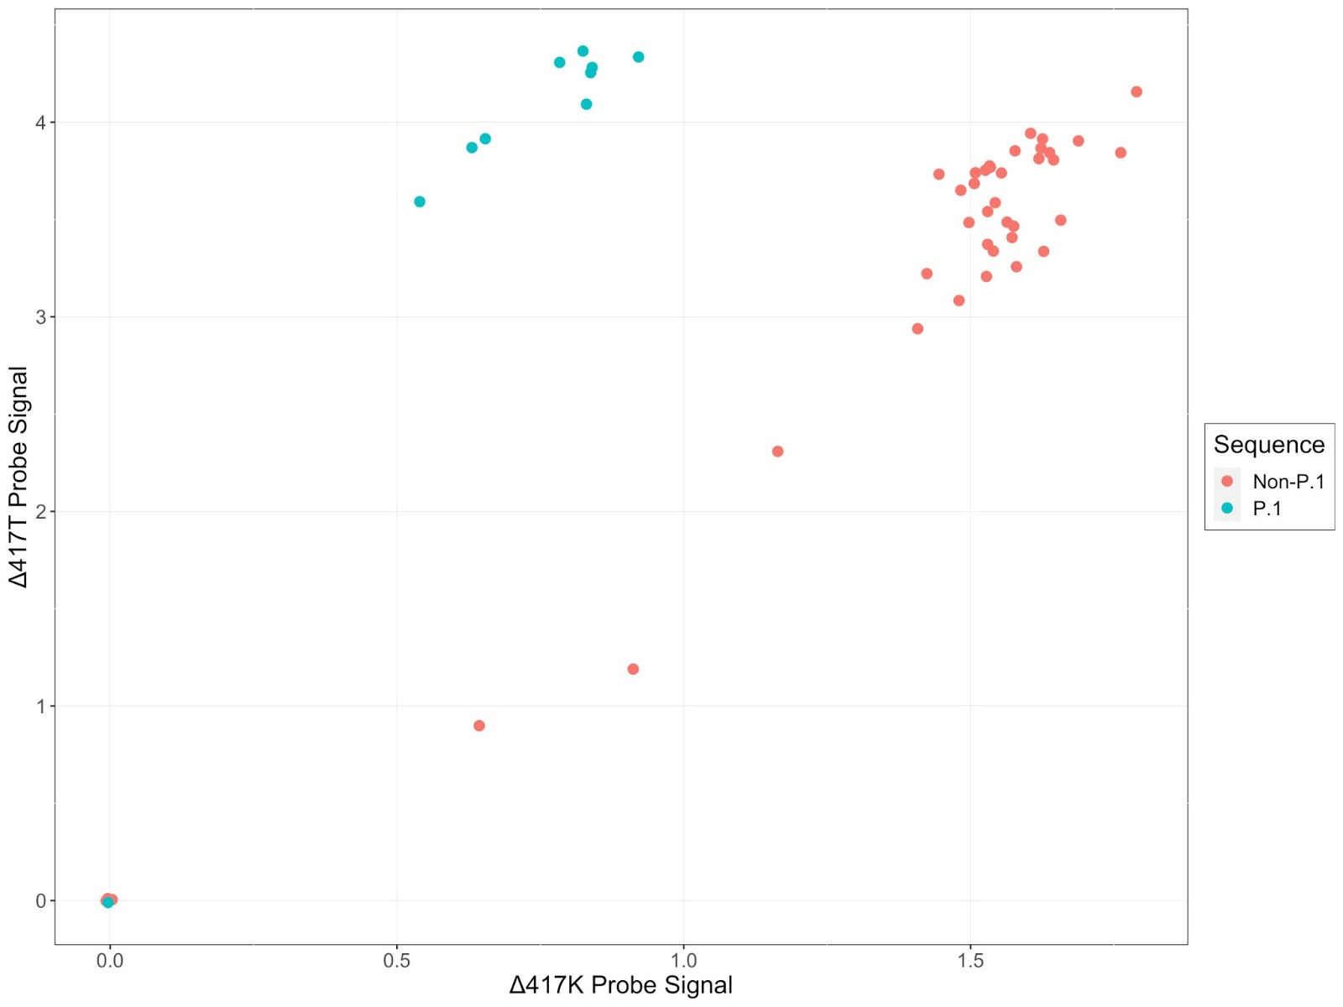
Supplementary Figure 1: Validation of P.1 ASP. Allelic discrimination of the P.1 assay was validated using 49 sequenced-confirmed samples (10 P.1, 39 non-P.1). Assay was performed as described in methods; cartesian plot visualizations change in signal for both probes from pre- and post-amplification reads. One P.1 sample and two non-P.1 samples failed to amplify and are located near the origin of the plot.
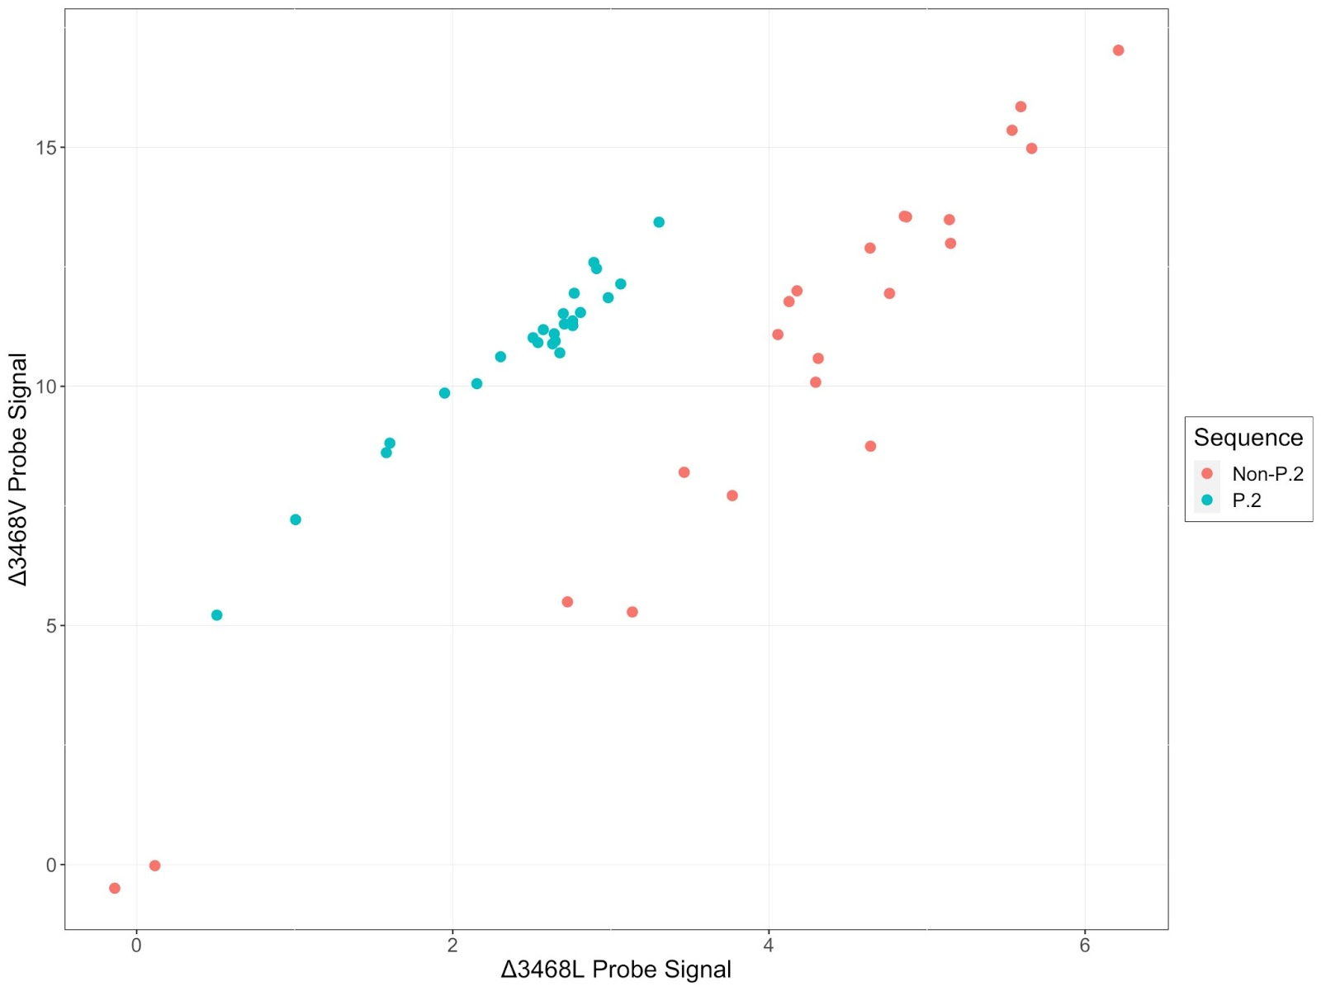Supplementary Figure 2: Validation of P.2 ASP. Allelic discrimination of the P.2 assay was validated using 47 sequenced-confirmed samples (25 P.2, 22 non-P.2). Assay was performed as described in Methods; cartesian plot visualizations change in signal for both probes from pre- and post-amplification reads. Two non-P.2 samples failed to amplify and are located near the origin of the plot.
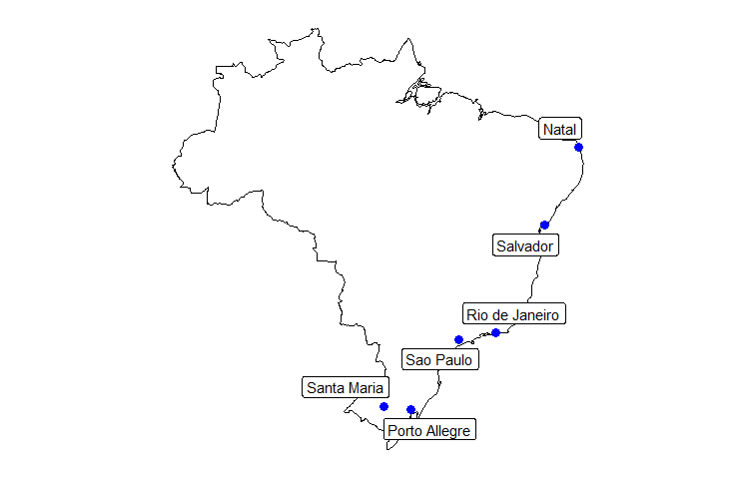
Supplementary Figure 3. Map of Brazil showing trial sites collecting samples in the present study.

Table S5 List of NAAT assays used in COV003 by study site
Location | Assays
Salvador | 1. Seegene Allplex multiplex  2. Thermofisher Taqpath multiplex
Porto Alegre | 1. US-CDC protocol  2. Xpert Xpress SARS-Cov-2, GeneXPert
Rio de Janeiro | 1. Allplex, Seegene SARS CoV-2 RT PCR  2. Xpert Xpress SARS-Cov-2 GeneXPert  3. BioFire Respiratory Panel 2.1 - including SARS-CoV-2, BioMérieux
São Paulo | 1. XGEN MASTER COVID-19 kit, Mobius Life Science
Natal | 1. Xgen Master COVID-19 Mobius Life  2. Norgen Biotek (2019-nCoV TaqMan RT-PCR)
Santa Maria | 1. In house assay based on Charite protocol https://www.who.int/docs/default-source/coronaviruse/protocol-v2-1.pdf?sfvrsn=a9ef618c_2 2. Bio-Manguinhos (FIOCRUZ) kit, also based on Charite protocol

Supplementary Material: Oxford Vaccine Trial Group
Lygia Accioly Tinoco | Hospital São Rafael e ID’OR, Brazil
Karla Cristina Marques Afonso Ferreira | Centro de Estudos e Pesquisas em Moléstias Infecciosas, Brazil
Cenusa Almeida | Hospital São Rafael e ID’OR, Brazil
Brian Angus | Jenner Institute, Nuffield Department of Medicine, University of Oxford, UK
Beatriz Arns | Hospital de Clinicas de Porto Alegre, Brazil
Laiana Arruda | Hospital São Rafael e ID’OR, Brazil
Renato De Ávila Kfouri | Universidade Federal de Sao Paulo, Brazil
Lucas Henrique Azevedo da Silva | Centro de Estudos e Pesquisas em Moléstias Infecciosas, Brazil
Matheus José Barbosa Moreira | Centro de Estudos e Pesquisas em Moléstias Infecciosas, Brazil
Brenda Vasconcelos Barbosa Paiva | IDOR, Rio De Janeiro; Hospital Quinta D'OR, Brazil
Louise Bates | Oxford Vaccine Group, Department of Paediatrics, University of Oxford, UK
Nancy Bellei | Universidade Federal de Sao Paulo, Brazil
Bruno Boettger | Universidade Federal de Sao Paulo, Brazil
Leandro Bonecker Lora | IDOR, Rio De Janeiro; Hospital Quinta D'OR, Brazil
Nina Amanda Borges de Araújo | Centro de Estudos e Pesquisas em Moléstias Infecciosas, Brazil
Chrystiane do Nascimento Brito de Oliveira | Centro de Estudos e Pesquisas em Moléstias Infecciosas, Brazil
Charlie Brown-O'Sullivan | Jenner Institute, Nuffield Department of Medicine, University of Oxford, UK
Daniel Calich Luz | Centro de Estudos e Pesquisas em Moléstias Infecciosas, Brazil
Joao Renato Cardoso Mourão | IDOR, Rio De Janeiro; Hospital Quinta D'OR, Brazil
Caroline Scherer Carvalho | Hospital Universitário de Santa Maria, Santa Maria, Brazil
Paola Cicconi | Jenner Institute, Nuffield Department of Medicine, University of Oxford, UK
Ana Gibertoni Cruz | Nuffield Department of Population Health, University of Oxford, UK
Debora Cunha | Hospital de Clinicas de Porto Alegre, Brazil
Daniel Marinho Da Costa | IDOR, Rio De Janeiro; Hospital Quinta D'OR, Brazil
Isabela Garrido Da Silva Gonzalez | Universidade Federal de Sao Paulo, Brazil
Priscila de Arruda Trindade | Department of Clinical and Toxicological Analysis- Universidade Federal de Santa Maria, Santa Maria, Brazil
Bruno Solano de Freitas Souza | Monte Tabor Centro Ítalo Brasileiro de Promoção Sanitária, Fiocruz-BA e I’DOR, Brazil
Sergio Carlos Assis De Jesus Junior | IDOR, Rio De Janeiro; Hospital Quinta D'OR, Brazil
Maria Isabel de Moraes Pinto | Universidade Federal de Sao Paulo, Brazil
Karolyne Porto De Mores | IDOR, Rio De Janeiro; Hospital Quinta D'OR, Brazil
Maristela Miyamoto de Nobrega | Universidade Federal de Sao Paulo, Brazil
Milla Dias Sampaio | Hospital São Rafael e ID’OR, Brazil
Janaína Keyla Dionísio dos Santos | Centro de Estudos e Pesquisas em Moléstias Infecciosas, Brazil
Alexander D. Douglas | Jenner Institute, Nuffield Department of Medicine, University of Oxford, UK
Suzete Nascimento Farias da Guarda | Universidade Federal da Bahia, Brazil e Hospital São Rafael, Brazil e ID’OR, Brazil
Mujtaba Ghulam Farooq | Oxford Vaccine Group, Department of Paediatrics, University of Oxford, UK
Elaine Shuo Feng | Oxford Vaccine Group, Department of Paediatrics, University of Oxford, UK
Marcel Catão Ferreira dos Santos | Centro de Estudos e Pesquisas em Moléstias Infecciosas, Brazil
Marília Miranda Franco | Rede D’OR, Brazil
Marianne Garcia de Oliveira | Centro de Estudos e Pesquisas em Moléstias Infecciosas, Brazil
Fernanda Garcia Spina | Universidade Federal de SaoPaulo, Brazil
Tannyth Gomes dos Santos | Centro de Estudos e Pesquisas em Moléstias Infecciosas, Brazil
Alvaro Henrique Goyanna | IDOR, RIO DE JANEIRO; Hospital Quinta D'OR, Brazil
Rosana Esteves Haddad | Vaxtrials, F&F Tower, Calle 50, Panamá, Panama
Adrian V. S. Hill | Jenner Institute, Nuffield Department of Medicine, University of Oxford, UK
Mimi M. Hou | Jenner Institute, Nuffield Department of Medicine, University of Oxford, UK
Bruna Junqueira | Hospital São Rafael e ID’OR, Brazil
Bruna Somavilla Kelling | Universidade Federal de Santa Maria, Santa Maria, Brazil
Baktash Khozoee | Jenner Institute, Nuffield Department of Medicine, University of Oxford, UK
Renan Gustavo Kunst | Hospital Universitário de Santa Maria, Santa Maria, Brazil
Jonathan Kwok | Nuffield Department of Medicine, University of Oxford, UK
Meera Madhavan | Jenner Institute, Nuffield Department of Medicine, University of Oxford, UK
José Antônio Mainardi de Carvalho | Department of Clinical and Toxicological Analysis-Universidade Federal de Santa Maria, Brazil
Olga Mazur | Oxford Vaccine Group, Department of Paediatrics, University of Oxford, UK
Angela M. Minassian | Jenner Institute, Nuffield Department of Medicine, University of Oxford, UK
Leonardo Motta Ramos | IDOR, Rio De Janeiro; Hospital Quinta D'OR, Brazil
Celia Hatsuko Myasaki | Universidade Federal de Sao Paulo, Brazil
Helena Carolina Noal | Programa de Pós Graduação em Enfermagem- PPGENF-Universidade Federal de Santa Maria, Brazil
Natália Nóbrega de Lima | Centro de Estudos e Pesquisas em Moléstias Infecciosas, Brazil
Rabiullah Noristani | Oxford Vaccine Group, Department of Paediatrics, University of Oxford, UK
Ana Luiza Perez | Hospital de Clinicas de Porto Alegre, Brazil
Jéssica Morgana Gediel Pinheiro | Hospital de Clinicas de Porto Alegre, Brazil
Priscila Pinheiro | Hospital São Rafael e ID’OR, Brazil
Marie Marcelle Prestes Camara | Centro de Estudos e Pesquisas em Moléstias Infecciosas, Brazil
Isabella Queiroz | Hospital São Rafael e ID’OR e UNIME, Brazil
Alessandra Ramos Souza | Universidade Federal de Sao Paulo, Brazil
Thais Regina Y Castro | Postgraduate Programme in Pharmaceutical Sciences- Universidade Federal de Santa Maria, Brazil
Hannah Robinson | Oxford Vaccine Group, Department of Paediatrics, University of Oxford, UK
Marianna Rocha Jorge | Hospital São Rafael e ID’OR, Brazil
Talita Rochetti | Universidade Federal de Sao Paulo, Brazil
Mariana Bernadi S. Saba | Universidade Federal de Sao Paulo, Brazil
Natalia Zerbinatti Salvador | IDOR, RIO DE JANEIRO; Hospital Quinta D'OR, Brazil
Thaina G Santos | Hospital de Clinicas de Porto Alegre, Brazil
Fernanda Caldeira Veloso Santos | Hospital Universitário de Santa Maria, Santa Maria, Brazil
Mayara Fraga Santos Guerra | IDOR, Rio De Janeiro; Hospital Quinta D'OR, Brazil
Samiullah Seddiqi | Oxford Vaccine Group, Department of Paediatrics, University of Oxford, UK
Roberta Senger | Hospital Universitário de Santa Maria, Santa Maria, Brazil
Robert Shaw | Oxford Vaccine Group, Department of Paediatrics, University of Oxford, UK
Airanuedida Silva Soares | Centro de Estudos e Pesquisas em Moléstias Infecciosas, Brazil
Rinn Song | Oxford Vaccine Group, Department of Paediatrics, University of Oxford, UK
Guilherme G Sorio | Hospital de Clinicas de Porto Alegre, Brazil
Ricardo Stein | Hospital de Clinicas de Porto Alegre, Brazil e Universidade Federal do Rio Grande do Sul, Brazil
Arabella V. S. Stuart | Oxford Vaccine Group, Department of Paediatrics, University of Oxford, UK
Tais Tasqueto Tassinari | Programa de Pós Graduação em Enfermagem- PPGENF-Universidade Federal de Santa Maria, Brazil
Cheryl Turner | Jenner Institute, Nuffield Department of Medicine, University of Oxford, UK
Tarsila Vieceli | Hospital de Clinicas de Porto Alegre, Brazil
Taiane A Vieira | Hospital de Clinicas de Porto Alegre, Brazil
João Gabriel Villar Cavalcanti | Centro de Estudos e Pesquisas em Moléstias Infecciosas, Brazil
Marion E. E. Watson | Jenner Institute, Nuffield Department of Medicine, University of Oxford, UK
Andy Yao | Oxford Vaccine Group, Department of Paediatrics, University of Oxford, UK
Rafael Zimmer | Hospital de Clinicas de Porto Alegre, Brazil

AMPHEUS Project
Oxford Viral Sequencing Group, Wellcome Centre for Human Genetics, University of Oxford, UK
David Buck
Angie Green
George MacIntyre-Cockett
Paolo Piazza
John A Todd
Amy Trebes
Oxford Viral Sequencing Group, Big Data Institute, University of Oxford, UK
Laura Thomson

Acknowledgements
Clinical Trials Research Governance Office, University of Oxford
Ronja Bahadori
Elaine Chick
Heather House
Claire Riddle
Data and Safety Monitoring Board (DSMB)
George Bouliotis
Steve Black
Elizabeth Bukusi
Cornelia Dekker
Robert Heyderman
Gregory Hussey
Paul Kaye
Bernhards Ogutu
Walter Orenstein
Sonia Ramos
Manish Sadarangani
Department of Paediatrics, University of Oxford
Georg A. Holländer
Endpoint Evaluation Committee
Jeremy Carr
Steve Chambers
Kim Davis
Simon Drysdale
Malick Gibani
Elizabeth Hammershaimb
Michael Harrington
Celina Jin
Seilesh Kadambari
Rama Kandasamy
Toby Maher
Jamilah Meghji
Claire Munro
David Pace
Rekha Rapaka
Robindra Basu Roy
Daniel Silman
Gemma Sinclair
Jing Wang
Jenner Institute, University of Oxford
Iona Tarbet
Nuffield Department of Medicine, University of Oxford
Richard Cornall
Richard Liwicki
Denis Murphy
Elizabeth Salter
Katherine Skinner
Philip Taylor
Oto Velicka
Oxford Research Services (Contracts)
Carly Banner
Sally Pelling-Deeves
Gary Priest
Oxford University Hospitals Trust
Bruno Holthof
Public Affairs Directorate and Divisional Communication Team
Alison Brindle
Alexander Buxton
James Colman
Chris McIntyre
Steve Pritchard

Supplementary References

1. Lythgoe KA, Hall M, Ferretti L, et al. SARS-CoV-2 within-host diversity and transmission. Science (New York, NY) 2021; 372(6539).
2. Wymant C, Blanquart F, Golubchik T, et al. Easy and accurate reconstruction of whole HIV genomes from short-read sequence data with shiver. Virus Evol 2018; 4(1): vey007.
3. Katoh K, Standley DM. MAFFT Multiple Sequence Alignment Software Version 7: Improvements in Performance and Usability. Molecular Biology and Evolution 2013; 30(4): 772-80.
4. Nguyen L-T, Schmidt HA, von Haeseler A, Minh BQ. IQ-TREE: A Fast and Effective Stochastic Algorithm for Estimating Maximum-Likelihood Phylogenies. Molecular Biology and Evolution 2015; 32(1): 268-74.
5. Ratcliff J, Nguyen D, Fish M, et al. Virological and serological characterization of critically ill patients with COVID-19 in the UK: a special focus on variant detection. medRxiv 2021: 2021.02.24.21251989.

