Supplemental Table 4. Probability of no or severe dyspepsia as a function of age among H. pylori-positive and –negative participants.

H. pylori status | Dyspepsia Severity | Equation for probability of dyspepsia  as a function of age (in years)
Positive | None* | 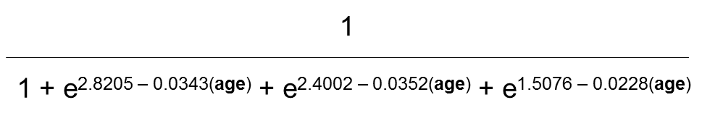
Positive | Severe** | 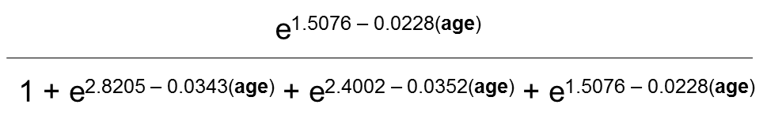
Negative | None* | 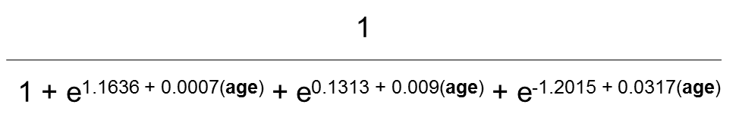
Negative | Severe** | 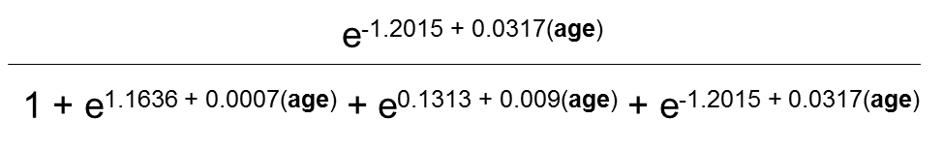

* Refers to a Short-Form Leeds Dyspepsia Questionnaire score of 0.
** Refers to a Short-Form Leeds Dyspepsia Questionnaire score greater than 15.
H. pylori: Helicobacter pylori.

