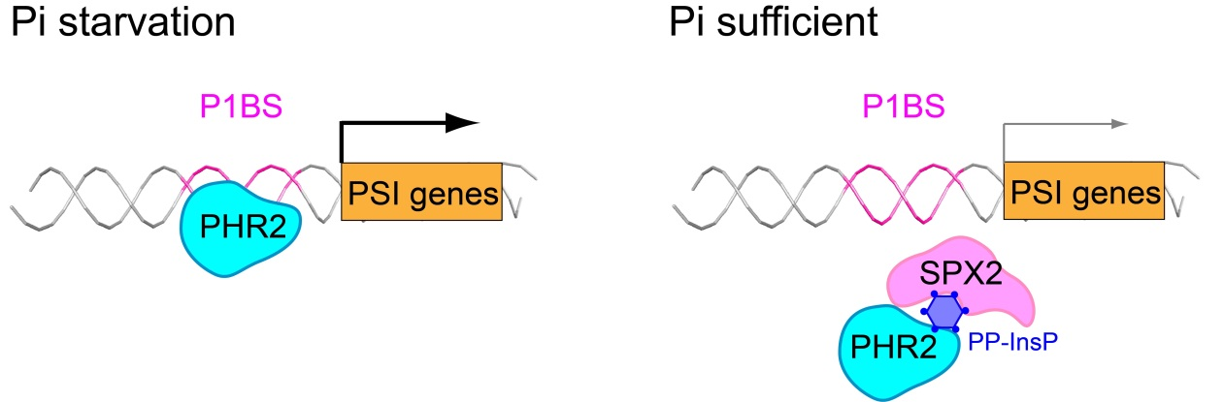
Supplementary Fig. 1. Regulation of PSI genes expression under Pi starvation and sufficient Pi conditions, respectively. PP-InsP is proposed to be a "molecular glue" mediating the association of PP-InsP receptor and interacting protein¹.

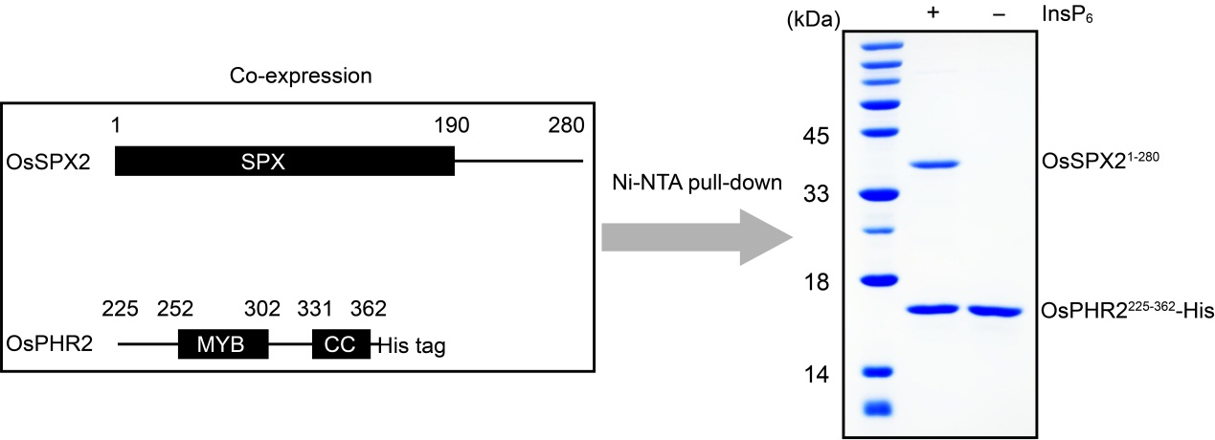
Supplementary Fig. 2. The association of rice SPX2 and rice PHR2 is InsP₆ dependent. Domain organizations of SPX, MYB and CC in rice SPX2 and PHR2 are schematically illustrated in the left frame. In the presence of InsP₆, the SPX2 can be co-eluted from Ni-NTA beads with His-tagged PHR2 (right frame). In contrast, SPX2 cannot be pulled down by His-tagged PHR2 in the absence of InsP₆. These results indicated that the interaction between SPX2 and PHR2 is InsP₆ dependent. The positions of SPX2 and PHR2 in the SDS-PAGE gel are highlighted, respectively.

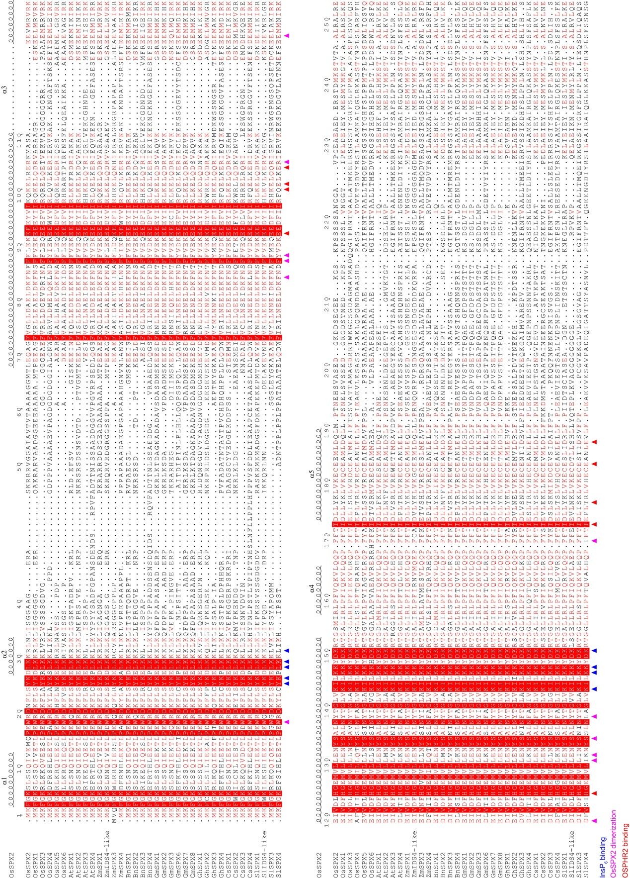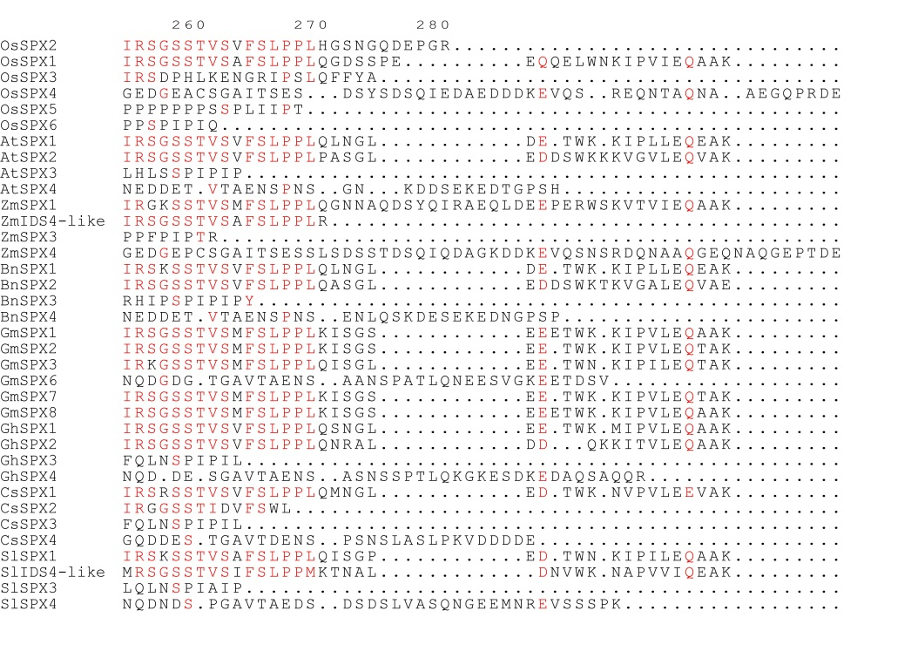
Supplementary Fig. 3. Sequence alignment of stand-alone SPX proteins. The sequence of Oryza Sativa SPX2 is aligned with other homologs. The alignment is generated using the MultAlin². The sequence identity is indicated by white letters against a red background, and the sequence of a similarity over 90% is indicated by red letters. The secondary elements of rice SPX2 are labeled at the top of the alignment. The residues responsible for InsP₆ binding, rice SPX2 dimerization and rice PHR2 binding are indicated with blue, magenta and red triangles at the bottom of the alignment, respectively.

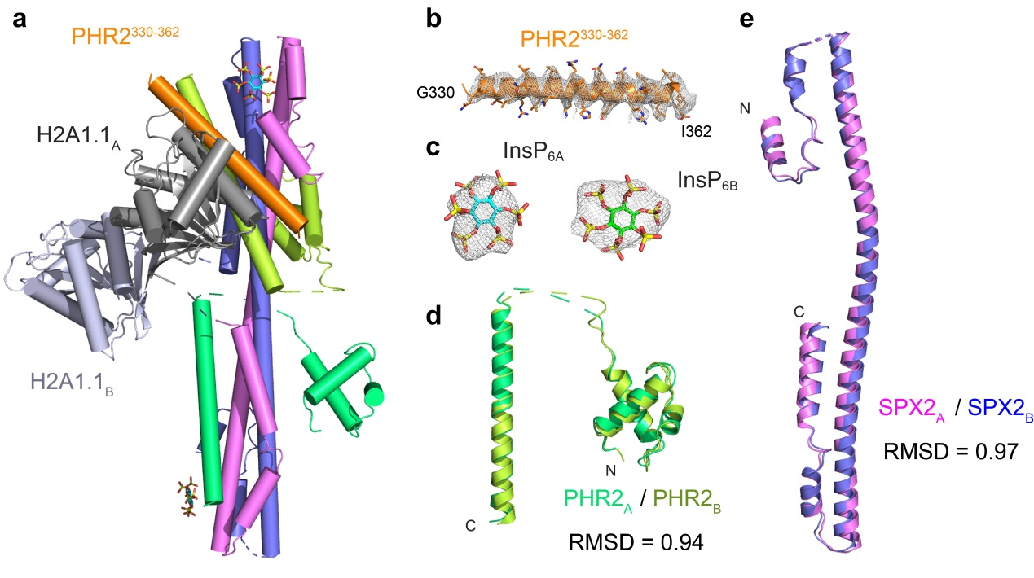
Supplementary Fig. 4. Overall structure of SPX2^{1-202/∆47-59}/InsP₆/PHR2²²⁵⁻³⁶² complex and particular elements presentation. a, The overall structure of mH2A1.1 fused SPX2^{1-202/∆47-59} in complex with InsP₆ and PHR2²²⁵⁻³⁶². The SPX2^{1-202//∆47-59}, InsP₆, and PHR2²²⁵⁻³⁶² are colored in the same scheme as Fig. 1a in the main text. The mH2A1.1 tags are colored in gray cartoon representation. In the crystal, some extra density can be unambiguously assigned to a PHR2 fragment that comprises the residues 330-362 of the CC domain. This PHR2³³⁰⁻³⁶² fragment is colored in orange cartoon representation. b, The composite omit map fits well with the PHR2³³⁰⁻³⁶² fragment. The 2Fo-Fc omit electron density map is contoured at 1.0 σ. The extra CC domain in the crystal may be degraded from the PHR2²²⁵⁻³⁶² (involves the MYB domain and CC domain) during crystallization process. Previous results have also indicated that the CC domain is easily cleaved from PHR2 due to proteolysis during crystallization process^{3,4}. For clearer visualization, the polypeptides of mH2A1.1 tag and PHR2³³⁰⁻³⁶² fragment are omitted in the main text presentation. c, The 2Fo-Fc omit electron density map of the two InsP₆ molecules. It is contoured at 1.5 σ. d, The structures of the two PHR2 protomers and, e, the two SPX2 protomers in the ternary complex are almost identically with a RMSD of 0.94 and 0.97, respectively.

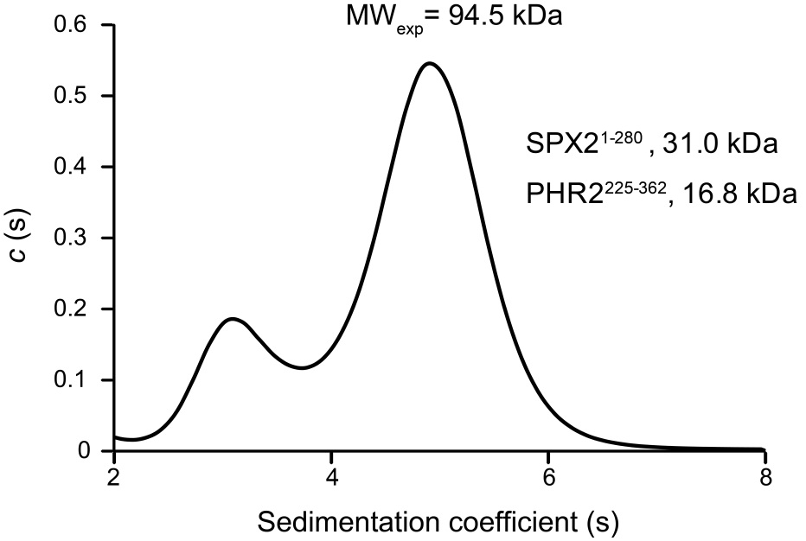
Supplementary Fig. 5. Analytical ultracentrifugation (AUC) characterizes the molecular weight of SXP2¹⁻²⁸⁰/InsP₆/PHR2²²⁵⁻³⁶² complex in solution. The major peak of experimentally measured molecular weight is 94.5 kDa, that is about twice of the sum of the full-length rice SPX2¹⁻²⁸⁰ and rice PHR2²²⁵⁻³⁶² (47.8 kDa in sum). It indicates that the SPX2 binds to PHR2 with a stoichiometry ratio of 2:2, and it is consisted with the crystal structure. The experiment was performed using the purified SPX2¹⁻²⁸⁰/PHR2²²⁵⁻³⁶² complex in the presence of 1 mM InsP₆. The minor peak in the AUC result may be contributed from the proteolysis or contamination.

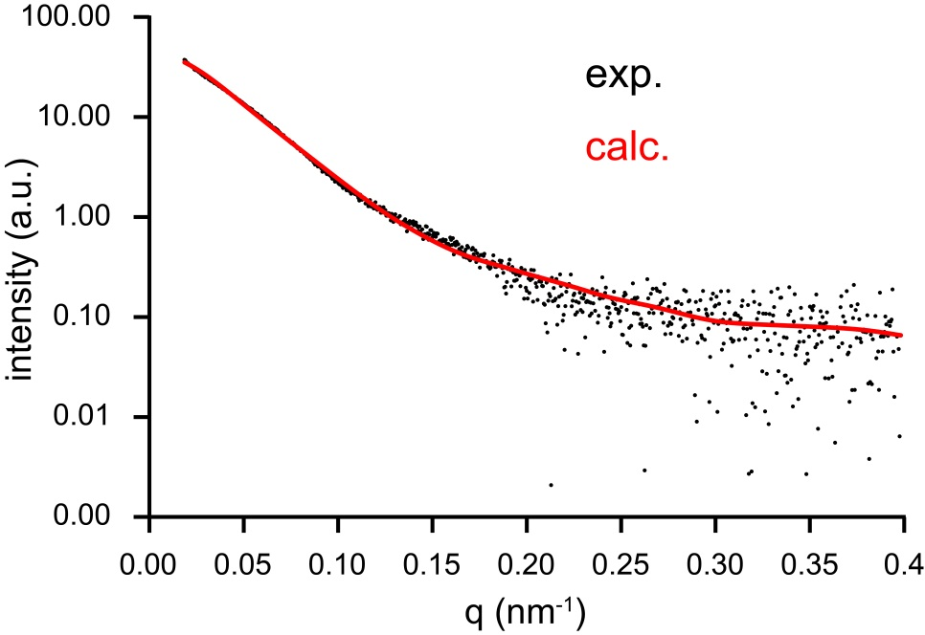
Supplementary Fig. 6. Small-angle X-ray scattering (SAXS) characterizes the structure of SXP2¹⁻²⁰²/InsP₆/PHR2²²⁵⁻³⁶² complex in solution. The calculated theoretical SAXS profile of the crystal structure (red line) fits well with the experimental data of SPX2¹⁻²⁰²/InsP₆/PHR2²²⁵⁻³⁶² complex in solution (black dots). It indicates that the crystal structure is maintained in solution, and that the internal-residues deletion (∆47-59) and mH2A1.1¹⁸¹⁻³⁶⁶ fusion of SPX2 have little impact on its structure and PHR2 association. The experiment was performed for the purified SPX2¹⁻²⁰²/PHR2²²⁵⁻³⁶² complex (no mH2A1.1 tag and no internal-residues deletion) in the presence of 1 mM InsP₆.
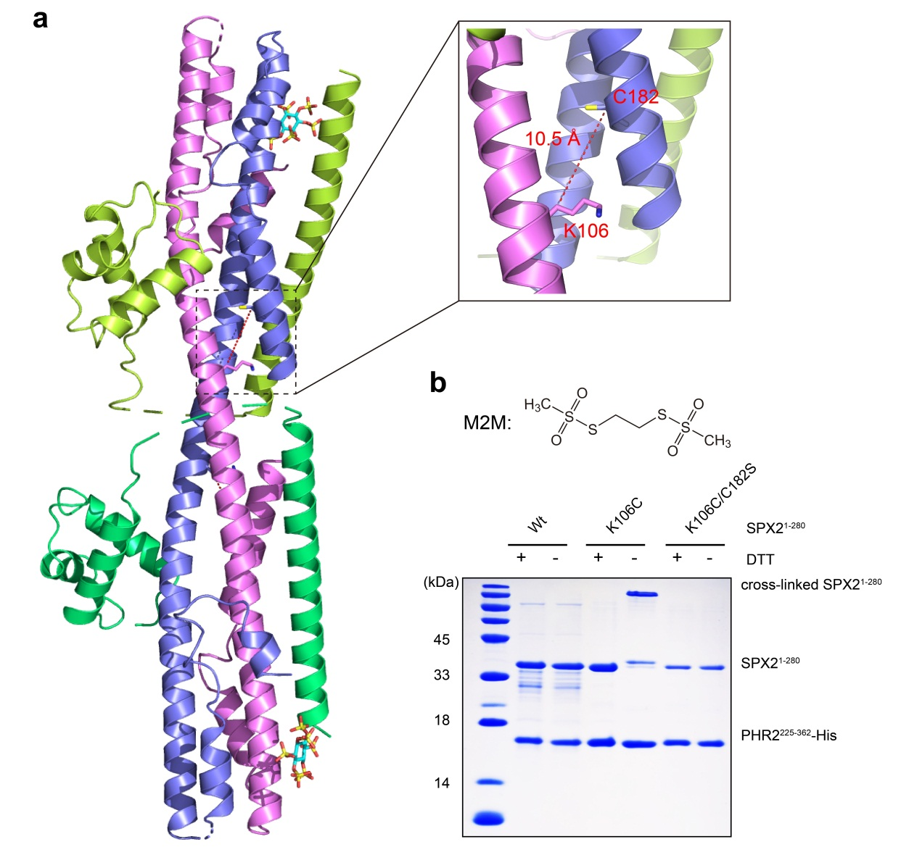
Supplementary Fig. 7. Thiol-directed chemical crosslinking validates the domain-swapped dimeric conformation of SPX2 in the SPX2/InsP₆/PHR2 complex. a, Representation of two spatially adjacent residues, K106 and C182, in the two protomers of the domain-swapped SPX2 dimer. The Cβ-Cβ distance between K106 and C182 is 10.5 Å. b, SDS-PAGE imaging of thiol-directed chemical crosslinking. The M2M (1,2-Ethanediyl Bismethanethiosulfonate) probe can crosslink two cysteine residues within a Cβ-Cβ distance of 11 Å. By mutating K106 of SPX2 into a cysteine, the SPX2 in the SPX2/PHR2 complex can be crosslinked by M2M, and the cross-linked SPX2 can be reversibly reduced by DTT (dithiothreitol). Neither the wildtype SPX2, possesses the endogenous C182, nor the K106C/C182S double mutant can be cross-linked. These data indicated that the crosslinking between K106 and C182 is specific. Thus, the thiol-directed chemical crosslinking results corroborate the domain-swapped dimeric conformation of SPX2. The crosslinking experiments were performed using the purified SPX2¹⁻²⁸⁰/PHR2²²⁵⁻³⁶² complex with particular mutations in the presence of 1 mM InsP₆.
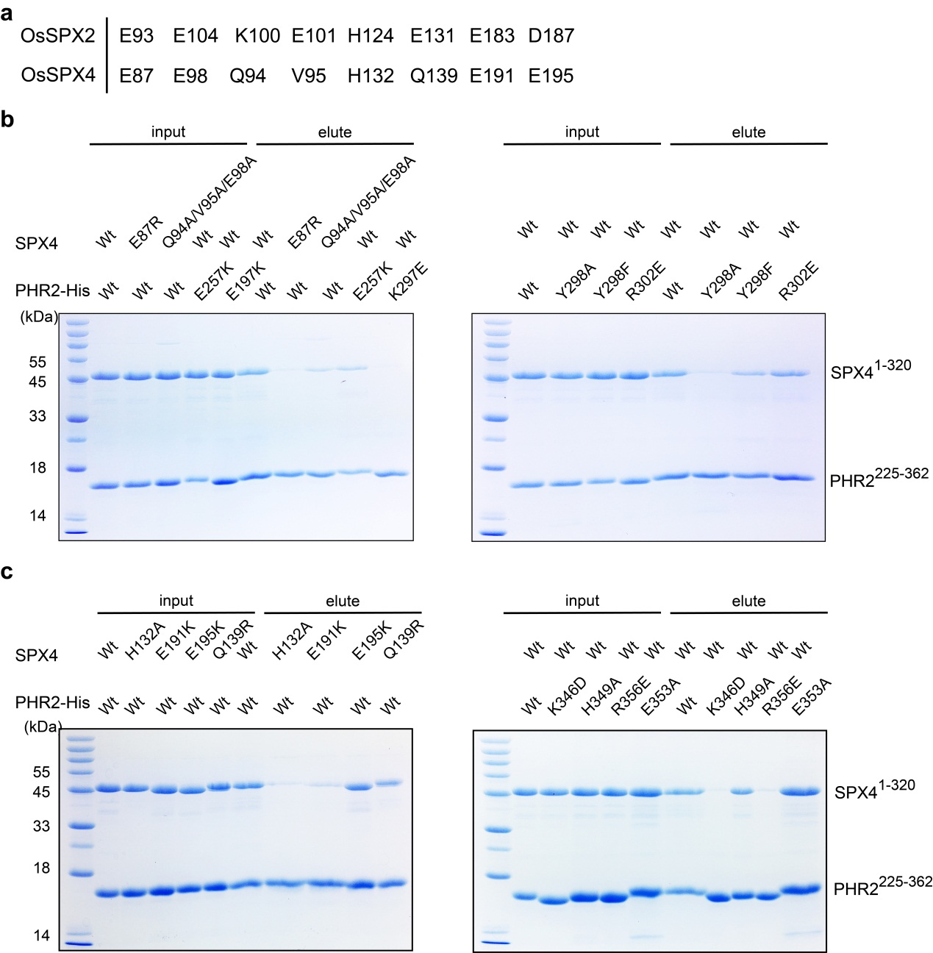

Supplementary Fig. 8. Pull-down analysis assesses the conserved interface residues contributing for the interaction between rice SPX4 and PHR2. a, Conserved key residues in rice SPX2 and SPX4 required for PHR2 binding. In vitro Ni-NTA pull-down characterizes the perturbed interactions between full-length SPX4¹⁻³²⁰ and His-tagged PHR2²²⁵⁻³⁶², upon residues mutation in the interface between SPX4 and, b, PHR2 ^{MYB} domain and, c, PHR2 ^{CC} domain, respectively. Different mutated versions of the full-length SPX4¹⁻³²⁰ and His-tagged PHR2²²⁵⁻³⁶² was prepared separately for the pull-down assay.

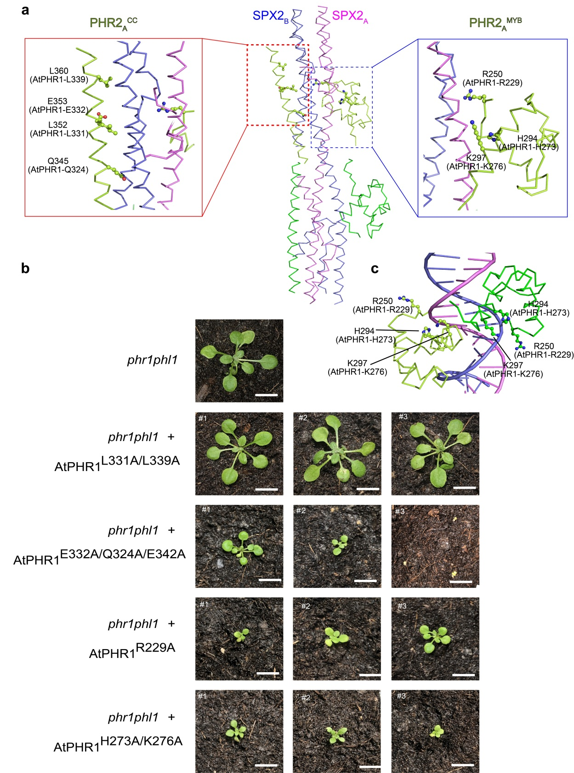
Supplementary Fig. 9. SPX – PHR complex interface mutations modulate the function of the related PHR1 transcription factor in Arabidopsis. a, Representation of the positions of the PHR^{CC} and PHR^{MYB} point mutations in the interaction interface. The PHR2 protomer A binds to the SPX2 dimer in the same way with protomer B, and only the details of protomer A are depicted. Details of the PHR^{CC} – SPX2 and PHR^{MYB} – SPX2 complex surfaces are shown in the red and blue frame, respectively. b, Growth phenotypes of AtPHR1 variants carrying point mutations in the PHR^{CC} – SPX and PHR^{MYB} – SPX domain interfaces. eGFP-AtPHR1 variants were expressed under the control of the endogenous AtPHR1 promoter in the phr1 phl1 mutant background⁵. Shown are the growth phenotypes of 2 week-old soil-grown plants (T1 generation, selected by FastRed seed fluorescence. #1, #2 and #3 represent independent lines). Scale bar = 1 cm. c, Representation of the positions of the PHR^{MYB} point mutations in promixity of the of PHR2^{MYB} – DNA recognition site.

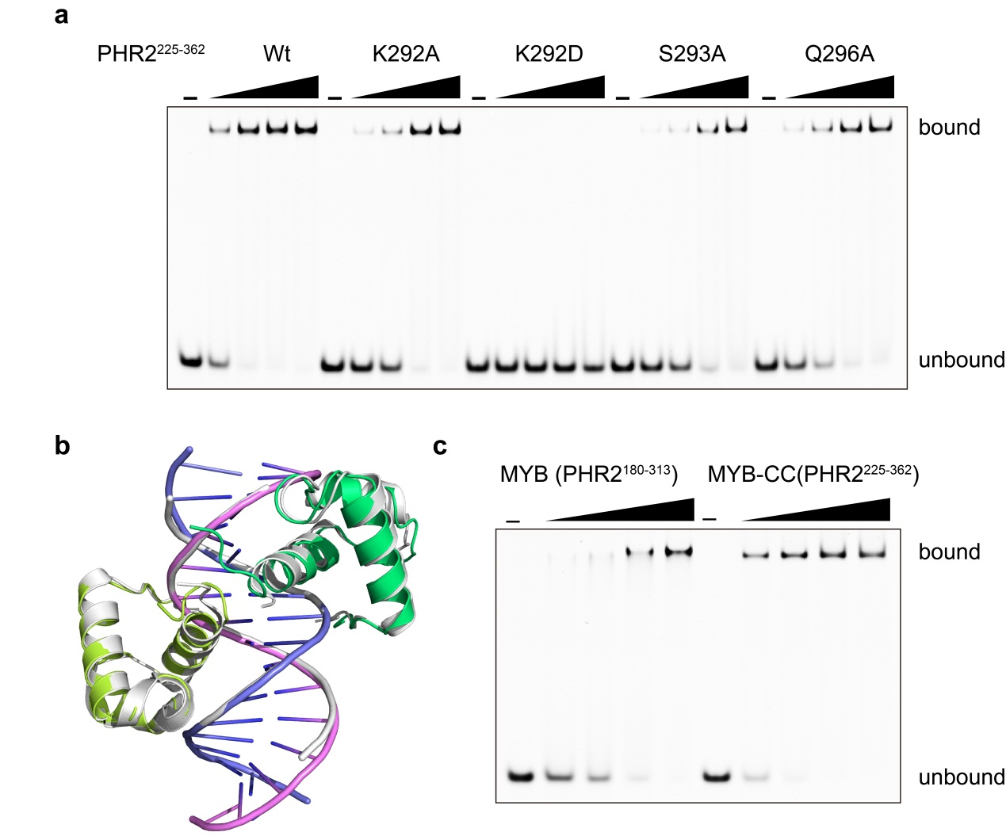
Supplementary Fig. 10. Characterize the recognition of P1BS motif by rice PHR2. a, Electophoretic mobility shift assay (EMSA) assessed the key residues of rice PHR2 for the recognition of P1BS. The boundary of PHR2²²⁵⁻³⁶² comprising the MYB and CC domains was used for the EMSA experiments. b, Structural comparison between the rice MYB^{PHR2}/P1BS complex and Arabidopsis MYB^{PHR1}/P1BS complex. Rice MYB^{PHR2}/P1BS structure is colored in the same scheme as Fig. 4a in the main text, and Arabidopsis MYB^{PHR1}/P1BS structure is colored in gray cartoon representation. c, EMSA results showed that the rice PHR2²²⁵⁻³⁶² comprising both MYB and CC domains has stronger binding affinity to P1BS than the only MYB domain (PHR2¹⁸⁰⁻³¹³). Each EMSA experiments was conducted for three biological replicates.

Supplementary Table 1. Statistics of crystal data collection and structures refinement.

structure | SPX2^{1-202/∆47-59}/InsP6/PHR2²²⁵⁻³⁶²  (PDB CODE: 7D3Y) | PHR2¹⁸⁰⁻³¹³/DNA  (PDN CODE: 7D3T)
Data collection
Space Group | P3₁ 2 1 | P 1 2₁ 1
Unit cell a, b, c,  α, β, γ (Å) (°) | 147.81, 147.81, 143.29  90.00, 90.00, 120.00 | 57.41, 100.82, 79.35  90.00, 102.46, 90.00
Wavelength (Å) | 0.9792 | 0.9785
Resolution (Å) | 45~3.11  (3.28~3.11) | 49~2.70  (2.83~2.70)
R_{merge} (%) | 4.9 (84.4) | 6.3 (103.8)
R_{pim} (%) | 1.2 (18.8) | 4.5 (69.1)
CC(1/2) (%) | 99.9 (95.7) | 99.7 (98.1)
I/σ | 35.4 (4.7) | 12.0 (1.7)
Completeness (%) | 99.9 (95.7) | 99.7 (98.1)
Number of measured reflections | 653,746 (99,405) | 81,972 (11,093)
Number of unique reflections | 32,993 (4,743) | 24,283 (3,197)
Redundancy | 19.8 (21.0) | 3.4 (3.5)
Wilson B factor (Å²) | 110.1 | 44.5
Refinement
R_{work} /R_{free} (%) | 22.02/25.26 | 21.28/25.78
Number of atoms
Protein main chain | 3640 | 956
Protein side chain | 3681 | 1015
Protein all atoms | 7321 | 1971
Water molecules | 0 | 9
Other entities | 72 | 1309
All atoms | 7393 | 3289
Average B value (Å²)
Protein main chain | 141.6 | 78.3
Protein side chain | 15.7 | 84.0
Protein all atoms | 146.2 | 84.3
Water molecules |  | 68.5
Other entities | 280.2 | 77.2
All atoms | 147.5 | 79.6
Rms deviations from ideal values
Bonds (Å) | 0.007 | 0.011
Angle (°) | 0.563 | 1.376
Ramachandran plot statistics (%)
Most favorable | 98.09 | 94.8
Additionally allowed | 1.92 | 5.2
Generously allowed | 0 | 0
Disallowed | 0 | 0
MolProbity score | 1.03 | 1.91
Values in parentheses are for the highest resolution shell. R_{merge}=Σ_{h}Σ_{i}|I_{h,i}-I_{h}|/Σ_{h}Σ_{i}I_{h,i}, where I_{h} is the mean intensity of the i observations of symmetry related reflections of h. R=Σ|F_{obs}-F_{calc}|/ΣF_{obs}, where F_{calc} is the calculated protein structure factor from the atomic model (R_{free} was calculated with 5% of the reflections selected).

Supplementary Table 2. Primers used for cloning PHR1 into the pUC-BpiI vector.
a, Golden Gate Level I constructs and primers. The AtPHR1 coding sequence and the AtPHR1 promoter were amplified from A. thaliana gDNA. Mutations targeting the AtPHR1 coding sequence were introduced by site-directed mutagenesis. Level I constructs were generated via BpiI cut-ligation into pUC-BpiI.
Primer | 5’-3’ Sequence
pPHR1_AB_F | TTTGAAGACTTTACGGGTCTCTGCGGTTTTGTAAAACTATGAATCA
pPHR1_AB_R | TTTGAAGACTTCAGAGGTCTCTCAGAGTTAATTTCGGAGGTGGTGG
PHR1_R229A_F | CACGAATGGCTTGGACGCCAGAGCTTCACGAGGCTTTTGTTGAGGCTG
PHR1_R229A_R | CGTCCAAGCCATTCGTGCCTTGCCCGTTCCGTTATTGCTGTTTGAA
PHR1_H273K276A_F | AAGCGCTTTACAGGCATATAGGACAGCTAGATATCGGCCAGAAC
PHR1_H273K276A_R | ATATGCCTGTAAAGCGCTTTTAACATGATATATAGTCAAGCCTTCAACTT
PHR1_E332A_F | AGCAGCTCGCGATTCAAAGAAACCTGCAACTCCGAATAGAAGAACAAG
PHR1_E332A_R | TCTTTGAATCGCGAGCTGCTCATGGAGTTGCTTCTGTACTTCCATCT
PHR1_Q324A_F | GATGGAAGTAGCGAAGCAACTCCATGAGCAGCTCGCGATTCAAAGAAACC
PHR1_Q324A_R | GTTGCTTCGCTACTTCCATCTGAAGTCGTAGAGCCTCTGTAAT
PHR1_E342A_F | CTCCGAATAGCAGAACAAGGCAAGTACCTGCAAATGATGTTCG
PHR1_E342A_R | CCTTGTTCTGCTATTCGGAGTTGCAGGTTTCTTTGAATCGCG
PHR1_L331A_F | CATGAGCAGGCCGAGATTCAAAGAAACCTGCAACTCCGAATAGAAG
PHR1_L331A_R | TGAATCTCGGCCTGCTCATGGAGTTGCTTCTGTACTTCCATCTGAAGT
PHR1_L339A_F | ACCTGCAAGCCCGAATAGAAGAACAAGGCAAGTACCTGCAAATGAT
PHR1_L339A_R | TTCTATTCGGGCTTGCAGGTTTCTTTGAATCTCGGCCTGCTCAT

b, Level II constructs. Level I constructs were assembled in Level II constructs via BsaI cut-ligation.
Level II constructs | Level I inserts
pLii_proPHR1:GFP-phr1^{R229A} | pLi_AB_proPHR1 + pLi_BC_GFP + pLi_CD_phr1^{R229A} + pLi_DE_dummy + pLi_E-F NOSter + pLi_FG_FastRed
pLii_proPHR1:GFP-phr1^{H273A/K276A} | pLi_AB_proPHR1 + pLi_BC_GFP + pLi_CD_phr1^{H273K276A} + pLi_DE_dummy + pLi_E-F NOSter + pLi_FG_FastRed
pLii_proPHR1:GFP-phr1^{E332A/Q324A/E342A} | pLi_AB_proPHR1 + pLi_BC_GFP + pLi_CD_phr1^{E332A/Q324A/E342A} + pLi_DE_dummy + pLi_E-F NOSter + pLi_FG_FastRed
pLii_proPHR1:GFP-phr1^{L331A/L339A} | pLi_AB_proPHR1 + pLi_BC_GFP + pLi_CD_phr1^{L331A/L339A} + pLi_DE_dummy + pLi_E-F NOSter + pLi_FG_FastRed

References
1 Desmarini, D., Lev, S., Furkert, D., Crossett, B., Saiardi, A., Kaufman-Francis, K., Li, C., Sorrell, T. C., Wilkinson-White, L., Matthews, J., Fiedler, D. & Djordjevic, J. T. IP7-SPX Domain Interaction Controls Fungal Virulence by Stabilizing Phosphate Signaling Machinery. mBio 11 (2020).
2 Corpet, F. Multiple sequence alignment with hierarchical clustering. Nucleic Acids Res 16, 10881-10890 (1988).
3 Jiang, M., Sun, L., Isupov, M. N., Littlechild, J. A., Wu, X., Wang, Q., Wang, Q., Yang, W. & Wu, Y. Structural basis for the Target DNA recognition and binding by the MYB domain of phosphate starvation response 1. FEBS J 286, 2809-2821 (2019).
4 Ried, M. K., Wild, R., Zhu, J., Pipercevic, J., Sturm, K., Broger, L., Harmel, R. K., Abriata, L. A., Hothorn, L. A., Fiedler, D., Hiller, S. & Hothorn, M. Inositol pyrophosphates promote the interaction of SPX domains with the coiled-coil motif of PHR transcription factors to regulate plant phosphate homeostasis. Nat Commun 12, 384 (2021).
5 Bustos, R., Castrillo, G., Linhares, F., Puga, M. I., Rubio, V., Perez-Perez, J., Solano, R., Leyva, A. & Paz-Ares, J. A central regulatory system largely controls transcriptional activation and repression responses to phosphate starvation in Arabidopsis. PLoS Genet 6, e1001102 (2010).

