Supplemental Material

Clinical Utility of aVR Lead T-wave in Electrocardiogram of Patients with ST-Elevation Myocardial Infarction
[Authors' names/affiliations are undisclosed for peer review]
Running title: T-wave in aVR Lead in ST-Elevation Myocardial Infarction

 | Supplemental Table 1. Independent determinants of T wave amplitude in aVR lead in STEMI patients
 |  |  | Correlation coefficient and 95%CI | P value
Age |  | >= 65 years vs <65 years | 0.195 (0.023, 0.357) | .026
Gender |  | Male vs female | -0.012 (-0.224, 0.201) | .913
DM |  | Present vs absent | -0.186 (-0.394, 0.023) | .075
HTN |  | Present vs absent | -0.159 (-0.322, 0.004) | .072
HC |  | Present vs absent | -0.067 (-0.276, 0.141) | .526
Cr (mg/dl) |  | >=1.2 vs <1.2 | -0.090 (-0.273, 0.093) | .321
BS (mg/dl) |  | >=200 vs <200 | -0.037 (-0.267, 0.193) | .754
Time from symptom ª (hours) |  | >=12 vs <12 | -0.135 (-0.317, 0.048) | .136
Systolic BP mmHg |  | >=100 vs 100 | 0.107 (-0.170, 0.384) | .448
HR/ min |  | >=90 vs <90 | 0.184 (0.010, 0.364) | .038
Killip class |  | > 1 vs <1 | 0.073 (-0.121, 0.267) | .815
Infarction location |  | Inferior vs anterior | 0.144 (-0.044, 0.333) | .116
PAH |  | Present vs absent | 0.248 (-0.015, 0.512) | .057
MR |  | No MR vs MR | -0.042 (-0.209, 0.126) | .625
LVEF (%) |  | >=40 vs <40 | -0.253 (-0.050, -0.456) | .015
a Time from symptom to hospital admission; BP, Blood pressure; HC, Hypercholesterolemia; HTN, Hypertension; HR, Heart rate; LVEF, Left ventricular ejection fraction; MR, Mitral regurgitation; PAH, Pulmonary arterial;
PCI, Percutaneous coronary intervention

a Numbers of patients in this category (percent in row)
b Of those discharged from the hospital (n=316)
Supplemental Table 2 . Performance of T wave amplitude in aVR lead at different cutoff points for prognosis of distinct endpoints in STEMI patients
 | T wave amplitude mV | Six month-cardiovascular mortality  n = 340 |  |  | In-hospital mortality  n = 340 |  |  | Re-hospitalization  n = 316^{b}
 |  | Present | Absent | Present |  | Absent | Present |  | Absent
Cutoff point of 0 mV | ≥0 | 13 (44.8)ª | 16 (55.2) | 7 (24.1) |  | 22 (75.9) | 10 (45.5) |  | 12 (54.5)
 | <0 | 39 (12.5) | 272 (87.5) | 17 (5.5) |  | 294 (94.5) | 60 (20.4) |  | 234 (79.6)
Cutoff point of -1 mV | -1≤ | 45 (24.7) | 137 (75.3) | 23 (12.6) |  | 159 (87.4) | 47 (29.6) |  | 112 (70.4)
 | <-1 | 7 (4.4) | 151 (95.6) | 1 (0.6) |  | 157 (99.4) | 23 (14.6) |  | 134 (85.4)
Cutoff point of -2 mV | -2≤ | 51 (16.6) | 256 (83.4) | 24 (7.8) |  | 283 (92.2) | 68 (24.0) |  | 215 (76.0)
 | <-2 | 1 (3.0) | 32 (97.0) | 0 (0.0) |  | 33 (100.0) | 2 (6.1) |  | 31 (93.9)

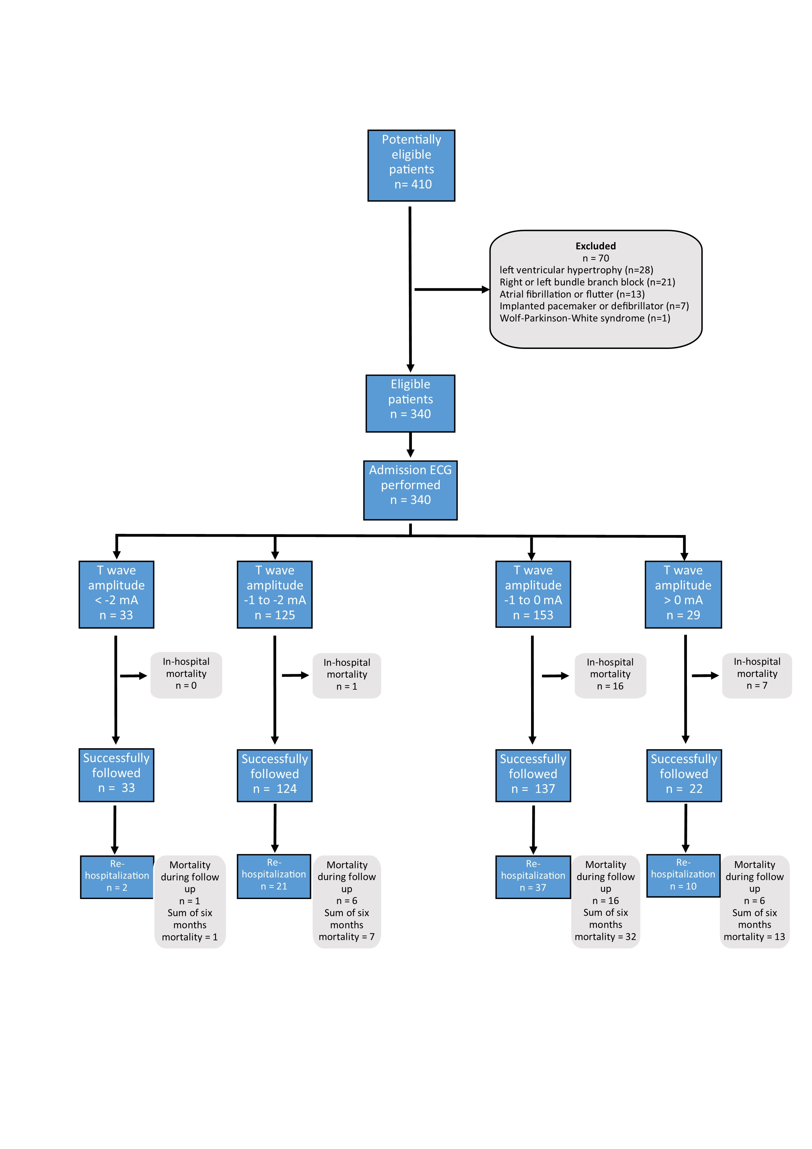 Supplemental Figure 1. STARD diagram reporting flow of participants through the study
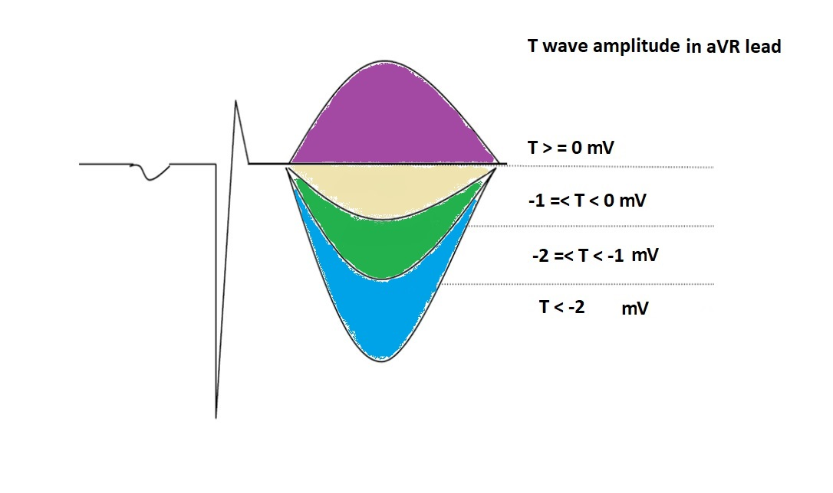
Supplemental Figure 2. Study groups based on T-wave amplitude.

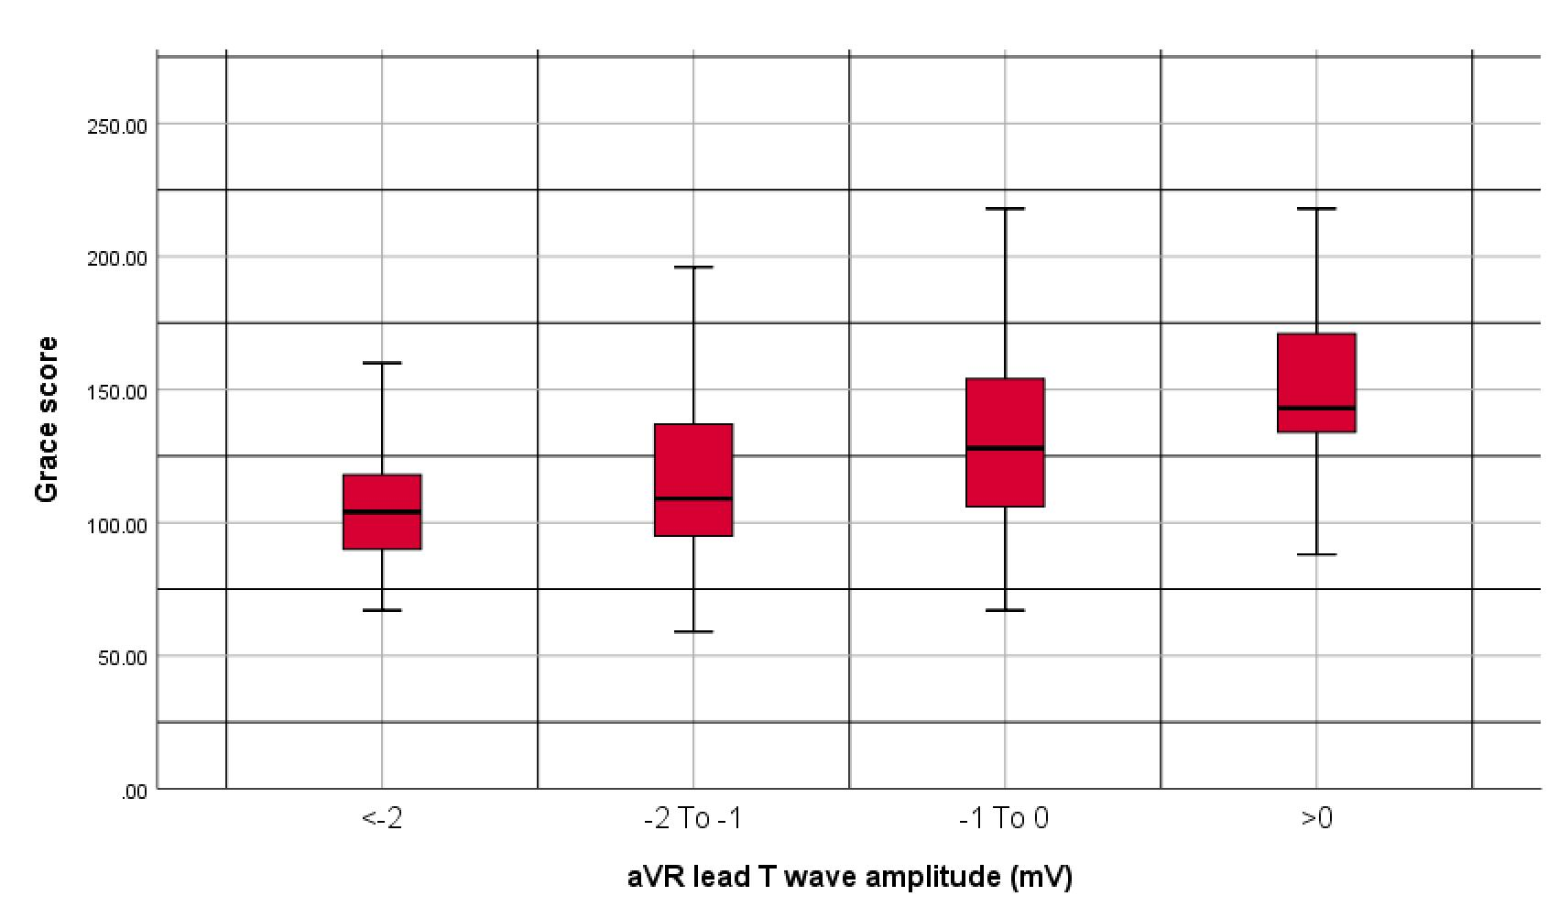 Supplemental Figure 3. Simple boxplot of Global Registry of Acute Coronary Events (GRACE) score in patients with different T wave amplitude in aVR lead.

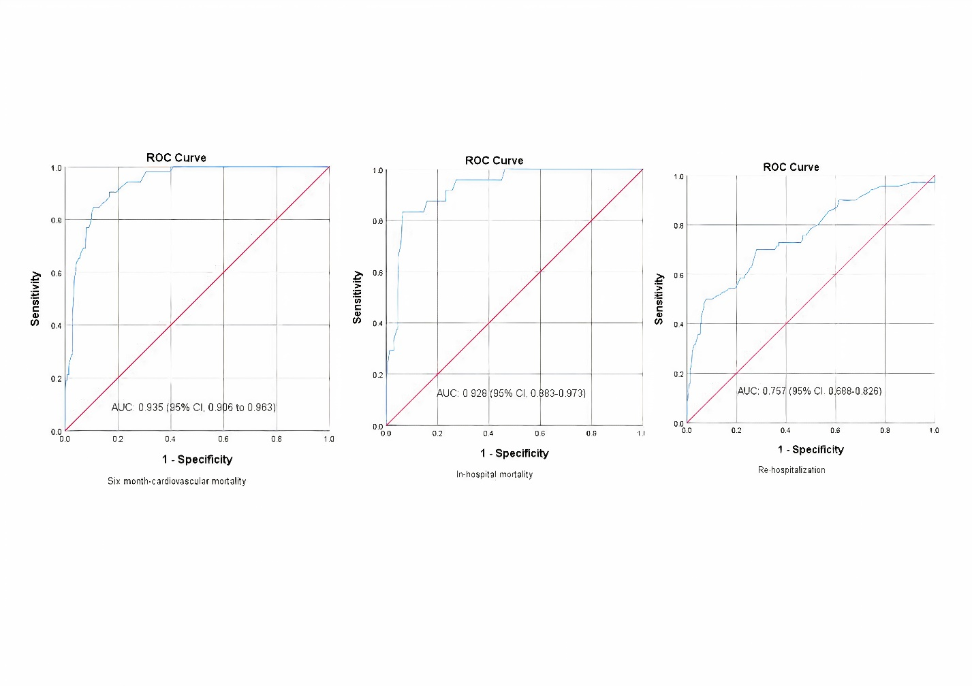

Supplemental Figure 4. Receiver Operating Characteristic (ROC) curve analysis for prognostic power of Global Registry of Acute Coronary Events (GRACE) score in patients with different T wave amplitude in aVR lead

