Supplementary materials
Molecular insights into tumor targeted therapy by carrier-free Lycorine Nanoparticles in vitro and in vivo

Shiyue Zhou, Yuling Qiu, Rui Liu, Shuangshuang Yin, Yingying Shao, Song Wu,
Qian Chen, Tao Wang, Bo Du, Haiyang Yu

Figure Legend for Supplementary Data

Supplementary Figure 1. Mean plasma concentration–time curves and in vivo cytotoxicity assay of Ly and DS-Ly NPs in mice plasma after intravenous (a) Mice were given 5mg/kg of Ly and DS-Ly NPs by intravenous injection, and blood was drawn at time points of 0.83, 0.16, 0.25, 0.5,0.75, 1, 2, 4, 6, 12 and 24 h. The plasma was separated and analyzed by LC–MS/MS. The pharmacokinetic parameters determined from the study are found in Table 1. (b) Effect of Ly and DS-Ly NPs treatments on serum ALT/AST levels. *p < 0.05 compared to control. #p < 0.05 compared to control treated with Ly (Student’s t-test).

Supplementary Figure 2. Full scans of western-blot data shown in Figure 3. Rectangles delimit cropped areas used in the indicated panels in Figure 3.

Supplementary Figure 3. Full scans of western-blot data shown in Figure 4. Rectangles delimit cropped areas used in the indicated panels in Figure 4.

Supplementary Figure 4. Full scans of western-blot data shown in Figure 5. Rectangles delimit cropped areas used in the indicated panels in Figure 5.

Supplementary Figure 5. Full scans of western-blot data shown in Figure 6. Rectangles delimit cropped areas used in the indicated panels in Figure 6.

Supplementary Figure 1
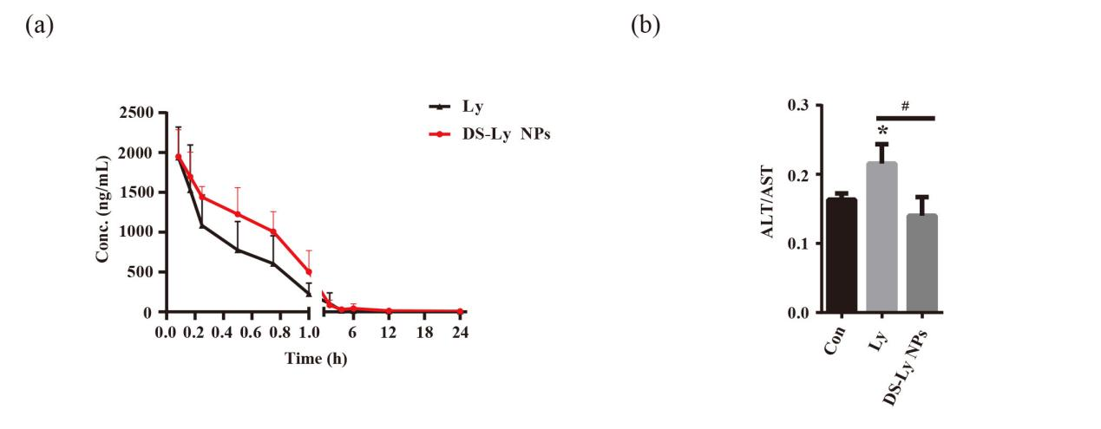

Table 1 The pharmacokinetic parameters of Ly and DS-Ly NPs in mice following intravenous injection at dose of 5mg/kg (n=6)

Parameters | Unit | Ly | DS-Ly NPs
AUC (0-t) | ug/L*h | 1326.035 ± 333.256 | 2112.674 ± 751.921
AUC (0-∞) | ug/L*h | 1335.224 ± 339.724 | 2132.8 ± 751.799
MRT (0-t) | h | 1.27 ± 0.808 | 1.477 ± 0.677
MRT (0-∞) | h | 1.312 ± 0.783 | 1.692 ± 0.877
t1/2z | h | 1.068 ± 0.205 | 2.13 ± 1.058
Tmax | h | 0.0833 | 0.0833
CLz | L/h/kg | 4.027 ± 1.361 | 10.727 ± 4.822
Cmax | ug/L | 1938.933 ± 380.863 | 1877.104 ± 349.578
Vz | L/kg | 6.149 ± 2.107 | 31.938 ± 19.814

Supplementary Figure 2
Figure 3C
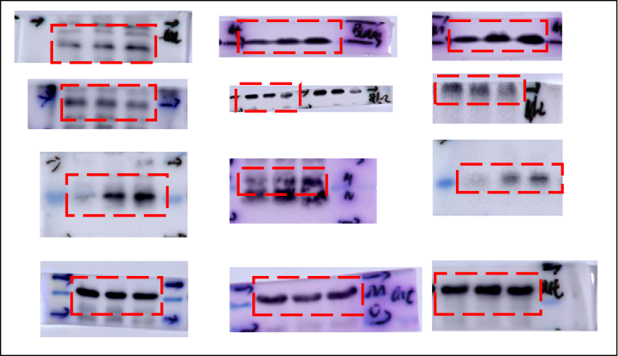

Supplementary Figure 3
Figure 4D
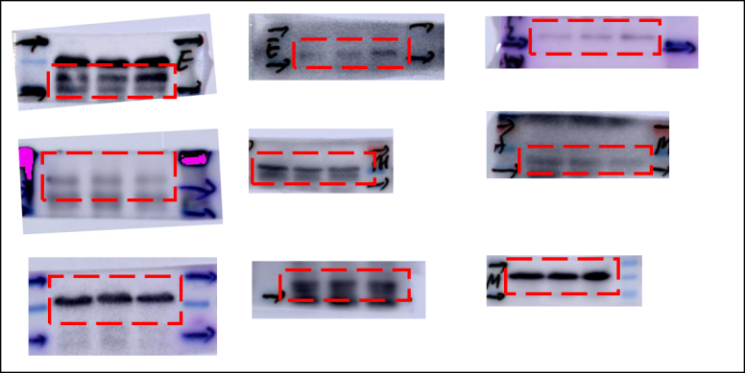

Figure 4E
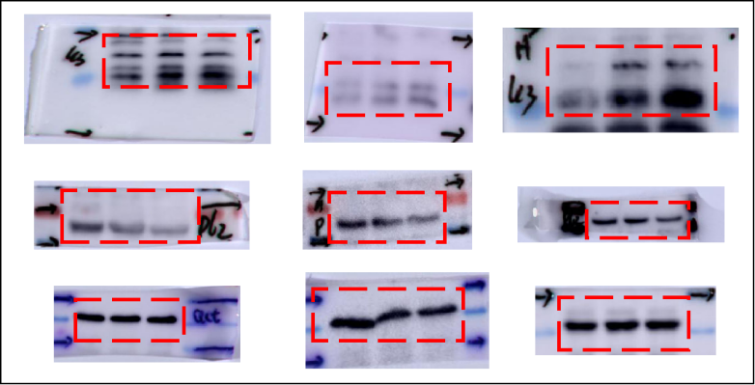

Supplementary Figure 4
Figure 5G
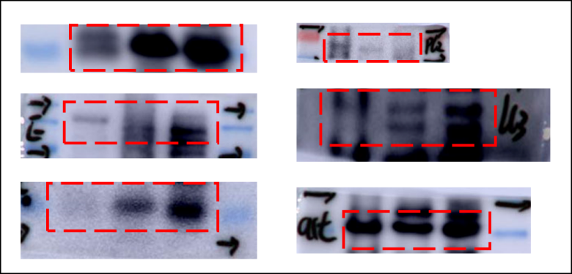

Supplementary Figure 5
Figure 6H
