Supplemental Materials
Table S1. Baseline characteristics of included and excluded participants with normal weight due to missing data
Characteristics | Excluded | Included | P value
No. of participants | 4361 | 40473
Age, years | 56.88±14.37 | 49.65±12.29 | <0.0001
Men, n (%) | 3734 (85.62) | 30427 (75.18) | <0.0001
High school or above, n (%) | 269 (6.41) | 3251 (8.27) | <0.0001
Income >800 yuan/month, n (%) | 487 (11.61) | 5626 (14.33) | <0.0001
BMI, kg/m² | 22.4±1.72 | 22.56±1.64 | <0.0001
SBP, mm Hg | 130.96±21.43 | 125.24±19.26 | <0.0001
DBP, mm Hg | 82.05±11.56 | 80.40±10.83 | <0.0001
Current smoker, n (%) | 1329 (31.37) | 13909 (35.19) | <0.0001
Current alcohol use, n (%) | 1298 (30.65) | 15152 (38.32) | <0.0001
Active physical activity, n (%) | 3902 (93.24) | 35525 (90.59) | <0.0001
Hypertension, n (%) | 1850 (42.42) | 12805 (31.64) | <0.0001
Diabetes Mellitus, n (%) | 348 (7.98) | 2360 (5.83) | <0.0001
Dyslipidemia, n (%) | 1368 (31.37) | 10913 (26.96) | <0.0001
Antihypertensive agents, n (%) | 302 (6.92) | 2254 (5.57) | 0.0002
Antidiabetic agents, n (%) | 67 (1.54) | 570 (1.41) | 0.4974
Lipid-lowering agents, n (%) | 19 (0.43) | 196 (0.48) | 0.6590
TC, mmol/L | 4.89±1.17 | 4.87±1.12 | 0.3160
HDL-C, mmol/L | 1.61±0.42 | 1.58±0.40 | <0.0001
LDL-C, mmol/L | 2.26±0.85 | 2.30±0.90 | 0.0111
Hs-CRP,mg/dL | 2.58±9.23 | 2.02±6.06 | <0.0001
Abbreviations: BMI, body mass index; DBP, diastolic blood pressure; FBG, fasting blood glucose; LDL-C, low-density lipoprotein cholesterol; HDL-C, high-density lipoprotein cholesterol; hs-CRP, high-sensitivity C-reactive protein; SBP, systolic blood pressure; TC, total cholesterol; TyG, triglyceride glucose.

Table S2. Subgroup analysis for the association TyG index trajectories with CVD
Variables | Low-stable | Moderate-stable | Elevated-decreasing | Moderate-increasing | Elevated-stable | P-interaction
Age
<60 years | Reference | 1.30(1.08-1.57) | 1.88(1.37-2.58) | 1.83(1.46-2.29) | 2.40(1.76-3.27) | 0.1397
≥60 years | Reference | 1.17(0.93-1.47) | 0.84(0.50-1.40) | 1.51(1.11-2.05) | 2.24(1.34-3.73)
Sex
Women | Reference | 1.49(0.88-2.52) | 1.61(0.68-3.84) | 1.43(0.76-2.70) | 2.84(1.28-6.31) | 0.2875
Men | Reference | 1.22(1.05-1.42) | 1.41(1.06-1.87) | 1.73(1.43-2.09) | 2.17(1.65-2.86)
Hypertension
No | Reference | 1.34(1.10-1.64) | 1.70(1.12-2.58) | 1.84(1.42-2.39) | 2.56(1.71-3.82) | 0.7677
Yes | Reference | 1.13(0.92-1.39) | 1.22(0.86-1.74) | 1.50(1.17-1.93) | 1.87(1.33-2.63)
Diabetes
No | Reference | 1.22(1.06-1.42) | 1.51(1.12-2.05) | 1.67(1.38-2.02) | 1.83(1.33-2.53) | 0.4031
Yes | Reference | 1.67(0.91-3.08) | 1.66(0.80-3.44) | 2.18(1.15-4.14) | 3.41(1.72-6.77)
Dyslipidemia
No | Reference | 1.20(1.02-1.40) | 1.47(0.76-2.85) | 1.76(1.42-2.19) | 3.42(2.10-5.57) | 0.1747
Yes | Reference | 1.43(0.99-2.08) | 1.55(1.02-2.36) | 1.74(1.18-2.56) | 2.22(1.45-3.39)
Abbreviations: CVD, cardiovascular disease; TyG index, triglyceride-glucose index.
Adjusted for age, sex, education, income, smoking status, drinking status, physical activity, history of hypertension, diabetes, dyslipidemia, use of antihypertensive agents, antidiabetic agents, lipid-lowering agents, body mass index, systolic blood pressure, diastolic blood pressure, high-density lipoprotein cholesterol, low-density lipoprotein cholesterol and high sensitivity C-reactive protein other than variables for stratification.

Table S3. Association with annual increase of TyG index with risk of cardiovascular disease subtypes
 | Annual increase rate of TyG index from 2006 to 2010
 | Q1 | Q2 | Q3 | Q4 | Q5
Range, per 1 unit/year | <-0.07 | -0.07~ -0.01 | -0.01~0.04 | 0.04~0.10 | ≥0.10
Total stroke | Reference | 1.12(0.94-1.35) | 1.16(0.96-1.40) | 1.23(1.04-1.46) | 1.39(1.15-1.67)
Ischemic stroke | Reference | 1.08(0.89-1.32) | 1.16(0.95-1.41) | 1.23(1.03-1.47) | 1.41(1.16-1.71)
Hemorrhagic stroke | Reference | 1.33(0.72-2.48) | 1.44(0.82-2.52) | 1.67(0.91-3.06) | 1.90(0.98-3.33)
Myocardial infarction | Reference | 1.48(0.99-2.21) | 1.63(0.95-2.33) | 1.70(1.17-2.47) | 1.79(1.21-2.66)
Abbreviations: TyG index, triglyceride-glucose index.
Adjusted for age, sex, education, income, smoking status, drinking status, physical activity, history of hypertension, diabetes, dyslipidemia, use of antihypertensive agents, antidiabetic agents, lipid-lowering agents, body mass index, systolic blood pressure, diastolic blood pressure, high-density lipoprotein cholesterol, low-density lipoprotein cholesterol and high sensitivity C-reactive protein.

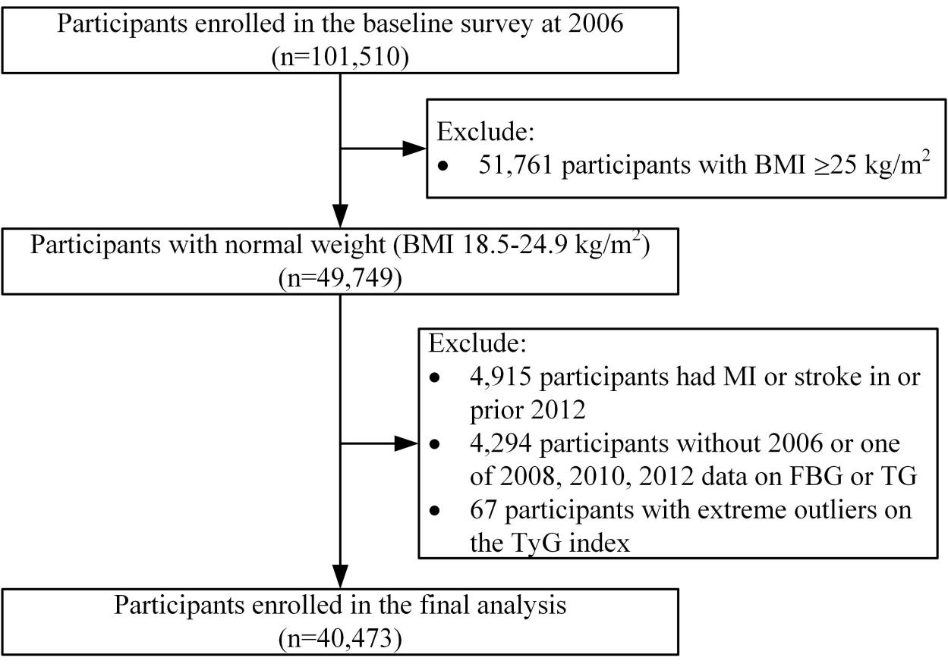
Figure S1. The flowchart of the study
Abbreviations: BMI, body mass index; FBG, fasting blood glucose; MI, myocardial infarction; TG, triglyceride; TyG index, triglyceride-glucose index.
Figure S2. Multivariable-adjusted hazard ratios for cardiovascular diseases based on restricted cubic spines with4 knots at 5th, 35th, 65th, and 95th percentiles of annual increase of TyG index during 2006-2012.
Abbreviations: TyG index, triglyceride-glucose index.
Adjusted for age, sex, education, income, smoking status, drinking status, physical activity, history of hypertension, diabetes, dyslipidemia, use of antihypertensive agents, antidiabetic agents, and lipid-lowering agents, body mass index, systolic blood pressure, diastolic blood pressure, high-density lipoprotein cholesterol, low-density lipoprotein cholesterol and high sensitivity C-reactive protein.

