**Figure 2.** Urinary extracellular vesicles (EVs) associated with generation of EVs (A, B) and calcium and phosphate physiology (C-F). **(A)** The total number of ANO4 (anoctamin-4) positive EVs, **(B)** HIP1 (Huntington interacting protein 1) positive EVs, **(C)** FGF23 (fibroblast growth factor 23) positive EVs, **(D)** Klotho positive EVs, **(E)** phosphate transporters 1 and 2 (PiT1) and **(F)** PiT2 positive EVs. Data is presented as natural log (base e = 2.71828) values. Numbers of EVs carrying ANO4, FGF23, Klotho, PiT1 and PiT2 were significantly lower in CSF compared with NSFs (P <0.05). There was a trend of reduced number of EVs carrying HIP1 in CSF than NSFs (P=0.06).

Number of EVs / mg creatinine

C. FGF23 positive

NSF

CSF

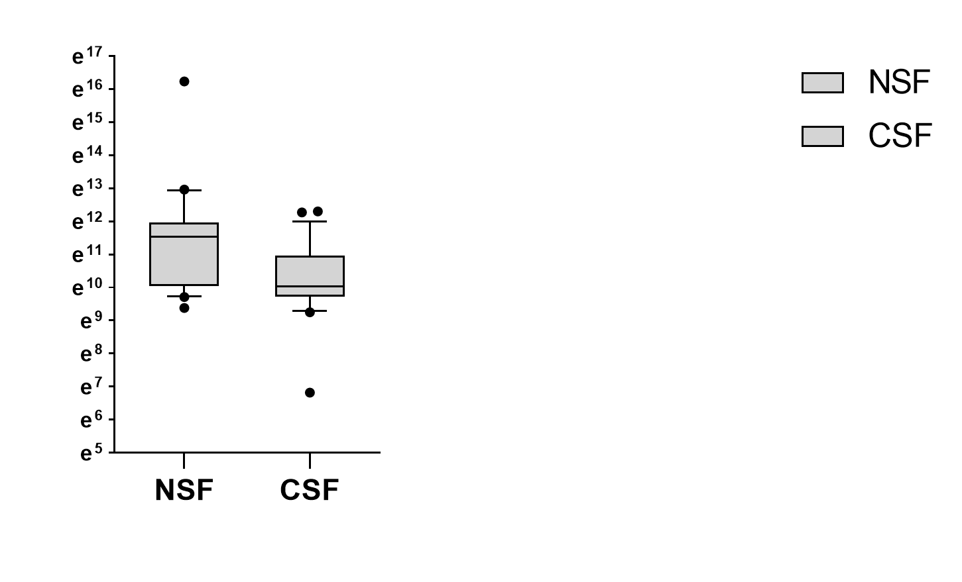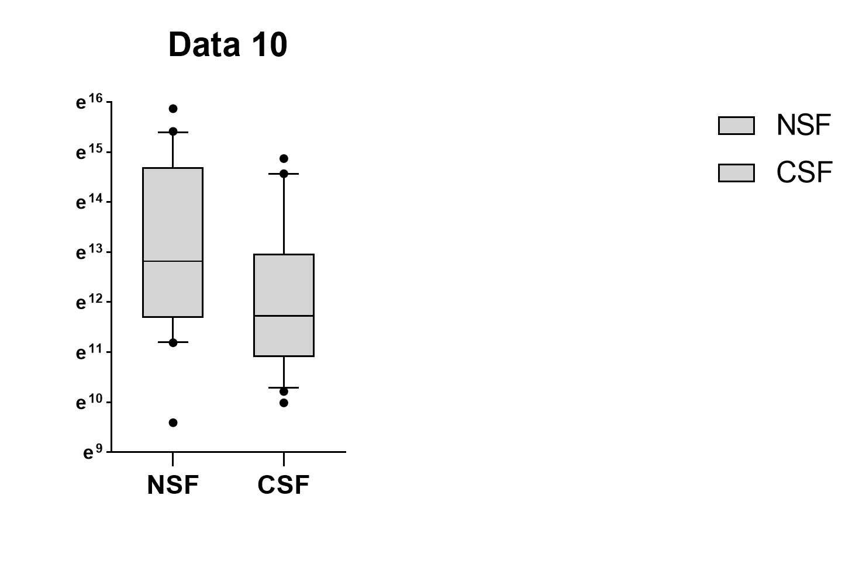

F. PiT2 positive

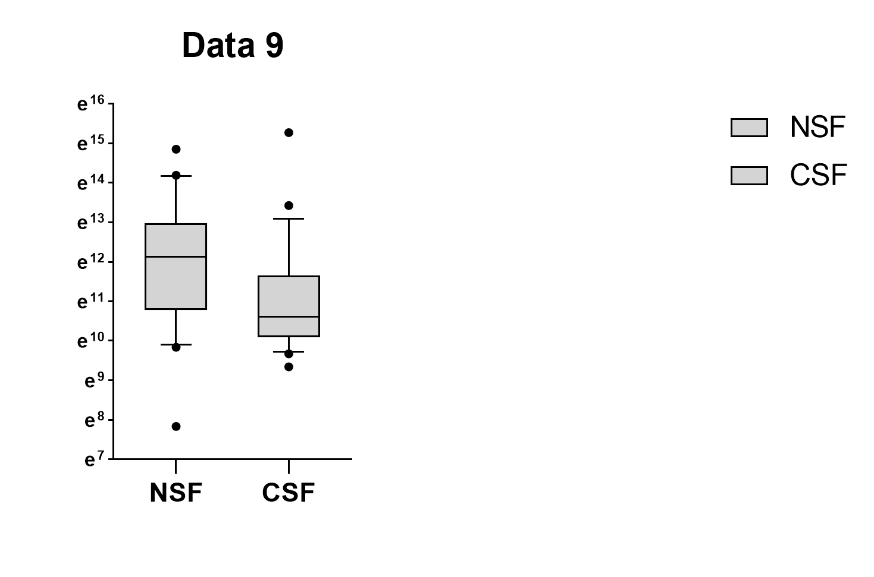

E. PiT1 positive

NSF

CSF

Number of EVs / mg creatinine

NSF

CSF

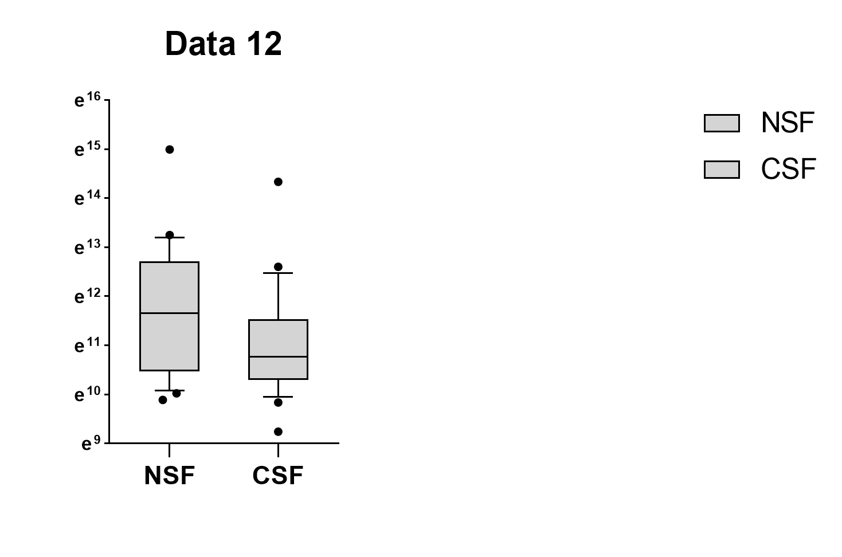

B. Huntington interacting

protein 1 (HIP1) positive

NSF

CSF

P <0.05

P <0.05

P <0.05

Number of EVs / mg creatinine

Number of EVs / mg creatinine

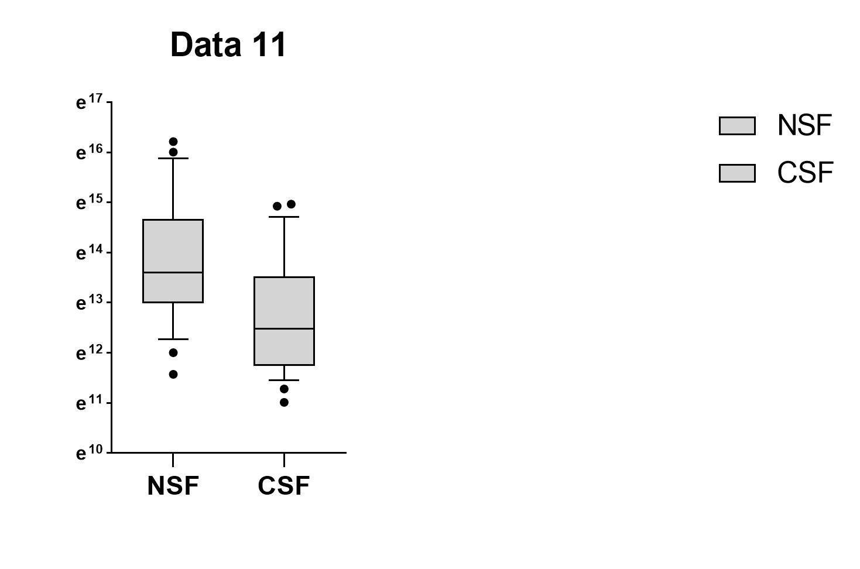

Number of EVs / mg creatinine

NSF

CSF

D. Klotho positive

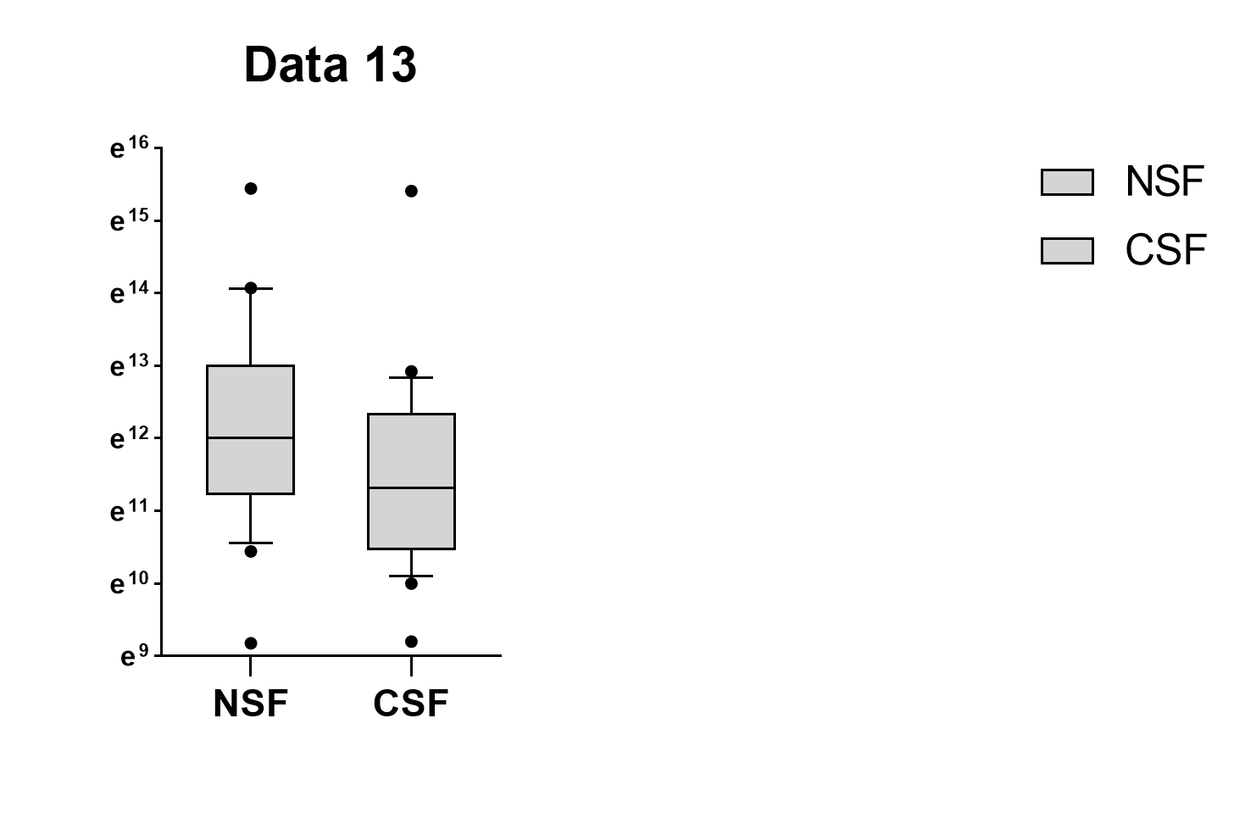

NSF

CSF

A. Anoctamin 4 (ANO4)

positive

Number of EVs / mg creatinine

P <0.05

P <0.05

P=0.06