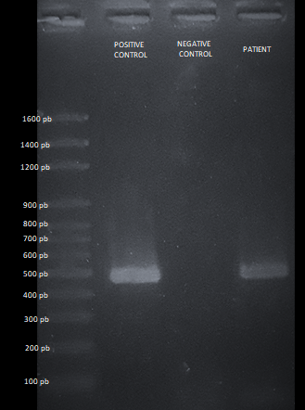

S3. Representative figure of a positive result for CPV-2 belonging to a patient in the CT + I group. A positive result is determined by a 466-bp amplicon.

