Appendix 1 Definitions of heatwaves

Heatwave ₁ (HW₁): HW₁ is specified as ≥ 2 successive days with maximum temperature higher than the 90th percentile of maximum temperature in each month of the current study (October=39°C, September=44.4°C, August=48°C, July=48.5°C, June=47°C, May=42.5°C, April= 35.5°C).

Equation 1

HW1 _{(Calculation method)} = Daily T_{max} > Th₁ for at least two successive days

Where:
T_{max} = Maximum air temperature
Th₁ = 90th percentile of maximum air temperature in each month for study duration

Heatwave ₂ (HW₂): HW₂ is specified as ≥ 3 successive days with maximum temperature higher than the 90th percentile of the maximum temperature (47°C) since 30 years ago[13].

Equation 2

HW2 _{(Calculation method)} = Daily T_{max} > Th₂ for at least three successive days

Where:
T_{max} = Maximum air temperature
Th₂ = 90th percentile of maximum air temperature (47°C) since 30 years ago

Appendix 2 Design (Main effect)

Main effect (ME) _{(As defined by Equation 3)}: To explore the effects of heat (Main effect: ME), the risk of mortality during the HWs was calculated. The calculation of the main effect was based on determining the risk of mortality at the median temperature during the HW days relative to the risk of death at the 65th percentile of annual temperature distribution (65th percentile represents the lowest number of death)[21, 22].

Equation 3

ME=$\frac{The risk of mortality at the median temperature during the HW days \left(HW=1\right)}{The risk of death at the 65th percentile of annul temperature distribution \left(65th percentile represents the lowest number of death that occurred\right)}$

Appendix 3 Design (Added effect)

Added effect (AE) _{(As defined by Equation 4)}: To investigate the effects caused by heat persistence (Added effect: AE), the risk of mortality at median temperatures during the HWs was estimated relative to the risk of mortality at median temperatures in the same period by calculating the added effect (Non-HWs days).
Thus, estimating the ME and AE individually helps to measure the added risk of HWs independent of the effects of warm temperature in different lags. Then, a binary variable was produced (with 0 and 1 allocated to HWs and non-HWs days, respectively). We used Excess Risk and Cumulative Excess Risk _{(As defined by Equation 5)} to estimate the main and added effects of HWs on mortality using the following formula [22, 46, 47]:

Equation 4

AE= $\frac{The risk of mortality at median temperature during the HWs (HW=1)}{The risk of mortality at median temperatures in the same period (HW=0)}$

Also, we calculated relative risks by commands in Distributed Lag Non-linear Model (DLNM) package [47].

Equation 5
Excess Risk _{(ER)} = (Relative Risk _{(RR)} ⁻1)*100
Cumulative Excess Risk _{(CER) lag0}= ER _{lag0}
CER _{lag0-2}= ER _{lag0}+ ER _{lag1}+ ER _{lag 2}

Appendix 4 Statistical analysis

We created cross-basis term for the temperature (Tmax) by below commands in R Software. Please look at R output.
KTMAX<-equalknots(dezh$TMAX,fun ="ns", df=2)
KlagTMAX<-logknots(13, fun="ns",df=3)
Cb.TMAX<- crossbasis(dezh$TMAX, argvar=list(knots= KTMAX),arglag=list(knots= KlagTMAX),lag=13, group= dezh$year)

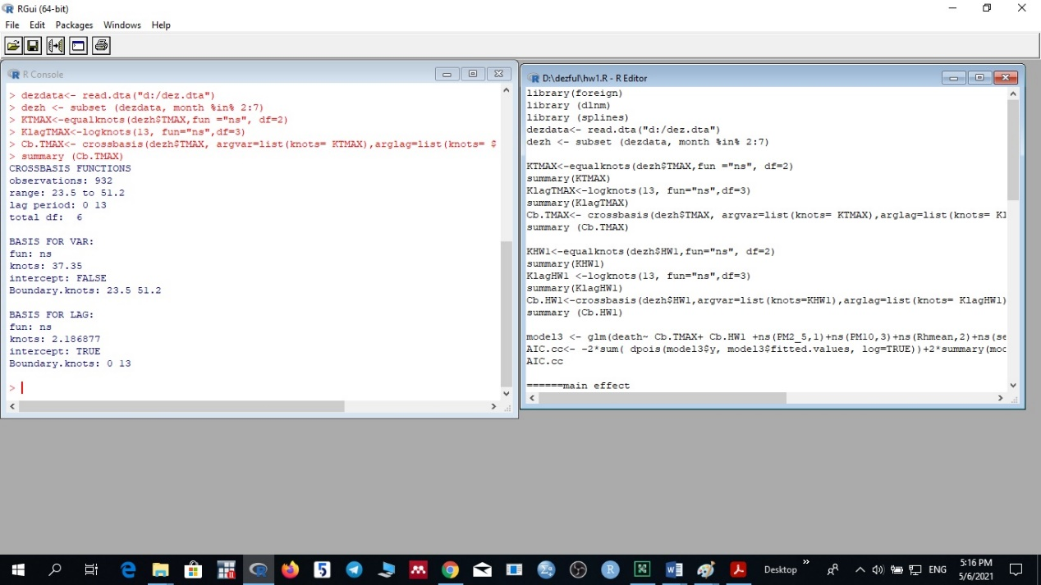

Equation 6

LogE [Y_{t}] = α+ cb (T₁, 2, 3) + cb (T₂, 2, 3) + ns (PM₁₀, df=3) + ns (PM_{2.5}, df=1) + ns (RH, df=2) + ns (Season, df=3) + ns (Time, df=7) + DOW+ Holidays

After running model (Equation 6), we used below commands in R to calculate main effect.

pred.TMAX <- crosspred(Cb.TMAX, model,cen=40.3, at=45)
dezhlag<- with (pred.TMAX,t (rbind( matRRfit,matRRlow,matRRhigh)))
colnames (dezhlag) <- c("RR","ci.low","ci.hi")
dezhlag

40.3= the 65th percentile of annual temperature distribution (65th percentile represent the lowest number if death that occurred).
45= the median temperature (Tmax) during heat wave days (HW=1).
Also we used below commands in R to calculate added effect.
pred.TMAX <- crosspred(Cb.TMAX, model,cen=43.4, at=45)
dezhlag<- with (pred.TMAX,t (rbind( matRRfit,matRRlow,matRRhigh)))
colnames (dezhlag) <- c("RR","ci.low","ci.hi")
dezhlag
43.4= the median temperature (Tmax) during the same period (HW=0, days without heat waves).
45= the median temperature (Tmax) during heat wave days (HW=1).
The model used in the manuscript is based on (packages/dlnm) Antonio Gasparini's model in R software.
References:
Gasparrini A, Armstrong B, Kenward MG. Distributed lag non‐linear models. Statistics in medicine. 2010 Sep 20;29(21):2224-34.
Gasparrini A. Distributed lag linear and non-linear models in R: the package dlnm. Journal of statistical software. 2011 Jul;43(8):1.
and http://www.maluty.pl/pub/mirrors/CRAN/web/packages/dlnm/dlnm.pdf

