Supplementary Materials
Integrated wireless theranostic contact lens for in situ electrical sensing and regulation of glaucoma
Cheng Yang^{1,3}, Qianni Wu², Junqing Liu⁴, Jingshan Mo¹, Xiangling Li^{1,5}, Chengduan Yang^{1,3}, Ziqi Liu¹, Jingbo Yang^{1,5}, Lelun Jiang⁵, Weirong Chen², Hui-jiuan Chen¹, Ji Wang³, Xi Xie^{1,3}*

- State Key Laboratory of Optoelectronic Materials and Technologies, Guangdong Province Key Laboratory of Display Material and Technology, School of Electronics and Information Technology, Sun Yat-Sen University, Guangzhou, 510006, China
- State Key Laboratory of Ophthalmology, Zhongshan Ophthalmic Center, Sun Yat-Sen University, Guangzhou, 510006, China
- The First Affiliated Hospital of Sun Yat-Sen University, Sun Yat-Sen University, Guangzhou, 510006, China
- Department of Cardiology, the First Affiliated Hospital of Jinan University, Guangzhou 510630, China
- School of Biomedical Engineering, Sun Yat-Sen University, Guangzhou, 510006, China

Email: xiexi27@mail.sysu.edu.cn

S1. The fabrication and structure of the WTCL.
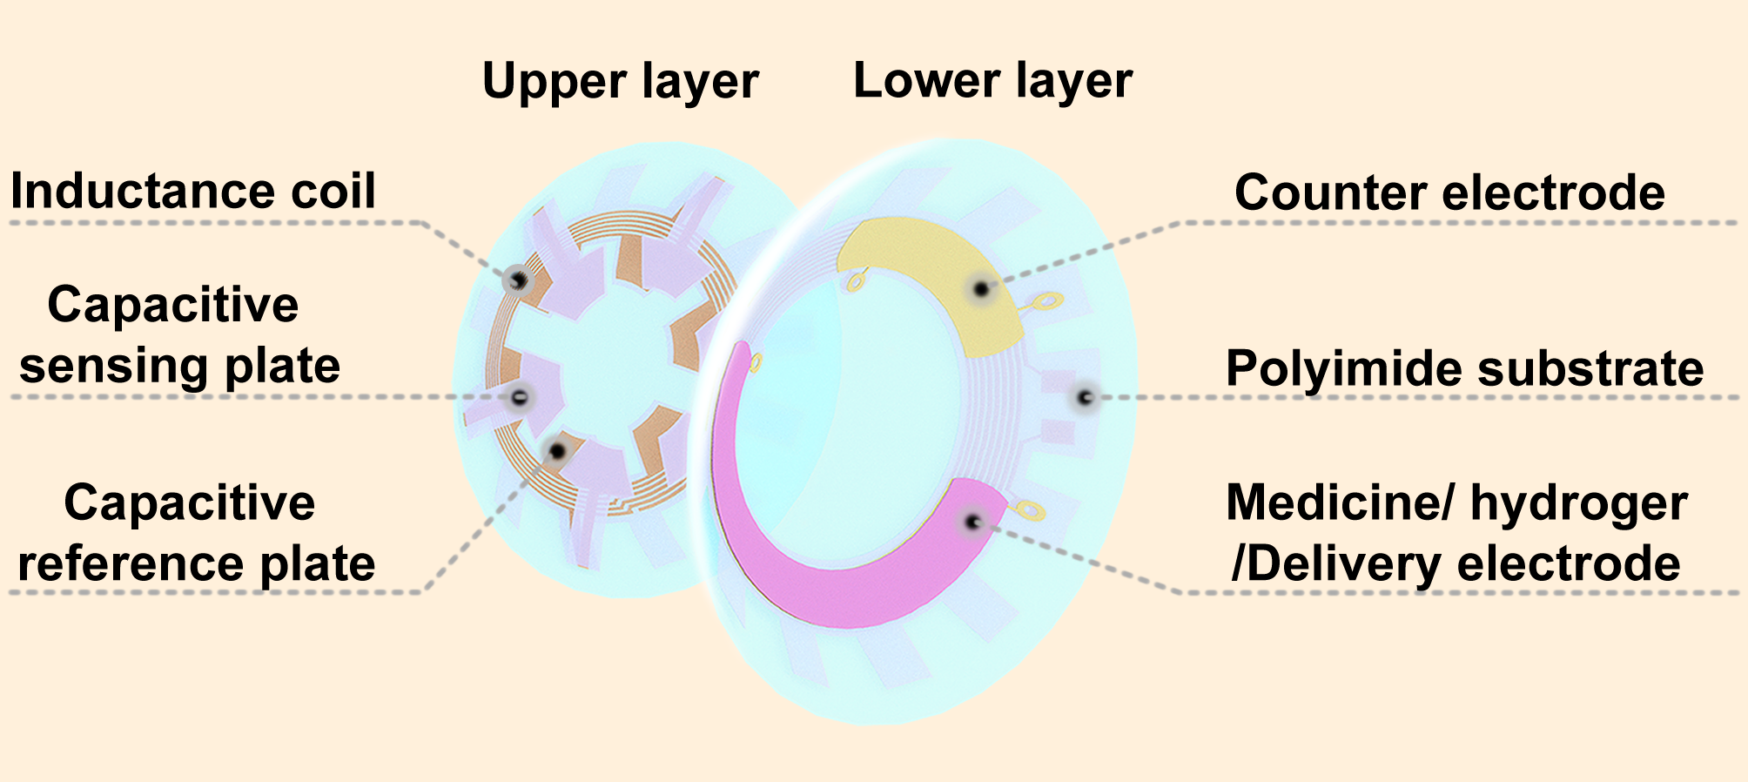
Figure S1.1 Structure of the WTCL. The reference plates and 5 coils of inductance were embedded in the upper lens, while dangling sensing plates that aligned with reference plate contacted the front surface of the lower lens, with a dielectric air film between the reference and sensing plates forming a variable capacitor. Drug delivery circuit was embedded in the lower lens, while the drugs-coated iontophoretic electrodes on the bottom side of delivery circuit were exposed and would be in contact with the cornea.

Table S1. Detailed parameters and size of WTCL
Contact lens | Contact lens diameter (mm) | 14.15
 | Base curve of lower contact lens (mm) | 8.6
 | Base curve of upper contact lens (mm) | 8.24
 | Thickness of each contact lens (μm) | 120
IOP Monitoring  circuits | Outer diameter of IOP sensing circuit d₁ (μm) | 10300
 | Inner diameter of IOP sensing circuit d₂ (μm) | 7900
 | Inner diameter of capacitor d₃ (μm) | 5000
 | Branch length of IOP sensing circuit d₄ (μm) | 2566
WPT  circuits | Branch width of WPT circuit d₅ (μm) | 1222
 | Branch length of WPT circuit d₆ (μm) | 986
 | Outer diameter of WPT circuit d₇ (μm) | 10800
 | Inner diameter of WPT circuit d₈ (μm) | 7450
 | Space of the inductance electrode (μm) | 70
 | Width of the inductance electrode (μm) | 80
 | Central angle of drug carrier’s electrode θ (deg) | 180
 | Central angle of counter electrode α (deg) | 50

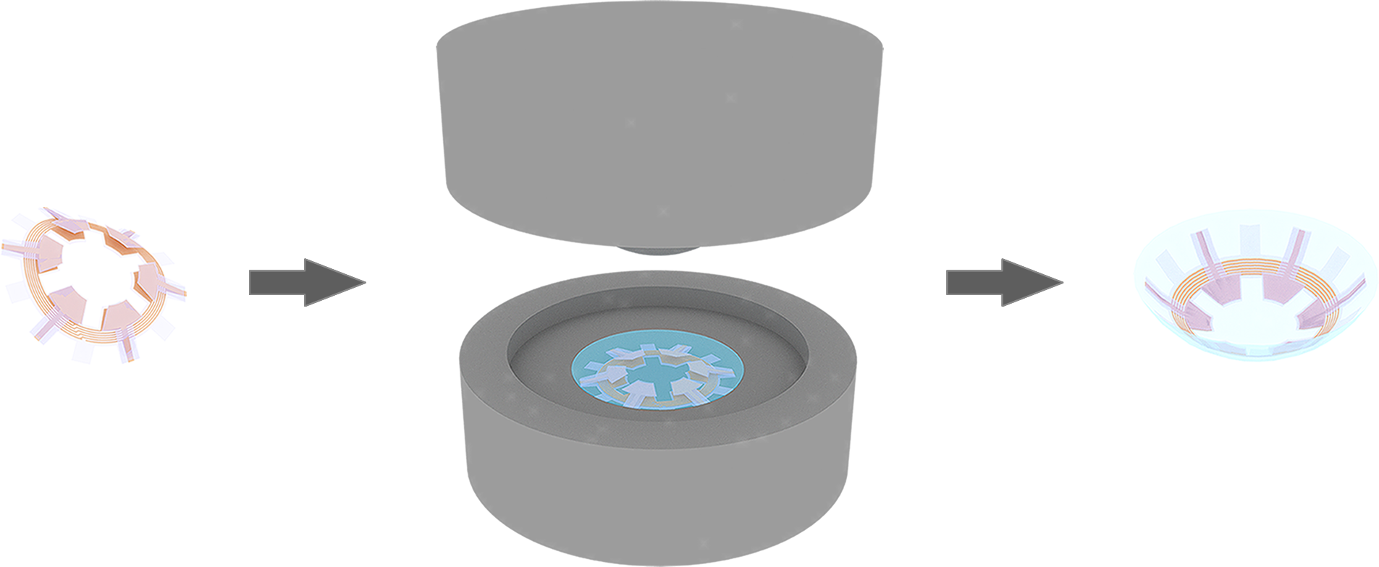
Figure S1.2 Schematic illustration of the cast-molding technique. The flexible IOP sensing circuit was folded, and positioned into the metal mold of contact lens. Polydimethylsiloxane (PDMS, Sylgard 184, Dow Corning) and curing agent were mixed according to the ration of 10:1 and then stirred sufficiently. The PDMS solution was placed in vacuum with pressure of 10 Pa for 30 min to remove bubbles, and then injected into the mold. After vacuum treatment (10 Pa, 30 min), the bottom mold and top mold were assembled and placed into oven (80 centigrade degree, 1.5 h). Finally, the contact lens embedded with circuit was detached from mold carefully.

S2. Supporting Information for the performance characterization of the IOP sensing module.
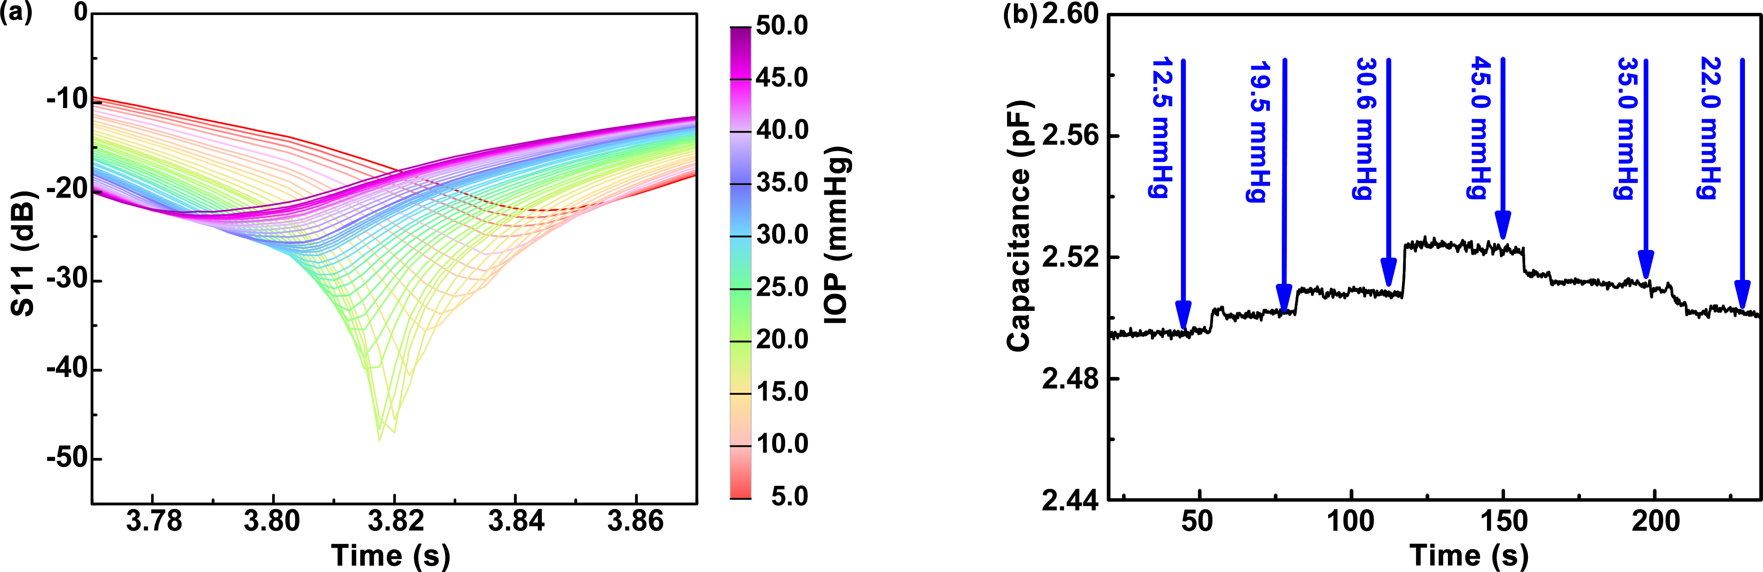
Figure S2.1 (a) The detailed reflection spectra of device-I following IOP ranging from 5 to 55 mmHg with the step of 1 mmHg. The static sensing performance was conducted by stepwise increase of IOP, which was controlled by microinfusion pump that drove saline solution into the anterior chamber and monitored by a pressure gauge. Meanwhile, the resonance frequencies of WTCL worn on the porcine eyeball at different IOP (5-50 mmHg) were recorded by Network analyzer connected to IOP reading coil (diameter: 17 mm, turns: 1) of the integrated antenna that was positioned above WTCL with nearly 6 mm-distance, where the resonant frequency of IOP monitoring module was found to shift to the lower frequency at higher IOP. (b) Capacitance change of the pressure sensing module as a function of time when the IOP was changed. During experiments, the WTCL was worn on porcine eyeball, and the IOP in porcine eye was controlled by the volume of infused saline solution with microinfusion pump. Meanwhile, a pressure gauge was adopted to track the IOP value. The capacitance formed by reference, sensing plates, and air film was connected with LCR meter (Changzhou Tonghui Electronic Co. Ltd., China) to recorded the value changes. Theoretically the resonant frequency is in inversely related to the capacitance according to the LCR circuit equation . The results were consistent with the theoretical prediction in that the increase of IOP would reduce the distance between the reference and sensing plates, hence led to the elevation of capacitance value.

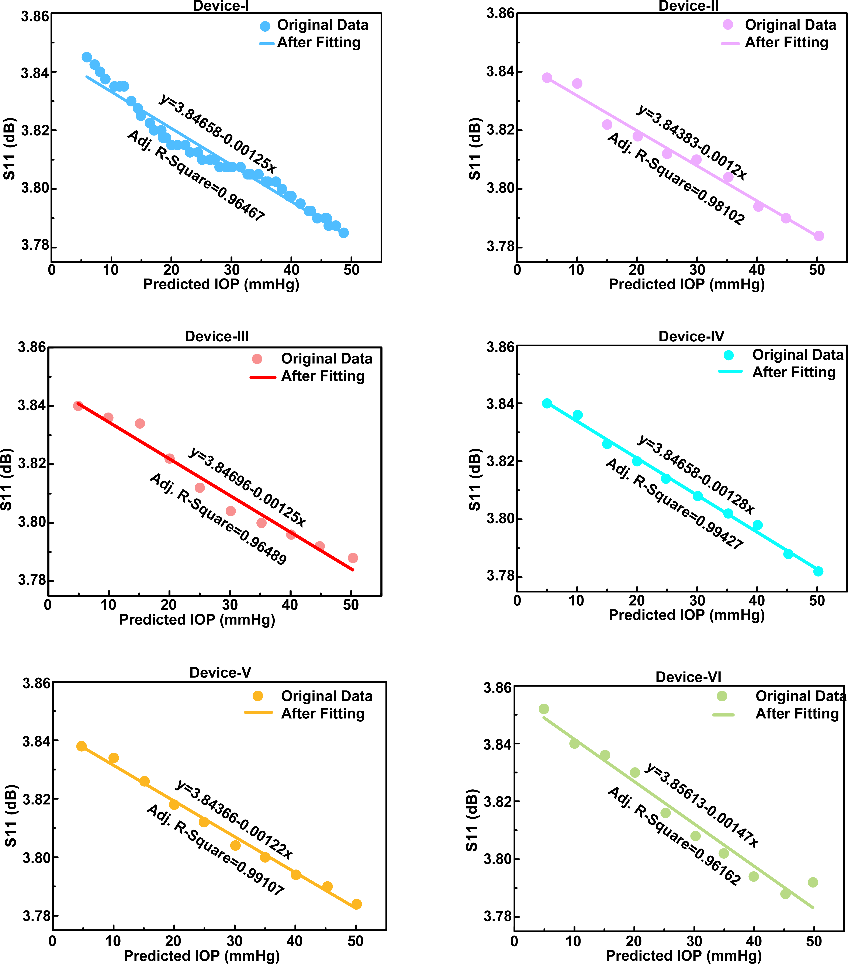
Figure S2.2 The relation of resonant frequency versus IOP value of six representative WTCL devices worn on the porcine eyeball at different IOP (5-50 mmHg). The values of resonant frequency were collected from reflection spectra of each representative WTCL devices. The IOP values were validated by commercial gauge. The relations of resonant frequency versus IOP value were processed by linear fitting. These results demonstrated that signal responses of these sensors were linearly correlated to the reference IOP.

Table S2. Summary of the performance of wearable and implantable IOP sensors reported in the literature.
Wearable / Implantable | Sensing  mechanism | Dielectric  material | Response  characteristics | Ref
 | Capacitance | Ecoflex | About 2.2 MHz/mmHg | ¹
 | Capacitance | Air | 23 kHz/mmHg | ²
 | Inductor | Phthalocyanine | 8 kHz/mmHg | ³
Wearable | Inductor | Parylene C | 57 kHz/mmHg | ⁴
 | Inductor | Parylene C | 35.1 kHz/mmHg | ⁵
 | Capacitance | Air | 1.25 MHz/mmHg | This work
 | Capacitance | Air | 243 kHz/mmHg | ⁶
Implantable | Capacitance | Air | 1.14 MHz/mmHg | ⁷
 | Capacitance | Air | 156 kHz/mmHg | ⁸

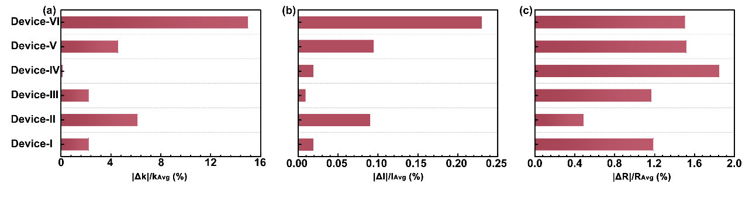
Figure S2.3 Assessment of the reproducibility of the six IOP sensors, where the (a) Normalized slope, (b) normalized intercept, and (c) normalized R-Square of each sensor were quantified. Normalized slope was defined as , where k represents linear fitting slope of IOP response from each sensor, k_{Avg} denotes the average value of all slopes. Normalized intercept was defined as , where I represents linear fitting intercept of IOP response from each sensor, I_{Avg} denotes average value of all intercept. Normalized R-Square was defined as , where R represents linear fitting R-Square of IOP response from each sensor, R_{Avg} denotes average value of all R-Square. These results showed that the linear relations of all the six devices overlapped well (variations of the normalized slope, intercept, and R-Square were <15%, <0.25%, and <2%, respectively) with each other, indicating the reliability and repeatability of the fabricated device using our design.

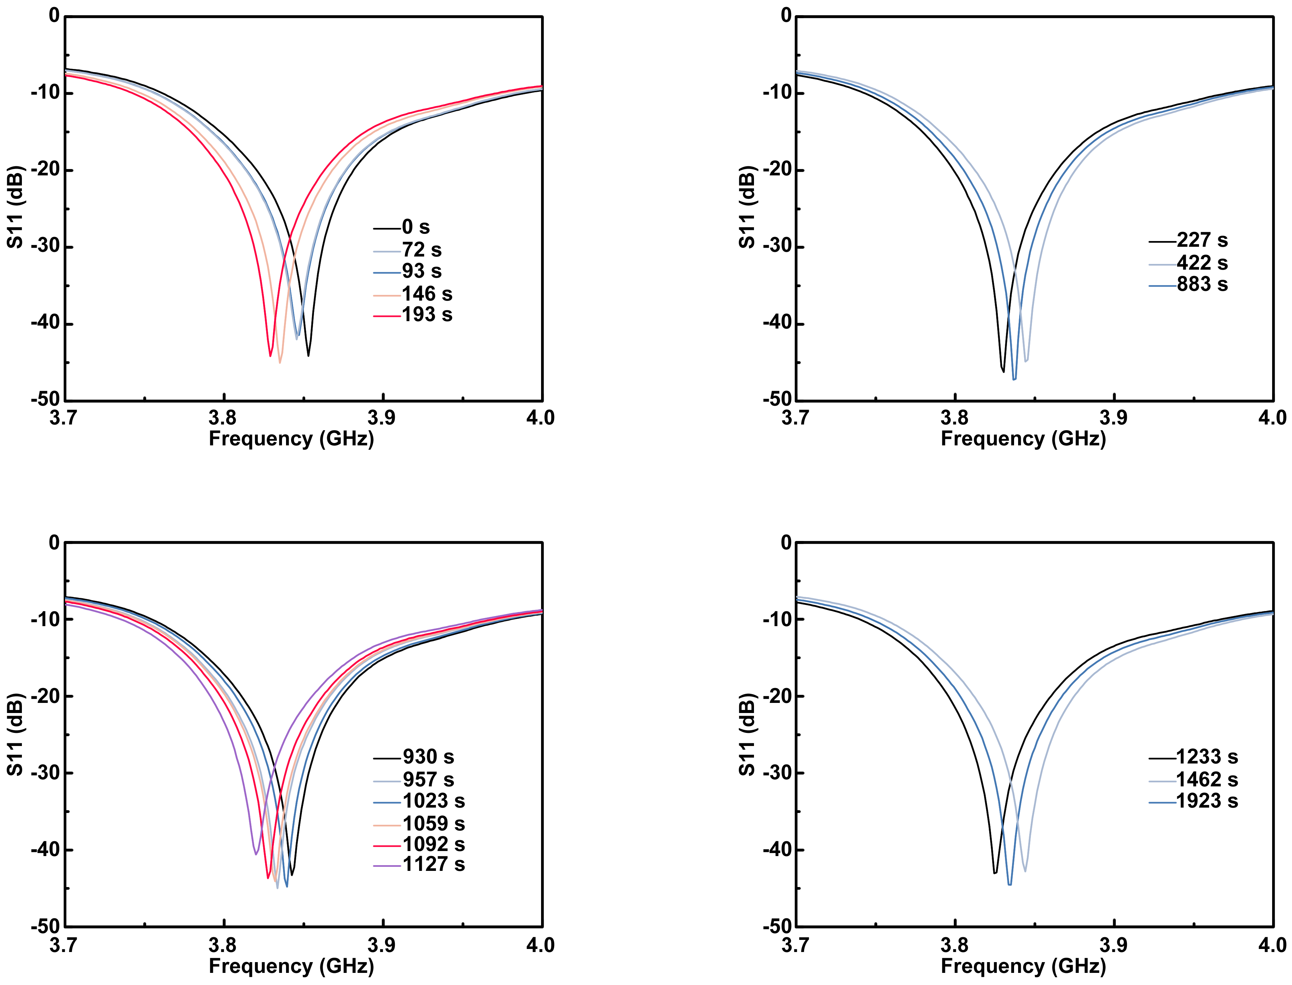
Figure S2.4 The detailed reflection spectra recorded during the continuous monitoring of IOP via WTCL. During the experiment process, saline solution was injected into the anterior chamber of porcine eye to elevate the IOP from 4.5 mmHg to 30 mmHg. Then, the pressure decreases down to 13 mmHg with the continuous leaking of solution from eyeball. Sequentially, saline was filled into eyeball to raise the pressure again. The corresponding reflection spectra in these four phases involving IOP elevation and decreasing collected wirelessly.

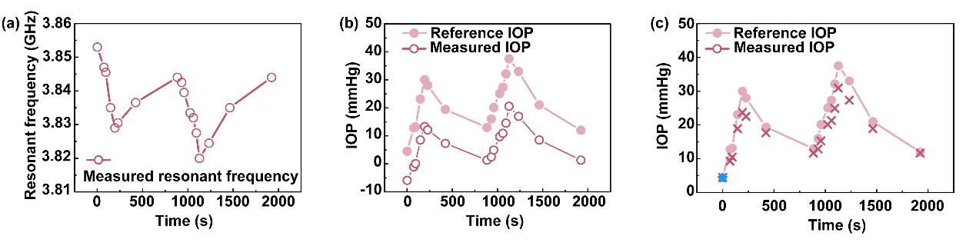
Figure S2.5 Illustration and analysis of the wireless IOP sensing experiment on the porcine eyeball during the continuous IOP monitoring process. (a) Wireless recorded resonant frequency of IOP sensing module during the continuous IOP monitoring. In the experiment process, saline solution was intermittently injected into the anterior chamber of porcine eye to induce IOP fluctuations. Meanwhile, IOP reading coil of integrated antenna could recorded the changes of resonant frequency wirelessly by WTCL worn on the in vitro eye. In addition, commercial pressure gauge was connected to the anterior chamber by a disposable intravenous infusion needle to independently track the reference IOP. (b) Reference IOP recorded by pressure gauge and measured IOP calculated from resonant frequency during the measurement process without calibration. (c) Measured IOP after calibration. Reference IOP was also shown as a control group. In the calibration process, the measured IOP calculated from resonant frequency was calibrated to the reference IOP (indicated with blue asterisk). Specifically, the measured IOP were proportionally scaled up according to the difference between the first measured IOP (at time points t=0 s) and the first reference IOP.

S3. Supporting Information for the performance characterization of the WPT module of the WTCL.
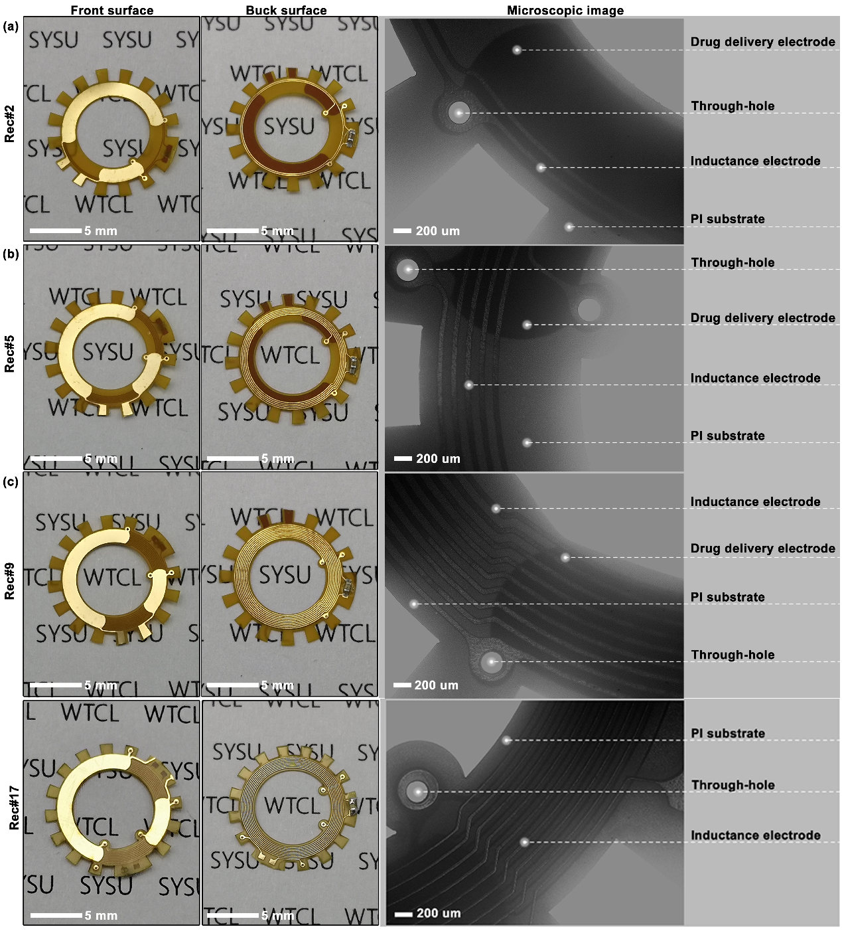
Figure S3.1 Optical and microscopic images of four WPT receive circuits (Rec#2, Rec#5, Rec#9, Rec#17). These four types of WPT receivers with 2, 5, 9, and 17 coils-design (namely Rec#2, Rec#5, Rec#9, and Rec#17, respectively) were designed to achieve optimal performance coupled with transmitter.

Table S3. Detailed parameters and size of four WPT receiver circuits.
 | Rec#2 | Rec#5 | Rec#9 | Rec#17
Number of layers | 2 | 2 | 2 | 3
Number of coil turns | 2 | 5 | 9 | 17
Width of the inductance electrode (μm) | 60 | 60 | 60 | 60/30
Space of the inductance electrode (μm) | 90 | 90 | 90 | 90/120
The inner diameter of inductance coil (mm) | 9.44 | 8.54 | 7.34 | 7.82
The outer diameter of inductance coil (mm) | 9.86 | 9.86 | 9.86 | 10.43
Parasitic resistance () | 1.5 | 2.8 | 4.5 | 23.5
Capacitor matched with inductance coil (nF) | 82 | 39 | 22 | 3.3

Table S4. Detailed parameters and size of WPT transmitter circuits.
Inductor (μH) | Capacitor matched with inductance coil (pF) | Parasitic resistance ()
180 | 196 | 2.9

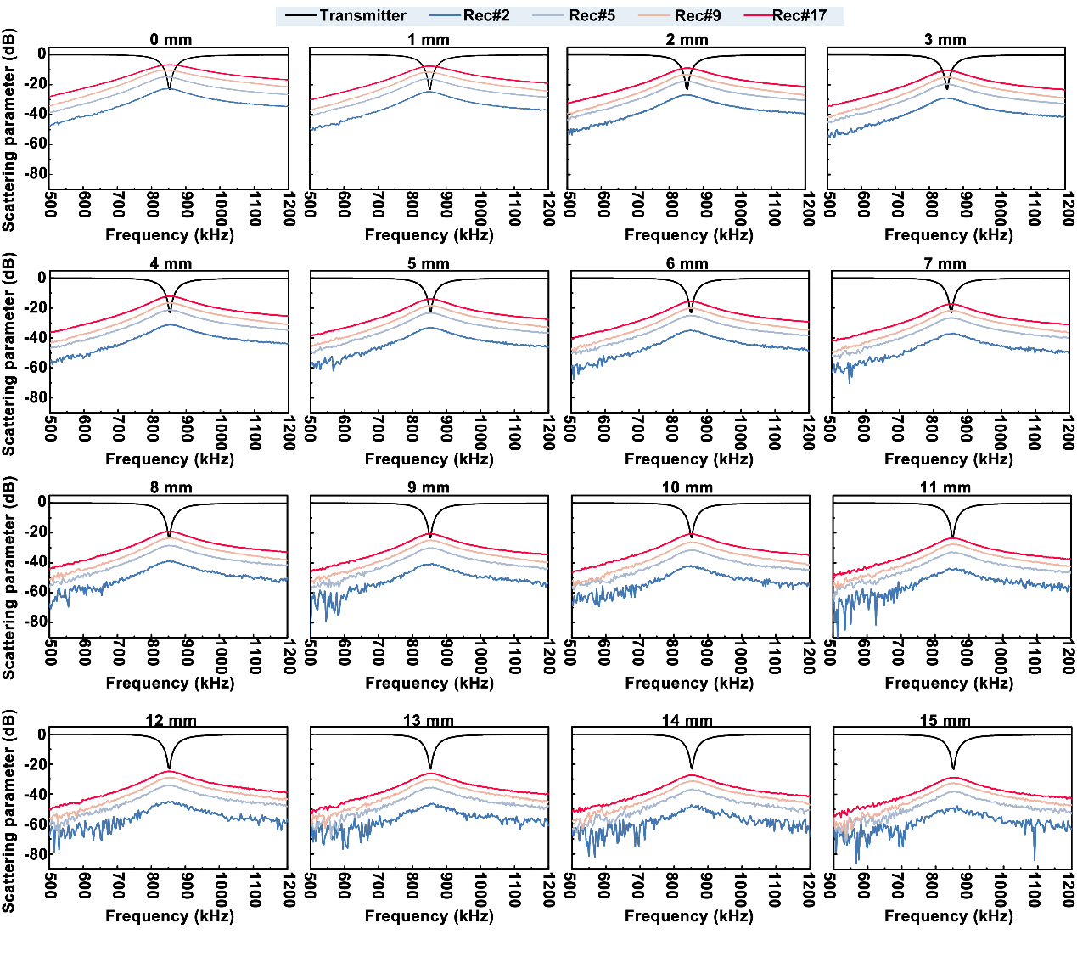
Figure S3.2. The influence of radiation distanced (0 mm to 15 mm with step of 1 mm) on scattering parameter spectra between the WPT coil/four receivers. In these experiments, the integrated antenna and WTCL, aligned with identical axis, were connected with network analyzer. The results of all receivers showed that the resonant frequency of transmitter and all receivers remain at 850 kHz. Insert loss (S21) of all receivers revealed that S21 of Rec#17 was significantly higher than other circuits under identical radiation distance. It indicated that the Rec#17 was better matched with the WPT transmitter compared to other receive circuits. Hence, the combination of transmitter and Rec#17 possessed the potential to provide optimized electric power for iontophoretic delivery.

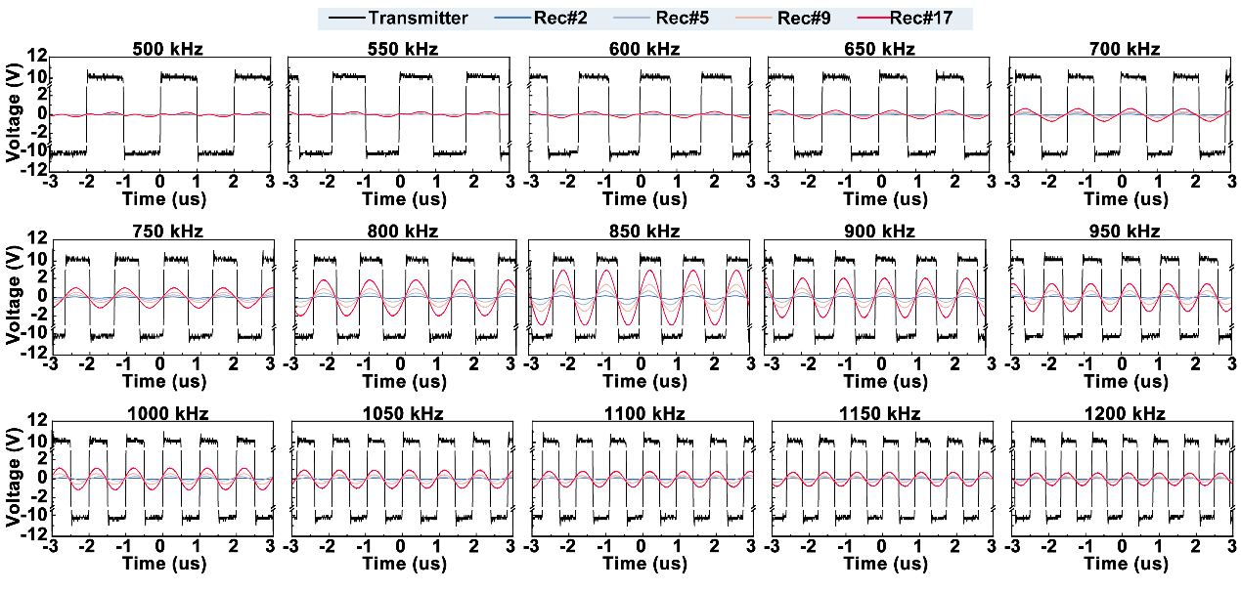
Figure S3.3. The influence of frequencies (500 KHz to 1200 KHz with step of 50 KHz) on wireless voltage supply performance of four WPT systems. In these tests, the integrated antenna and WTCL, aligned with identical axis, were connected with waveform generator and oscilloscope, respectively. The distance between integrated antenna and WTCL was set at 6 mm. Sequentially, a series of square wave with different frequency (500 kHz to 1200 kHz with step of 50 kHz) were exerted on transmitter. Then the collected voltage of four receivers were recorded by oscilloscope in turn. Results shown that all of receivers exhibit higher values of voltage peak to peak (Vpp) at 850 kHz.

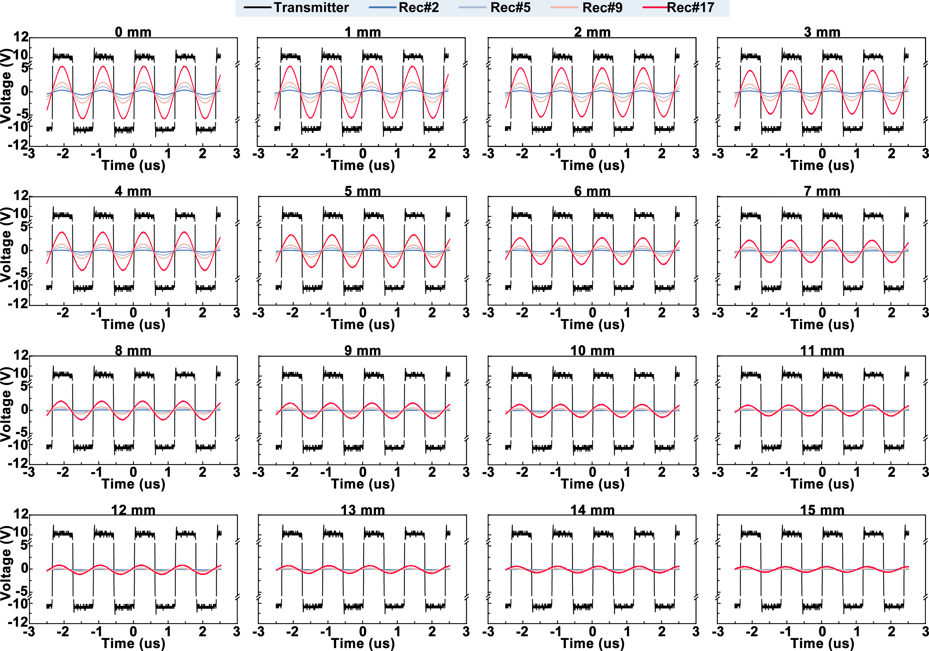
Figure S3.4. The influence of radiation distances (0 mm to 15 mm with step of 1 mm) on wireless voltage supply performance of four WPT systems. In these tests, the integrated antenna and WTCL, aligned with identical axis, were connected with waveform generator and oscilloscope, respectively. The square voltage wave exerted on transmitter of integrated antenna was kept with 20 Vpp at 850 kHz. In these tests, the Rec#17 exhibited higher voltage compared to the other three circuits under conditions of same radiation distance.

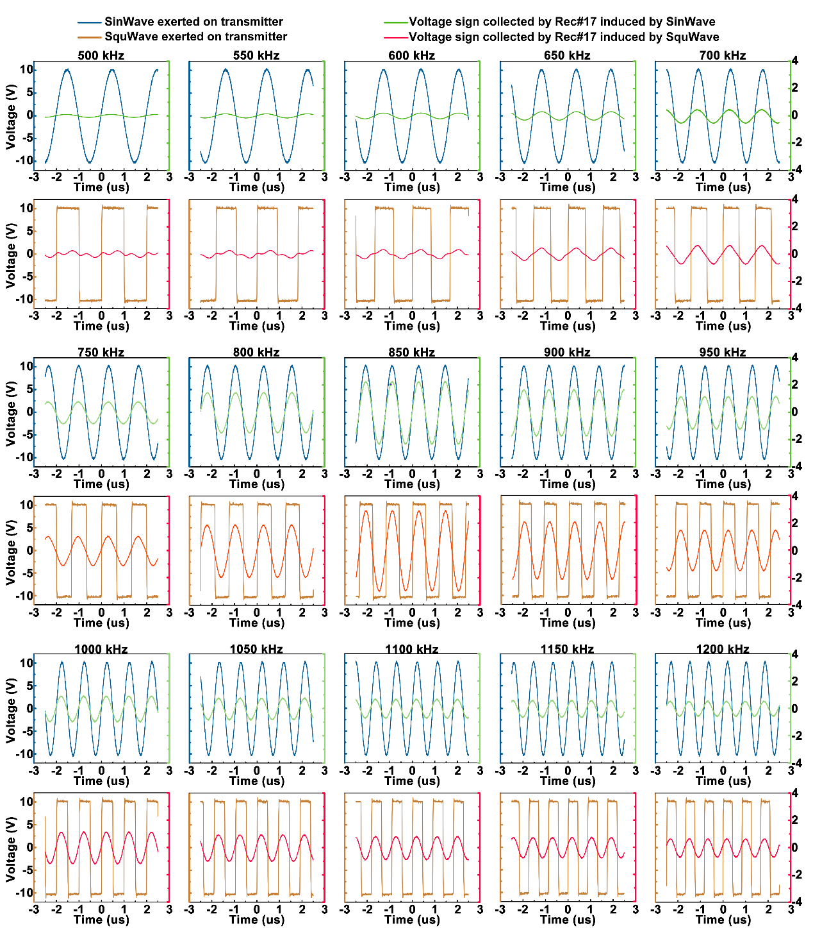
Figure S3.5. The influence of square wave and sine wave’s frequencies (20 Vpp, 500 KHz to 1200 KHz with step of 50 KHz) on the performance of wireless power supply via WPT systems (Transmitter and Rec#17 with the radiation distance of 6 mm). In these tests, the integrated antenna and WTCL, aligned with identical axis, were connected with waveform generator and oscilloscope, respectively. The distance between integrated antenna and WTCL was kept at 6 mm. These figures reveal that 850 kHz remain was the optimal frequency for the WPT system consist of the Rec#17 and transmitter to acquire higher voltage regardless of voltage waveform.
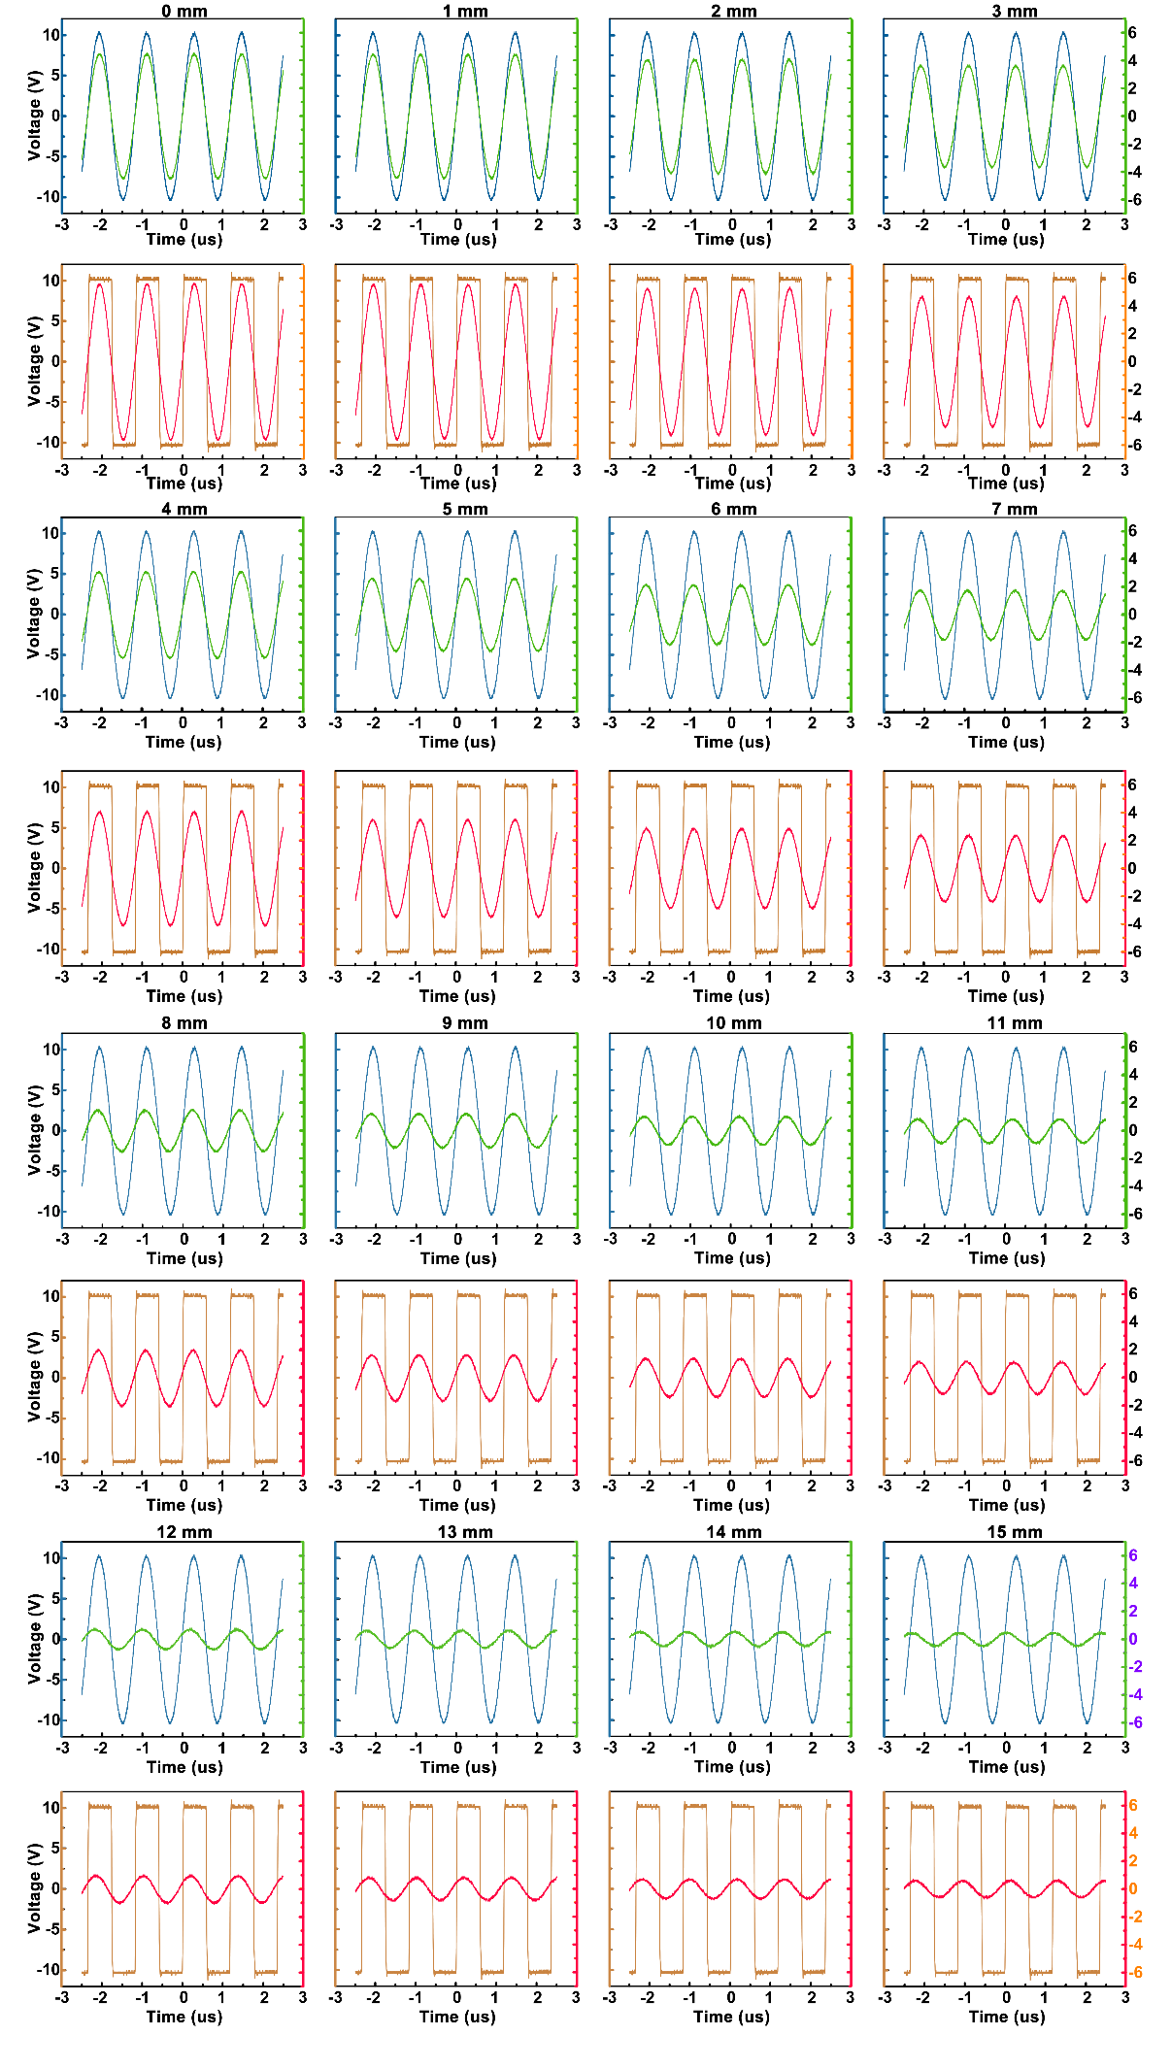
Figure S3.6. The influence of radiation distances (0 mm to 15 mm with step of 1 mm) on wireless power supply performance of the fourth WPT systems (Transmitter and Rec#17). In these tests, the integrated antenna and WTCL, aligned with identical axis, were connected with waveform generator and oscilloscope, respectively. The voltage wave exerted on transmitter of integrated antenna was set at 20 Vpp and 850 kHz. Results shown that Vpp of Rec#17 induced by the sine voltage wave exerted on transmitter was slightly lower than the Vpp via SquWave. It further demonstrated that the square voltage wave exerted on transmitter possessed the potential to provide higher transferred voltage in receiver circuit.

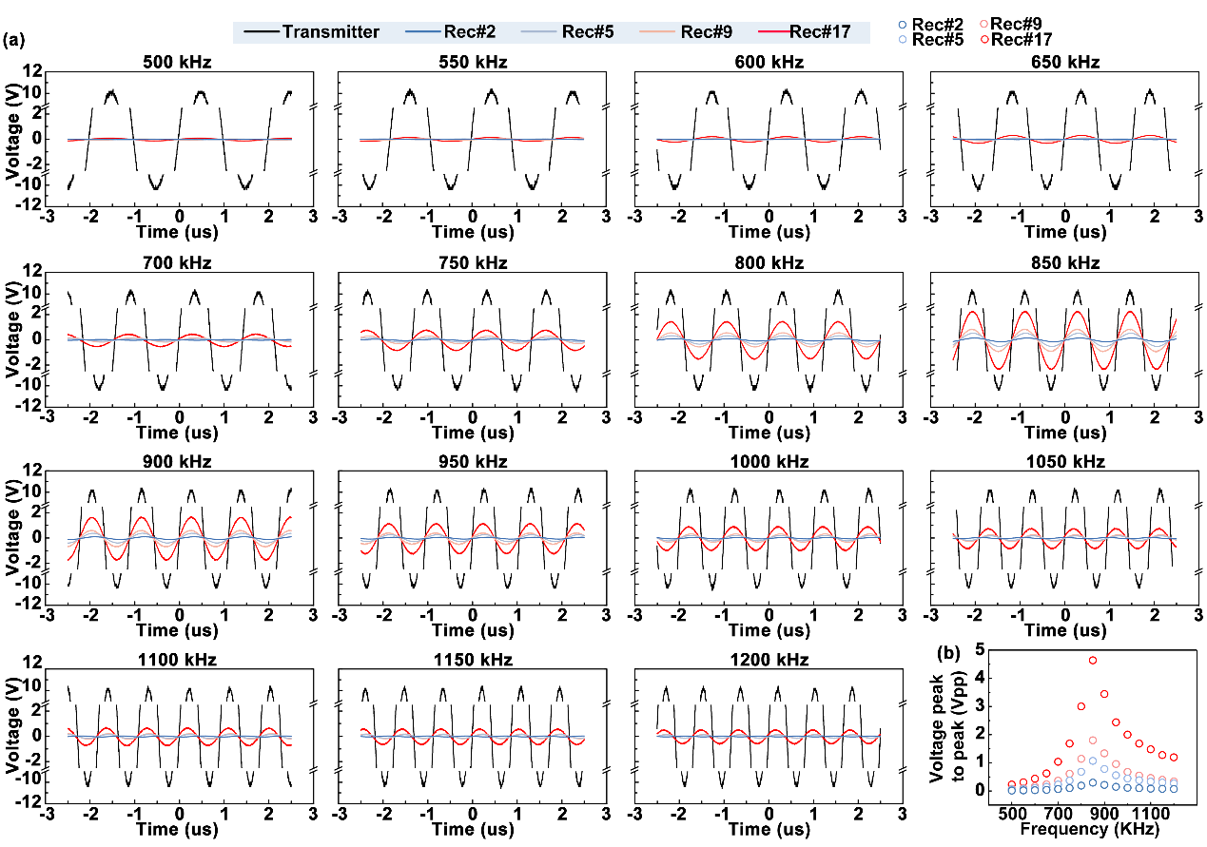
Figure S3.7. (a) Vpp recorded from different receivers induced by sine voltage (20 Vpp) with different frequencies exerted on transmitter. In these tests, the integrated antenna and WTCL, aligned with identical axis, were connected with waveform generator and oscilloscope, respectively. The distance between integrated antenna and WTCL was set at 6 mm. (b) The Vpp were plotted as a function of frequency. Similar to the activation by square wave voltage, the acquired Vpp on receiver circuit induced by transmitter with sine wave were also maximized at 850 kHz. The results reveal that 850 kHz was the optimal operation frequency of these receiver circuits for supplying higher Vpp.

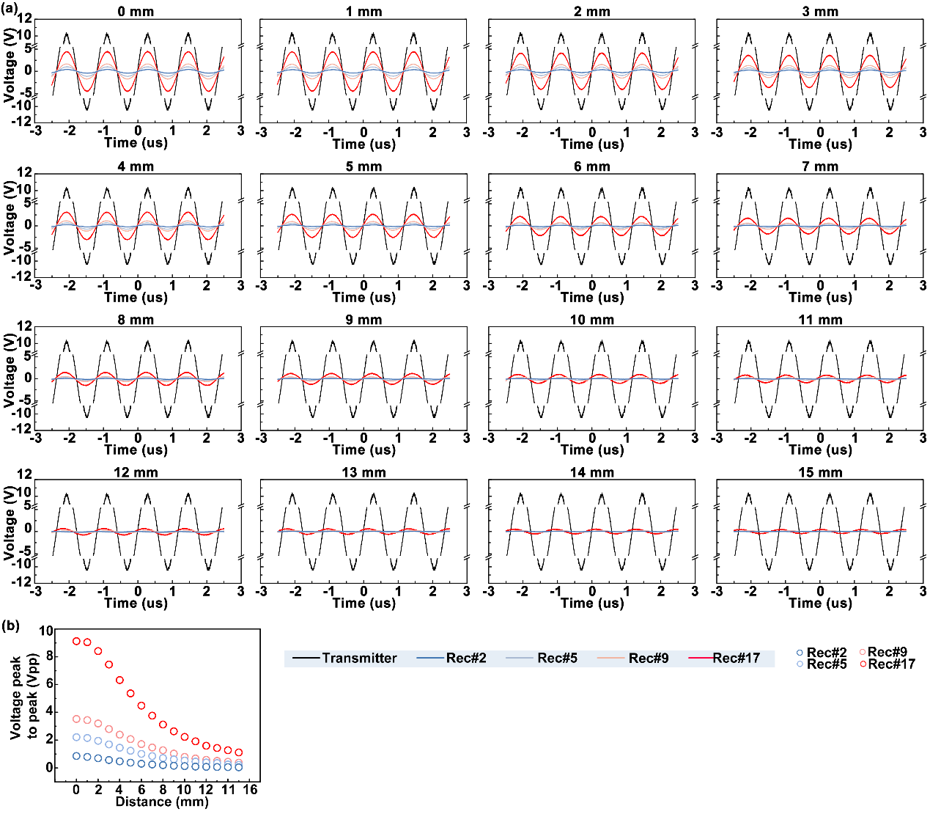
Figure S3.8. (a) Vpp recorded from different receivers induced by sine voltage applied on transmitter under different radiation distances (0 to 15 mm with the step of 1 mm). In these tests, the integrated antenna and WTCL, aligned with identical axis, were connected with waveform generator and oscilloscope, respectively. The voltage wave exerted on transmitter of integrated antenna was kept with 20 Vpp at 850 kHz. (b) The Vpp values were plotted as a function of radiation distance.

S4. Theoretical calculations for the performance of WPT groups.
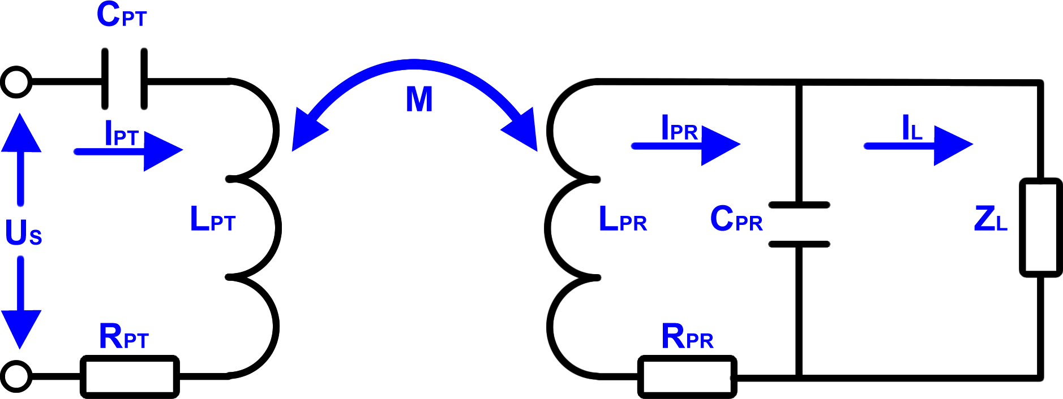
Figure S4.1. Schematic circuit for the derivation of the power transfer efficiency equation. U_{s}, R_{PT}, L_{PT}, C_{PT}, I_{PT} refer to the alternating voltage supplied for the transmitter, parasitic resistance, inductor, capacitor and alternating current in transmitter. Correspondingly, R_{PR}, L_{PR}, C_{PR}, R_{L} denote the parasitic resistance, inductor, capacitor and electric load in receiver circuit. I_{PR} represents the total alternating current in receiver circuit. I_{L} is the alternating current flow through electric load.

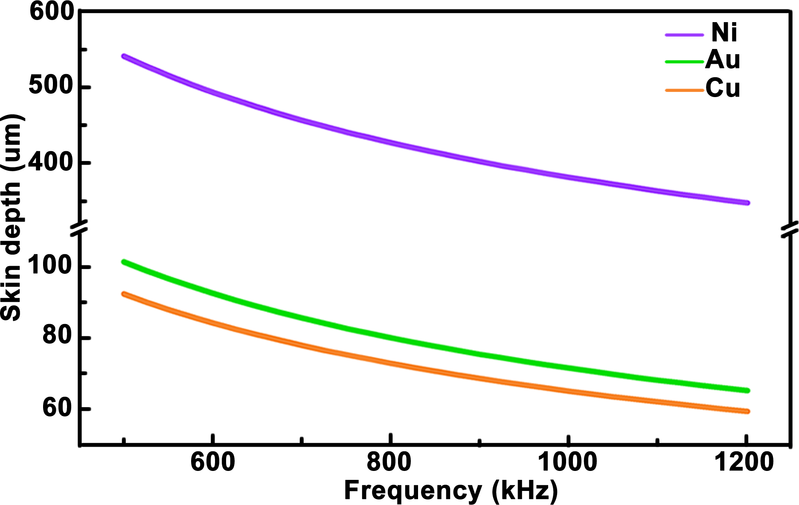
Figure S4.2. Calculated skin depth of conductor composited of Ni, Au, and Cu in the frequency range from 500 kHz to 1.2 MHz. Detailed parameters (relative magnetic permeability and conductivity of the conductive matter) were listed in Table S5. Calculation results show that the skin depth decreased gradually as the operation frequency increases from 500 kHz to 1.2 MHz. Moreover, the skin depth of Au, Cu, and Ni are 78.19 um, 71.23 um, and 415.19 um, respectively at alternating current in 850 kHz. The parameters of these conductive materials are thicker than its practical thickness in WPT receiver circuits. It indicated that alternating current with frequency of 850 kHz was distributed in the whole cross-section of the conductor, which suggested almost negligible power loss caused by skin effect needed to be considered in the WPT subsystem.

Table S5. Relative magnetic permeability and conductivity of the conductive matter⁹.
Conductive materials | Relative magnetic permeability | Conductivity σ (S/m)
Copper (Cu) | 0.999900 | 5.88×10⁷
Nickle (Ni) | 120 | 1.44×10⁴
Gold (Au) | 0.999983 | 4.88×10⁷

S5. Characterization of cross-coupling between IOP monitoring and WPT activated iontophoresis of the WTCL.
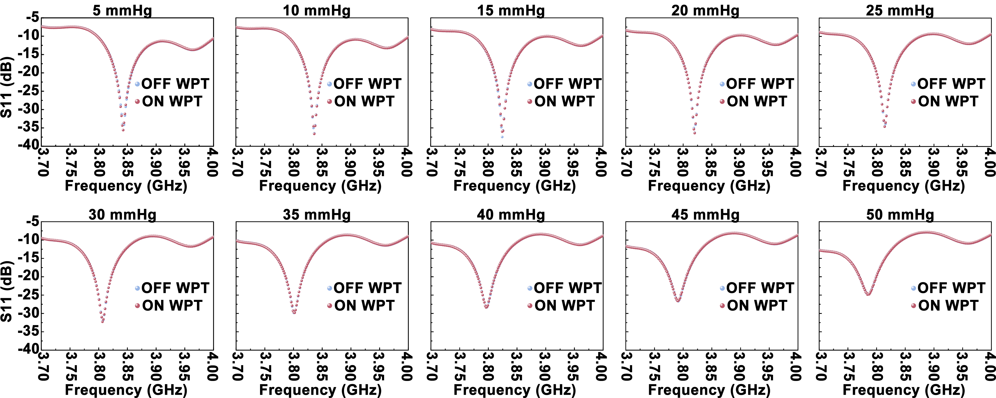
Figure S5.1. The influence generated by the radiation of WPT transmitter to IOP sensing performance. The distance between integrated antenna and WTCL was set at 6 mm. Network analyzer was connected to the IOP reading coil of the integrated antenna to monitor the physiological pressure transduced by WTCL. Saline solution were injected into the anterior chamber of porcine eyes via a infusion needles (0.45×13.5 mm) controlled by syringe pump to achieve IOPs ranging from 5 to 50 mmHg with the step of 5 mmHg. During the process of IOP sensing, the power generated by waveform generator for WPT transmitter was turned on and off to evaluate the S11 response of the IOP monitoring module.

S5. Theoretical simulations of iontophoretic medicines administration via COMSOL Multiphysics 5.5.
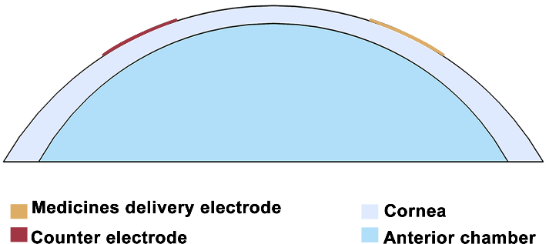
Figure S5.1. Sectional view of 3D model of ocular drug delivery with the structures and components imitating the actual scenario, which was simulated using COMSOL Multiphysics 5.5 to evaluate the feasibility of enhanced trans-corneal drug delivery by the iontophoretic electrode on WTCL.

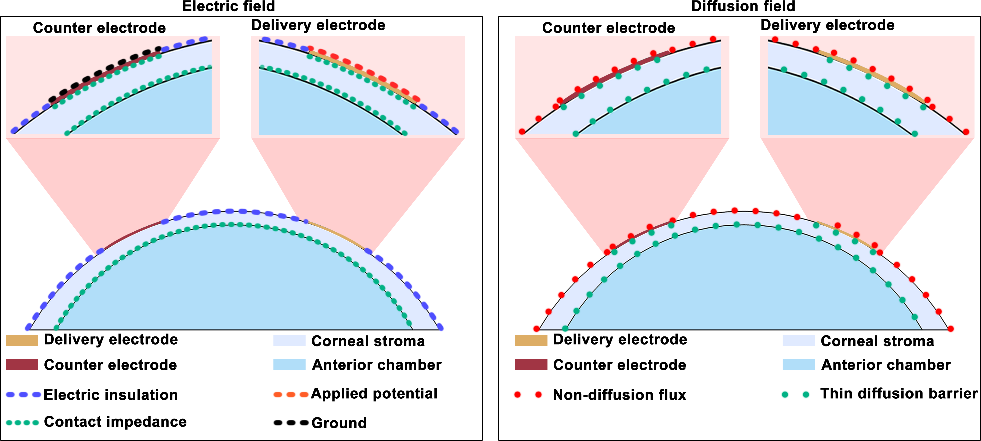
Figure S5.2. Boundary condition of the COMSOL delivery model. Anterior segment of the eye was modeled as aqueous humor, cornea including epithelial cell, stroma, and endothelial cell layer. The cornea presented a diffusion barrier for the drug molecules. The total drug amount in this system was set as constant, initially 100% loaded in the hydrogel. The average concentration of the drugs in the aqueous humor volume was quantified to evaluate the delivery efficiency.

Table S6. Detailed parameters and size of four WPT receiver circuits.
Components | Symbol | Value | Definition
pHEMA hydrogel | Hh | 50µm | The thickness of pHEMA hydrogel.
pHEMA hydrogel | σh | 0.2 S/m | The electrical conductivity of pHEMA hydrogel.
pHEMA hydrogel | Dh | 0.1 | The relative diffusivity of brimonidine in pHEMA hydrogel.
pHEMA hydrogel | Ap | 16.98 mm² | The area of pHEMA hydrogel
pHEMA hydrogel | Cg0 | 1 mmol/m³ | Medicinesof brimonidine concentration in hydrogel
Counter electrode | An | 4.78 mm² | The area of counter electrode
Corneal stroma | σc¹⁰ | 0.2 S/m | The electrical conductivity of corneal stroma.
Corneal stroma | Dc | 0.1 | The relative diffusivity of brimonidine in corneal stroma.
Corneal stroma | Hst | 300 µm | The thickness of corneal stroma.
Corneal epithelial cell layer | Hepc | 100 µm | The thickness of corneal epithelial cell layer (modeled as the top boundary of the corneal layer).
Corneal epithelial cell layer | σepc | 0.021 S/m | The electrical conductivity of corneal epithelial cell layer.
Corneal epithelial cell layer | Depc | 0.01 | The relative diffusivity of brimonidine in corneal epithelial cell layer.
Corneal endothelial cells layer | Hepe | 100 µm | The thickness of corneal endothelial cells layer (modeled as the bottom boundary of the corneal layer).
Corneal endothelial cells layer | σepe | 0.021 S/m | The electrical conductivity of corneal endothelial cells layer.
Corneal endothelial cells layer | Depe | 0.01 | The relative diffusivity of brimonidine in corneal endothelial cells layer.
Aqueous humor | σa | 2.1 S/m | The electrical conductivity of aqueous humor.
Brimonidine | Da | 1E-9 m^2/s | The diffusivity of brimonidine in aqueous humor.
Brimonidine | Z | 2 | Charge of brimonidine
Electric potential | U0 | Variable

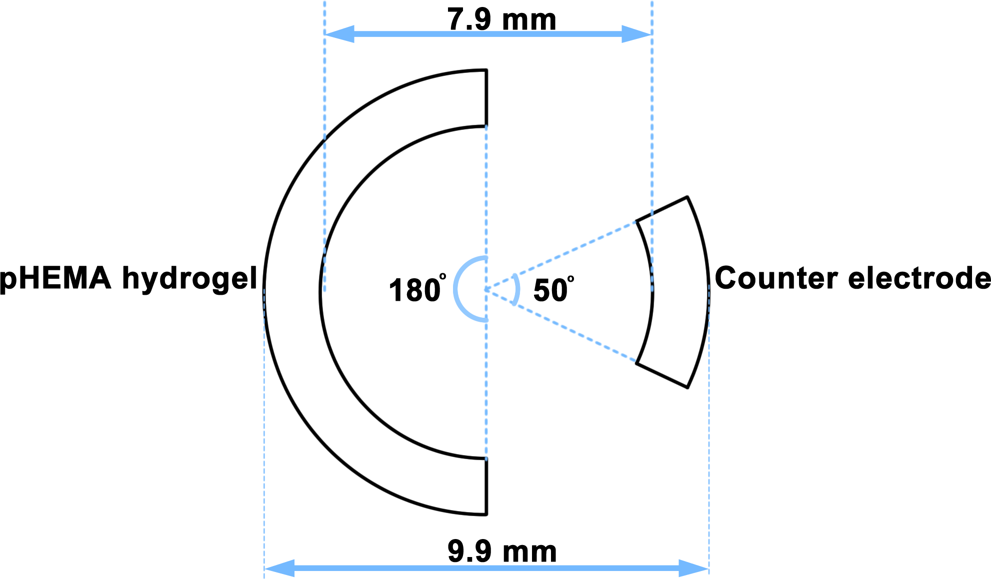
Figure S5.3. The CAD diagram showing the 2D dimensions of iontophoretic electrode in the simulation model. Counter electrode and pHEMA hydrogel that served as reservoir to load bio-active compounds were attached on cornea. Furthermore, the back surface of hydrogel was attached to the drug delivery electrode. The counter electrode was labeled with ground in electric field.

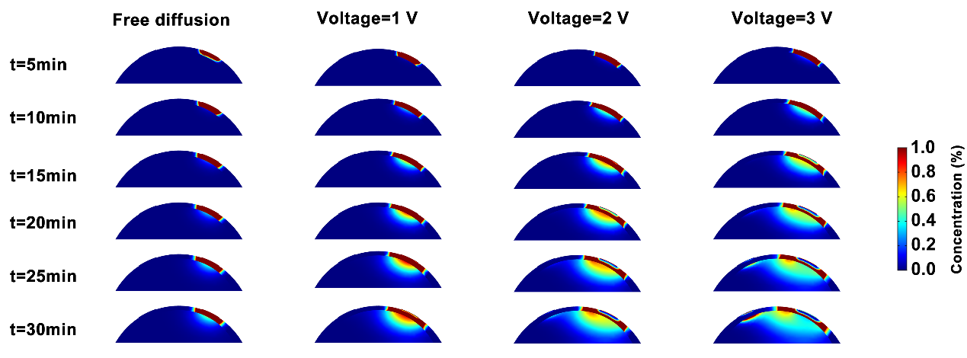
Figure S5.4. Illustration of the diffusion profile of drug molecules in the anterior region of the eye after iontophoresis at 0, 1, 2 and 3 V for t=5 min to 30 min with the step of 5 min via WTCL. Under constant electrical voltages, the electrode generated electric field across cornea. For drug delivery, the initial drug concentration was set as Cg0 in hydrogel. Drug molecules were driven into aqueous humor across corneal barriers by the effect of electrophoresis under the means of this electric field. The average drug concentration in the anterior chamber (aqueous humor) was calculated to evaluate the medicines administration efficiency.

S6. Supporting information for in vivo experiments.
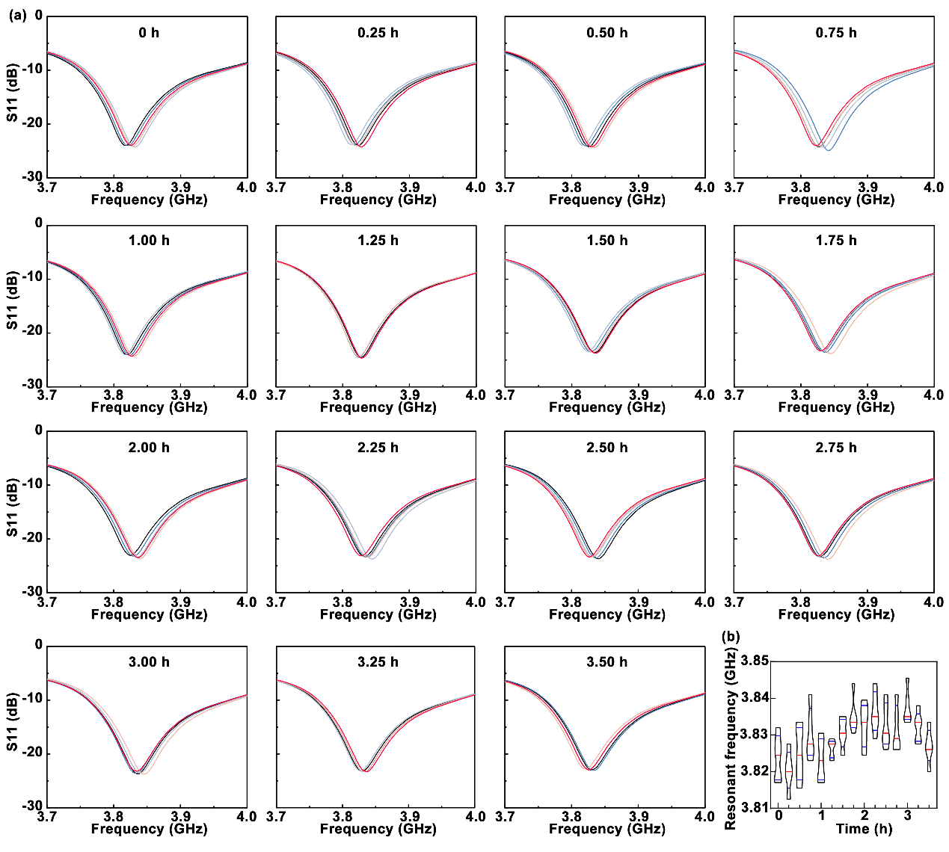
Figure S6.1. (a) Scattering parameters of IOP sensing module at each measurement time point during the WTCL#1 experimental group in Figure 6g in main text. During synergistic IOP monitoring and in situ drug delivery by WTCL, the scattering parameter of IOP monitoring module was recorded wirelessly by network analyzer every 15 minutes, while the resonant frequency measurements were repeated for 5 times at each time point. (b) Resonant frequency fluctuations as the function of time. The resonant frequency could be further converted to IOP, according to the standard curve of resonant frequency-IOP.

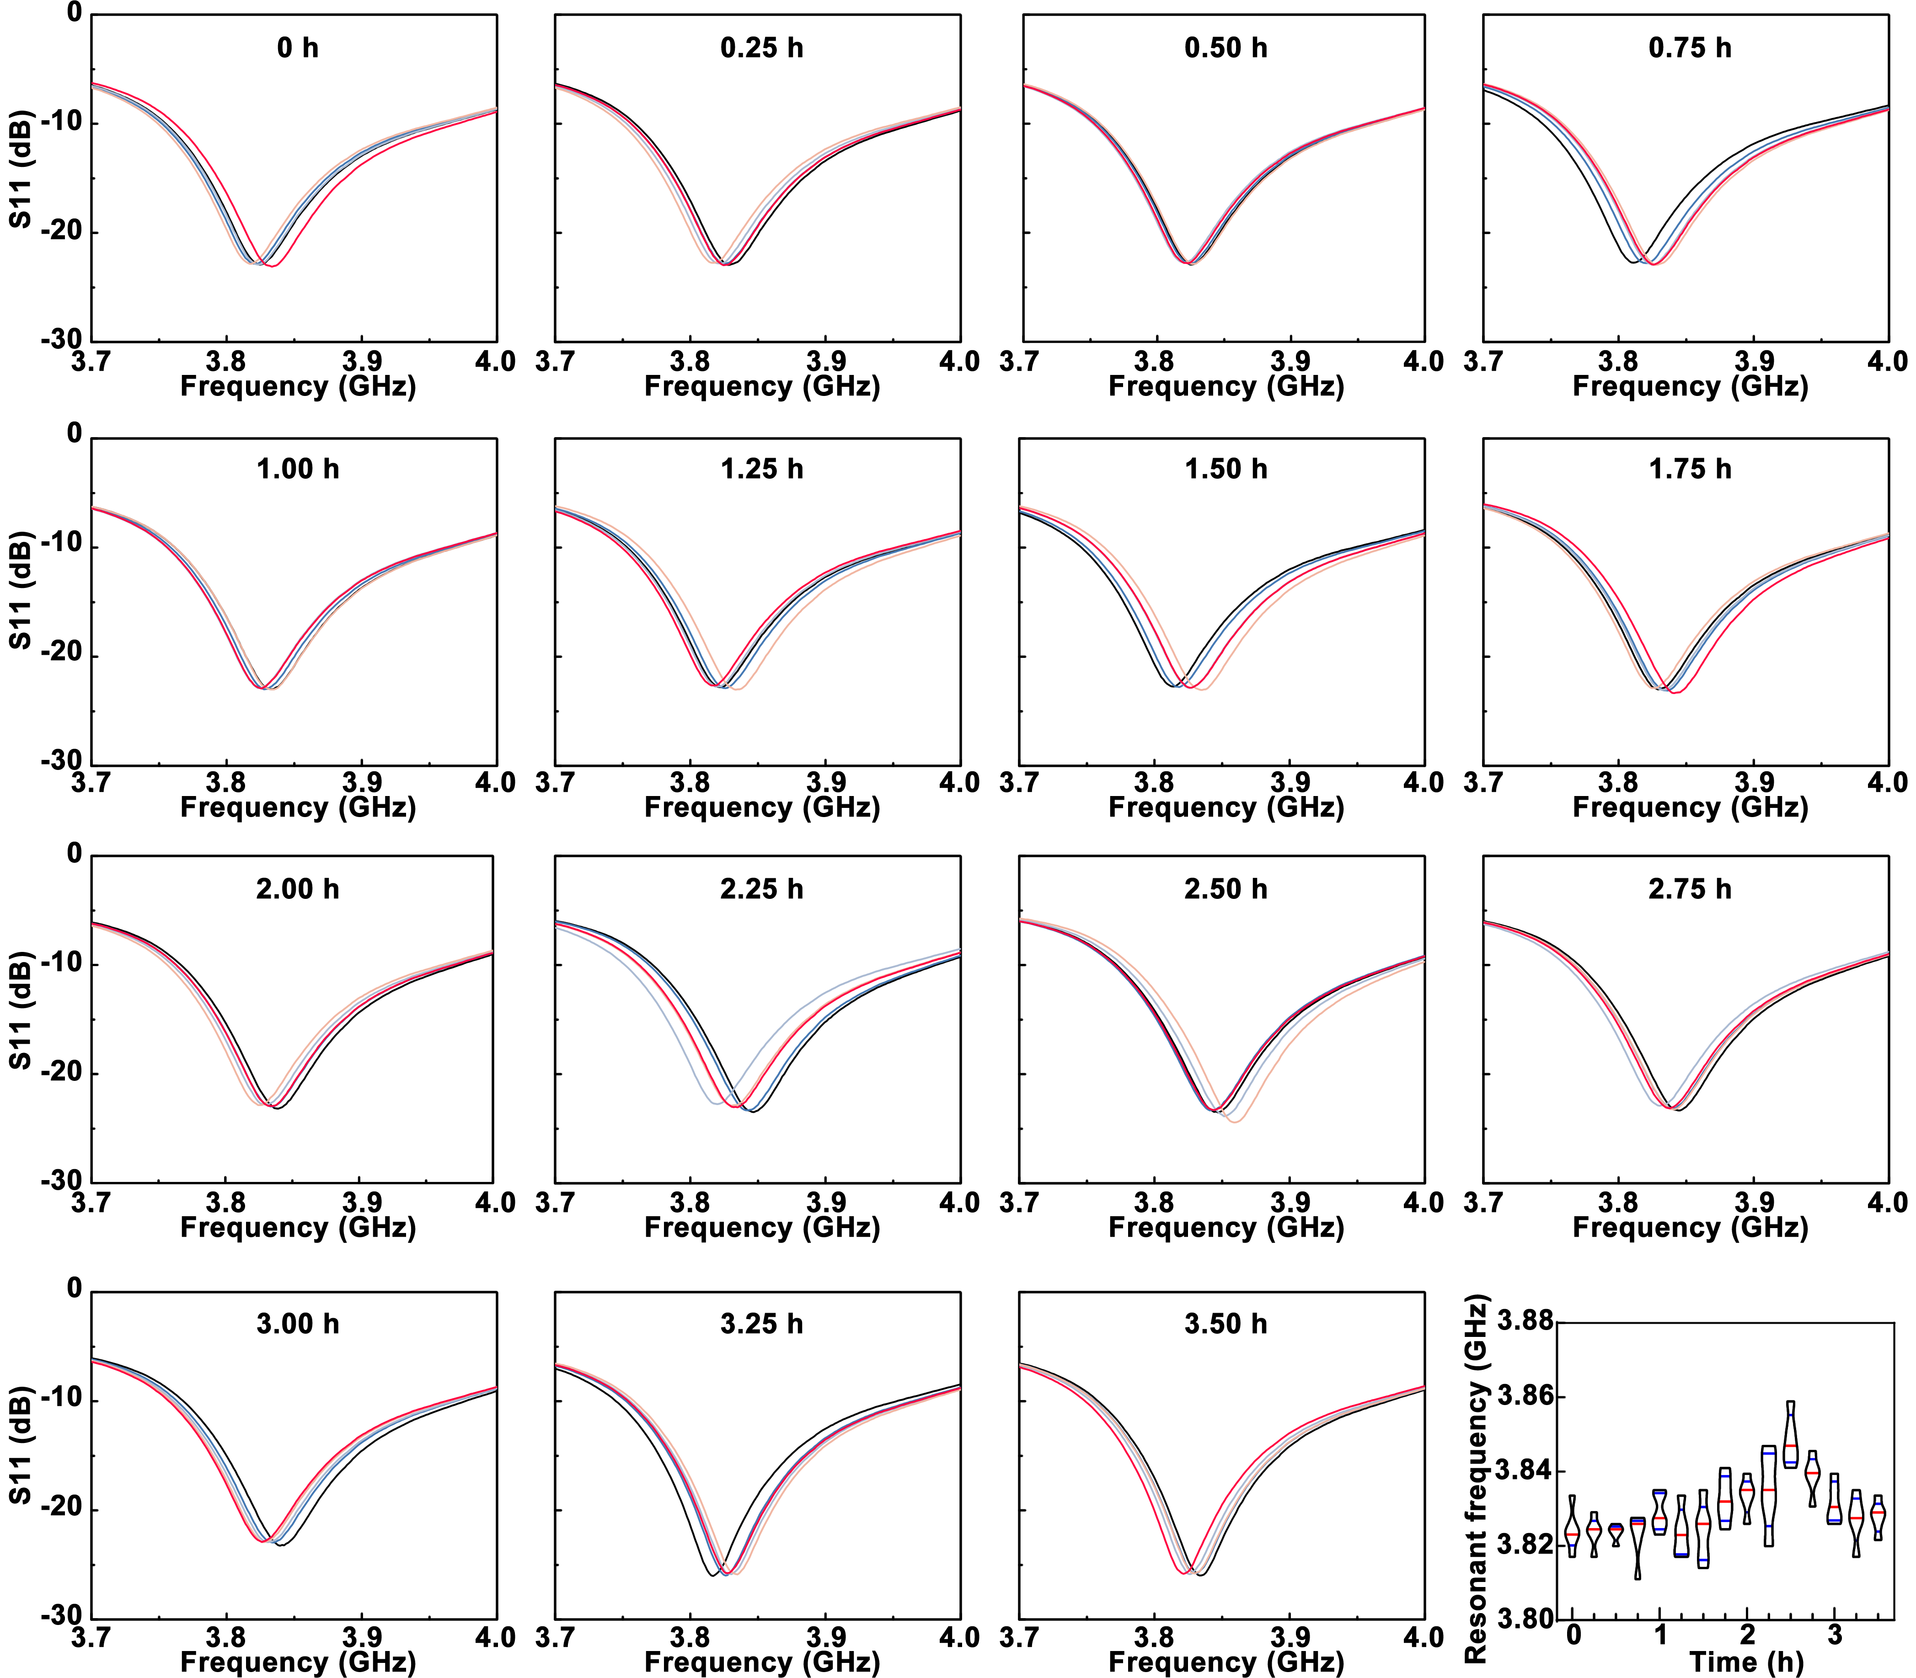
Figure S6.2. (a) Scattering parameters of IOP sensing module at each measurement time point during the WTCL#2 experimental group in Figure 6g in main text. During synergistic IOP monitoring and in situ drug delivery by WTCL, the scattering parameter of IOP monitoring module was recorded wirelessly by network analyzer every 15 minutes, while the resonant frequency measurements were repeated for 5 times at each time point. (b) Resonant frequency fluctuations as the function of time. The resonant frequency could be further converted to IOP, according to the standard curve of resonant frequency-IOP.

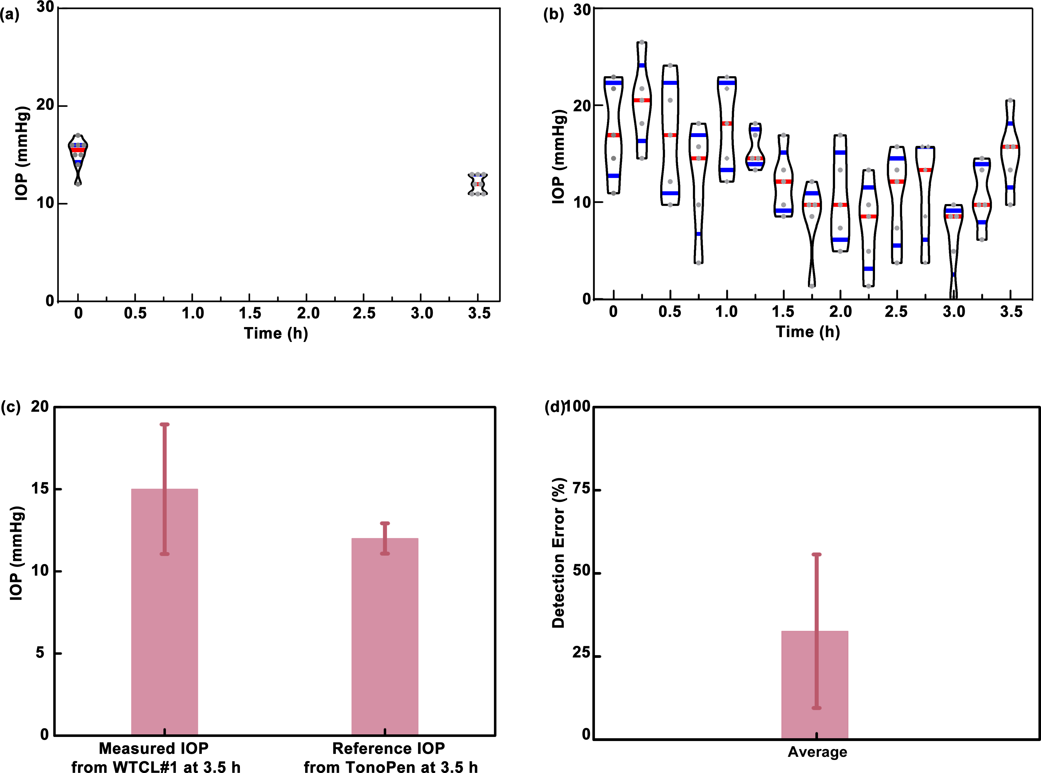
Figure S6.3. (a) Reference IOP values, related to Figure 6g (I) in main text, captured by Tonopen before and after WTCL#1 experiment in Figure 6g in main text, which could be employed to calibrate the measured IOP and analyze detection error. (b) IOP values calculated from the resonant frequency values of WTCL#1 experiment in Supporting Information Figure S6.1, without calibration using the reference data via Tonopen measurement. (c) The measured IOP via WTCL#1 at the end of experiment (initially calibrated with the reference IOP provided by Tonopen), and the comparison to the reference IOP measured via Tonopen at the end of experiment. (d) The detection error of IOP monitoring using WTCL with calibration. The detection error could be expressed as where P represents the real-time pressure recorded by WTCL at 3.5 h, P_{Avg} denotes the average IOP collected by TonoPen at 3.5 h.
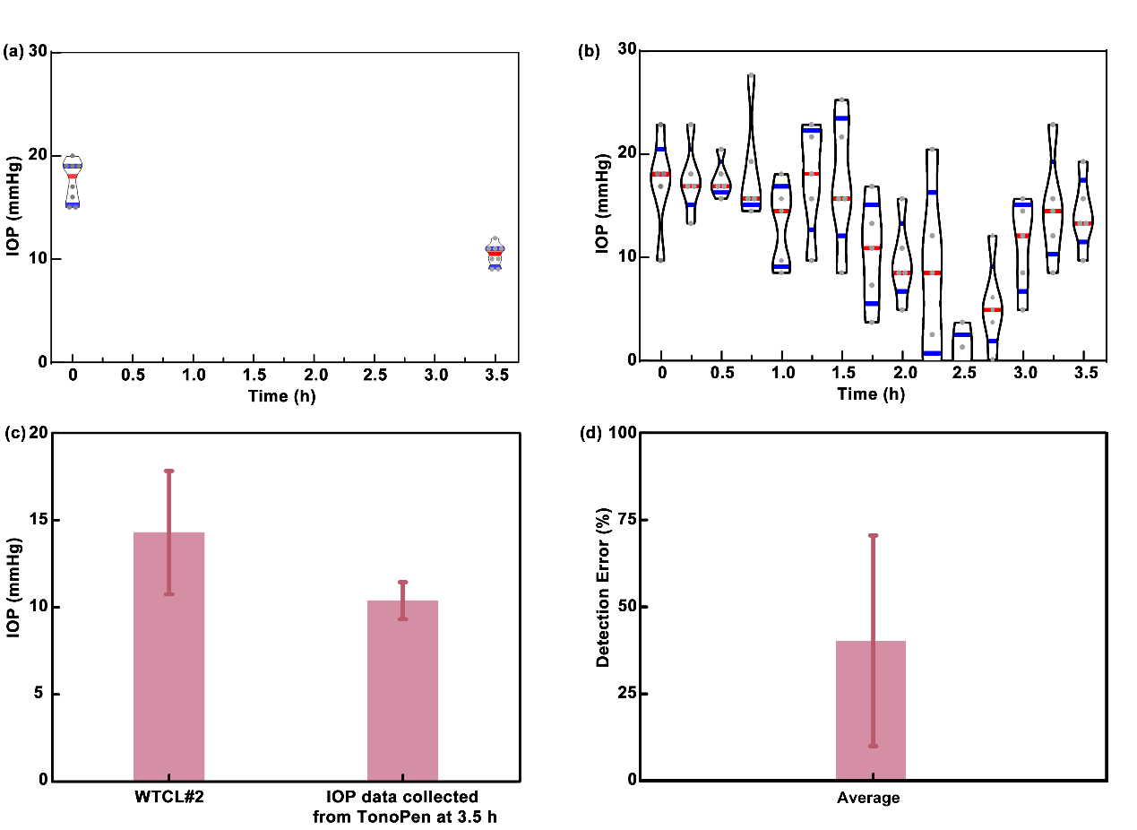
Figure S6.4. (a) (a) Reference IOP values, related to Figure 6g (II) in main text, captured by Tonopen before and after WTCL#2 experiment in Figure 6g in main text, which could be employed to calibrate the measured IOP and analyze detection error. (b) IOP values calculated from the resonant frequency values of WTCL#2 experiment in Supporting Information Figure S6.2, without calibration using the reference data via Tonopen measurement. (c) The measured IOP via WTCL#2 at the end of experiment (initially calibrated with the reference IOP provided by Tonopen), and the comparison to the reference IOP measured via Tonopen at the end of experiment. (d) The detection error of IOP monitoring using WTCL with calibration. The detection error could be expressed as where P represents the real-time pressure recorded by WTCL at 3.5 h, P_{Avg} denotes the average IOP collected by TonoPen at 3.5 h.

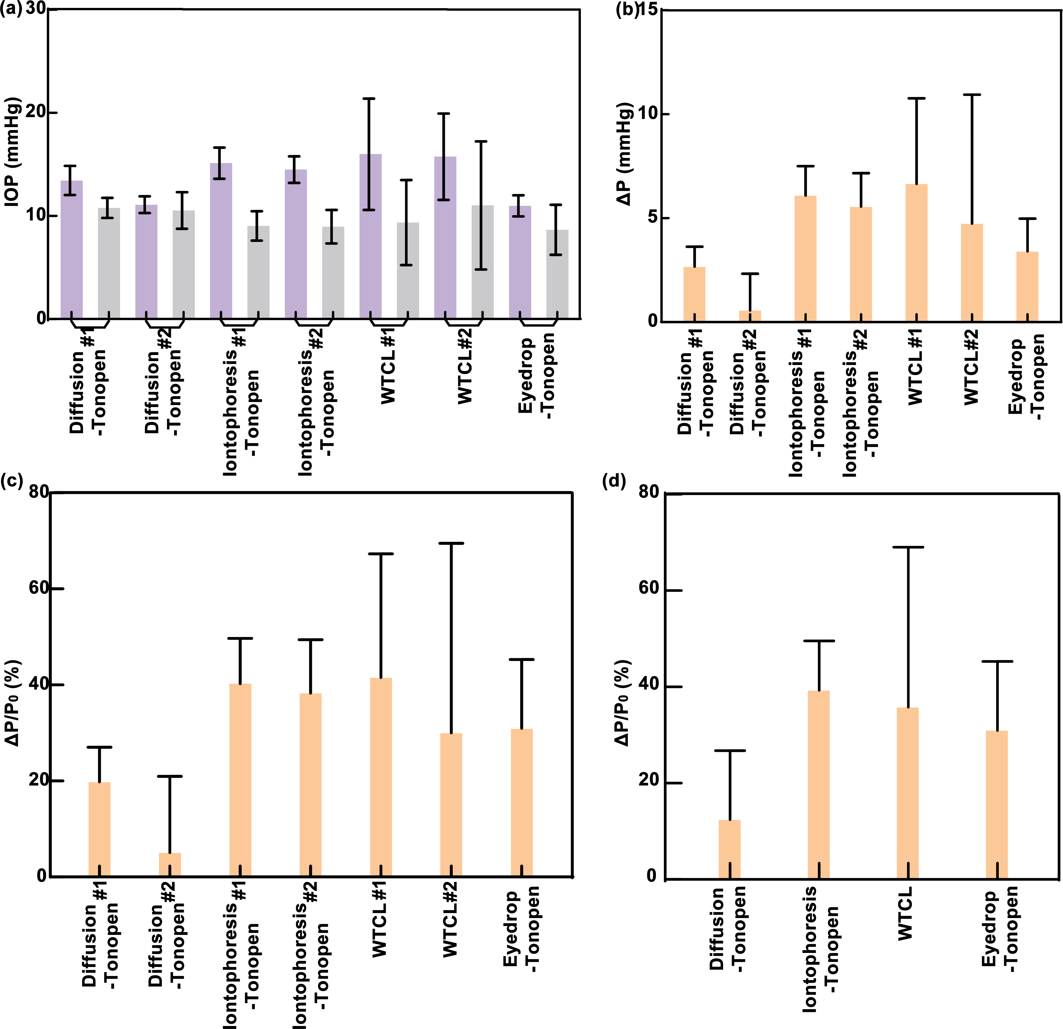
Figure S6.5. Assessment of IOP reduction effect after 0.5 hour of drug administration, summarizing based on Figure 6e-6h in main text. (a) Analysis of the measured IOP value (either by WTCL or TonoPen) recorded in the different period of experiments. The purple columns refers to the IOP data in the initial period (in 1 hour) before drug delivery. The gray columns represent the IOP data recorded right (in 0.5 hour) after drug delivery. (b) IOP changes (ΔP) at different delivery experiments. ΔP could be expressed as: , where P denotes the real-time IOP recorded in 0.5 hour after drug delivery, P_{0Avg} represents the average IOP before drug delivery. (c) Normalized IOP changes (ΔP/P_{0Avg}) in different drug delivery experiments. ΔP/P_{0Avg} could be expressed as: , where P denotes the real-time IOP recorded in 0.5 hour right after drug delivery, while P_{0Avg} represents the average IOP before drug delivery. (d) Assessment of IOP reduction effect by different drug delivery methods. ΔP recorded from different experimental animal groups in the same delivery approach were averaged to calculate ΔP/P_{0Avg} for analyzing IOP reduction effect.

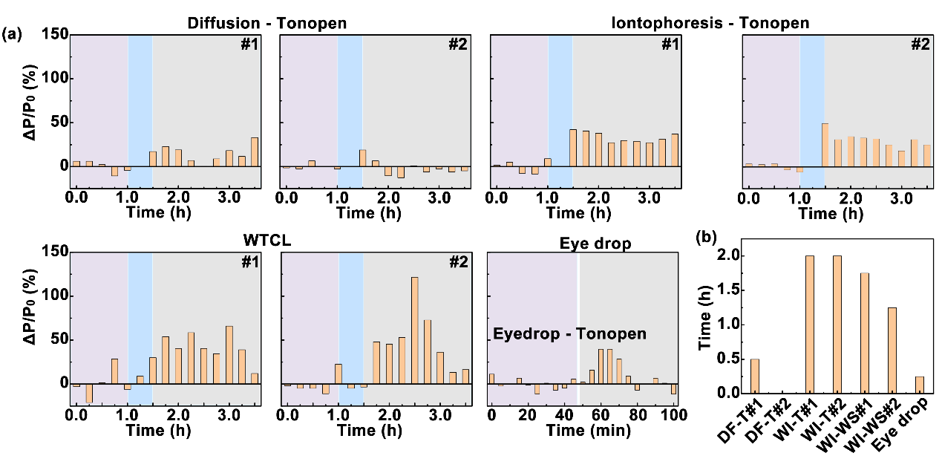
Figure S6.6. Analysis of the duration of IOP reduction. (a) ΔP/P_{0Avg} at each time point by different drug delivery approach. (b) Quantifications of IOP reduction duration by different drug delivery approach. ΔP/P_{0Avg}≥20% was identified as the effective IOP regulation¹¹, and the period during which the IOP meet this criteria was defined as the effective IOP regulation period.
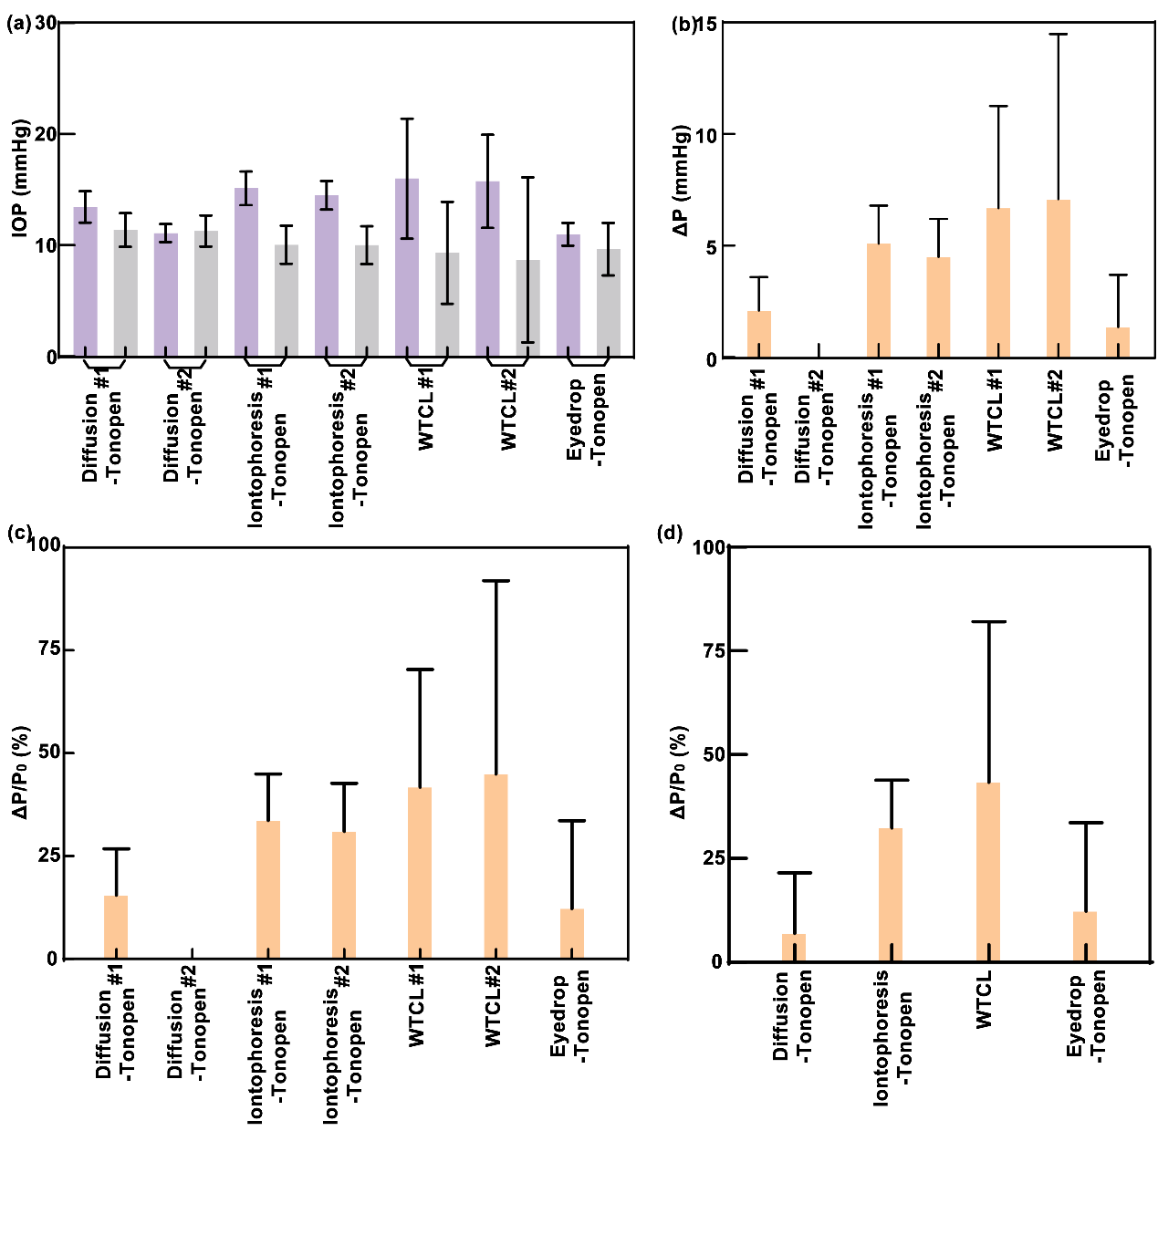
Figure S6.7. Assessment of IOP reduction effect after 0.5 hour of drug administration, summarizing based on Figure 6e-6h in main text. (a) Analysis of the measured IOP value (either by WTCL or TonoPen) recorded in the different period of experiments. The purple columns refers to the IOP data in the initial period (in 1 hour) before drug delivery. The gray columns represent the IOP data recorded in 2 hours after drug delivery. (b) IOP changes (ΔP) at different delivery experiments. ΔP could be expressed as: , where P denotes the real-time IOP recorded in 2 hours after drug delivery, P_{0Avg} represents the average IOP before drug delivery. (c) Normalized IOP changes (ΔP/P_{0Avg}) in different drug delivery experiments. ΔP/P_{0Avg} could be expressed as: , where P denotes the real-time IOP recorded in 0.5 hour after drug delivery, while P_{0Avg} represents the average IOP before drug delivery. (d) Assessment of IOP reduction effect by different drug delivery methods. ΔP recorded from different experimental animal groups in the same delivery approach were averaged to calculate ΔP/P_{0Avg} for analyzing IOP reduction effect.

S7. Thermal analysis
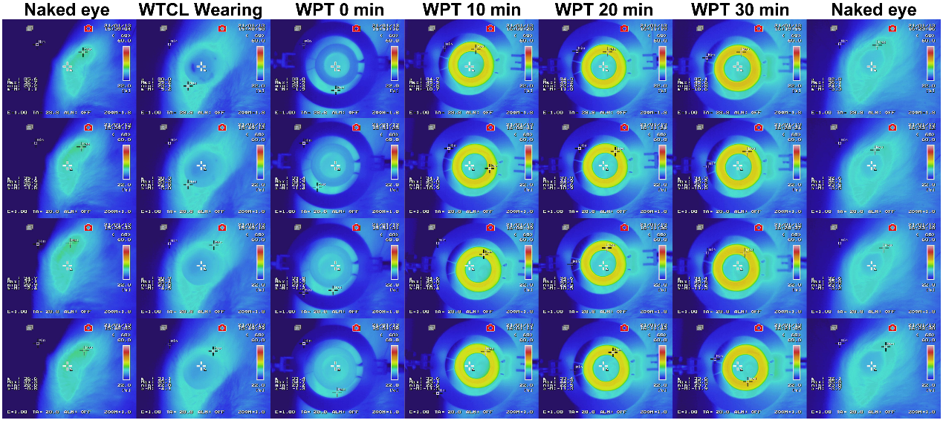
Figure S7.1. Time slot infrared images showing the temperature variations of the ocular surface tissue, WTCL, and integrated antenna measured by infrared camera during the 30 min WPT process. WTCL was worn on rabbit’s eye, and integrated antenna connected to waveform generator was posited above WTCL with the distance of 6 mm. Square voltage with 20 Vpp at 850 kHz produced from waveform generator was exerted on WPT transmitter. At each time point, 4 infrared images were recorded.

Reference:
1 Kim, J., Kim, M., Lee, M.-S., Kim, K., Ji, S., Kim, Y.-T., Park, J., Na, K., Bae, K.-H., Kim, H. K., Bien, F., Lee, C. Y. & Park, J.-U. Wearable smart sensor systems integrated on soft contact lenses for wireless ocular diagnostics. Nat. Commun. 8, 14997 (2017).
2 Chen, G.-Z., Chan, I.-S. & Lam, D. C. C. Capacitive contact lens sensor for continuous non-invasive intraocular pressure monitoring. Sens. Actuator A-Phys. 203, 112-118 (2013).
3 Chen, G.-Z., Chan, I.-S., Leung, L. K. K. & Lam, D. C. C. Soft wearable contact lens sensor for continuous intraocular pressure monitoring. Med. Eng. Phys. 36, 1134-1139 (2014).
4 Kouhani, M. H. M., Weber, A. & Li, W. in 2017 IEEE 30th International Conference on Micro Electro Mechanical Systems (MEMS). 557-560.
5 Kouhani, M. H. M., Wu, J., Tavakoli, A., Weber, A. J. & Li, W. Wireless, passive strain sensor in a doughnut-shaped contact lens for continuous non-invasive self-monitoring of intraocular pressure. Lab Chip 20, 332-342 (2020).
6 Chen, P., Saati, S., Varma, R., Humayun, M. S. & Tai, Y. Wireless Intraocular Pressure Sensing Using Microfabricated Minimally Invasive Flexible-Coiled LC Sensor Implant. J. Microelectromech. Syst. 19, 721-734 (2010).
7 Chen, P., Rodger, D. C., Saati, S., Humayun, M. S. & Tai, Y. Microfabricated Implantable Parylene-Based Wireless Passive Intraocular Pressure Sensors. J. Microelectromech. Syst. 17, 1342-1351 (2008).
8 Crum, B. Parylene Based Wireless Intraocular Pressure Sensor for Glaucoma Research, Michigan State University, (2013).
9 Zhang, Y., Huo, Z., Wang, X., Han, X., Wu, W., Wan, B., Wang, H., Zhai, J., Tao, J., Pan, C. & Wang, Z. L. High precision epidermal radio frequency antenna via nanofiber network for wireless stretchable multifunction electronics. Nat. Commun. 11, 5629 (2020).
10 Klyce, S. D. Electrical profiles in the corneal epithelium. 226, 407-429 (1972).
11 Jonas, J. B., Aung, T., Bourne, R. R., Bron, A. M., Ritch, R. & Panda-Jonas, S. Glaucoma. Lancet 390, 2183-2193 (2017).

