Table1 : List of Bioactive Compounds in ethanolic extract of Ocimum tenuiflorum (KT)

R/T (min) | Name of the Compound | Percentage Abundance | Molecular Formula | MW (g/mol) | 3D Structure
4.4 | Eugenol | 0.31 | C10H12O2 | 164.2 | 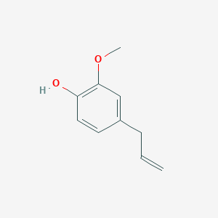
4.69 | Thymol | 13.67 | C10H14O | 150.22 | 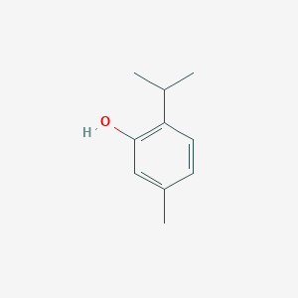
5.06 | Caffeic Acid | 12.83 | C9H8O4 | 180.16 | 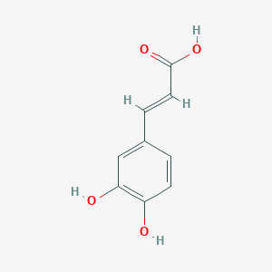
7 | Gallic Acid | 0.61 | C6H2(OH)3COOH | 170.12 | 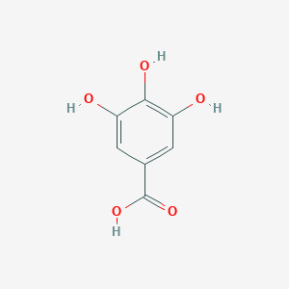
7.5 | Cinnamic Acid | 6.05 | C9H8O2 | 148.16 | 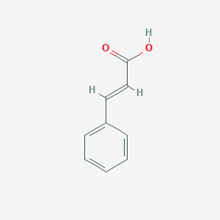
7.78 | P-Coumaric Acid | 7.7 | C9H8O3 | 164.16 | 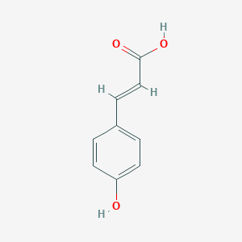
8.94 | Rosmarinic Acid | 2.07 | C18H16O8 | 360.3 | 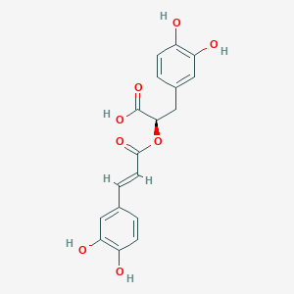
9.33 | Ursolic Acid | 7.4 | C30H48O3 | 456.7 | 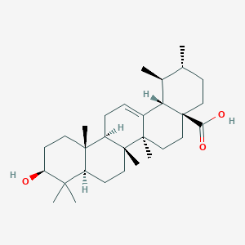
9.78 | Oleanolic Acid | 6.09 | C30H48O3 | 456.7 | 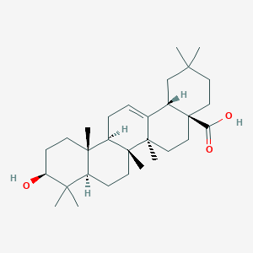
10.43 | Linalool | 20.48 | C10H18O | 154.25 | 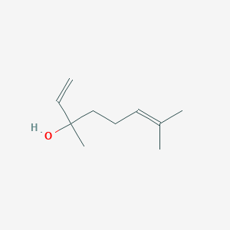
10.84 | β-Caryophyllene | 0.17 |  |  | 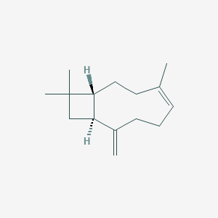
11.19 | Carvacrol | 1.49 | C10H14O | 150.22 | 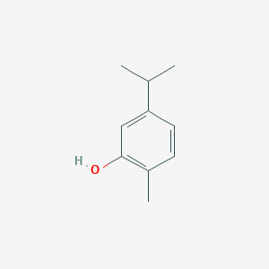
11.68 | Catechol | 11.22 | C6H6O2 | 110.11 | 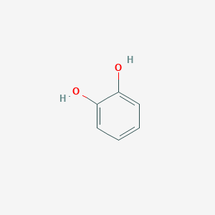
12.31 | Luteolin | 0.68 | C15H10O6 | 286.24 | 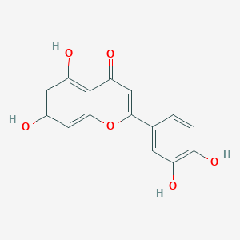
13.63 | Diosmetin | 0.05 | C16H12O6 | 300.26 | 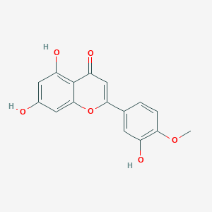
13.93 | Kaempferol | 0.43 | C15H10O6 | 286.24 | 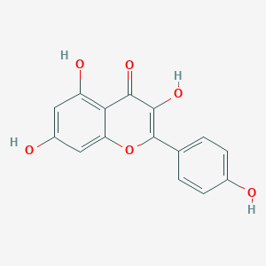
15.83 | Apigenin | 0.48 | C15H10O5 | 270.24 | 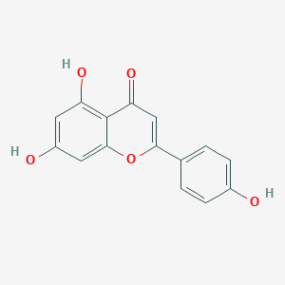
18.25 | Rosmarinic Acid | 0.34 | C18H16O8 | 360.3
18.84 | Genistein | 1.39 | C15H10O5 | 270.24 | 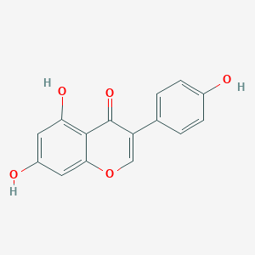
19.4 | Eucalyptol | 0.07 | C10H18O | 154.25 | 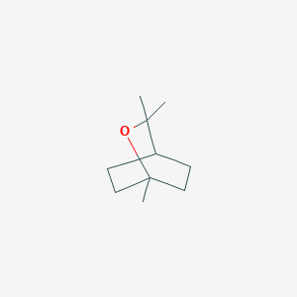

Table 2: Docking studies between the phytocompounds of KT and biofilm protein of S. aureus (3TIP)
BIOACTIVE COMPOUND | PHYTO-CHEMICALS | BIOFILM FORMING PROTEIN | AUTODOCK RESULTS | ENERGY VALUE (∆G^{O}) Kcal/mol
ESSENTIAL OILS | EUGENOL | 3TIP (Staphylococcus aureus) |  | -4.20
 | THYMOL | 3TIP (Staphylococcus aureus) |  | -4.07
TERPENOIDS | OLEANOLIC ACID | 3TIP (Staphylococcus aureus) |  | -6.53
 | URSOLIC ACID | 3TIP (Staphylococcus aureus) |  | -6.42
 | LINALOOL | 3TIP (Staphylococcus aureus) |  | -5.86
 | β-CARYOPHYLLENE | 3TIP (Staphylococcus aureus) |  | -4.40
 | CARVACROL | 3TIP (Staphylococcus aureus) |  | -4.09
OTHER PHENOLIC COMPOUNDS | ROSMARINIC ACID | 3TIP (Staphylococcus aureus) |  | -5.62
Table 3: LIGPLOT analysis depicting the major interacting amino acid residues
SL. NO. | BIOACTIVE COMPOUND | PHYTO-CHEMICAL | BIOFILM FORMING PROTEIN | LIGPLOT
 |  |  |  |  | HYDROPHOBIC BOND | HYDROGEN  BOND
1. | ESSENTIAL OILS | EUGENOL | 3TIP (Staphylococcus aureus) | 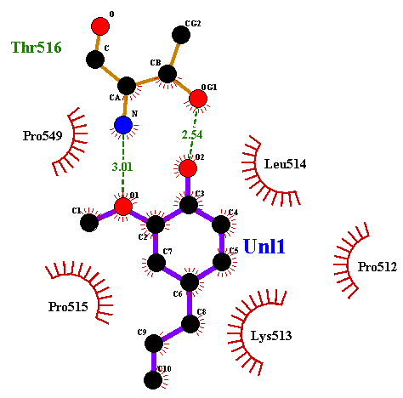 | LYS513 (3.95)  PRO549 (3.97) | THR516 (2.54)  THR516 (3.01)
 |  | THYMOL | 3TIP (Staphylococcus aureus) | 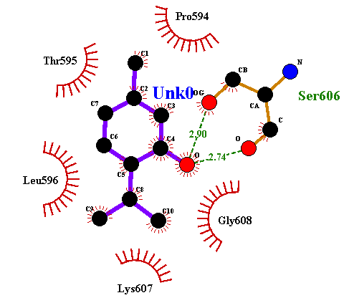 | PRO594 (3.41)  LEU596 (3.44) | LEU596 (2.74)  SER606 (2.90)
2. | TERPENOIDS | OLEANOLIC ACID | 3TIP (Staphylococcus aureus) | 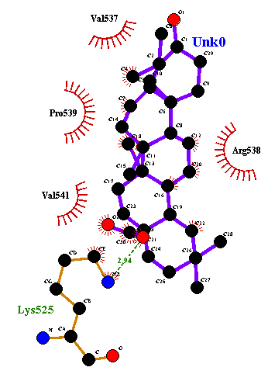 | ARG538 (3.23) | LYS525 (2.88)
 |  | URSOLIC ACID | 3TIP (Staphylococcus aureus) | 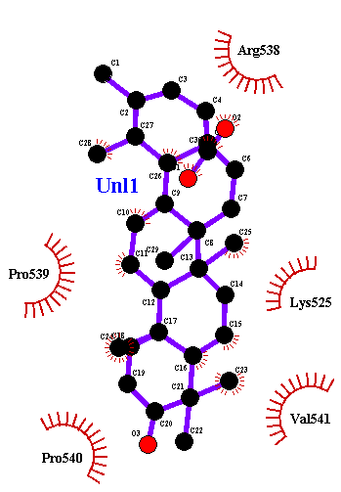 | ARG538 (3.03)  VAL541 (3.37) | -
 |  | LINALOOL | 3TIP (Staphylococcus aureus) | 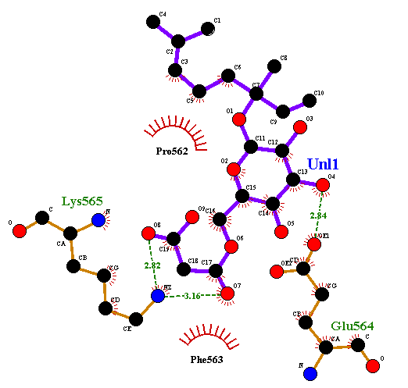 | PRO562 (3.40) | GLU564 (2.84)  GLU564 (2.84)  LYS565 (3.23)
 |  | Β-CARYOPHYLLENE | 3TIP (Staphylococcus aureus) | 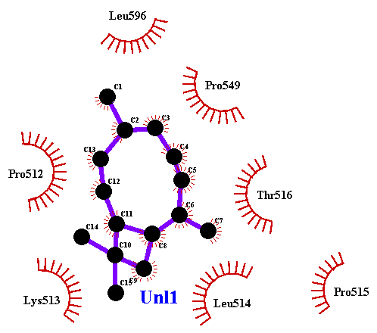 | PRO549 (3.17)  LEU596 (3.50) | -
 |  | CARVACROL | 3TIP (Staphylococcus aureus) | 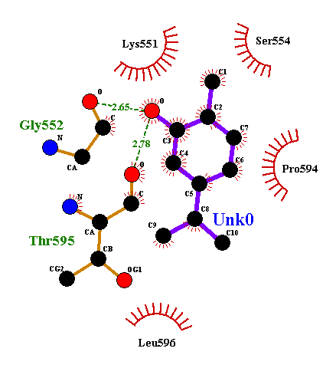 | LYS551 (387)  PRO594 (3.62)  LEU596 (3.87)  LEU596 (3.88) | GLY552 (2.72)  GLY (2.03)  THR (2.46)
3. | OTHER PHENOLIC COMPOUNDS | ROSMARINIC ACID | 3TIP (Staphylococcus aureus) | 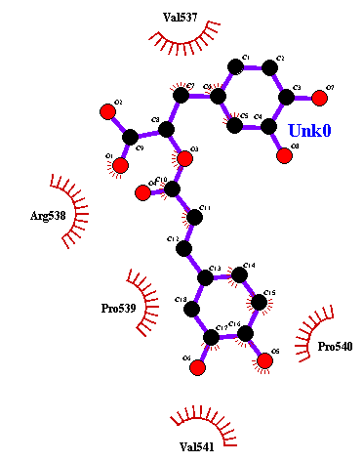 | ARG538 (3.75)  PRO539 (3.34)  VAL541 (3.97) | -

Table 4: CABS-FLEX analysis showing the major alterations in the interacting residues in presence of phytocompounds
SL. NO. | BIOACTIVE COMPOUNDS | PHYTOCHEMICAL | BIOFILM FORMING PROTEIN | ROOT MEAN SQUARE FUNCTION
1. | ESSENTIAL OILS | EUGENOL | 3TIP (Staphylococcus aureus)
 |  | THYMOL | 3TIP (Staphylococcus aureus)
2. | TERPENOIDS | OLEANOLIC ACID | 3TIP (Staphylococcus aureus)
 |  | URSOLIC ACID | 3TIP (Staphylococcus aureus)
 |  | LINALOOL | 3TIP (Staphylococcus aureus)
 |  | β-CARYOPHYLLENE | 3TIP (Staphylococcus aureus)
 |  | CARVACROL | 3TIP (Staphylococcus aureus)
3. | OTHER PHENOLIC COMPOUNDS | ROSMARINIC ACID | 3TIP (Staphylococcus aureus)

