Table S1. Oligonucleotide sequences used for amplification of the H. pylori virulence genes of interest.
Target gene | Primer designation | Oligonucleotide sequence (5΄-3΄) | Annealing temperature (°C) | PCR product (bp) | Reference
16S rRNA | C97-20  H3A-20 | GGCTATGACGGGTATCCGGC  GCCGTGCAGCACCTGTTTTC | 58 | 764 | [38]
glmM | GlmM2-F  GlmM1-R | GGATAAGCTTTTAGGGGTGTTAGGGG  GCTTACTTTCTAACACTAACGCGC | 56 | 296 | [38]
cagL | cagL-B4  cagL-B5 | GCAGAATTCATAACAAGCGGCTTAAAG  ATTAGAATTCATAGCCTATCGTCTCAG | 60 | 695 | [38]
cagA | 93089  93261 | AATACACCAACGCCTCCAAG  TTGTTGCCGCTTTTGCTCTC | 57 | 400 | [38]
vacA s1/s2 | VA1-F  VA1-R | ATGGAAATACAACAAACACAC  CTGCTTGAATGCGCCAAAC | 57 | 259/286 | [38]
vacA m1/m2 | VAG-F  VAG-R | CAATCTGTCCAATCAAGCGAG  GCGTCAAAATAATTCCAAGG | 57 | 570/645 | [38]
babA2 | bab7-F  bab7-R | CCAAACGAAACAAAAAGCGT  GCTTGTGTAAAAGCCGTCGT | 52 | 271 | [39]
sabA | F1-HP726-jhp663  R1-HP725-jhp662 | TTTTTGTCAGCTACGCGTTC  ACCGAAGTGATAACGGCTTG | 56 | 487 | [39]
dupA | DupA-F  DupA-R | ATTCACGCCTAAGACCTCA  CTGAGAAGCCTTATTATCTTGTTGG | 55 | 581 | [39]

Table S2. Demographic data and clinical characteristics of patients colonized with H. pylori strains (n=70) in this study.
No. | Strains | Clinical status | Gender | Age (years) | cagI GenBank no.ª | cagN GenBank no.
1 | HC3 | PUD | Male | 46 | Negative^{b} | NA
2 | OC4 | PUD | Female | 58 | MG573078 | MG559675
3 | OC30 | NUD | Male | 56 | MG573079 | MG559676
4 | HC114 | PUD | Female | 49 | Negative | NA
5 | OC149 | NUD | Female | 31 | MG573080 | NA
6 | HC168 | PUD | Male | 49 | NA^{c} | NA
7 | HC175 | NUD | Female | 27 | Negative | NA
8 | OC175 | NUD | Female | 30 | MG573081 | MG559677
9 | OC179 | GC | Female | 63 | NA | MG559678
10 | OC180 | IM | Female | 39 | Negative | NA
11 | OC217 | NUD | Female | 42 | Negative | Negative
12 | OC235 | PUD | Female | 75 | NA | NA
13 | OC245 | IM | Male | 48 | NA | Negative
14 | OC250 | PUD | Male | 57 | NA | NA
15 | OC485 | NUD | Male | 54 | NA | MG559679
16 | OC494 | NUD | Female | 42 | MG573082 | MG559680
17 | OC505 | NUD | Female | 39 | NA | NA
18 | OC557 | PUD | Female | 50 | Negative | Negative
19 | OC562 | NUD | Female | 43 | MG573083 | NA
20 | OC571 | NUD | Female | 49 | Negative | MG559681
21 | OC573 | NUD | Female | 36 | MG573084 | MG559682
22 | OC576 | NUD | Female | 42 | MG573085 | MG559683
23 | OC606 | PUD | Male | 60 | NA | MG559684
24 | OC639 | PUD | Male | 25 | Negative | MG559685
25 | OC656 | PUD | Male | 41 | NA | MG559686
26 | OC658 | NUD | Female | 33 | NA | MG559687
27 | OC661 | NUD | Male | 33 | MG573086 | MG559688
28 | OC688 | IM | Female | 42 | MG573087 | MG559689
29 | OC722 | NUD | Female | 43 | MG573088 | MG559718
30 | OC723 | NUD | Male | 47 | NA | MG559690
31 | OC728 | NUD | Female | 23 | NA | MG559691
32 | OC731 | NUD | Female | 24 | MG573089 | NA
33 | OC734 | NUD | Male | 50 | MG573090 | MG559692
34 | OC743 | NUD | Male | 60 | Negative | MG559693
35 | OC749 | NUD | Male | 70 | NA | MG559694
36 | OC751 | NUD | Female | 44 | MG573091 | MG559695
37 | OC770 | NUD | Female | 73 | MG573092 | MG559696
38 | OC775 | PUD | Female | 39 | NA | MG559697
39 | OC776 | NUD | Male | 34 | MG573093 | NA
40 | OC785 | NUD | Male | 60 | Negative | MG559719
41 | OC790 | NUD | Male | 26 | NA | MG559720
42 | OC793 | NUD | Female | 41 | MG573094 | MG559698
43 | OC796 | PUD | Female | 51 | MG573095 | MG559699
44 | OC797 | IM | Female | 28 | NA | NA
45 | OC803 | NUD | Male | 52 | NA | MG559700
46 | OC805 | NUD | Female | 48 | MG573096 | MG559701
47 | OC808 | NUD | Female | 65 | NA | MG559702
48 | OC810 | NUD | Female | 53 | NA | NA
49 | OC814 | PUD | Female | 25 | NA | MG559703
50 | OC815 | NUD | Female | 34 | MG573105 | Negative
51 | OC816 | NUD | Male | 14 | NA | MG559704
52 | OC819 | PUD | Female | 32 | NA | MG559705
53 | OC824 | PUD | Female | 43 | MG573097 | NA
54 | OC840 | IM | Male | 54 | NA | MG559706
55 | OC846 | NUD | Female | 52 | MG573098 | MG559707
56 | OC852 | IM | Male | 45 | NA | MG559708
57 | OC854 | NUD | Female | 71 | MG573099 | Negative
58 | OC884 | NUD | Female | 60 | Negative | Negative
59 | OC897 | PUD | Female | 60 | Negative | MG559709
60 | OC912 | PUD | Female | 64 | MG573100 | MG559710
61 | OC913 | PUD | Male | 42 | MG573106 | NA
62 | OC937 | NUD | Female | 48 | MG573101 | MG559711
63 | OC939 | PUD | Male | 54 | MG573102 | MG559712
64 | OC975 | IM | Female | 31 | MG573107 | MG559713
65 | OC978 | PUD | Female | 45 | MG573103 | MG559714
66 | OC983 | PUD | Female | 55 | Negative | NA
67 | OC996 | PUD | Female | 52 | MG573104 | MG559715
68 | OC1021 | PUD | Female | 50 | NA | MG559716
69 | OC1028 | NUD | Female | 27 | Negative | MG559717
70 | OC1031 | NUD | Female | 52 | NA | NA
GC, gastric cancer; IM, intestinal metaplasia; NUD, nonulcer dyspepsia; PUD, peptic ulcer disease; NA, not assigned.
ªThe accession numbers are deposited in GenBank database for cagI and cagN gene sequences of the H. pylori strains in this study.
^{b}The cagI-negative or cagN-negative H. pylori strains.
^{c}The cagI-positive or cagN-positive H. pylori strains that either were not sequenced or sequenced unsuccessfully.

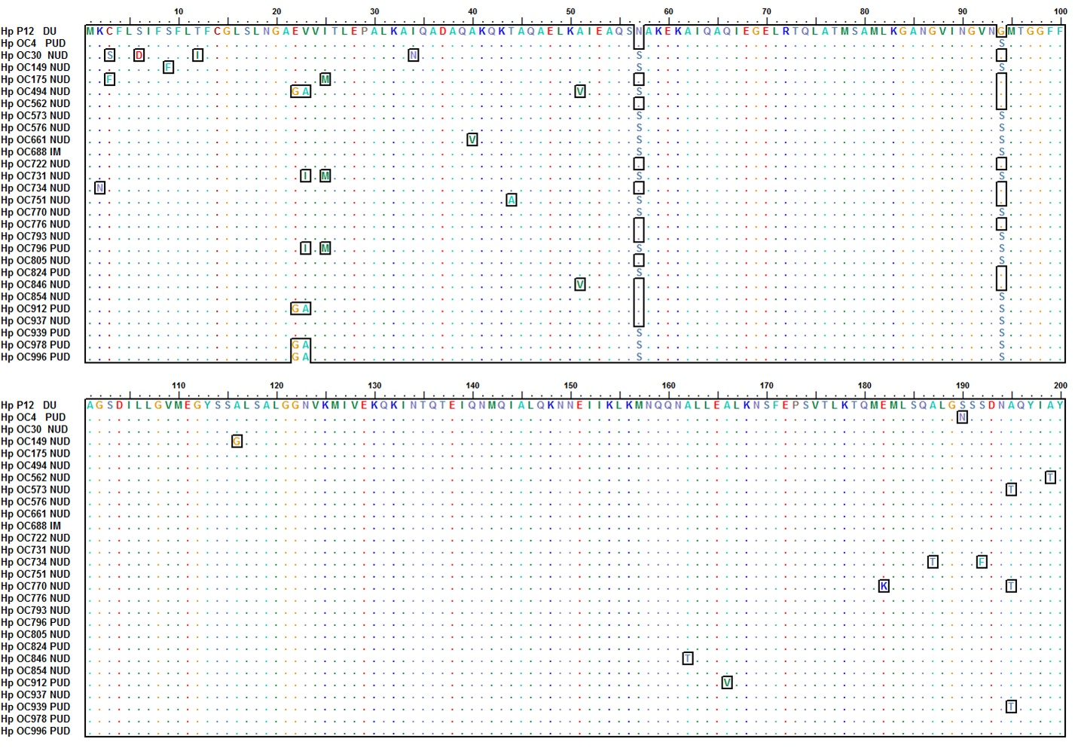
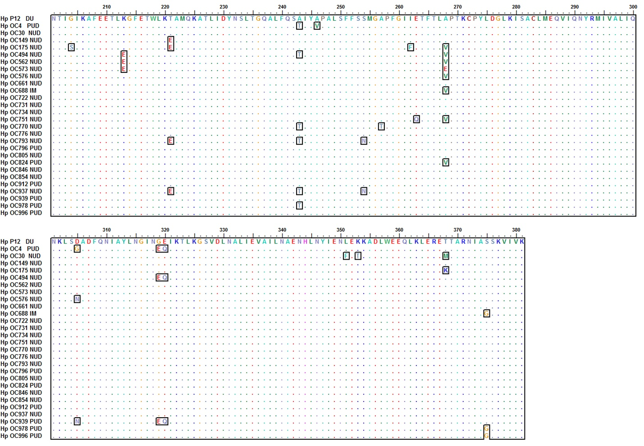
Figure S1. Complete alignment of CagI sequences among H. pylori strains (n=27) from patients with different clinical status. The amino acid sequences were compared with the CagI sequences of H. pylori strain P12 (is shown on the top line), as a reference strain. The variable and infrequent amino acid residues are surrounded by black borders. Notably, the C-terminal hexapeptide motif consisting of the SKVIVK sequence were highly conserved among the strains.

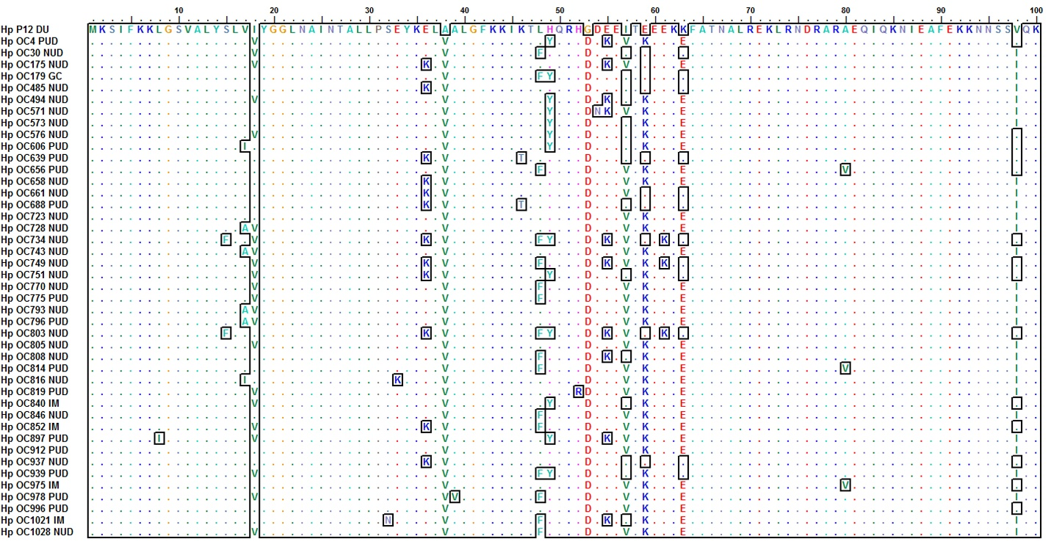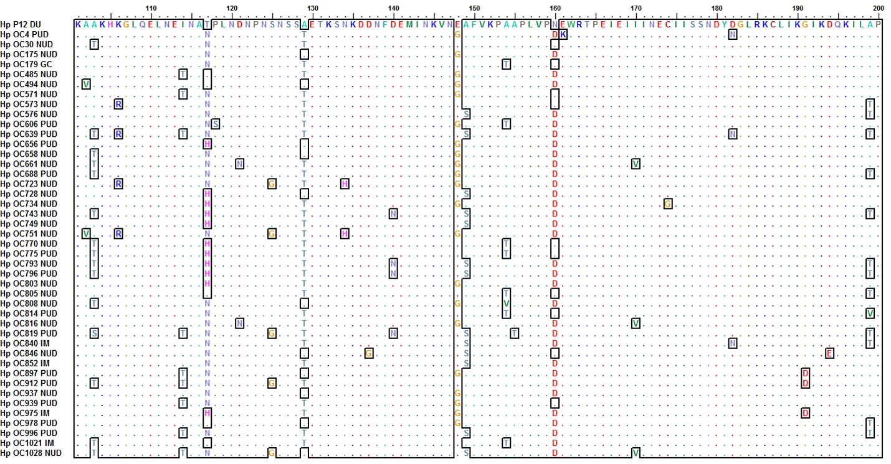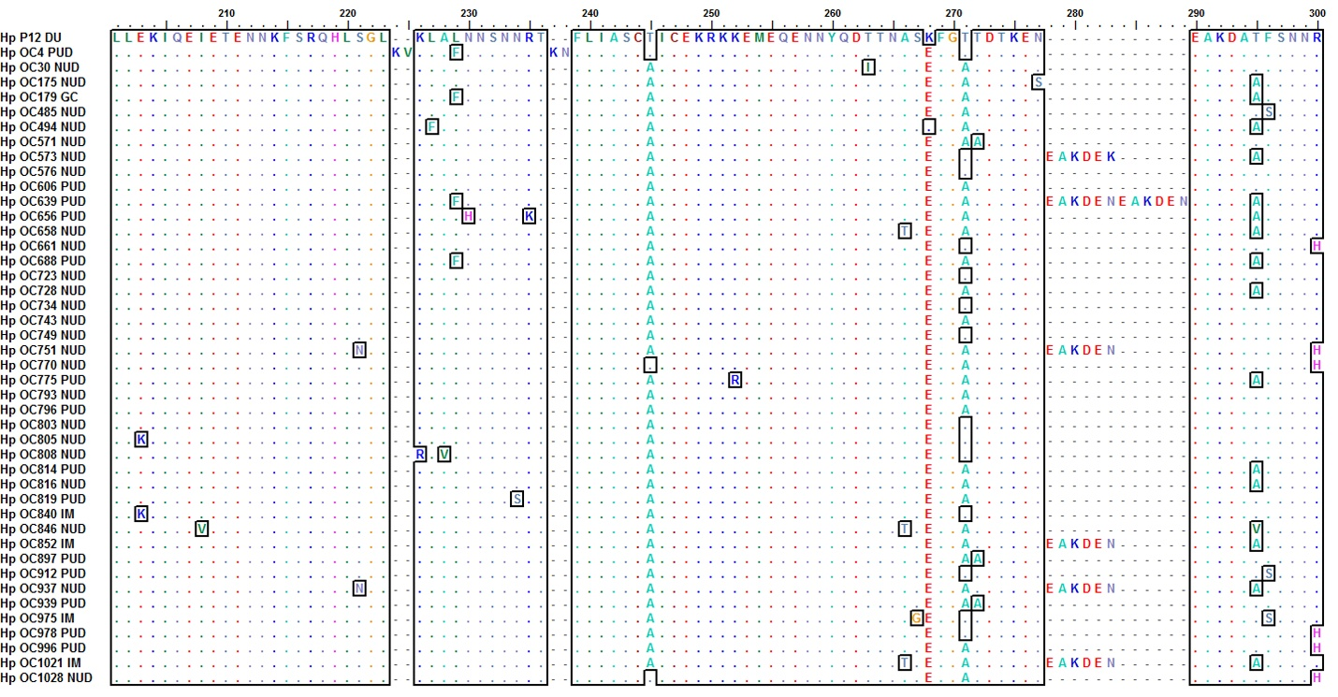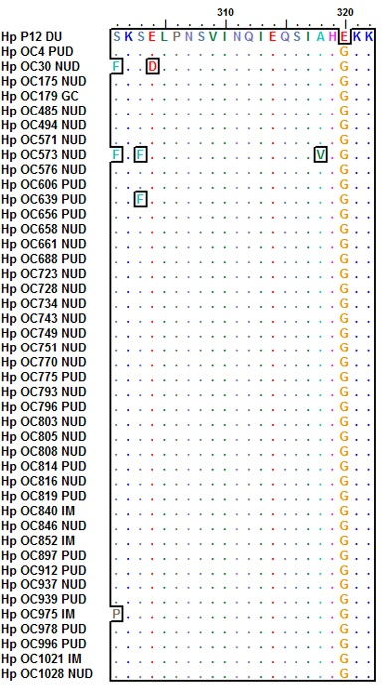
CagNHM
Hexapeptide motif
Figure S2. Complete alignment of CagN sequences among 43 H. pylori strains from patients with different clinical status. The amino acid sequences were compared with the CagN sequences of H. pylori strain P12 (is shown on the top line), as a reference strain. The variable and infrequent amino acid residues are surrounded by black borders. Notably, the CagN hypervariable motif (CagNHM) and the hypothetical hexapeptide motif (EAKDEN/K) are indicated at residues 53-63 and 278-283, respectively.

