Supplement 2

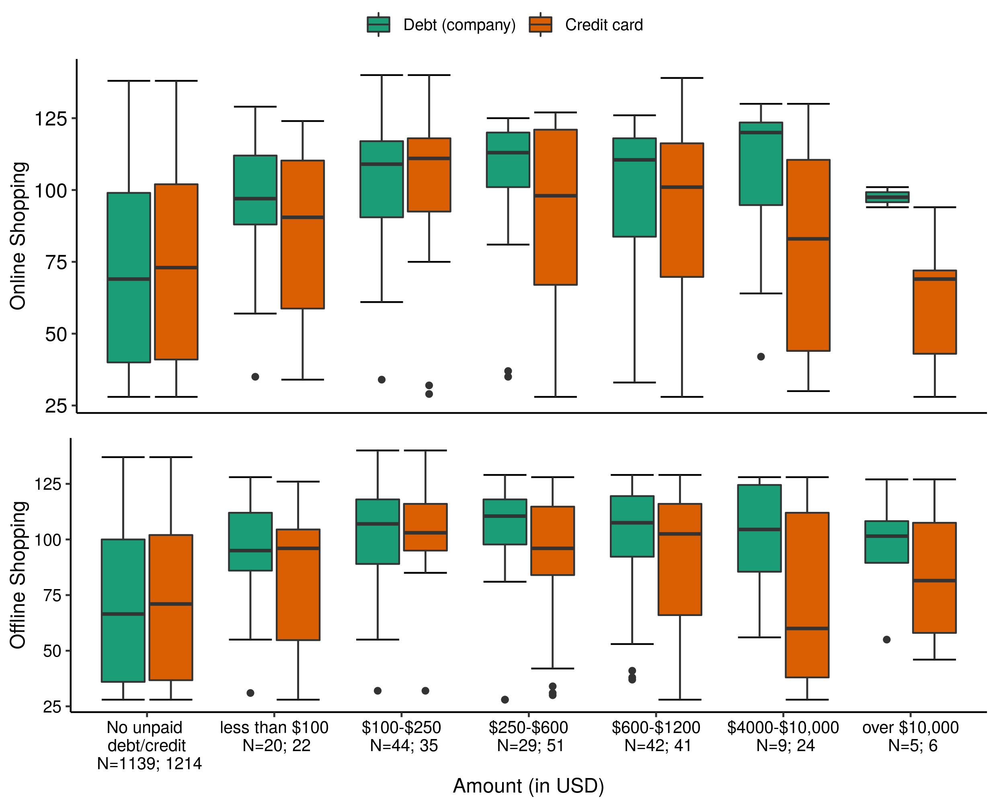
Shopping-related credit card balance and debts.
Note: Company debt refers to the unpaid balance the participant owes the company, and credit card debt refers to the amount of unpaid balance on the credit card. “N” refers to the number of datapoints regarding company dept and credit card debt respectively. Lower and upper hinges of the boxplot correspond to the first and third quartiles (the 25th and 75th percentiles) of the data. Data beyond the end of the whiskers are outliers. Statistics do not confirm the relationship between online/offline compulsive buying and debt/credit card balance, but those with debt / unpaid credit balance report higher tendencies of online / offline compulsive buying (see text)

