Supplementary Information

Manifold Dynamic Non-Covalent Interactions for Steering Molecular Assembly and Cyclization

Shaotang Song^{1,7}, Lulu Wang^{1,7}, Jie Su^{1,7}, Zhen Xu², Chia-Hsiu Hsu^{3,4}, Chenqiang Hua⁵, Pin Lyu¹, Jing Li¹, Xinnan Peng¹, Takahiro Kojima², Shunpei Nobusue², Mykola Telychko¹, Yi Zheng⁵, Feng-Chuan Chuang^{3,4}, Hiroshi Sakaguchi*², Ming Wah Wong*¹, Jiong Lu*^{1,6}.

¹Department of Chemistry, National University of Singapore, 3 Science Drive 3, Singapore 117543
²Institute of Advanced Energy, Kyoto University, Uji, Kyoto 611-0011, Japan
³Department of Physics, National Sun Yat-sen University, Kaohsiung 80424, Taiwan
⁴Physics Division, National Center for Theoretical Sciences, Taipei, 10617, Taiwan
⁵Zhejiang Province Key Laboratory of Quantum Technology and Device, Department of
Physics, Zhejiang University, Hangzhou, People’s Republic of China
⁶Centre for Advanced 2D Materials (CA2DM), National University of Singapore, 6 Science Drive 2, Singapore 117546, Singapore
⁷Authors with equal contribution
Corresponding Author: Hiroshi Sakaguchi (sakaguchi.hiroshi.7z@kyoto-u.ac.jp), Ming Wah Wong (chmwmw@nus.edu.sg), Jiong Lu (chmluj@nus.edu.sg).

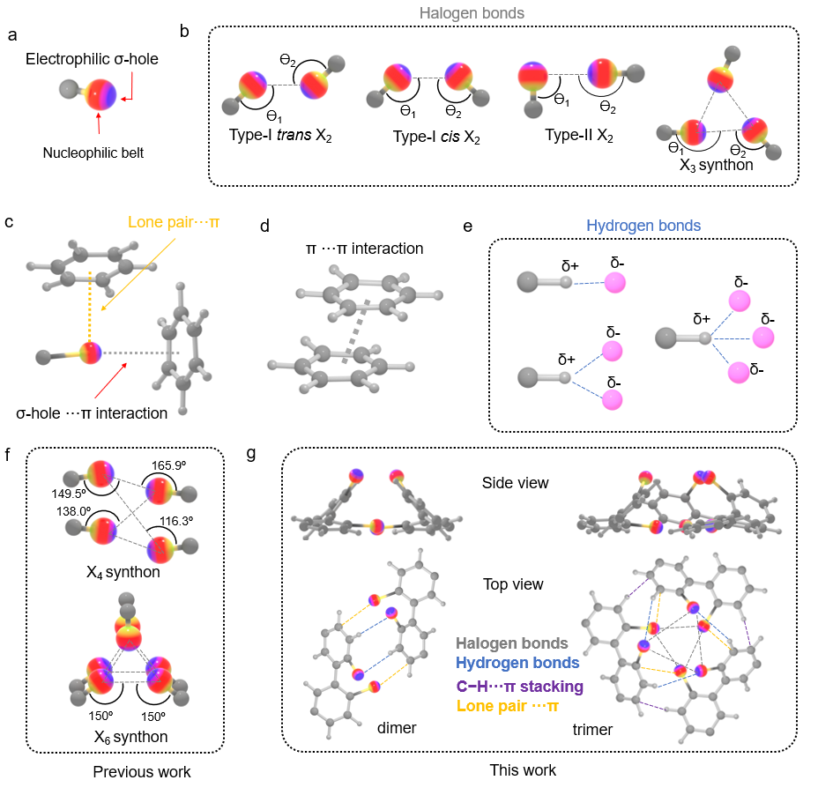 Figure S1. Schematic illustration of a variety of noncovalent interactions. (a) Anisotropic electron density distribution of a typical halogen atom represented by electron rich nucleophilic belt and electron deficient electrophilic σ-hole. Red and blue color denote the negative and positive value of the electrostatic potential on the halogen atom. (b) Halogen bonds including trans- and cis-configuration of type-I, Type-II X₂ and X₃ synthon halogen-halogen contacts (X denotes halogen atoms, e.g. I, Br, and Cl. Ɵ₁ ≈ Ɵ₂ for type-I; Ɵ₁ ≈ 180º for type-II Ɵ₂ ≈ 90º; Ɵ₁ ≈ 180º, Ɵ₂ ≈ 90º for X₃ synthon. (c) Lone pair···π and σ-hole···π interactions. (d) π···π interaction. (e) Single, bifurcated, and trifurcated hydrogen bonds. (f) Previously reported X₄ and X₆ synthons within close-packed single crystals.¹ (g) The complex interactions including halogen bonds, hydrogen bonds, π-π stacking, and lone pair-π stacking presented in this work within dimer and trimer clusters on Au(111). The angles are labelled in Figure S4 and Figure S5.
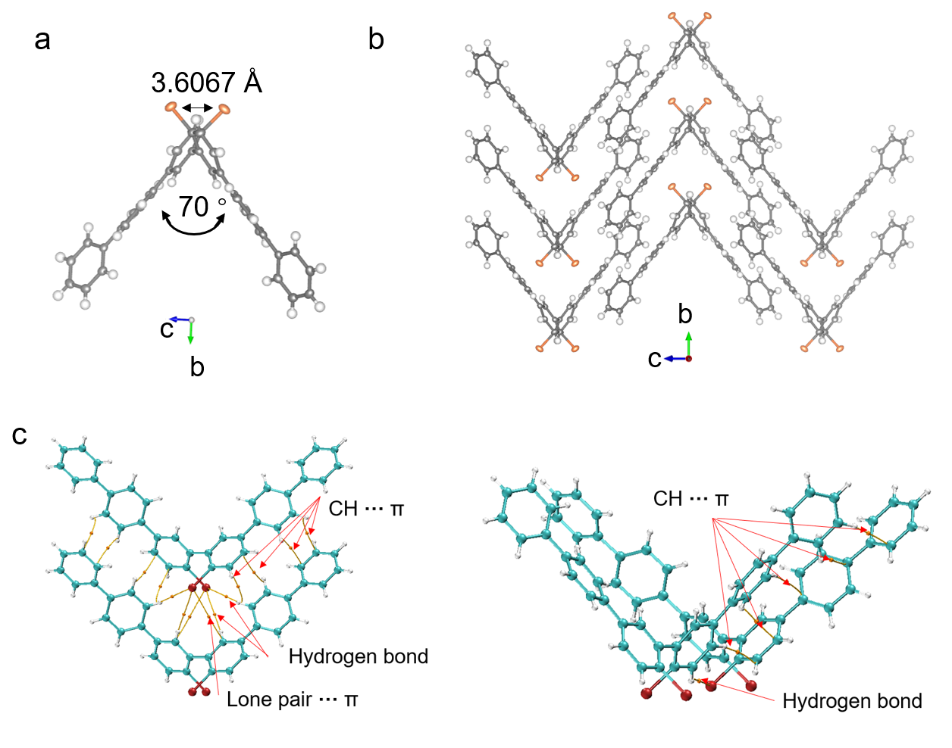
Figure S2. (a) Atomic structure of precursor 1 determined via Single crystal X-ray diffraction (b) Crystalline packing of precursor 1 (c) AIM analysis of the noncovalent interactions of precursor 1 in the solid-state bulk single crystals.

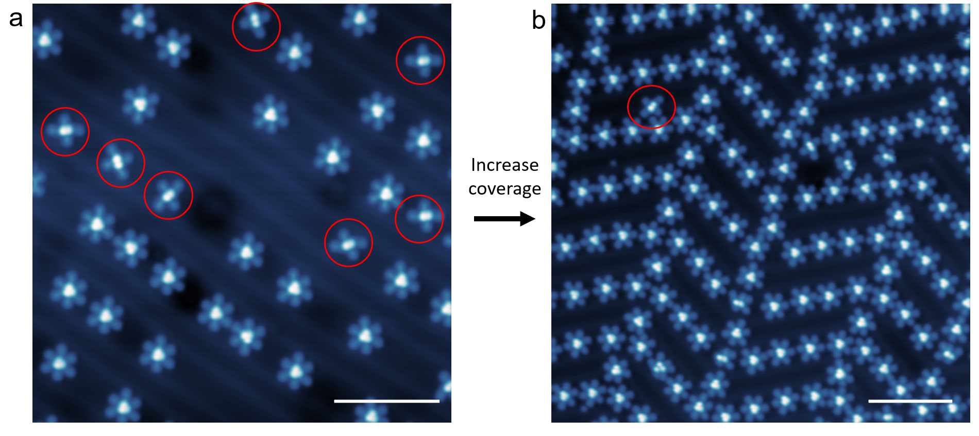
Figure S3. Large-scale STM images of molecular clusters at different coverages. Increasing the coverage from ~0.1 ML (a) to ~0.3 ML (b) leads to the transformation of the dimer to trimer clusters. The dimer cluster (highlighted by red circle) ratio dramatically decreases from ~20% to < 1%. Scale bars in (a) and (b) are 10 nm.

Table S1. Calculated electron density of bond critical point (BCP) for the intermolecular interaction in the dimer cluster in wb97xd 6-31+G**level of theory.

Type | BCP | ρ (r), (a. u.) | Laplacian ρ (r), (a. u.)
Hydrogen Bond | a1 | 0.00880 | 0.02728
 | a2 | 0.00837 | 0.02582
lone pair ···π | b1 | 0.00588 | 0.01833
 | b2 | 0.00609 | 0.01955

Table S2. Calculated electron density of BCP for the intermolecular interaction in the trimer cluster in wb97xd 6-31+G**level of theory.

Type | BCP | ρ (r), (a. u.) | Laplacian ρ (r), (a. u.)
Halogen bond | a1 | 0.00812 | 0.02707
 | a2 | 0.00817 | 0.02725
 | a3 | 0.00828 | 0.02747
 | a4 | 0.00223 | 0.00543
 | a5 | 0.00258 | 0.00618
 | a6 | 0.00249 | 0.00599
Hydrogen Bond | b1 | 0.00264 | 0.00798
 | b2 | 0.00288 | 0.00873
 | b3 | 0.00276 | 0.00833
C-H···π | c1 | 0.00604 | 0.01954
 | c2 | 0.00556 | 0.01787
 | c3 | 0.00626 | 0.02032
lone pair ···π | d1 | 0.00843 | 0.02372
 | d2 | 0.00833 | 0.02338
 | d3 | 0.00778 | 0.02141

Table S3. Symmetry—adapted perturbation theory (SAPT) calculation show interaction energies of the dimer and trimer.

Interaction type | Dimer (kJ/mol) | Trimer (kJ/mol)
Electrostatics | -24.00 | -51.15
Exchange | 50.04 | 146.63
Induction | -6.70 | -13.88
Dispersion | -49.75 | -137.54
Total | -30.41 | -55.94

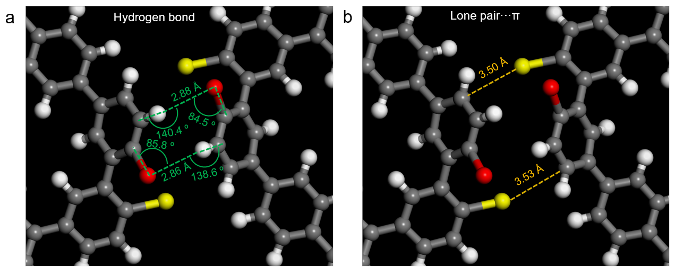
Figure S4. Noncovalent bond analysis including (a) hydrogen bond and (b) lone pair···π interactions of the dimer cluster.

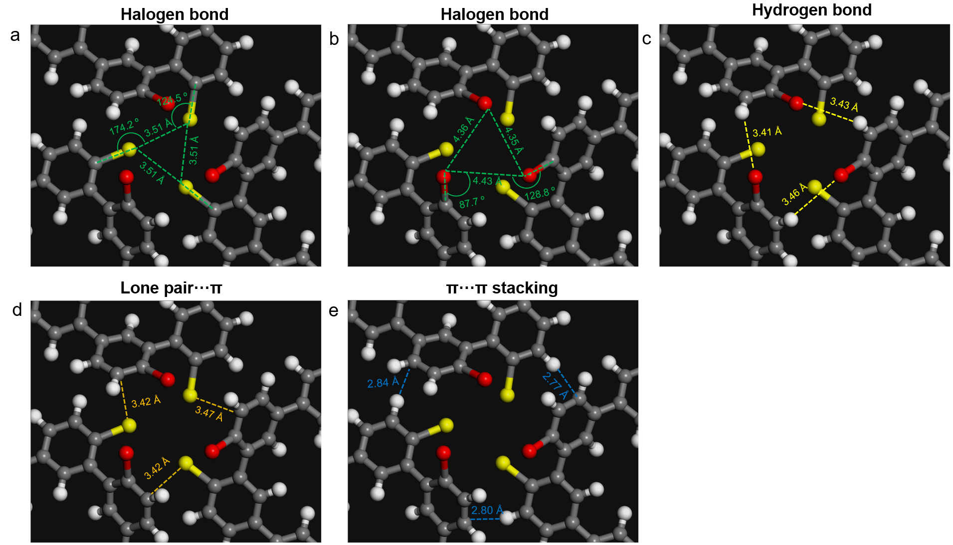
Figure S5. Noncovalent bond analysis including (a and b) halogen bond, (c) hydrogen bond, (d) lone pair···π, and (e) π···π interactions of the trimer cluster.

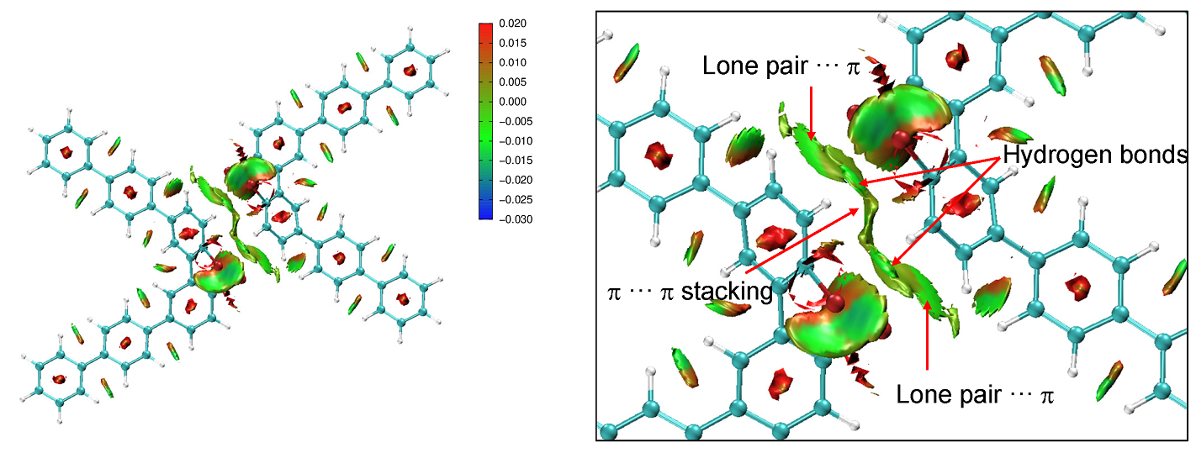
Figure S6. NCl plot of the dimer cluster shows the presence of noncovalent interactions including lone pair···π, π···π and C−H···Br as indicated by green discs.

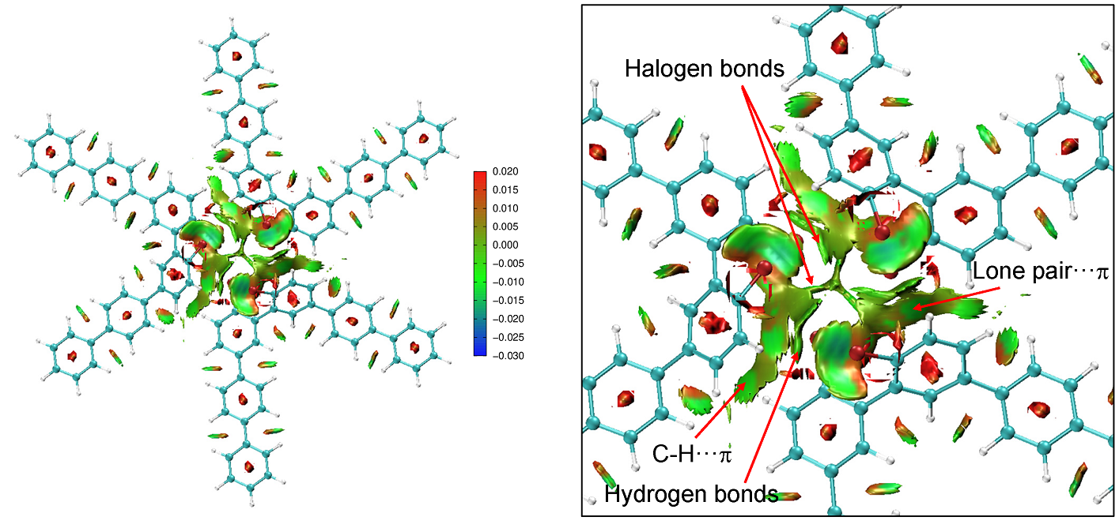

Figure S7. NCl plot of the trimer cluster shows the presence of noncovalent interactions including Br···Br, C−H···π, lone pair···π, C−H···Br, and π···π as indicated by green discs.

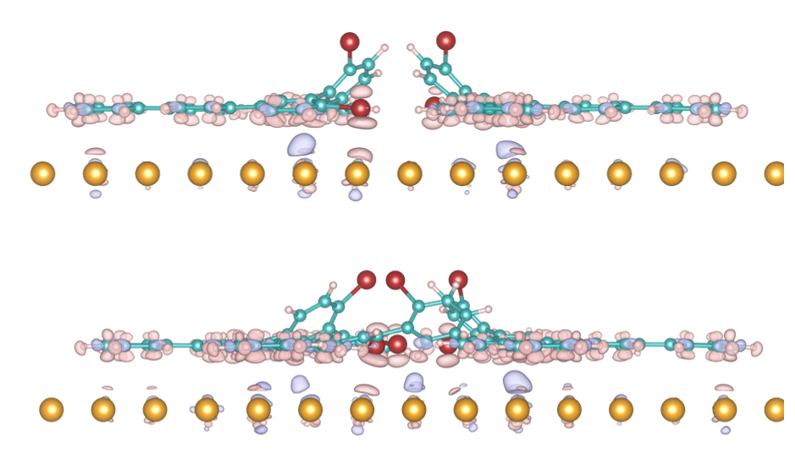
Figure S8. Electron density difference calculations (isosurface value of 0.001 e/Å³) of the dimer (upper panel) and trimer (lower panel) clusters on Au(111) substrate. The depletion and accumulation of negative charge is denoted by pink and purple color, respectively. It shows a negligible charge transfer between molecule and substrate, indicating a rather limited influence of the substrate to the noncovalent interactions of the dimer (upper panel) and trimer (lower panel) clusters. Note, a large size of molecular clusters introduces a large unit cell size so that the use of a monolayer Au atoms makes the DFT calculation more feasible.

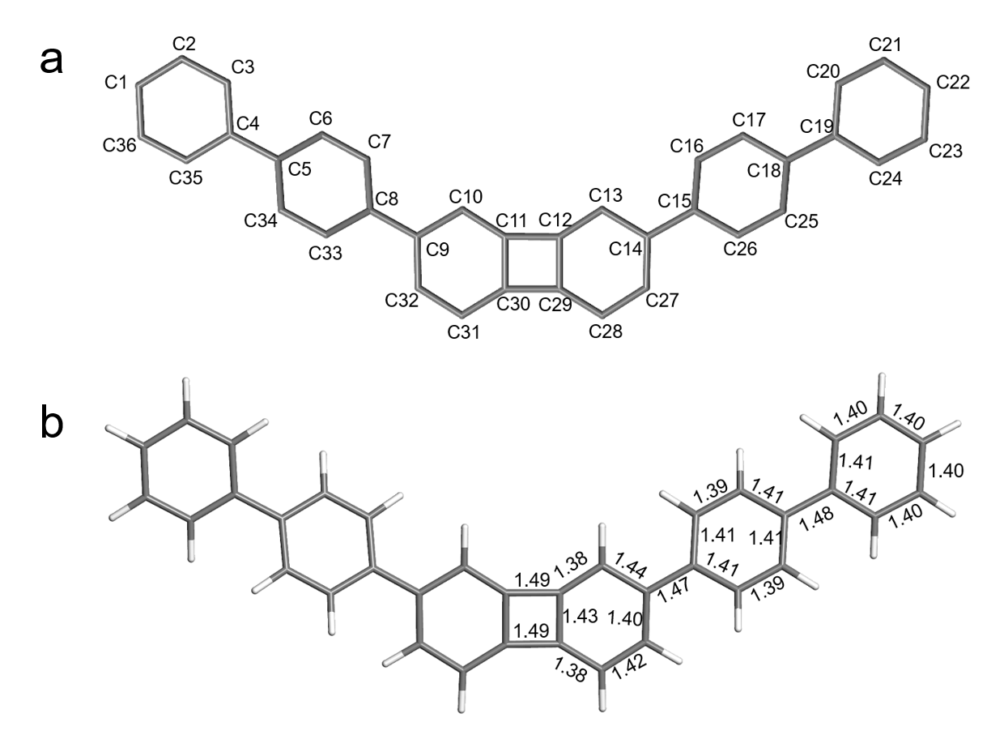
Figure S9. Schematic drawing of product 2 with labeled carbon number (a) and calculated C-C bond length (b) on Au(111).

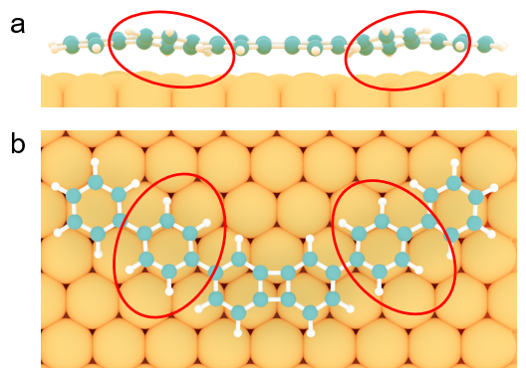
Figure S10. Adsorption geometry of product 2 on Au(111). Side view (a) and top view (b). The benzene rings (red-circle-highlighted) are slightly tilted due to steric hindrance from its neighboring rings, which is also reflected in the ncAFM experimental results (Figure S11).

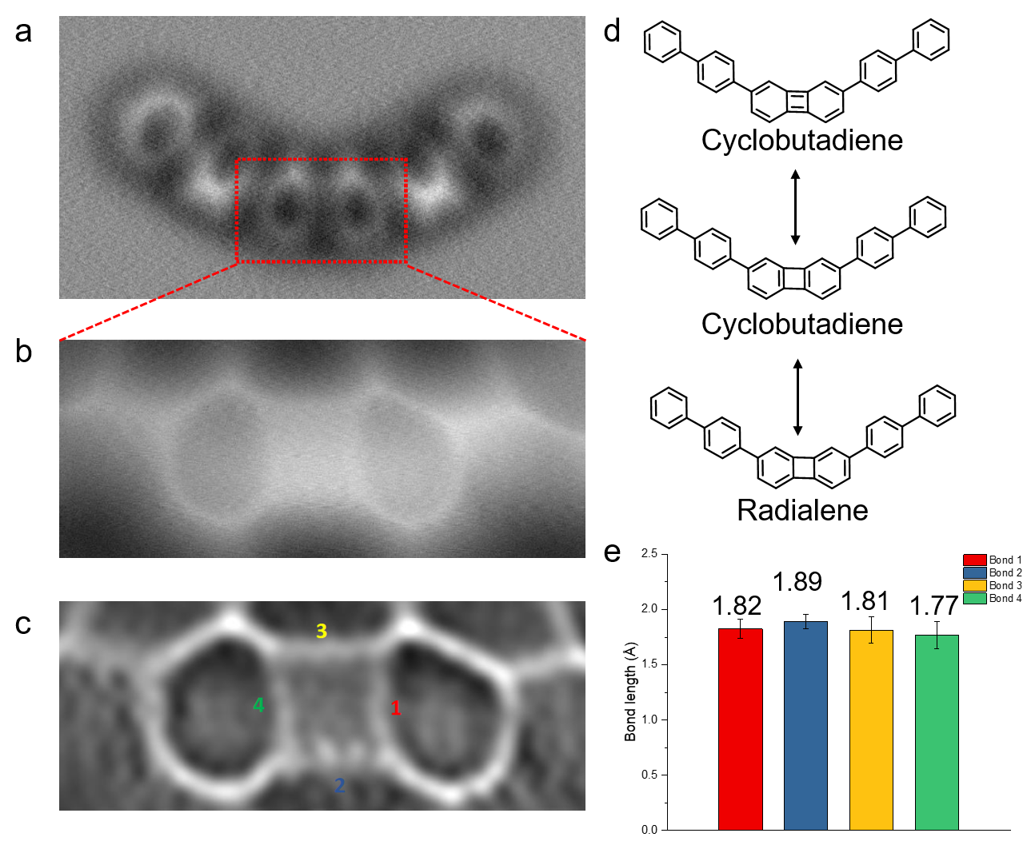
Figure S11. (a) nc-AFM image of product 2. (b) Magnified nc-AFM image and (c) the corresponding Laplace filtered nc-AFM image of the central part of 2. (d) Resonance structures of product 2 including the cyclobutadiene form and radialene form, respectively. (e) Four-membered ring shows a nearly identical length of the four C-C bonds as revealed in the bond-order analysis plot, which indicates the radialene form of product 2.

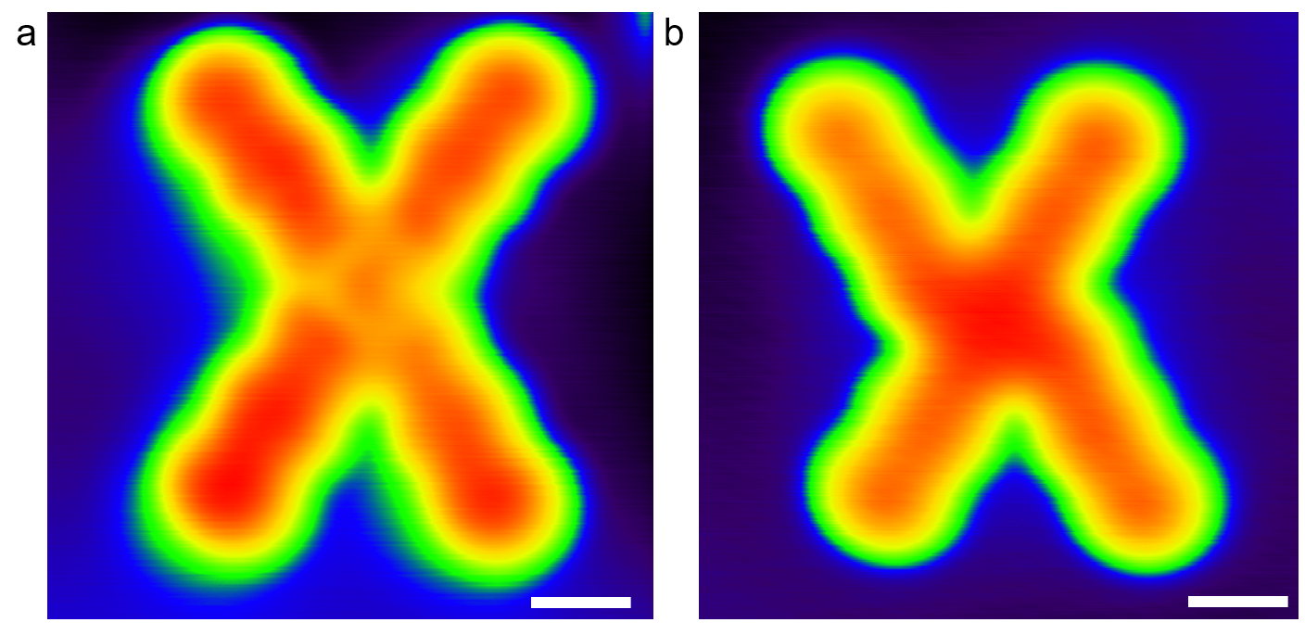
Figure S12. Constant current STM images of product 3 (a) and product 4 (b). The dim dot in the center of product 3 represents a Au adatom. In contrast, the planar motif in product 4 is a dibenzo[e,l]pyrene core. Scale bars are 0.5 nm.

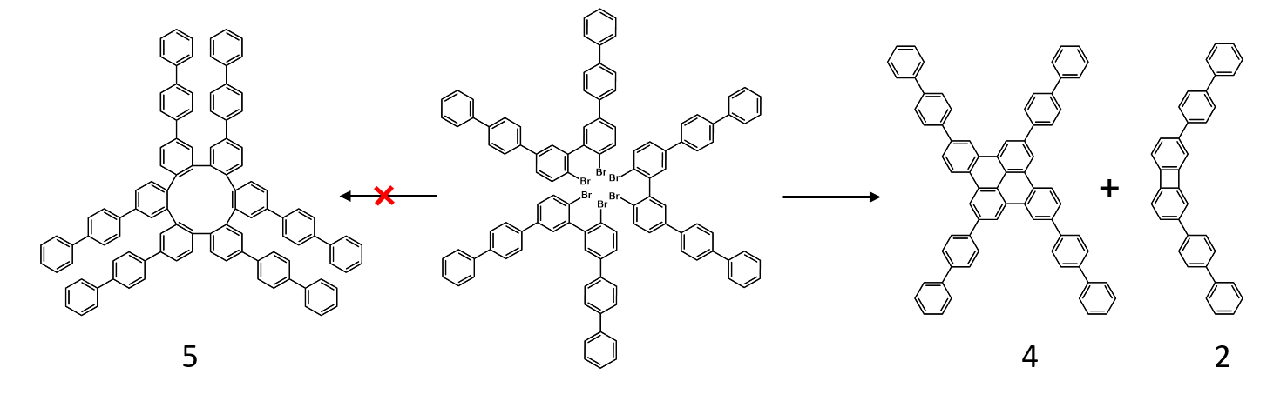
Figure S13. The proposed on-surface reaction pathways for the transformation of the trimer cluster into the product 2 and 4. Note the formation of 5 is prohibited, presumably due to a high steric hindrance.

Synthesis
All chemical reactions were performed under nitrogen using standard Schlenk techniques. NMR spectra were recorded on JEOL JNM-ECA600 (600 MHz for ¹H, 151 MHz for ¹³C) instruments. NMR spectra were reported in parts per million using tetramethylsilane (δ 0.00 ppm for chloroform-d) or residual solvent (δ 7.26 ppm for chloroform-d) as the internal standard for ¹H NMR, and from the solvent carbon (δ 77.00 ppm for chloroform-d) for ¹³C NMR. Thin-layer chromatography (TLC) and column chromatography were performed on Art. 5554 (Merck KGaA) and silica gel 60N (Kanto Chemical Co.), respectively. Gel permeation chromatography (GPC) was performed on an LC-9210NEXT or LC-9201 system (Japan Analytical Industry) with JAIGEL 1H and 2H polystyrene columns (eluent: CHCl₃, flow: 3.5 mL/min).

2,2'-dibromo-5,5'-diiodo-1,1'-biphenyl was prepared according to the literature². The other commercially available reagents were purchased from TCI, Wako, Sigma-Aldrich and used as received, unless otherwise noted.

Scheme S2. The synthetic route of precursor 1.

2,2'-dibromo-5,5'-diiodo-1,1'-biphenyl (100 mg, 0.18 mmol, 1equiv), [1,1′-biphenyl]-4-ylboronic acid (126.74 mg, 0.64 mmol, 4equiv) and KOH (80.80 mg, 1.44 mmol, 8equiv) were added to a mixture of nitrobenzene (10 mL) and water (5 mL). Pd(PPh₃)₄ (20.8 mg, 0.018mmol, 0.1 equiv) was added after the suspension was degassed by Freeze-Pump-Thaw method for three times. The mixture was heated to 60℃ for 6h under N₂. The mixture was diluted with 10 mL DCM and the organic layer was collected, washed with brine and then evaporated under vacuum. As-obtained white solid was passed through a short silica gel pad, further purified by GPC and recrystallized using hexane. The product was obtained in 25 mg (23% yield). ¹H NMR (600 MHz,) δ 7.78 (dd, J = 8.5, 3.0 Hz, 2H), 7.72 – 7.66 (m, 8H), 7.65 – 7.60 (m, 6H), 7.57 (dd, J = 8.4, 2.6 Hz, 2H), 7.46 (t, J = 7.7 Hz, 4H), 7.37 (t, J = 7.4 Hz, 2H). ¹³C NMR (151 MHz, Chloroform-d) δ 142.09, 140.48, 140.28, 139.61, 138.26, 132.87, 129.40, 128.63, 127.66, 127.44, 127.28, 127.15, 126.84, 122.34.

Single crystal X-ray diffraction data
Single crystals of precursor 1 suitable for crystallographic analysis were obtained by vapour diffusion of methanol into chloroform solution of 1. The structures of 1 is shown in Figure S14 and the crystallographic data are summarized in Supporting Table 1.
Single crystals were measured at low temperature (T = 100 K) on a four circles goniometer Kappa geometry Bruker AXS D8 Venture equipped with a Photon 100 CMOS active pixel sensor detector using a Molybdenum monochromatized (λ = 0.71073 Å) X-ray radiation. Molecules were solved with Olex2¹ with XT² structure solution program using intrinsic phasing. Refinement of structures were performed with XL³ refinement package using least squares minimization. CIF files (CCDC-2040518 and 2040519) can be obtained from the Cambridge Crystallographic Data Centre.
Table S4. Crystal data and structure refinement for precursor 1.

Identification code K546
Empirical formula C36 H24 Br2
Formula weight 616.37
Temperature 100(2) K
Wavelength 0.71073 Å
Crystal system Monoclinic
Space group P2/n
Unit cell dimensions a = 18.1145(13) Å a= 90°.
b = 6.8754(5) Å b= 112.806(2)°.
c = 23.0990(17) Å g = 90°.
Volume 2651.9(3) Å3
Z 4
Density (calculated) 1.544 Mg/m3
Absorption coefficient 3.081 mm-1
F(000) 1240
Crystal size 0.488 x 0.096 x 0.087 mm3
Theta range for data collection 2.963 to 28.279°.
Index ranges -22<=h<=24, -9<=k<=9, -30<=l<=30
Reflections collected 86535
Independent reflections 6571 [R(int) = 0.0900]
Completeness to theta = 25.242° 99.8 %
Absorption correction Semi-empirical from equivalents
Max. and min. transmission 0.7459 and 0.6053
Refinement method Full-matrix least-squares on F2
Data / restraints / parameters 6571 / 0 / 343
Goodness-of-fit on F2 1.029
Final R indices [I>2sigma(I)] R1 = 0.0384, wR2 = 0.0820
R indices (all data) R1 = 0.0623, wR2 = 0.0929
Extinction coefficient n/a
Largest diff. peak and hole 0.432 and -0.759 e.Å-3

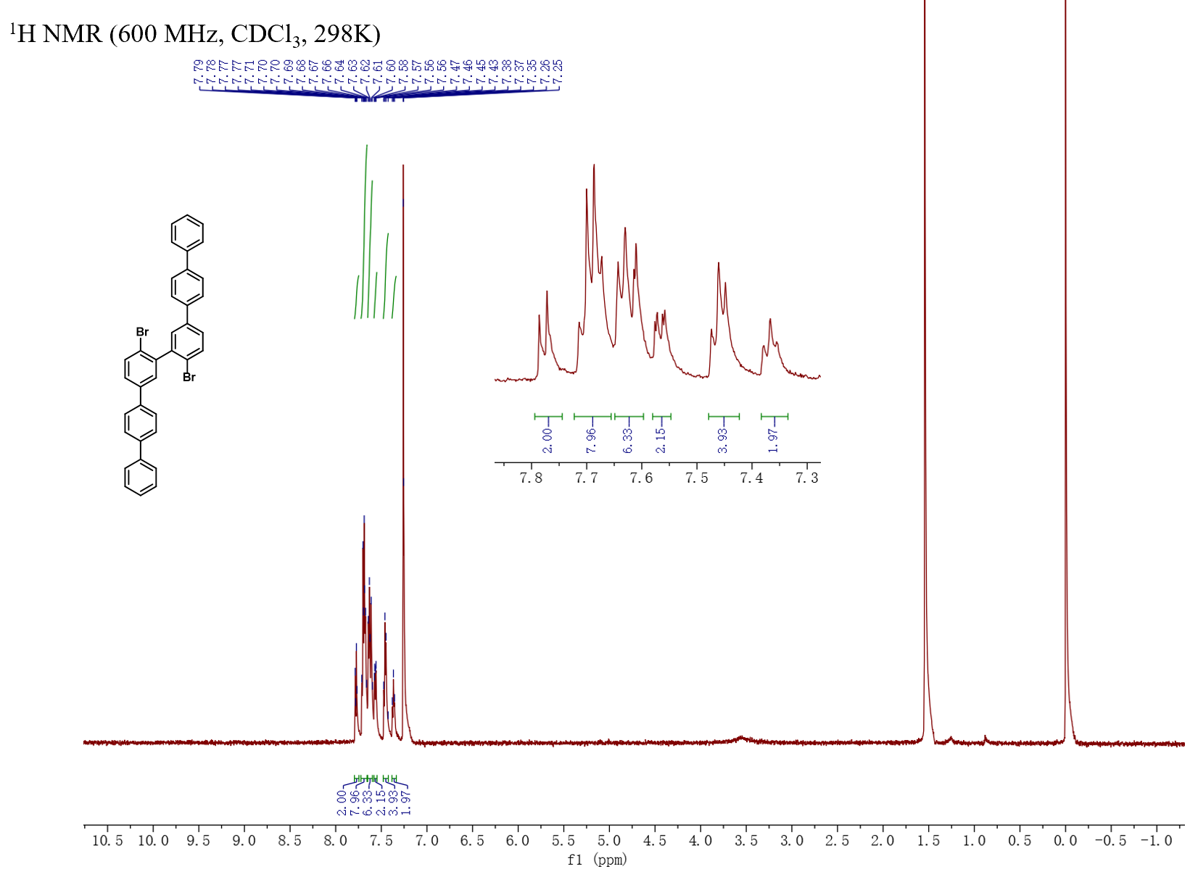

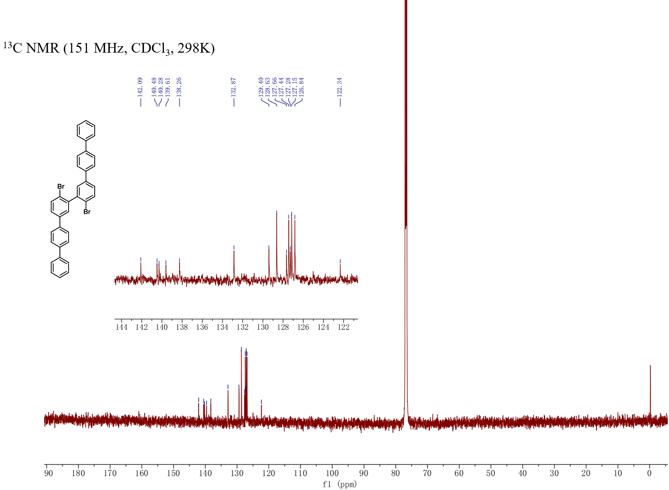

References

1. M. A. Niyas, R. Ramakrishnan, V. Vijay, E. Sebastian, and M. Hariharan, J. Am. Chem. Soc. 2019, 141, 4536–4540.
2. Chan, K. L. Scott E. Watkins, Chris S. K. Mak, Mary J. McKiernan, Carl R. Towns
Sofia I. Pascua and Andrew B. Holmes, Chem. Commun. 5766-5768 (2005).

