Supplementary material–Report on image processing
Acquisition and reconstruction | Acquisition parameters Siemens Biograph mCT 64  PET CT  ¹⁸F-FDG activity (MBq)* 350-550 (3.70-7.77MBq/kg) –  Min/bed position 2.5 –  Crystal LSO –  Reconstruction OSEM + PSF + TOF –  Matrix (pixels) 200×200 512×512  Resolution (mm) 4.0 0.7  Slice thickness (mm) 3mm 3mm  Slices – 64  Voltage (kV) – 140  Tube current (mA) – 64  Reconstruction Gaussian filtering with a full-width at half maximum of 2.0mm; 2 iterations and 21 subsets B70f very sharp  *Administered activity was calculated according to the European Association of Nuclear Medicine (EANM) guidelines, version 1.0, and from February 2015, version 2.0
Approach | The images were analyzed as a volume (3D).
Process structure | Image acquisition -> reconstruction ->anonymization -> segmentation -> export -> data augmentation -> CNN training and validation
Software | 3D-Slicer 4.11.20200930 (www.slicer.com)  Python 3.8.5 (www.python.org)  Tensorflow-gpu 2.3.1 (Google, www.tensorflow.org)
Data availability | All the original patient DICOM files are stored in the institutional PACS. Anonymized DICOM files are stored on the Department's hard disk. The trained models are stored in the local server.
Data conversion
Procedure | None
Image post-acquisition processing
Procedure | None
Segmentation
ROI | The VOI included the primary tumor lesion. To consider the tumor edge pattern, the generated bounding box is dilated by 1 pixel (PET images) and 3.00mm (CT images).
Procedure | The VOIs were semi-automatically defined on PET images using a semi-automatic segmentation method developed by Beichel et al. [1] (3D-Slicer, PET-IndiC extension). VOIs on CT images were semi-automatically defined with NVIDIA AI-Assisted Annotation (3D-Slicer, Segment Editor module), using boundary point-based CT segmentation model of lung tumor.
Interpolation
Voxel dimensions | 4.07mm³ for PET images; 0.73mm³ for CT images
Image interpolation method | Nearest Neighbor
Image intensity rounding | Not applicable
ROI interpolation method | Not applicable
ROI partial volume | Not applicable
Re-segmentation
ROI mask criteria | None
Discretization
Discretization method | None
Feature calculation
Feature set | None
Feature parameters | None

Supplementary material–Propensity score parameter list
The variables used in calculating the propensity score | Age, gender, smoking history, fasting blood glucose, GGN number grouping
Propensity score algorithm | Logistic regression model
C-statistical | 0.6864
Matching method | Greed matching within specified caliper distances
Distance metric | 0.6
Matching ratio | 4:1
Use of replacement | With replacement
Matching sample size | No Y=0: 92 cases Total:115
 | No Y=1: 23 cases

Supplementary material–Training of the deep learning model
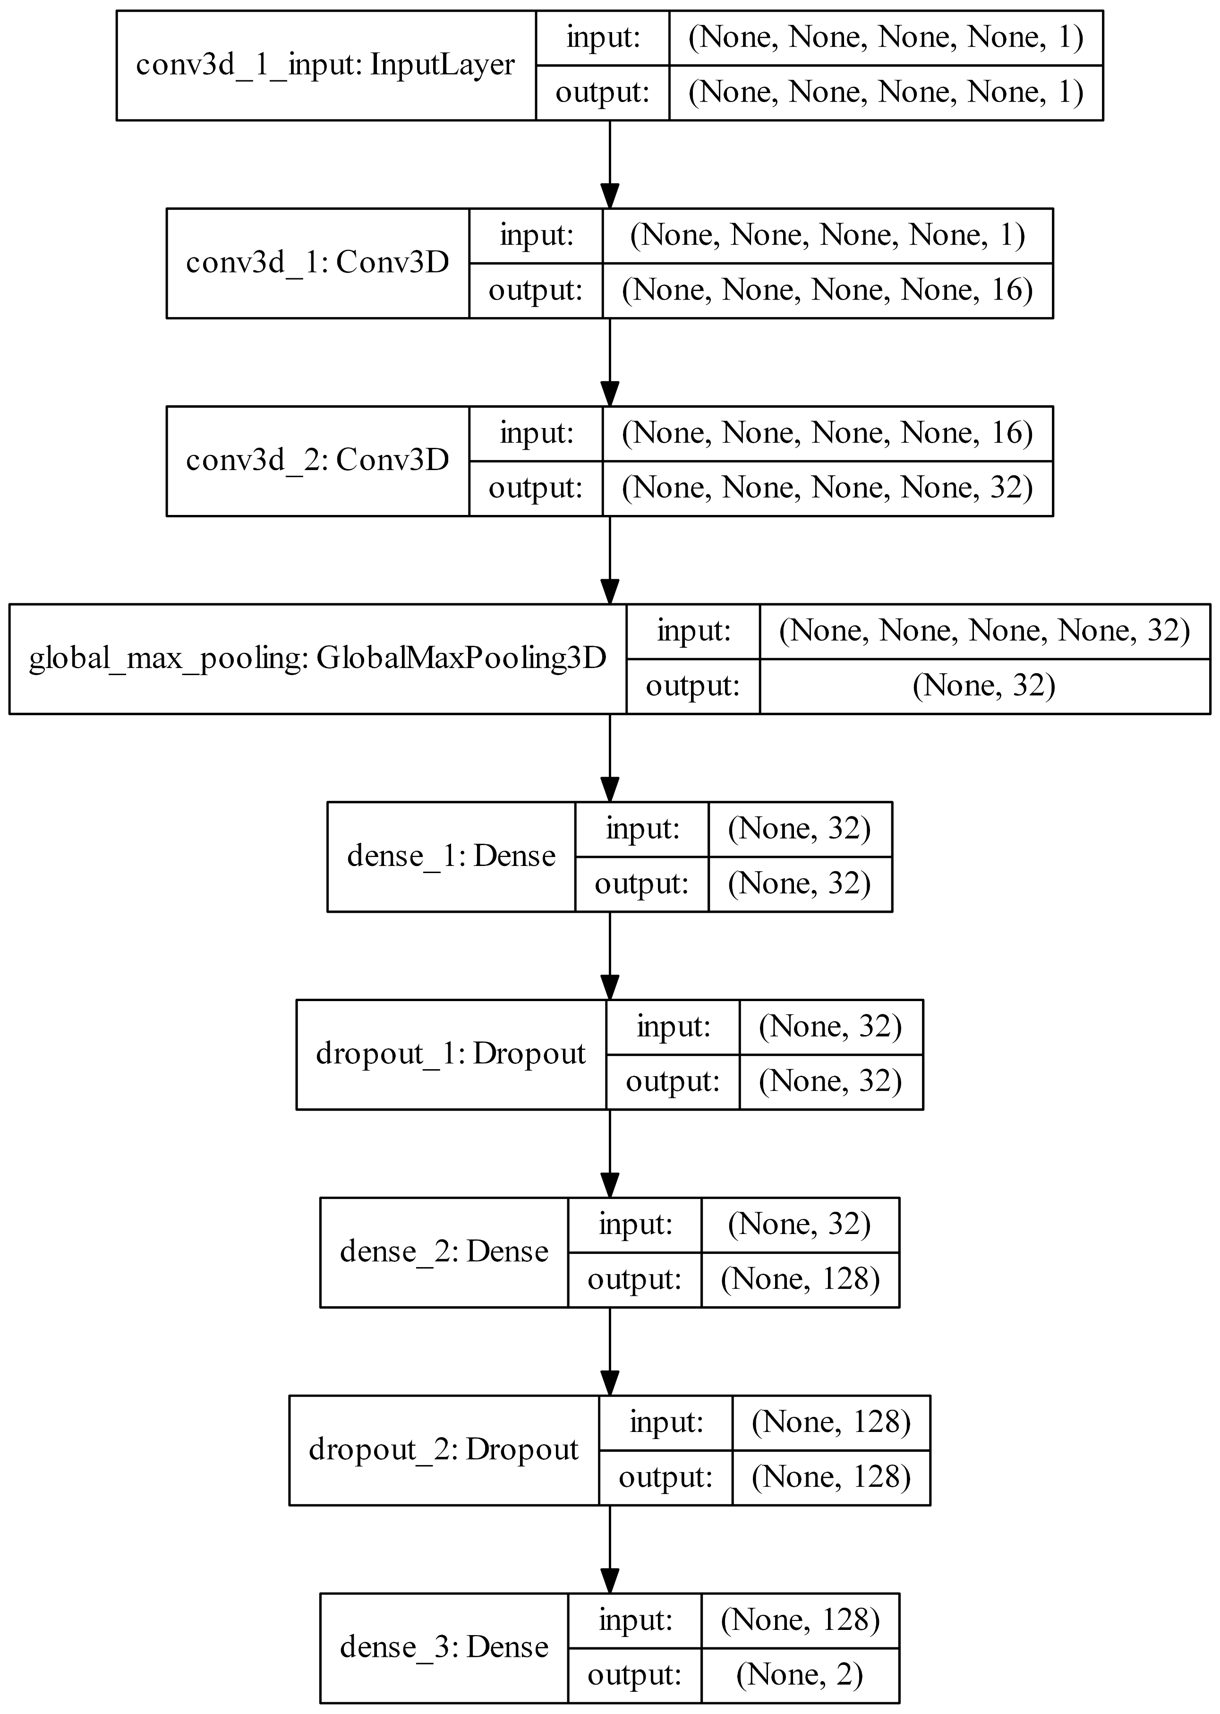
Figure S1. Tumor size adaptive PET 3D-CNN
More specifically, two 3D convolutional layers with 16 and 32 convolution kernels (5×5×5) are followed by the global max pooling layer [2]. The activation function of the two convolutional layers is tanh. Regardless of the input size, the global max pooling layer will generate a 32-dimensional feature vector. Besides, the fully connected layer produces a 128-dimensional feature vector. Implement a dropout of 0.5 after the fully connected layer to avoid overfitting [3]. The target output is whether GGN is benign or IAC. Here, we tried the optional global average pooling layer and found that the model's fitting effect became worse.
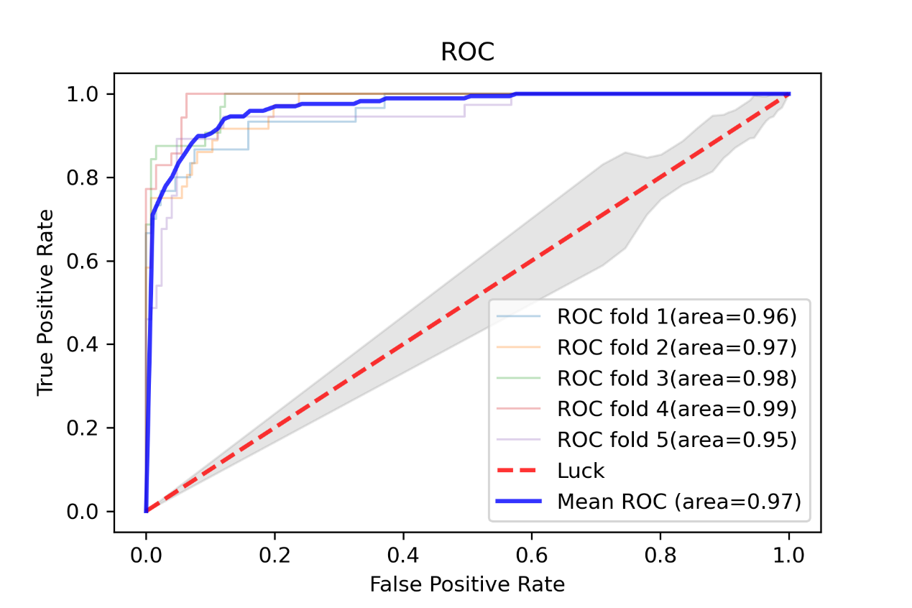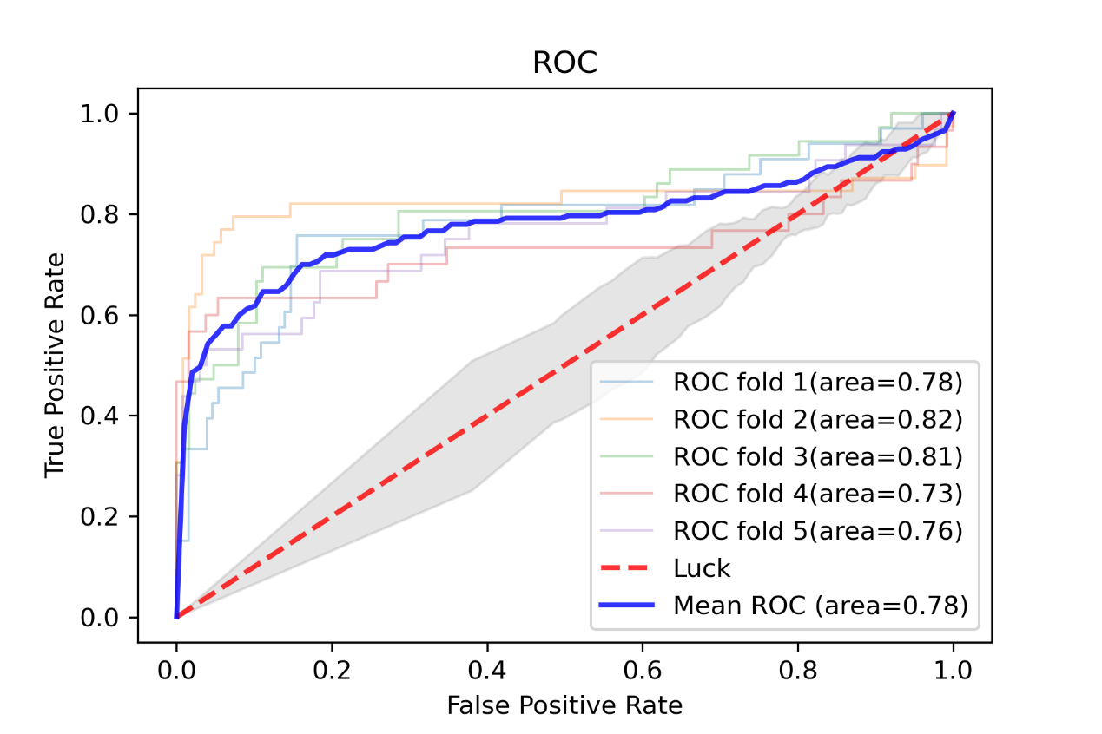
Figure S2. Comparison of the training effects of PET-CNN global max pooling and global average pooling

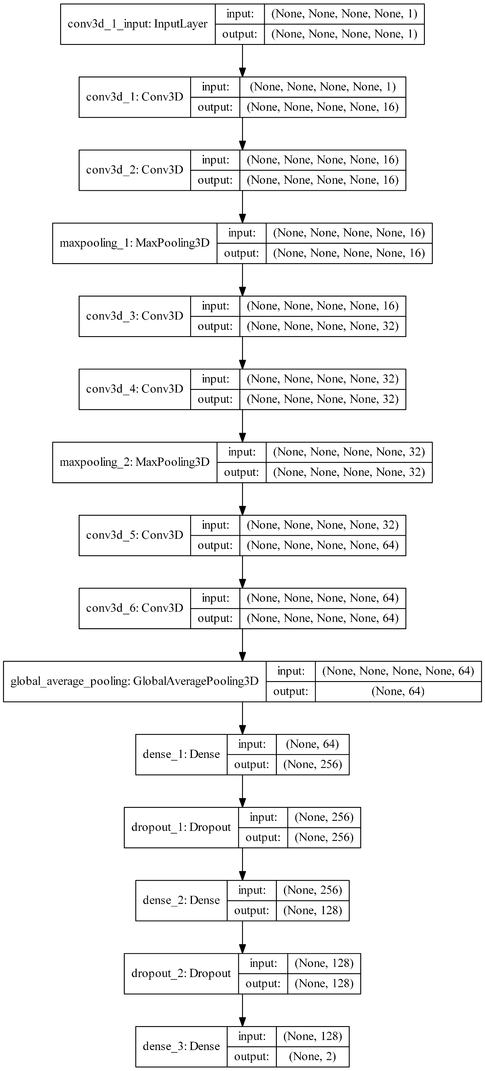
Figure S3. Tumor size adaptive CT 3D-CNN
Considering the smaller pixels and larger matrix of CT, we adopted a deeper CNN and a larger network. More specifically, two 3D convolutional layers with 16 convolution kernels (5×5×5) are followed by the maxpooling layer, followed by two 3D convolutional layers of 32 convolution kernels (5×5×5) and maxpooling layer, followed by two 3D convolutional layers of 64 convolution kernels (5×5×5) and global average pooling layer [4]. The activation function of the convolutional layer is tanh. Regardless of the input size, the global average pooling layer will generate a 64-dimensional feature vector. Besides, the fully connected layer produces a 128-dimensional feature vector. Implement a dropout of 0.5 after the fully connected layer to avoid overfitting [3]. The target output is whether GGN is benign or IAC. Here, we tried the optional global max pooling layer and found that the training process model does not converge.
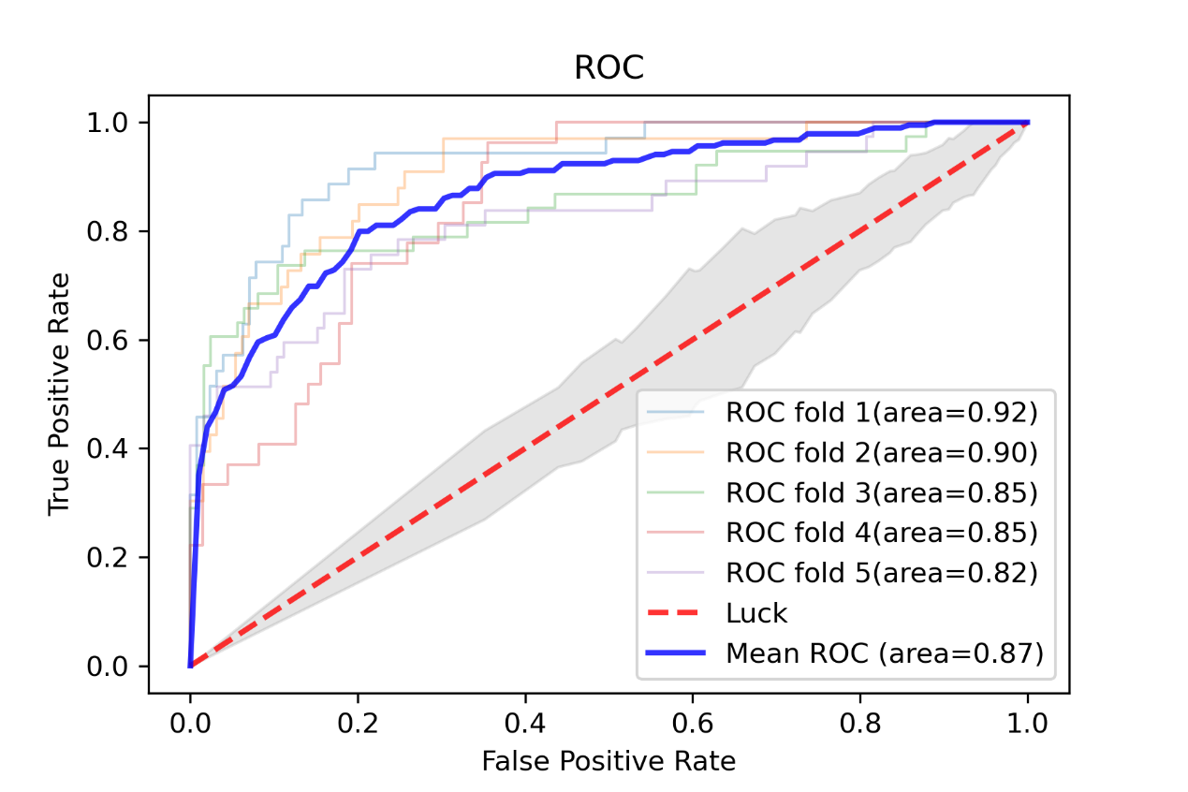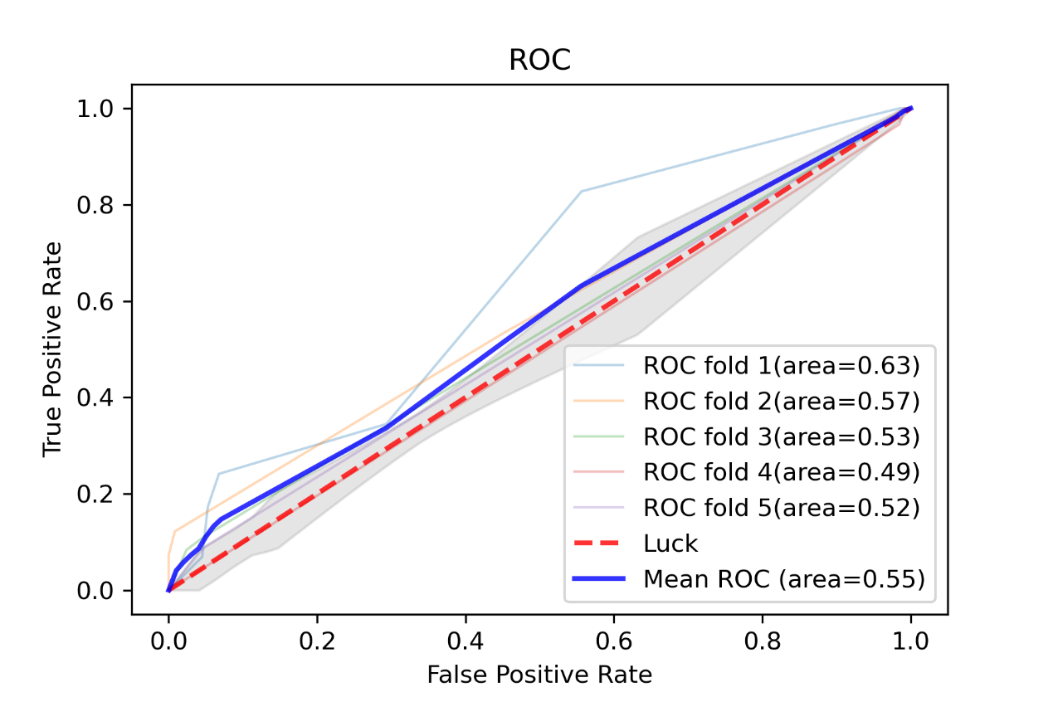
Figure S4. Comparison of the training effects of CT-CNN global average pooling and global max pooling

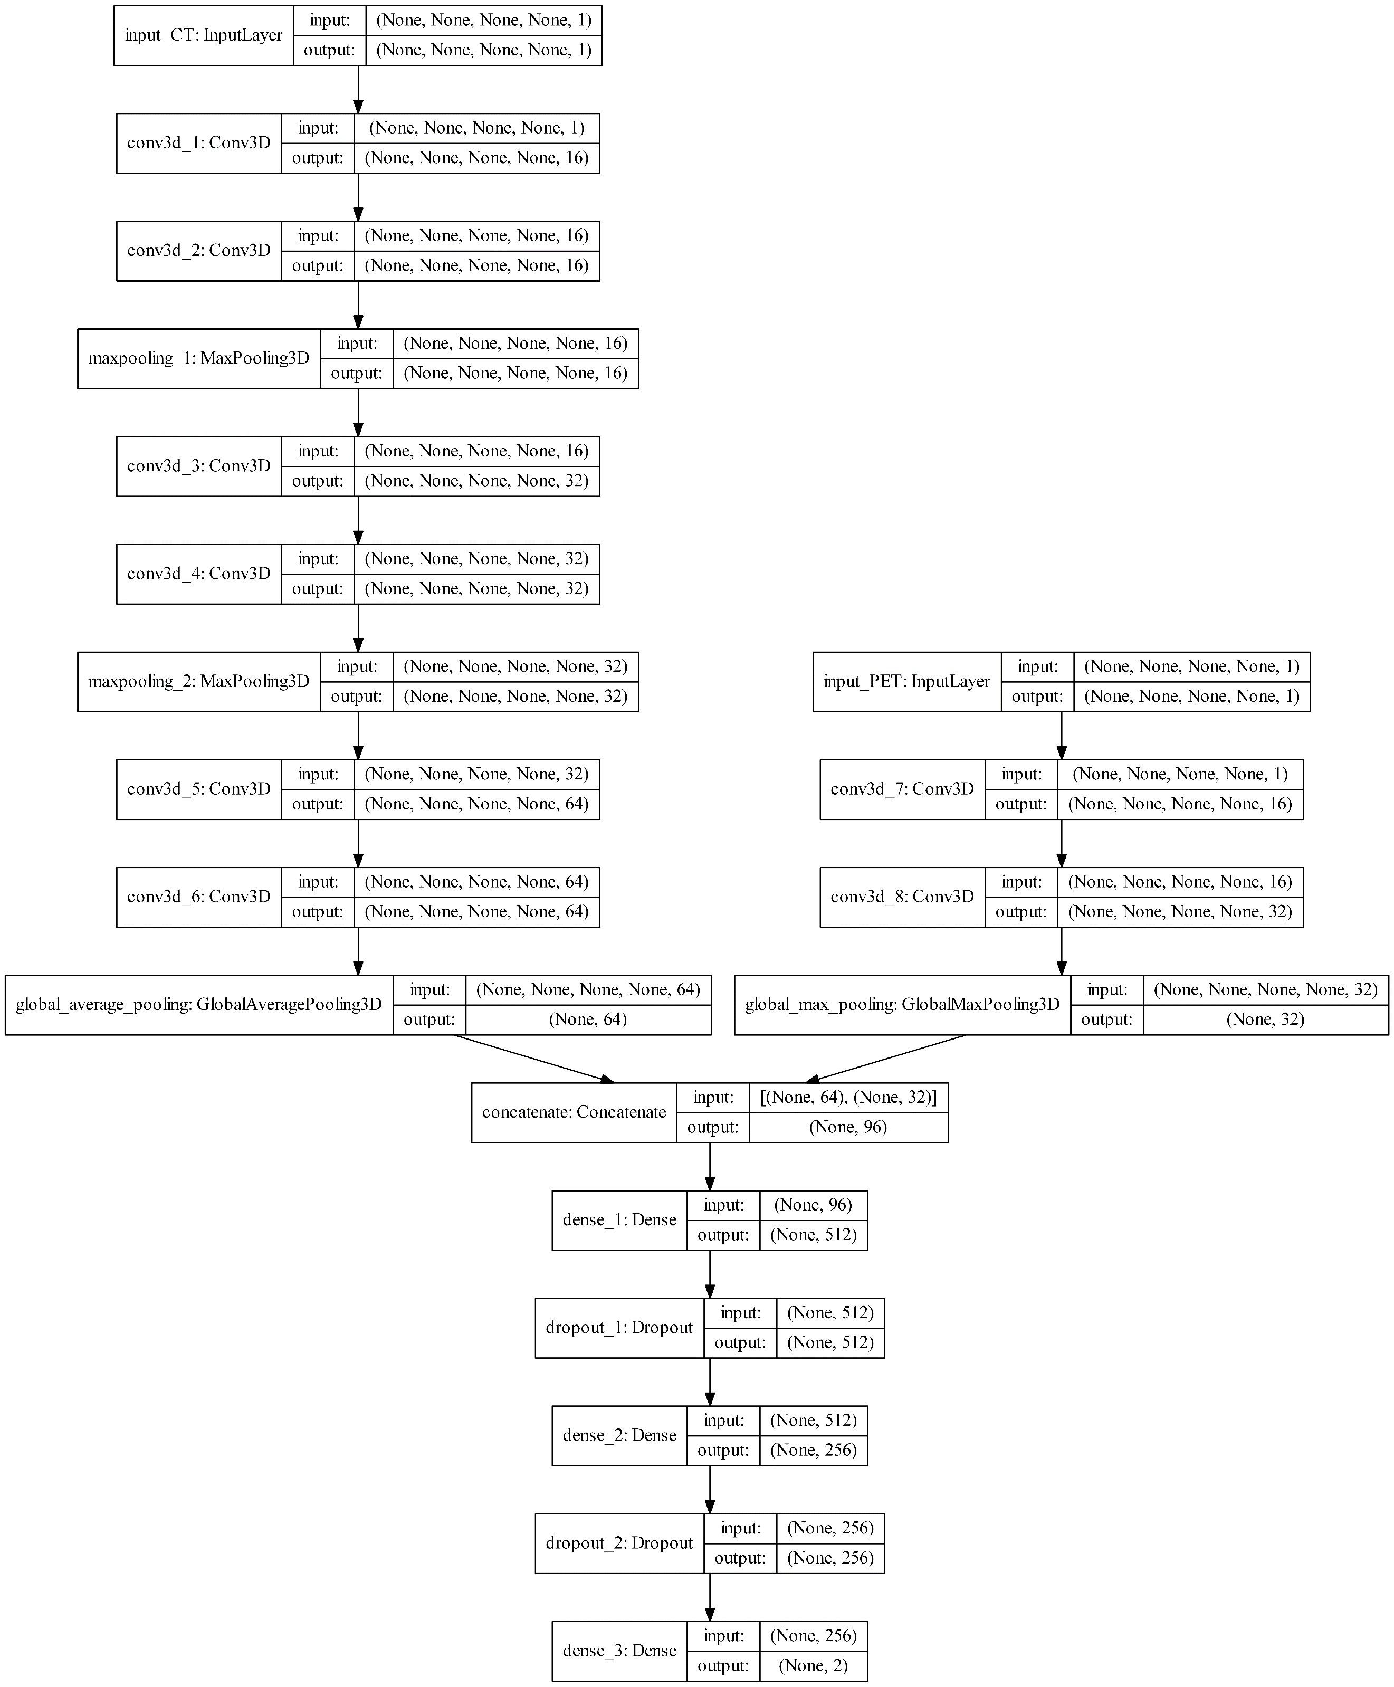
Figure S5. Tumor size adaptive PET/CT 3D-CNN
To integrate PET and CT information, we connect the two inputs of PET and CT through the concatenate layer to generate a 96-dimensional feature vector. Besides, the fully connected layer produces a 256-dimensional feature vector. Implement a dropout of 0.5 after the fully connected layer to avoid overfitting [3]. The target output is whether GGN is benign or IAC.

References
1. Beichel RR, Van Tol M, Ulrich EJ, Bauer C, Chang T, Plichta KA, et al. Semiautomated segmentation of head and neck cancers in 18F-FDG PET scans: A just-enough-interaction approach. Medical physics. 2016;43:2948-64. doi:10.1118/1.4948679.
2. Zhou B, Khosla A, Lapedriza A, Oliva A, Torralba A. Learning deep features for discriminative localization. Proceedings of the IEEE conference on computer vision and pattern recognition; 2016. p. 2921-9.
3. Srivastava N, Hinton G, Krizhevsky A, Sutskever I, Salakhutdinov R. Dropout: a simple way to prevent neural networks from overfitting. The journal of machine learning research. 2014;15:1929-58.
4. Lin M, Chen Q, Yan S. Network in network. arXiv preprint arXiv:13124400. 2013.

