Supplementary Figure 1 for the circTP63 mRNA level in SK-hep1 and SUN-387 after treatment by RNase R in Figure 1.

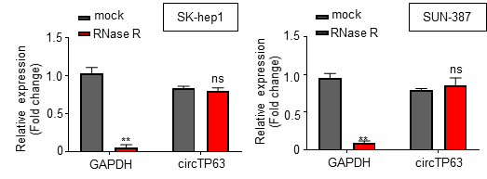

Supplementary Figure 2 for the morphological analysis of SK-hep1 and SUN-387 cells after si-circTP63 in Figure 2.
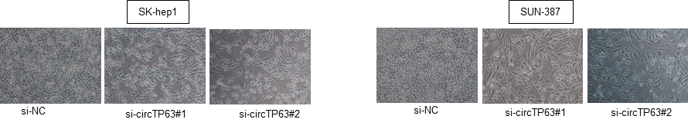

Supplementary Figure 3 for the rescue experiment for the circTP63 siRNAs in RT-qPCR (A), Cell viability (B), Cell migration and invasion (C), and Colony formation (D) assays.

Supplementary Figure 4 for Tumor volumes and weights of Hep3B cells with circTP63 overexpression xenograft nude models.
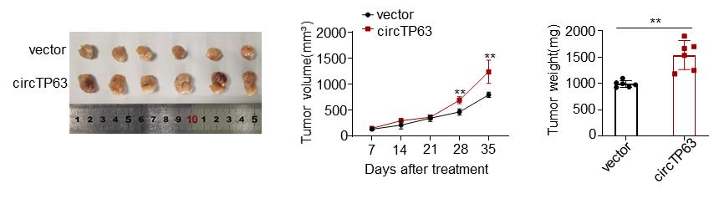

Supplementary Figure 5 for the EMT biomarker analysis in SK-hep1 and SUN-387 cells transfected with si-NC, si-circTP63#1, si-circTP63#1 + miR-155-5p inhibitor or si-circTP63#1 + pcDNA3.1-ZBTB18.
