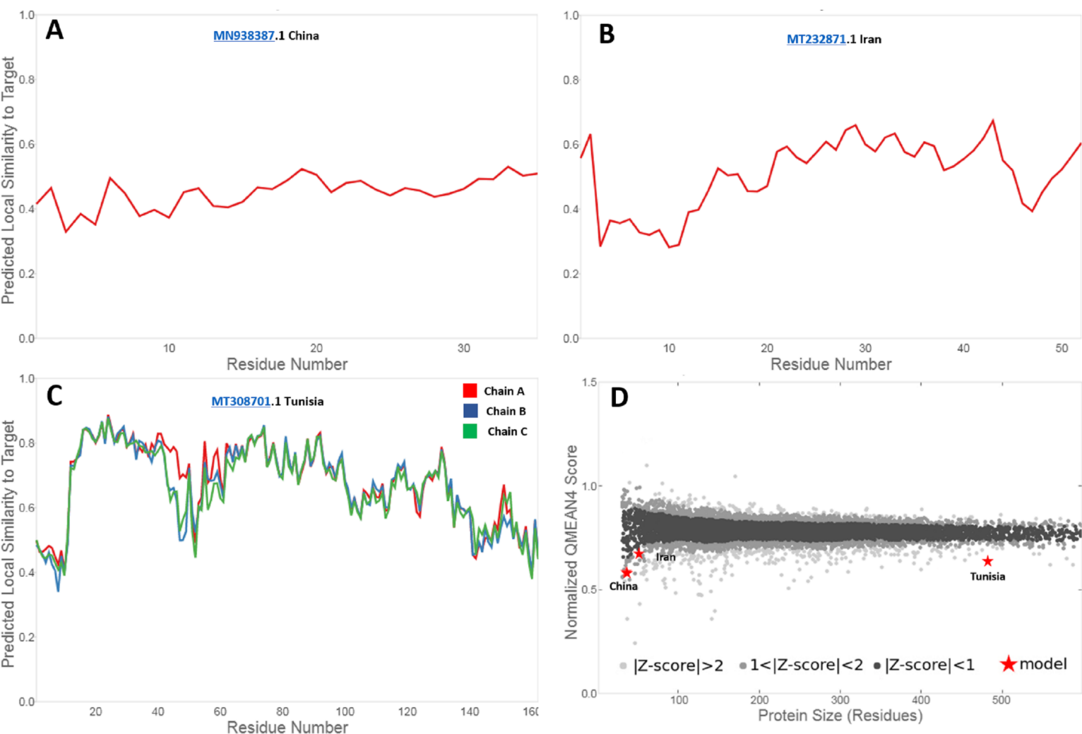
The local quality estimates comparison of the amino acid sequences of the three S glycoproteins in China, Iran, and Tunisia.
For panels (A, B, and C), the x-axis shows protein length (number of residues). For panel (D), the y-axis is the normalized QMEAN score. Every dot in panel (D) represents one experimental protein structure. The red stars represent the actual models normalized QMEAN score.

