From wastes to functions: Preparation of layered double hydroxides from industrial waste and its removal performance towards phosphates
Liping Xiao^{a, *}, Yan Li^{b}, Qiaoping Kong^{a, *}, Yunlong Lanª
ª School of Environmental and Municipal Engineering, Qingdao University of Technology, Qingdao 266033, PR China
^{b} School of Civil Engineering, Liaoning Technical University, Fuxin 123000, PR China

Supporting information for “2.1. Chemicals and materials”
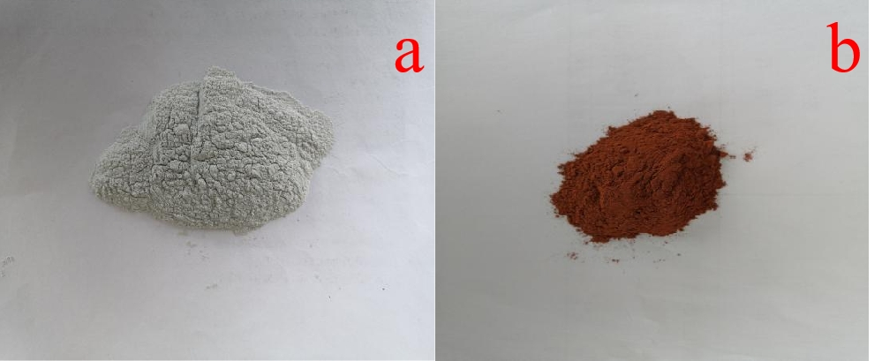
Fig. S1 The picture of raw calcium carbide slag powder (a) and red mud powder.
Table S1 The chemical composition of calcium carbide slag.
Component | CaO | Al₂O₃ | MgO | SiO₂ | Fe₂O₃ | Others
Composition（w/%） | 89.94 | 2.81 | 0.14 | 5.69 | 0.29 | 1.13
Table S2 The chemical composition of red mud.
Component | CaO | Al₂O₃ | Na₂O | SiO₂ | Fe₂O₃ | Others
Composition（w/%） | 4.48 | 16.91 | 3.06 | 6.60 | 46.41 | 22.54
Supporting information for “2.2. Preparation of CR-LDH”
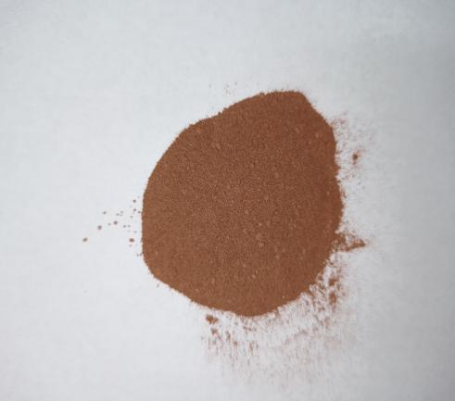
Fig. S2 Picture of CR-LDHs.
Supporting information for “3.2.7 Application of CR-LDH to practical phosphate-containing wastewater”
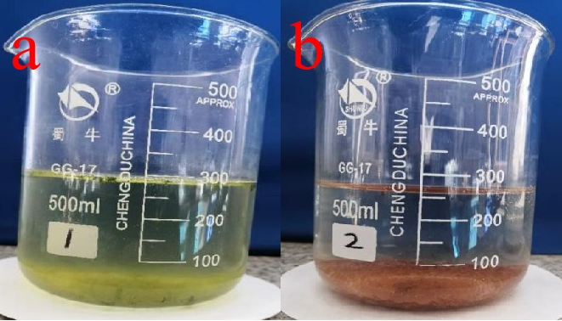
Fig. S3 Photos of practical phosphate-containing wastewater before CR-LDH adsorption (a) and after CR-LDH adsorption (b).
Supporting information for “3.3 Adsorption mechanism”
Fig. S4 FT-IR pattern of CR-LDH before and after adsorption of phosphate.

* Corresponding author at: School of Environmental and Municipal Engineering, Qingdao University of Technology, Qingdao 266033, PR China. - mail address: xxllpp11@126.com (L. P. Xiao); kongqiaoping@qut.edu.cn (Q. P. Kong)

