a
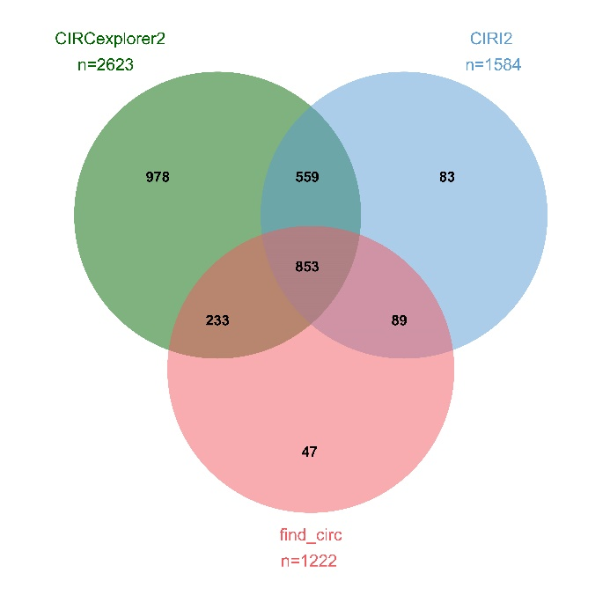
b
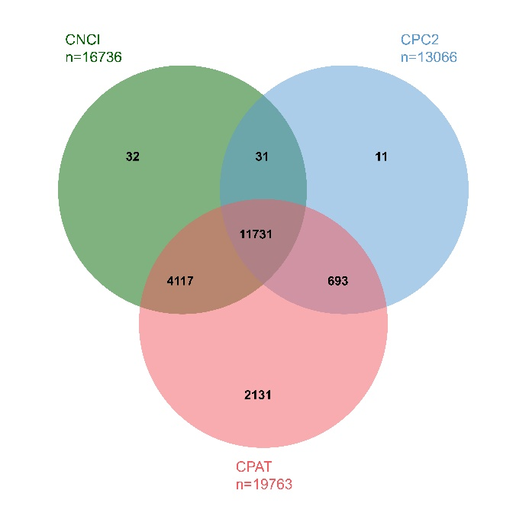
The intersection of novel lncRNAs and novel circRNAs detected by multiple software. (a) The intersection of CPAT, CPC2, and CNCI gives 11731 novel lncRNAs. (b) The intersection of find_circ, CIRCexplorer2, and CIRI2 gives 853 novel circRNAs

