Supporting Information
Tailoring of a Visible-Light-Absorbing Biaxial Ferroelectric towards Broadband Self-Driven Photodetection
Shiguo Han, Maofan Li, Yi Liu, Wuqian Guo, Maochun Hong, Zhihua Sun* & Junhua Luo*

Experimental Procedures
Material Synthesis. Compound 1 was synthesized from the concentrated aqueous HI solutions (57%) containing PbI₂, CH₃CH₂NH₃I and C₅H₁₁NH₃I with a molar ratio of 3:2:2. Then, the reaction mixture was stirred with heating for 30 min to dissolve the components thoroughly. Subsequently, large-size crystals were grown by the temperature cooling method with the temperature lowing rate of 1 K/day.
Thermal measurements. Differential scanning calorimetry (DSC) measurement was performed using the NETZSCH DSC 200 F3 with the heating/cooling rates of 5 K/min.
Single-crystal X-ray diffraction. Variable-temperature single crystal diffraction data of 1 were collected on a Bruker D8 Quest/Venture diffractometer with Mo-Ka radiation (λ = 0.77 Å) at 260 K, 320 K and 350 K, respectively. The data reduction and multi-scan absorption correction were performed using the Crystalclear software package (Rigaku, 2005).
Optical measurements. Ultraviolet-visible diffuse reflectance spectrometry was performed on a PerkinElmer Lambda 950 UV-vis-IR spectrophotometer.
Electrical measurements. The dielectric constants were measured using the two-probe AC impedance method with an Impedance Analyzer (TH2828A). Photoelectric measurements were measured using a Keithley 6517B source meter.
Ferroelectric measurements. Single-crystal sample with the thickness of ~1 mm was cut and polished for the measurements of pyroelectric and ferroelectric properties. In order to avoid electric discharge at high electric field, single crystal of 1 was immersed in silicone oil to measure the P-E hysteresis loops.
Computational methods. Density function theory (DFT) calculations were performed using the plane-wave pseudopotential method implemented in the Cambridge Sequential Total Energy Package (CASTEP) software package. The exchange-correlation potential was calculated using the Ceperley and Alder-Perdew and Zunger (CA-PZ) functional within local-density approximation (LDA). Ultrasoft pseudopotential were adapted, and valence electrons were provided by the package. The numbers of plane waves included in the basis sets were determined by a cutoff energy 280 eV, and the numerical integration of the Brillouin zone was performed using a Monkhorst-Pack κ-point sampling of 1×2×2.

Figures
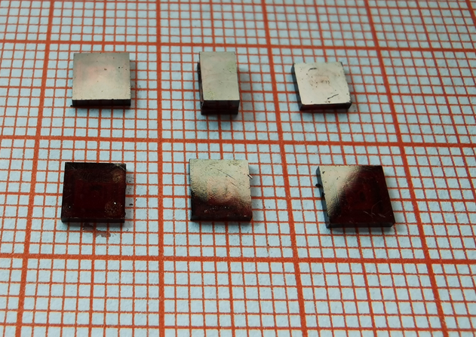
Figure S1. Bulk crystal of 1 grown from the concentrated HI solution by the temperature lowering method.

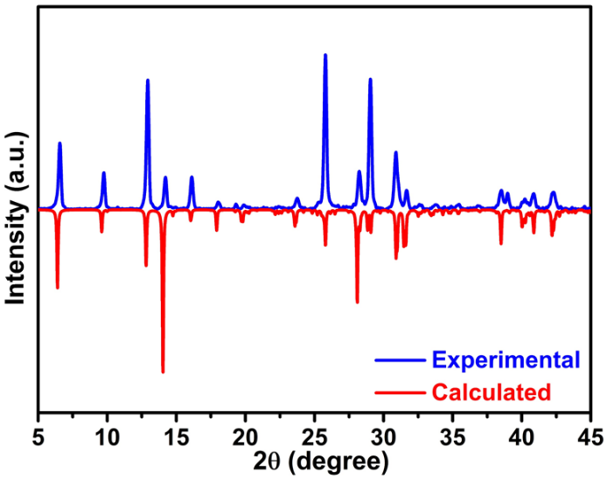
Figure S2. Experimental and calculated PXRD patterns of 1 at room temperature.

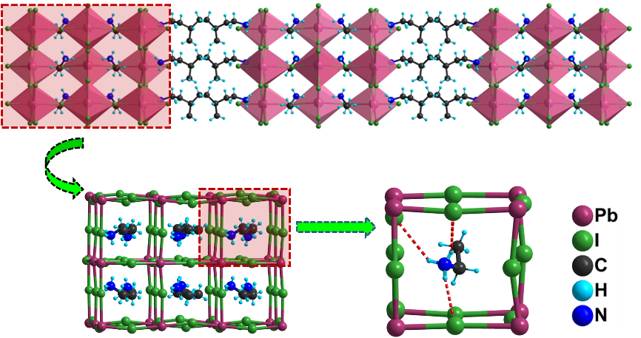
Figure S3. The organic ethylammonium cation is confined in the cavity enclosed by distorted corner-sharing PbI₆ octahedra, being linked together by the strong N-H···I hydrogen bonds. Red imaginary lines represent the N−H···I hydrogen bonds.
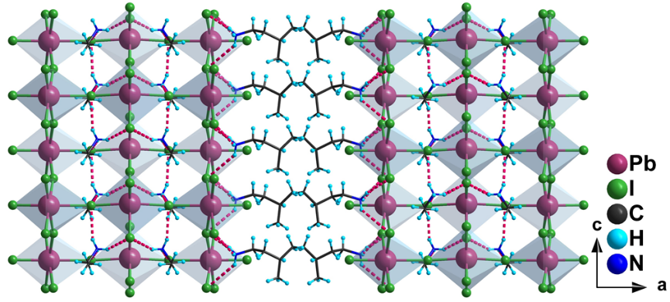
Figure S4. Diagram of N-H∙∙∙I Hydrogen bonds between inorganic perovskite sheets and organic isopentylammonium/ethylammonium cations of 1 at FEP. Red imaginary lines represent the N−H···I hydrogen bonds.

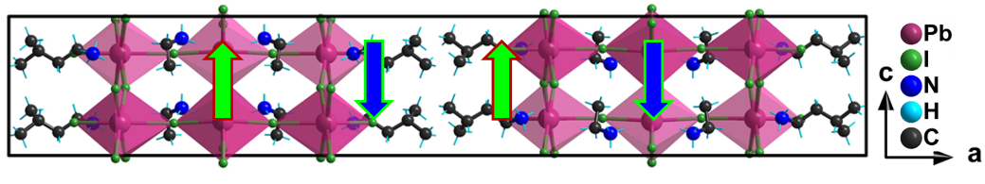
Figure S5. The unit cell of crystal structure of 1 at AFEP. The green and blue arrowheads denote antiparallel alignment of dipoles related to dynamic orientation of structural moieties.
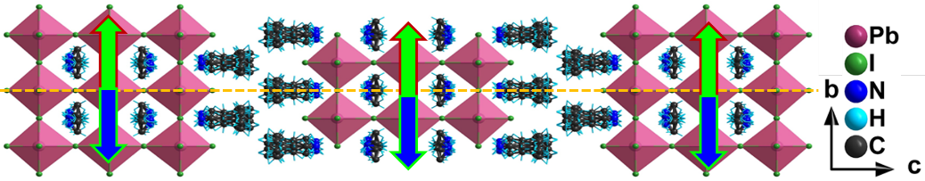
Figure S6. Schematic representation of crystal structure for 1 at PEP. The yellow-dashed line denotes the crystallographic mirror plane.

Table S1. Crystal data and structure refinement for 1 at different temperatures: FEP (260 K); AFEP (320 K) and PEP (350 K).
Temperature | FEP (at 260 K) | AFEP (at 320 K) | PEP (at 350 K)
Empirical formula | C₁₄H₄₄I₁₀N₄Pb₃ | C₁₄H₄₄I₁₀N₄Pb₃ | C₁₄H₄₄I₁₀N₄Pb₃
Crystallographic system, space group | Orthorhombic,  Cmc2₁ | Orthorhombic,  Pmcn | Tetragonal,  I4/mmm
 | 55.225(6) Å | 54.941(11) Å | 6.3847(10) Å
Cell parameters | 8.9515(8) Å | 8.9136(17) Å | 6.3847(10) Å
 | 9.0019(9) Å | 8.9822(15) Å | 55.873(9) Å
V (Å³) | 4450.1(7) | 4398.8(14) | 2277.6(8)
Z | 4 | 4 | 2
Calculated density (g/cm³) | 3.223 | 3.260 | 3.148
F(000) | 3728.0 | 3728.0 | 1864.0
Theta range (º) | 4.426-55.08 | 5.082-52.836 | 5.834-52.652
Limiting indices | -71 ≤ h ≤ 71 | -68 ≤ h ≤ 48 | -7 ≤ h ≤ 7
 | -11 ≤ k ≤ 11 | -11 ≤ k ≤ 10 | -7 ≤ k ≤ 7
 | -10 ≤ l ≤ 11 | -11 ≤ l ≤ 10 | -69 ≤ l ≤ 69
Reflections collected / unique | 18281/4535 | 19201/4506 | 8673/778
 | Rint = 0.0998 | Rint = 0.1074 | Rint = 0.0678
Data/restraints/parameters | 4535/110/150 | 4506/110/150 | 778/169/100
GOF. | 1.051 | 1.064 | 1.046
Final R indices [I > 2σ(I)] | R₁ = 0.0944,  wR₂ = 0.2500 | R₁ = 0.1376,  wR₂ = 0.2576 | R₁ = 0.0605, wR₂ = 0.1164
Table S2. Bond Lengths of Pb-I of crystal 1 at FEP (260 K).
Atom | Atom | Bond length (Å) | Atom | Atom | Bond length (Å)
Pb₂ | I₅^{#1} | 3.238(2) | Pb₁ | I₄ | 3.4608(18)
Pb₂ | I₅ | 3.323(2) | Pb₁ | I₃ | 3.1763(19)
Pb₂ | I₄^{#2} | 3.1924(16) | Pb₁ | I₃^{#4} | 3.2109(19)
Pb₂ | I₄ | 3.1923(16) | Pb₁ | I₁ | 3.195(2)
Pb₂ | I₆ | 3.243(3) | Pb₁ | I₁^{#5} | 3.178(2)
Pb₂ | I₆^{#3} | 3.183(2) | Pb₁ | I₂ | 2.998(2)
Symmetry transformations used to generate equivalent atoms:
^{#1} 1-X,1-Y,1/2+Z; ^{#2} 1-X, +Y, +Z; ^{#3} 1-X,2-Y,1/2+Z; ^{#4} +X,1-Y, -1/2+Z; ^{#5} +X, 2-Y,1/2+Z

Table S3. Bond angles of I-Pb-I of crystal 1 at FEP (260 K).
Bond | Bond angle (˚) | Bond | Bond angle (˚)
I₅^{#1}-Pb₂-I₅ | 88.38(3) | I₃-Pb₁-I₄ | 82.38(6)
I₅^{#1}-Pb₂-I₆ | 173.11(6) | I₃^{#4}-Pb₁-I₄ | 82.45(6)
I₄^{#2}-Pb₂-I₅ | 85.53(4) | I₃-Pb₁-I₃^{#4} | 89.61(2)
I₄^{#2}-Pb₂-I₅^{#1} | 90.40(5) | I₃-Pb₁-I₁ | 177.49(6)
I₄-Pb₂-I₅^{#1} | 90.40(5) | I₃-Pb₁-I₁^{#5} | 92.15(5)
I₄-Pb₂-I₅ | 85.54(4) | I₁-Pb₁-I₄ | 95.96(6)
I₄-Pb₂-I₄^{#2} | 171.01(8) | I₁^{#5}-Pb₁-I₄ | 96.06(6)
I₄^{#2}-Pb₂-I₆ | 89.07(5) | I₁^{#5}-Pb₁-I₃^{#4} | 177.53(6)
I₄-Pb₂-I₆ | 89.07(5) | I₁-Pb₁-I₃^{#4} | 88.31(5)
I₆^{#3}-Pb₂-I₅ | 177.06(7) | I₁^{#5}-Pb₁-I₁ | 89.89(2)
I₆-Pb₂-I₅ | 84.73(6) | I₂-Pb₁-I₄ | 169.49(6)
I₆^{#3}-Pb₂-I₅^{#1} | 94.56(7) | I₂-Pb₁-I₃^{#4} | 90.60(8)
I₆^{#3}-Pb₂-I₄ | 94.43(4) | I₂-Pb₁-I₃ | 89.72(8)
I₆^{#3}-Pb₂-I₄^{#2} | 94.43(4) | I₂-Pb₁-I₁^{#5} | 91.15(8)
I₆^{#3}-Pb₂-I₆ | 92.33(3) | I₂-Pb₁-I₁ | 91.70(8)
Symmetry transformations used to generate equivalent atoms:
^{#1} 1-X, 1-Y, 1/2+Z; ^{#2} 1-X, +Y, +Z; ^{#3} -X, 2-Y, 1/2+Z; ^{#4} +X, 1-Y, -1/2+Z; ^{#5} +X, 2-Y, 1/2+Z

Table S4. N-H∙∙∙I Hydrogen bonds of crystal 1 at FEP (260 K).
D-H···A | d(D-H) | d(H···A) | < DHA | d(D···A)
N₁-H_{1C}∙∙∙I₄ | 0.890 | 2.779 | 163.79 | 3.642
N₁-H_{1D}∙∙∙I₄^{#1} | 0.890 | 2.865 | 156.97 | 3.700
N₁-H_{1E}∙∙∙I₆^{#2} | 0.890 | 3.061 | 144.60 | 3.822
N₂-H_{2B}∙∙∙I₁ | 0.890 | 2.789 | 131.14 | 3.440
N₂-H_{2C}∙∙∙I₃^{#3} | 0.890 | 2.755 | 166.91 | 3.627
Symmetry transformations used to generate equivalent atoms:
^{#1} X, -Y+1, Z+1/2; ^{#2} -X+1, -Y+1, Z+1/2, ^{#3} X, -Y+1, Z-1/2

Table S5. Bandgap of 1 and some other lead-halide perovskite ferroelectric.
Compound | Bandgap | Refs
1 | ~1.80 eV | This work
(C₄H₉NH₃)₂(C₂H₅NH₃)₂Pb₃I₁₀ | ~1.90 eV | [1]
(4,4-difluorocyclohexylammnium)₂PbI₄ | ~2.38 eV | [2]
[(CH₃)₃NCH₂I]PbI₃ | ~2.82 eV | [3]
[4-(aminomethyl)-piperidinium]₂PbI₄ | ~2.38 eV | [4]
R-1-(4-chlorophenyl)-ethylammonium]₂PbI₄ | ~2.34 eV | [5]
S-1-(4-chlorophenyl)-ethylammonium]₂PbI₄ | ~2.36 eV
(C₄H₉NH₃)₂(CH₃NH₃)₂Pb₃Br₁₀ | ~2.42 eV | [6]
(C₄H₉NH₃)₂(CH₃NH₃)Pb₂Br₇ | ~2.55 eV | [7]
(C₄H₉NH₃)₂(NH₂CHNH₂)Pb₂Br₇ | ~2.35 eV | [8]
(C₄H₉NH₃)₂CsPb₂Br₇ | ~2.68 eV | [9]
(ethylammonium)₄Pb₃Br₁₀ | ~2.70 eV | [10]
(cyclohexylammonium)₂PbBr₄ | ~2.95 eV | [11]
(benzylammonium)₂PbCl₄ | ~3.65 eV | [12]
(C₄H₉NH₃)₂PbCl₄ | ~3.49 eV | [13]

[1] Han, S. G. et al. High-Temperature Antiferroelectric of Lead Iodide Hybrid Perovskites. J. Am. Chem. Soc. 141, 12470-12474 (2019).
[2] Sha, T. T. et al. Fluorinated 2D Lead Iodide Perovskite Ferroelectrics. Adv. Mater. 31, 1901843 (2019).
[3] Hua, X. N. et al. A Room-Temperature Hybrid Lead Iodide Perovskite Ferroelectric. J. Am. Chem. Soc. 140, 12296-12302 (2018).
[4] Park, I. H. et al. Ferroelectricity and Rashba Effect in a Two-Dimensional Dion-Jacobson Hybrid Organic-Inorganic Perovskite. J. Am. Chem. Soc. 141, 15972-15976 (2019).
[5] Yang, C. K. et al. The First 2D Homochiral Lead Iodide Perovskite Ferroelectrics: [R- and S-1-(4-Chlorophenyl) ethylammonium]₂PbI₄. Adv. Mater. 31, 1808088 (2019).
[6] Li, L. L. et al. Tailored Engineering of an Unusual (C₄H₉NH₃)₂(CH₃NH₃)₂Pb₃Br₁₀ Two‐Dimensional Multilayered Perovskite Ferroelectric for a High‐Performance Photodetector. Angew. Chem. Int. Ed. 56, 12150-12154 (2017).
[7] Li, L. L. et al. Two-Dimensional Hybrid Perovskite-Type Ferroelectric for Highly Polarization-Sensitive Shortwave Photodetection. J. Am. Chem. Soc. 141, 2623-2629 (2019).
[8] Li, L. L. et al. Bilayered Hybrid Perovskite Ferroelectric with Giant Two-Photon Absorption. J. Am. Chem. Soc. 140, 6806-6809 (2018).
[9] Wu, Z. Y. et al. Alloying n-Butylamine into CsPbBr₃ To Give a Two-Dimensional Bilayered Perovskite Ferroelectric Material. Angew. Chem. Int. Ed. 57, 8140-8143 (2018).
[10] Wang, S. S. et al. An Unprecedented Biaxial Trilayered Hybrid Perovskite Ferroelectric with Directionally Tunable Photovoltaic Effects. J. Am. Chem. Soc. 141, 7693-7697 (2019).
[11] Sun, Z. H. et al. A Photoferroelectric Perovskite-Type Organometallic Halide with Exceptional Anisotropy of Bulk Photovoltaic Effects. Angew. Chem. Int. Ed. 55, 6545-6550 (2016).
[12] Liao, W. Q. et al. A lead-halide perovskite molecular ferroelectric semiconductor. Nature Communications 6, 7338 (2015).
[13] Ji, C. M. et al. The First 2D Hybrid Perovskite Ferroelectric Showing Broadband White‐Light Emission with High Color Rendering Index. Adv. Funct. Mater. 29, 1805038 (2019).

