Bioaugmentation of Bacillus amyloliquefaciens-Bacillus kochii co-cultivation to improve sensory qualities of flue-cured tobacco
Xinying Wu^{a,b,d} Pengcheng zhu^{a,c}, Dongliang Li^{c}, Tainfei Zheng ^{a,b}, Wen Cai^{c}, Jianghua Li^{a,b}, Baoyu Zhang^{a,b}, Beibei zhu^{c}, Juan Zhang^{a,b *}, Guocheng Du^{a,b*}
a: School of Biotechnology, Jiangnan University, 1800 Lihu Road, Wuxi 214122, China
b: Key laboratory of industrial biotechnology, Ministry of education, Jiangnan University, Wuxi, 214122, China
c: Technical Research Center, China Tobacco Sichuan industrial Co., Ltd.,56 Chenglong Road, Chengdu 610000, China
d: School of Liquor and Food Engineering, Guizhou University, Guiyang 550025, China

* Corresponding author.
Guocheng Du:
E-mail addresses: gcdu@jiangnan.edu.cn (gc. Du).
Juan Zhang:
E-mail addresses: zhangj@jiangnan.edu.cn (J. Zhang).

Journal name：Archives of Microbiology

A
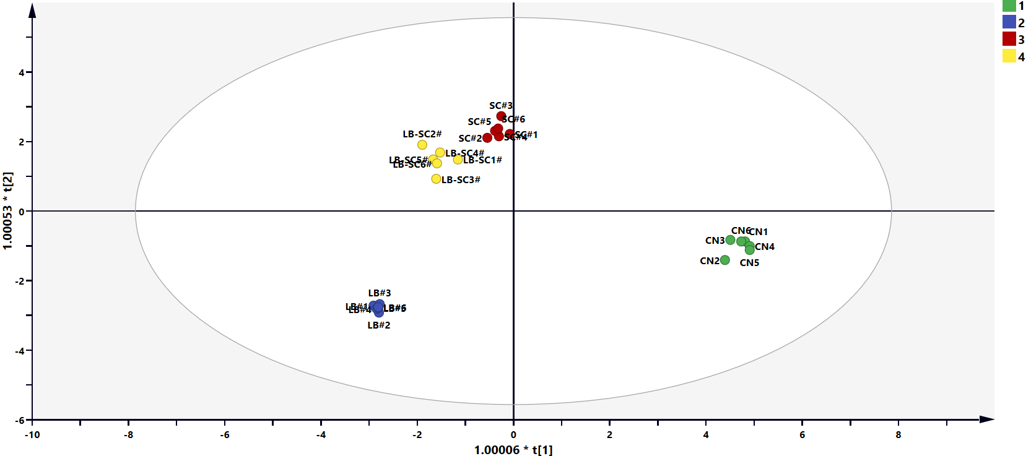
B

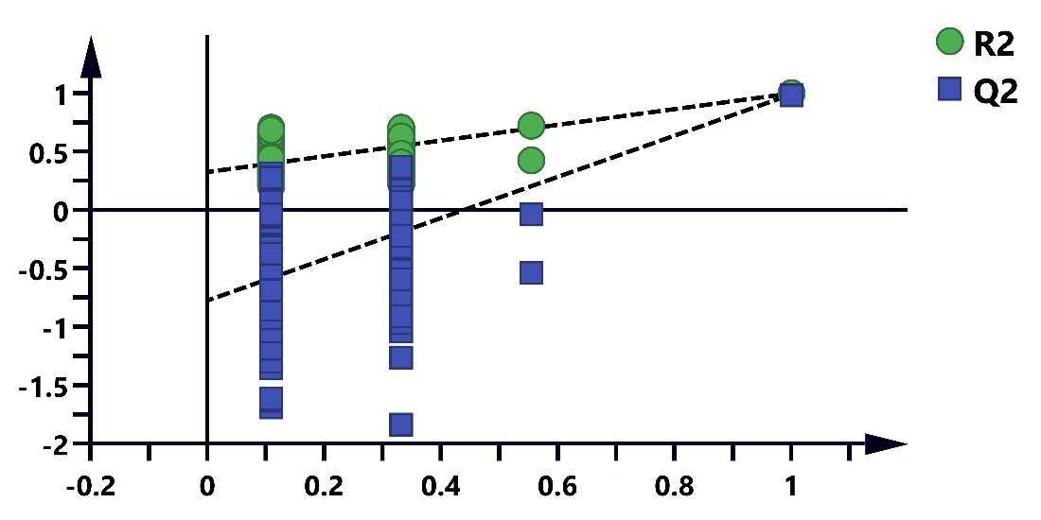
C
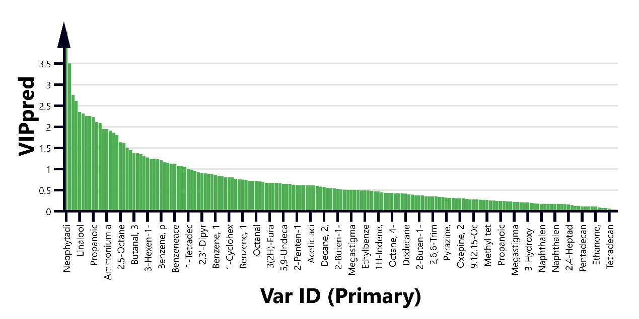
Fig. S1 OPLS-DA analysis for bioaugmentation and control samples: (A) scatter plot of based on relative the content of volatile components; (B) the permutations plot of OPLS-DA model with 200-time permutation tests (the intercepts of R2 and Q2 were 0.997 and 0.988 respectively); (C) VIP value analysis of volatile components.
CN1-6 represented six duplicate controls; LB1-6 represented the six duplicate samples of B. amyloliquefaciens LB monoculture. SC1-6 represented the six duplicate samples of B. kochii SC monoculture. LS-SC represented the six duplicate samples of B. amyloliquefaciens LB-B. kochii SC coculture.

