**Supplementary Table 1**. Inclusion and exclusion criteria of the study

|  |  |
| --- | --- |
| **inclusion criteria** | **exclusion criteria** |
| * Women or man, aged of 18 to 40 years * Body mass index (BMI) between 18 and 25 kg/m2 * In good general health as evidenced by medical history and physical examination * Non-smoker * Caucasian * For women: use of effective contraception * H2 – producer as evidenced by the screening test * Provision of signed and dated informed consent form * Stated willingness to comply with all study procedures and availability for the duration of the study | * Subjects presenting gastro-intestinal disorders such as ulcers, diverticulitis and inflammatory bowel diseases * Subject presenting allergy or food intolerance (lactose, gluten) * Subjects with psychiatric problems and/or using antipsychotics * Current or recent (< 4 weeks) intake of antibiotics, probiotics, prebiotics, fiber complement, and/or any products modulation gut transit * Feeding particular diet such as vegetarian diet or hyper protein diet * Chronic intake of drug, excepted contraceptive drug * Pregnant or lactating women or women who did not use effective contraception * Subjects who drink more than 3 glasses of alcohol per day (> 30 g of alcohol per day) * Subjects having participated to another clinical trial 1 month before the screening test visit * Subjects presenting an allergy or intolerance to one component of the product tested |

**Supplementary Figure 2.** Exhaled H2 after lactulose intake



**Supplementary Table 2.** Baseline score of gastrointestinal symptoms of the participants at fasting state1

|  |  |  |  |  |  |  |  |
| --- | --- | --- | --- | --- | --- | --- | --- |
|  | **Test day maltodextrin** | | | **Test day**  **chitin glucan** | | | **q-value** |
| Nausea | 0.5 | ± | 0.5 | 0.0 | ± | 0.0 | 1.0 |
| Flatulence | 3.5 | ± | 1.5 | 0.6 | ± | 0.6 | 0.8 |
| Bloating | 3.3 | ± | 1.8 | 2.6 | ± | 1.2 | 1.0 |
| Bramp | 0.6 | ± | 0.6 | 0.6 | ± | 0.6 | 1.0 |
| Rumbling | 2.0 | ± | 1.1 | 2.8 | ± | 1.5 | 1.0 |
| Reflux | 0.0 | ± | 0.0 | 0.7 | ± | 0.7 | 1.0 |
| Discomfort | 2.3 | ± | 2.3 | 0.6 | ± | 0.6 | 1.0 |
| Burp | 0.4 | ± | 0.4 | 0.0 | ± | 0.0 | 1.0 |

1Values are means ± SEM (q > 0.05, matched-pairs Wilcoxon signed-rank test).

**Supplementary Table 3.** Baseline production of breath volatile metabolites (ppm) of the participants at fasting state1

|  |  |  |  |  |  |  |  |
| --- | --- | --- | --- | --- | --- | --- | --- |
|  | **Test day**  **maltodextrin** | | | **Test day**  **chitin glucan** | | | **q-value** |
| butanol | 0.112 | ± | 0.009 | 0.142 | ± | 0.018 | 0.542 |
| 1-propanol | 0.248 | ± | 0.058 | 0.271 | ± | 0.039 | 0.706 |
| 2.3-butanedione | 0.145 | ± | 0.014 | 0.116 | ± | 0.012 | 0.153 |
| 2-methylbutyric acid | 0.022 | ± | 0.002 | 0.021 | ± | 0.001 | 0.871 |
| 2-propanol | 0.292 | ± | 0.070 | 0.312 | ± | 0.044 | 0.706 |
| 3-methylbutyric acid | 0.005 | ± | 0.001 | 0.006 | ± | 0.000 | 0.871 |
| acetaldehyde | 0.058 | ± | 0.008 | 0.046 | ± | 0.003 | 0.153 |
| acetic acid | 0.126 | ± | 0.015 | 0.139 | ± | 0.012 | 0.706 |
| 3-hydroxybutanone | 0.033 | ± | 0.002 | 0.029 | ± | 0.002 | 0.313 |
| acetone | 3.976 | ± | 1.192 | 2.916 | ± | 0.723 | 0.706 |
| acetonitrile | 0.068 | ± | 0.024 | 0.045 | ± | 0.012 | 0.706 |
| benzaldehyde | 0.011 | ± | 0.002 | 0.012 | ± | 0.001 | 0.871 |
| benzene | 0.035 | ± | 0.005 | 0.042 | ± | 0.006 | 0.706 |
| butyric acid | 0.049 | ± | 0.003 | 0.040 | ± | 0.002 | 0.184 |
| ethane | 0.003 | ± | 0.001 | 0.002 | ± | 0.000 | 0.153 |
| ethanol | 0.670 | ± | 0.158 | 0.697 | ± | 0.206 | 1.000 |
| caproic acid | 0.008 | ± | 0.002 | 0.008 | ± | 0.001 | 0.718 |
| hydrogen sulfide | 0.011 | ± | 0.001 | 0.011 | ± | 0.001 | 1.000 |
| isoprene | 0.557 | ± | 0.075 | 0.450 | ± | 0.042 | 0.153 |
| methane | 38.920 | ± | 6.703 | 32.103 | ± | 5.044 | 0.706 |
| methanol | 0.315 | ± | 0.056 | 0.173 | ± | 0.023 | 0.153 |
| pentane | 0.601 | ± | 0.029 | 0.442 | ± | 0.018 | 0.016* |
| valeric acid | 0.010 | ± | 0.001 | 0.010 | ± | 0.000 | 0.871 |
| phenol | 0.134 | ± | 0.026 | 0.121 | ± | 0.011 | 0.830 |
| propionic acid | 0.176 | ± | 0.040 | 0.295 | ± | 0.055 | 0.153 |
| triethylamine | 0.008 | ± | 0.000 | 0.007 | ± | 0.001 | 0.156 |

1Values are means ± SEM. (*q < 0.05, matched-pairs Wilcoxon signed-rank test).

**Supplementary Figure 2.** Targeted BVM concentrations of healthy subjects, corrected for baseline, after chitin glucan intake compared to maltodextrin intake1

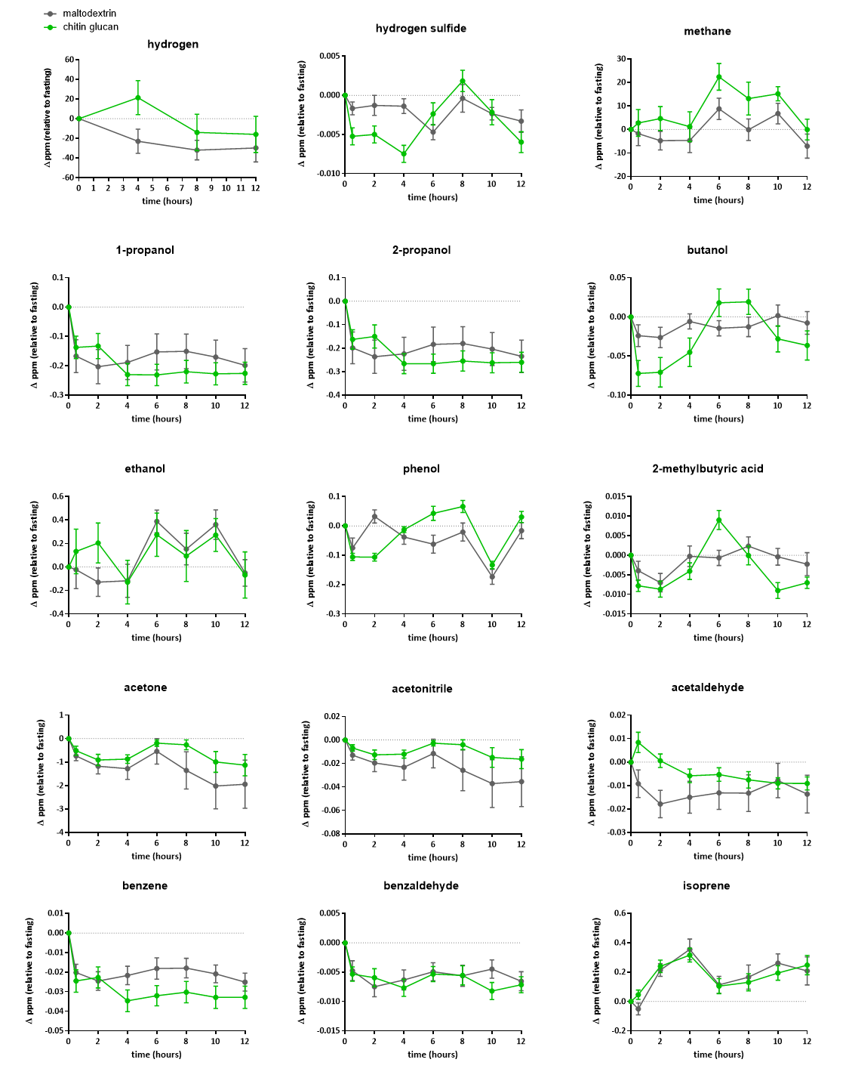

1Data are means ± SEM (p>0.05; matched-pairs Wilcoxon signed-rank test on net AUC).