Table S1
Chemical compounds detected in the common effluent treatment plant samples using GC/MS analysis (TP01: CETP collection tank; TP02: Textile industry effluent; TP03: Clariflocculator tank outlet; TP04: Dissolved air flotation tank outlet; TP05: Aeration tank; TP06: Final outlet of effluent; TP07: Sludge disposal; TP08: Final sludge disposal)
Predicted compounds | TP01 | TP02 | TP03 | TP04 | TP05 | TP06 | TP07 | TP08
 | ( peak area %)
Diethyl, 1ethynylcyclohexyl ester | 3.3 | ND# | ND | ND | ND | ND | ND | ND
1,2-benzenedicarboxylic acid | 2.00 | 5.04 | 1.33 | ND | ND | 3.72 | ND | 7.48
Phthalic acid | 5.47 | 4.14 | ND | 9.95 | 30.64 | 3.43 | ND | 17.84
Oxalic acid, allyl octadecyl ester | 9.71 | ND | ND | 21.09 | ND | 10.89 | 12.31 | 28.59
Benzenesulfonamide, 4-amino-n-ethyl | 28.54 | ND | ND | ND | ND | ND | ND | ND
1-hexyl-2-nitrocyclohexane | 11.17 | 14.32 | ND | 22.98 | 7.57 | 8.34 | ND | 12.33
Cyclopentane, (2-hexyloctyl)- | 5.85 | ND | ND | ND | ND | ND | ND | 15.8
Bis(2-ethylhexyl) phthalate | 2.81 | ND | 0.33 | ND | ND | ND | 3.68 | ND
2-methylhexacosane | 2.01 | ND | ND | ND | ND | ND | ND | ND
Decane, 3-ethyl-3-methyl | 2.05 | ND | ND | ND | ND | ND | ND | ND
Octatriacontane, 1,38-dibromo- | 1.33 | ND | ND | ND | ND | ND | ND | ND
1-bromo-4-bromomethyldecane | ND | 25.04 | ND | ND | ND | ND | ND | ND
Phenol, 2,6-bis(1,1-dimethylethyl)- | ND | 7.17 | ND | ND | ND | ND | ND | ND
4-tetradecene, | ND | 6.22 | ND | ND | ND | ND | ND | ND
Sulfurous acid, hexyl pentadecyl ester | ND | 2.04 | ND | ND | ND | ND | 5.71 | 11.31
Octadecane, 3-ethyl-5-(2-ethylbutyl) | ND | 3.2 | ND | ND | ND | ND | ND | ND
Heptacosane | ND | 6.85 | ND | ND | ND | ND | ND | ND
Hydrazine, (2-methyl-1-propenyl) | ND | 1.14 | 10 | 14.77 | ND | ND | ND | ND
Dimethoxyamine | ND | 1.3 | ND | ND | ND | ND | ND | ND
1-butanamine, n-(1-methylethyl | ND | ND | 0.61 | ND | ND | ND | ND | ND
Pentane, 2,2,4-trimethyl-4-nitro | ND | ND | 0.27 | ND | ND | ND | ND | ND
2-cyano-2,3-dimethyl-, diethyl ester | ND | ND | 53.00 | ND | ND | ND | ND | ND
Benzenesulfonyl fluoride | ND | ND | ND | 10.54 | ND | ND | 22.88 | ND
4-ethyl-4-methyl-1-hexene | ND | ND | ND | 4.15 | ND | ND | ND | ND
2-[(1,3-dioxobutyl)amino]ethyl ester | ND | ND | ND | ND | 14.1 | ND | ND | ND
4-trifluoroacetoxyhexadecane | ND | ND | ND | ND | 22.41 | ND | ND | ND
2-propenoic acid | ND | ND | ND | ND | 14.1 | ND | ND | ND
1-propanamine, n-nitro- | ND | ND | ND | ND | ND | 2.84 | ND | ND
2-hexenal, 2-ethyl- | ND | ND | ND | ND | ND | 24.11 | ND | ND
1,7-dimethyl-4-(1-methylethyl) cyclodecane | ND | ND | ND | ND | ND | 13.64 | ND | ND
1,1'-biphenyl]-4,4'-diamine, 2,2'-dichloro | ND | ND | ND | ND | ND | 11.59 | ND | ND
1,11-dibromoundecane | ND | ND | ND | ND | ND | ND | 6.7 | ND
Benzeneacetic acid, 2-tetradecyl ester | ND | ND | ND | ND | ND | ND | 3.28 | ND
2-undecene, 5-methyl | ND | ND | ND | ND | ND | ND | 2.38 | ND
Dichloroacetic acid | ND | ND | ND | ND | ND | ND | 7.38 | ND
Cyclohexane, (2-decyldodecyl) | ND | ND | ND | ND | ND | ND | ND | 6.64
Note: # ND: Not Detected

Table S2
Gene abundance with in each metagenome dataset for Benzoate degradation
KEGG ID | Genes | Enzymes | TP01 | TP02 | TP03 | TP04 | TP05 | TP06 | TP07 | TP08
K14333 | DHBD | 2,3-dihydroxybenzoate decarboxylase [EC:4.1.1.46] | 3 | 1 | 4 | 4 | 7 | 7 | 6 | 7
K00446 | dmpB, xylE | catechol 2,3-dioxygenase [EC:1.13.11.2] | 16 | 4 | 17 | 19 | 25 | 17 | 13 | 29
K07104 | catE | catechol 2,3-dioxygenase [EC:1.13.11.2] | 15 | 21 | 22 | 24 | 9 | 5 | 27 | 9
K10621 | cmtC, dhbA | 2,3-dihydroxy-p-cumate/2,3-dihydroxybenzoate 3,4-dioxygenase [EC:1.13.11.- 1.13.11.14] | 1 | 0 | 1 | 1 | 2 | 2 | 1 | 2
K10622 | cmtD, dhbB | HCOMODA/2-hydroxy-3-carboxy-muconic semialdehyde decarboxylase [EC:4.1.1.-] | 1 | 0 | 1 | 2 | 2 | 1 | 2 | 0
K10216 | dmpD, xylF | 2-hydroxymuconate-semialdehyde hydrolase [EC:3.7.1.9] | 10 | 5 | 10 | 10 | 16 | 10 | 13 | 11
K02554 | mhpD | 2-keto-4-pentenoate hydratase [EC:4.2.1.80] | 5 | 5 | 11 | 7 | 12 | 6 | 10 | 8
K18364 | bphH, xylJ, tesE | 2-oxopent-4-enoate/cis-2-oxohex-4-enoate hydratase [EC:4.2.1.80 4.2.1.132] | 5 | 4 | 9 | 12 | 11 | 4 | 12 | 10
K01666 | mhpE | 4-hydroxy 2-oxovalerate aldolase [EC:4.1.3.39] | 17 | 8 | 18 | 17 | 18 | 11 | 23 | 15
K18365 | bphI, xylK, nahM, tesG | 4-hydroxy-2-oxovalerate/4-hydroxy-2-oxohexanoate aldolase [EC:4.1.3.39 4.1.3.43] | 12 | 5 | 11 | 15 | 10 | 5 | 9 | 11
K10217 | dmpC, xylG, praB | aminomuconate-semialdehyde/2-hydroxymuconate-6-semialdehyde dehydrogenase [EC:1.2.1.32 1.2.1.85] | 10 | 4 | 15 | 18 | 25 | 14 | 18 | 23
K01617 | dmpH, xylI, nahK | 2-oxo-3-hexenedioate decarboxylase [EC:4.1.1.77] | 10 | 1 | 7 | 11 | 16 | 9 | 5 | 7
K01821 | praC, xylH | 4-oxalocrotonate tautomerase [EC:5.3.2.6] | 31 | 14 | 31 | 30 | 25 | 10 | 32 | 24
K04116 | aliA | cyclohexanecarboxylate-CoA ligase [EC:6.2.1.-] | 1 | 0 | 0 | 2 | 6 | 2 | 1 | 4
K04117 | aliB | cyclohexanecarboxyl-CoA dehydrogenase [EC:1.3.99.-] | 3 | 0 | 5 | 4 | 5 | 3 | 6 | 6
K07535 | badH | 2-hydroxycyclohexanecarboxyl-CoA dehydrogenase [EC:1.1.1.-] | 8 | 4 | 7 | 6 | 10 | 4 | 8 | 10
K07536 | badI | 2-ketocyclohexanecarboxyl-CoA hydrolase [EC:3.1.2.-] | 3 | 0 | 1 | 1 | 4 | 2 | 0 | 5
K04118 | - | pimeloyl-CoA dehydrogenase [EC:1.3.1.62] | 7 | 2 | 5 | 7 | 19 | 11 | 12 | 10
K04112 | bcrC, badD | benzoyl-CoA reductase subunit C [EC:1.3.7.8] | 0 | 0 | 0 | 0 | 1 | 3 | 3 | 4
K19515 | bamB | benzoyl-CoA reductase subunit BamB [EC:1.3.-.-] | 0 | 0 | 0 | 0 | 0 | 0 | 1 | 0
K15511 | boxA | benzoyl-CoA 2,3-epoxidase subunit A [EC:1.14.13.208] | 2 | 2 | 1 | 2 | 8 | 6 | 4 | 10
K15513 | boxC | benzoyl-CoA-dihydrodiol lyase [EC:4.1.2.44] | 3 |  | 3 | 6 | 13 | 8 | 3 | 11
K07538 | had | 6-hydroxycyclohex-1-ene-1-carbonyl-CoA dehydrogenase [EC:1.1.1.368] | 0 | 0 | 0 | 0 | 1 | 0 | 0 | 1
K07539 | oah | 6-oxocyclohex-1-ene-carbonyl-CoA hydrolase [EC:3.7.1.21] | 1 | 0 | 0 | 0 | 1 | 2 | 0 | 3
K15514 | boxD | 3,4-dehydroadipyl-CoA semialdehyde dehydrogenase [EC:1.2.1.77] | 2 | 0 | 1 | 3 | 4 | 3 | 2 | 2
K01782 | fadJ | enoyl-CoA hydratase [EC:1.1.1.35] | 43 | 14 | 38 | 41 | 51 | 33 | 50 | 56
K00632 | fadA, fadI | acetyl-CoA acyltransferase [EC:2.3.1.16] | 67 | 26 | 73 | 68 | 82 | 49 | 104 | 74
K16173 | acd | glutaryl-CoA dehydrogenase (non-decarboxylating) [EC:1.3.99.32] | 0 | 0 | 0 | 1 | 2 | 2 | 0 | 2
K00252 | GCDH, gcdH | glutaryl-CoA dehydrogenase [EC:1.3.8.6] | 43 | 22 | 50 | 45 | 84 | 45 | 62 | 62
K01615 | gcdA | glutaconyl-CoA decarboxylase [EC:4.1.1.70] | 2 | 4 | 3 | 2 |  | 1 | 4 | 1
K01692 | paaF, echA | enoyl-CoA hydratase [EC:4.2.1.17] | 77 | 26 | 60 | 81 | 141 | 70 | 89 | 130
K00074 | paaH, hbd, fadB, mmgB | 3-hydroxybutyryl-CoA dehydrogenase [EC:1.1.1.157] | 64 | 43 | 77 | 89 | 97 | 56 | 103 | 93
K00626 | atoB | acetyl-CoA C-acetyltransferase [EC:2.3.1.9] | 141 | 86 | 168 | 185 | 245 | 128 | 228 | 218
K04108 | hcrA, hbaC | 4-hydroxybenzoyl-CoA reductase subunit alpha [EC:1.3.7.9] | 0 | 1 | 0 | 0 | 3 | 2 | 0 | 3
K04107 | hcrC, hbaB | 4-hydroxybenzoyl-CoA reductase subunit alpha [EC:1.3.7.9] | 0 | 0 | 0 | 0 | 1 | 0 | 2 | 0
K04110 | badA | benzoate-CoA ligase [EC:6.2.1.25] | 1 |  | 1 | 3 | 5 | 2 | 2 | 6
K01075 | - | 4-hydroxybenzoyl-CoA thioesterase [EC:3.1.2.23] | 10 | 7 | 12 | 14 | 11 | 4 | 15 | 13
K04105 | hbaA | 4-hydroxybenzoate-CoA ligase [EC:6.2.1.27 6.2.1.25] | 0 | 0 | 0 | 0 | 1 | 0 | 0 | 1
K07824 | CYP53A1 | benzoate 4-monooxygenase [EC:1.14.14.92] | 0 | 0 | 0 | 0 | 1 | 0 | 0 | 1
K00481 | pobA | p-hydroxybenzoate 3-monooxygenase [EC:1.14.13.2] | 8 | 1 | 8 | 10 | 16 | 10 | 10 | 16
K16268 | todC2, bedC2, tcbAb | benzene/toluene/chlorobenzene dioxygenase subunit beta [EC:1.14.12.3 1.14.12.11 1.14.12.26] | 0 | 0 | 1 | 1 | 0 | 0 | 1 | 0
K05549 | benA-xylX | benzoate/toluate 1,2-dioxygenase subunit alpha [EC:1.14.12.10 1.14.12.-] | 23 | 7 | 31 | 27 | 44 | 28 | 27 | 31
K05550 | benB-xylY | benzoate/toluate 1,2-dioxygenase subunit beta [EC:1.14.12.10 1.14.12.-] | 11 | 3 | 13 | 11 | 11 | 10 | 7 | 11
K05783 | benD-xylL | dihydroxycyclohexadiene carboxylate dehydrogenase [EC:1.3.1.25 1.3.1.-] | 3 | 2 | 7 | 4 | 3 | 2 | 5 | 1
K04100 | ligA | protocatechuate 4,5-dioxygenase, alpha chain [EC:1.13.11.8] | 6 | 1 | 4 | 4 | 13 | 6 | 7 | 11
K04101 | ligB | protocatechuate 4,5-dioxygenase, beta chain [EC:1.13.11.8] | 6 | 1 | 7 | 12 | 34 | 12 | 9 | 25
K10216 | dmpD, xylF | 2-hydroxymuconate-semialdehyde hydrolase [EC:3.7.1.9] | 10 | 5 | 10 | 10 | 16 | 10 | 13 | 11
K10218 | ligK, galC | 4-hydroxy-4-methyl-2-oxoglutarate aldolase [EC:4.1.3.17] | 14 | 12 | 18 | 18 | 12 | 5 | 23 | 13
K10220 | ligJ | 4-oxalmesaconate hydratase [EC:4.2.1.83] | 7 | 3 | 5 | 6 | 19 | 9 | 5 | 15
K16515 | galB | 4-oxalomesaconate hydratase [EC:4.2.1.83] | 4 | 0 | 4 | 3 | 8 | 5 | 3 | 6
K16514 | galD | 4-oxalomesaconate tautomerase [EC:5.3.2.8] | 5 | 1 | 7 | 4 | 7 | 3 | 12 | 9
K10221 | ligI | 2-pyrone-4,6-dicarboxylate lactonase [EC:3.1.1.57] | 12 | 7 | 8 | 5 | 14 | 9 | 17 | 10
K10219 | ligC | 2-hydroxy-4-carboxymuconate semialdehyde hemiacetal dehydrogenase [EC:1.1.1.312] | 6 | 1 | 4 | 7 | 13 | 8 | 11 | 12
K20941 | graF | gamma-resorcylate decarboxylase [EC:4.1.1.103] | 0 | 0 | 2 | 0 | 3 | 0 | 1 | 4
K20943 | - | resorcinol 4-hydroxylase (NADPH) [EC:1.14.13.219] | 0 | 0 | 0 | 0 | 0 | 0 | 0 | 1
K20942 | graA | resorcinol 4-hydroxylase (FADH2) [EC:1.14.14.27] | 1 | 0 | 2 | 0 | 0 | 0 | 1 | 2
K04098 | chqB | hydroxyquinol 1,2-dioxygenase [EC:1.13.11.37] | 2 | 2 | 1 | 5 | 15 | 8 | 6 | 12
K00217 | - | maleylacetate reductase [EC:1.3.1.32] | 15 | 4 | 17 | 17 | 16 | 10 | 17 | 19
K00448 | pcaG | protocatechuate 3,4-dioxygenase, alpha subunit [EC:1.13.11.3] | 8 | 2 | 12 | 11 | 16 | 10 | 12 | 16
K00449 | pcaH | protocatechuate 3,4-dioxygenase, beta subunit [EC:1.13.11.3] | 9 | 6 | 12 | 8 | 15 | 9 | 17 | 14
K01607 | pcaC | 4-carboxymuconolactone decarboxylase [EC:4.1.1.44] | 41 | 27 | 42 | 55 | 49 | 28 | 58 | 48
K03381 | catA | catechol 1,2-dioxygenase [EC:1.13.11.1] | 14 | 7 | 19 | 17 | 15 | 7 | 17 | 12
K01857 | pcaB | 3-carboxy-cis,cis-muconate cycloisomerase [EC:5.5.1.2] | 10 | 3 | 7 | 9 | 15 | 7 | 13 | 14
K03464 | catC | muconolactone D-isomerase [EC:5.3.3.4] | 5 | 2 | 7 | 9 | 2 | 1 | 8 | 2
K01055 | pcaD | 3-oxoadipate enol-lactonase [EC:3.1.1.24] | 17 | 7 | 27 | 36 | 34 | 17 | 32 | 31
K01031 | pcaI | 3-oxoadipate CoA-transferase, alpha subunit [EC:2.8.3.6] | 5 | 9 | 10 | 9 | 16 | 10 | 9 | 17
K01032 | pcaJ | 3-oxoadipate CoA-transferase, beta subunit [EC:2.8.3.6] | 5 | 9 | 10 | 10 | 12 | 6 | 7 | 10
K07823 | pcaF | 3-oxoadipyl-CoA thiolase [EC:2.3.1.174] | 3 | 1 | 5 | 4 | 3 | 3 | 5 | 4

Table S2
Metabolic pathways for phenylalanine degradation and gene abundance in each metagenome datasets
KEGG ID | Genes | Enzymes | Enzyme commission number | TP01 | TP02 | TP03 | TP04 | TP05 | TP06 | TP07 | TP08
K02618 | paaZ | oxepin-CoA hydrolase / 3-oxo-5,6-dehydrosuberyl-CoA semialdehyde dehydrogenase | EC:3.3.2.12 1.2.1.91 | 16 | 16 | 22 | 22 | 41 | 31 | 23 | 42
K02609 | paaA | ring-1,2-phenylacetyl-CoA epoxidase subunit PaaA | EC:1.14.13.149 | 8 | 3 | 9 | 11 | 21 | 13 | 12 | 19
K02610 | paaB | ring-1,2-phenylacetyl-CoA epoxidase subunit PaaB | - | 7 | 4 | 5 | 7 | 8 | 5 | 10 | 8
K02611 | paaC | ring-1,2-phenylacetyl-CoA epoxidase subunit PaaC | EC:1.14.13.149 | 8 | 2 | 7 | 10 | 16 | 8 | 11 | 12
K02612 | paaD | ring-1,2-phenylacetyl-CoA epoxidase subunit PaaD | - | 10 | 10 | 9 | 15 | 9 | 9 | 15 | 8
K02613 | paaE | ring-1,2-phenylacetyl-CoA epoxidase subunit PaaE | - | 13 | 5 | 17 | 24 | 20 | 14 | 14 | 23
K01692 | paaF, echA | enoyl-CoA hydratase | EC:4.2.1.17 | 77 | 26 | 60 | 81 | 141 | 70 | 89 | 130
K15866 | paaG | 2-(1,2-epoxy-1,2-dihydrophenyl)acetyl-CoA isomerase | EC:5.3.3.18 | 42 | 14 | 39 | 43 | 87 | 44 | 46 | 77
K00074 | paaH, hbd, fadB, mmgB | 3-hydroxybutyryl-CoA dehydrogenase | EC:1.1.1.157 | 64 | 43 | 77 | 89 | 97 | 56 | 103 | 93
K02615 | paaJ | 3-oxo-5,6-didehydrosuberyl-CoA/3-oxoadipyl-CoA thiolase | EC:2.3.1.223 2.3.1.174 | 2 | 1 | 5 | 5 | 2 | 2 | 5 | 2
K01912 | paaK | phenylacetate-CoA ligase | EC:6.2.1.30 | 97 | 90 | 119 | 131 | 81 | 43 | 189 | 77
K02616 | paaX | phenylacetic acid degradation operon negative regulatory protein | - | 8 | 0 | 5 | 5 | 3 | 0 | 9 | 5
K02617 | paaY | phenylacetic acid degradation protein | - | 36 | 27 | 50 | 42 | 36 | 29 | 52 | 34
(TP01: CETP collection tank; TP02: Textile industry effluent; TP03: Clariflocculator tank outlet; TP04: Dissolved air flotation tank outlet; TP05: Aeration tank; TP06: Final outlet of effluent; TP07: Sludge disposal; TP08: Final sludge disposal)

Table S3
Metabolic pathways and abundance of gene in metagenome dataset for degradation of 1,2 Dichloromethane
KEGG ID | Genes | Enzymes and Enzyme commission number | TP01 | TP02 | TP03 | TP04 | TP05 | TP06 | TP07 | TP08
K01563 | dhaA | haloalkane dehalogenase [EC:3.8.1.5] | 5 | 0 | 3 | 4 | 18 | 10 | 6 | 13
K14028 | mdh1, mxaF | methanol dehydrogenase (cytochrome c) subunit 1 [EC:1.1.2.7] | 5 | 0 | 3 | 3 | 5 | 2 | 8 | 4
K01561 | dehH | haloacetate dehalogenase [EC:3.8.1.3] | 5 | 1 | 8 | 7 | 15 | 9 | 11 | 19
K01560 | - | 2-haloacid dehalogenase [EC:3.8.1.2] | 33 | 21 | 36 | 38 | 34 | 21 | 48 | 31
K00128 | ALDH | aldehyde dehydrogenase (NAD+) [EC:1.2.1.3] | 66 | 38 | 76 | 82 | 162 | 111 | 99 | 158
(TP01: CETP collection tank; TP02: Textile industry effluent; TP03: Clariflocculator tank outlet; TP04: Dissolved air flotation tank outlet; TP05: Aeration tank; TP06: Final outlet of effluent; TP07: Sludge disposal; TP08: Final sludge disposal)

Table S4
Metabolic pathways for Benzoate degradation and gene abundance of in study dataset
KEGG ID | Gene Name | Enzyme Name | Enzyme commission number | Bacillus licheniformis | Pseudomonas aeruginosa
K00446 | dmpB, xylE | Catechol 2,3-dioxygenase | EC:1.13.11.2 | 1 | 0
K07104 | catE | Catechol 2,3-dioxygenase | EC:1.13.11.2 | 1 | 0
K00632 | fadA, fadI | Acetyl-CoA acyltransferase | EC:2.3.1.16 | 7 | 6
K00074 | paaH, hbd, fadB, mmgB | 3-hydroxybutyryl-CoA dehydrogenase | EC:1.1.1.157 | 4 | 3
K00626 | atoB | Acetyl-CoA C-acetyltransferase | EC:2.3.1.9 | 6 | 5
K00481 | pobA | p-hydroxybenzoate 3-monooxygenase | EC:1.14.13.2 | 0 | 1
K00448 | pcaG | Protocatechuate 3,4-dioxygenase, alpha subunit | EC:1.13.11.3 | 0 | 2
K00449 | pcaH | Protocatechuate 3,4-dioxygenase, beta subunit | EC:1.13.11.3 | 0 | 1
K01607 | pcaC | 4-carboxymuconolactone decarboxylase | EC:4.1.1.44 | 0 | 1
K03381 | catA | Catechol 1,2-dioxygenase | EC:1.13.11.1 | 0 | 2
K01857 | pcaB | 3-carboxy-cis,cis-muconate cycloisomerase | EC:5.5.1.2 | 0 | 1
K03464 | catC | Muconolactone D-isomerase | EC:5.3.3.4 | 0 | 1
K01055 | pcaD | 3-oxoadipate enol-lactonase | EC:3.1.1.24 | 0 | 3
K01031 | pcaI | 3-oxoadipate CoA-transferase, alpha subunit | EC:2.8.3.6 | 0 | 3
K05783 | benD-xylL | dihydroxycyclohexadiene carboxylate dehydrogenase | EC:1.3.1.25 | 0 | 1
K05549 | benA-xylX | benzoate/toluate 1,2-dioxygenase subunit alpha | EC:1.14.12.10 | 0 | 1

Table S5
Metabolic pathways for Phenylalanine degradation and abundance of each gene in study dataset

KEGG ID | Gene Name | Enzymes | Enzyme commission number | Bacillus licheniformis | Pseudomonas aeruginosa
K01692 | paaF, echA | enoyl-CoA hydratase | EC:4.2.1.17 | 2 | 11
K00074 | paaH, hbd, fadB, mmgB | 3-hydroxybutyryl-CoA dehydrogenase | EC:1.1.1.157 | 2 | 3

Table S6
Metabolic pathways for 1,2 Dichloromethane degradation and abundance of each gene in study dataset

KEGG ID | Gene Name | Enzyme Name | Enzyme commission number | Bacillus licheniformis | Pseudomonas aeruginosa
K00128 | ALDH | aldehyde dehydrogenase (NAD+) | EC:1.2.1.3 | 3 | 3

Fig. S1: Rarefaction curve analysis of the stages of CETP- Vatva metagenome sequences

Fig. S2: COG based mapping of metagenomics derived ORFs at level 1 ((TP01: CETP collection tank; TP02: Textile industry effluent; TP03: Clariflocculator tank outlet; TP04: Dissolved air Flotation tank outlet; TP05: Aeration tank; TP06: Final outlet of effluent; TP07: Sludge disposal; TP08: Final sludge disposal).

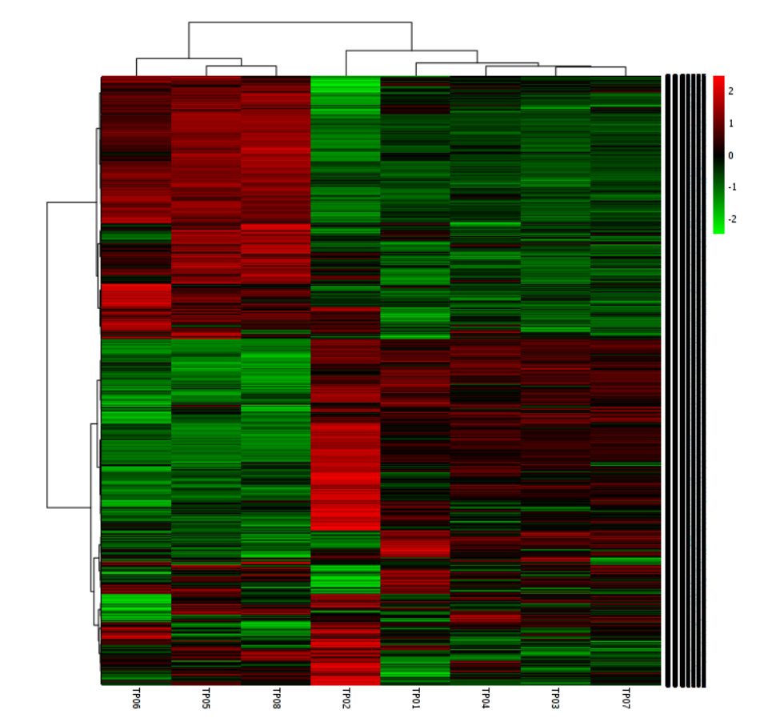
Fig. S3: Heatmap representing the clustering of distance measure using Euclidean and clustering algorithm at COG level 2 ((TP01: CETP collection tank; TP02: Textile industry effluent; TP03: Clariflocculator tank outlet; TP04: Dissolved air Flotation tank outlet; TP05: Aeration tank; TP06: Final outlet of effluent; TP07: Sludge disposal; TP08: Final sludge disposal).

Fig. S4 KEGG based mapping of metagenomics derived ORFs at level 1(TP01: CETP collection tank; TP02: Textile industry effluent; TP03: Clariflocculator tank outlet; TP04: Dissolved air Flotation tank outlet; TP05: Aeration tank; TP06: Final outlet of effluent; TP07: Sludge disposal; TP08: Final sludge disposal).
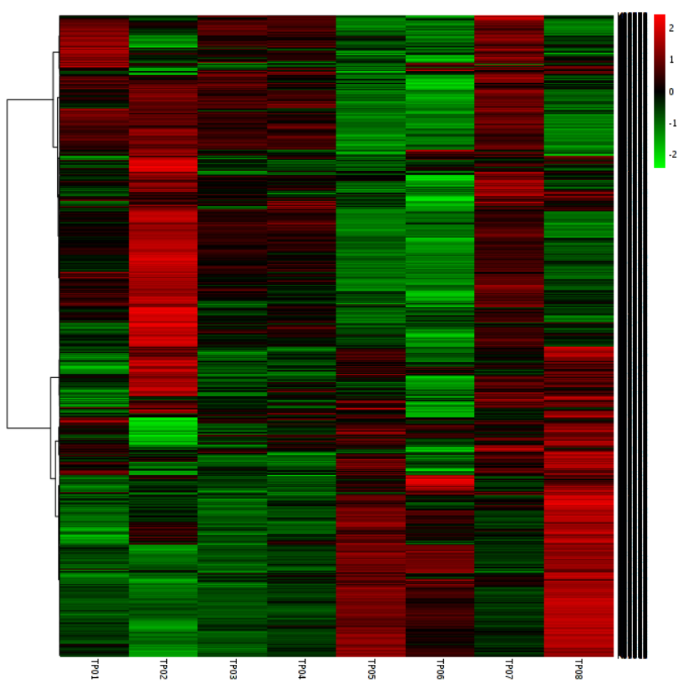
Fig. S5: Clustering result shown as heatmap (distance measure using euclidean and clustering algorithm using at KEGG level 2((TP01: CETP collection tank; TP02: Textile industry effluent; TP03: Clariflocculator tank outlet; TP04: Dissolved air Flotation tank outlet; TP05: Aeration tank; TP06: Final outlet of effluent; TP07: Sludge disposal; TP08: Final sludge disposal).

