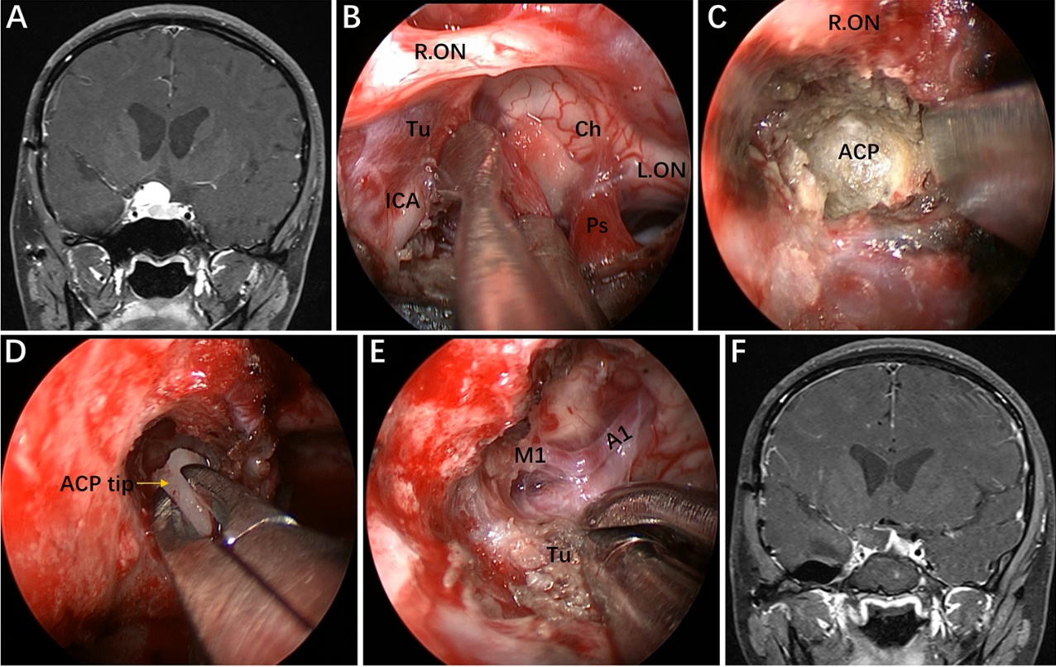
Fig. S4. Case 2, A 25-year-old woman presented with headache and decreased vision in her right eye for 6 months. A: Preoperative coronal Gd-enhanced MRI demonstrating a right recurrent ACP meningioma. B: Removal of the tumor on the medial and upper parts of the supraclinoidal ICA. C and D: Removal of the ACP invaded by the tumor. E: Separation of tumor adhering to the bifurcation of the ICA through the infraoptic corridor. F: Postoperative MRI showing total tumor removal. Some panels of the figure have been published in Journal of Neurosurgery. Published with permission. The figure is available in color only online.

