Table S1. Comparison of group/subgroup size of AP2/EREBP superfamily between this study and the previous study.
This study |  |  | Previous study (Wang et al., 2019)
Classification | Group | No. | Classification | Group | No.
AP2 family |  | 18 | AP2 family |  | 18
 | Double AP2 domain | 16
 | Single AP2 domain | 2
AP2/ERF family |  | 93 | ERF family |  | 91
 | DREB | 32 |  | Group 1-5 | 33
 | ERF | 61 |  | Group 6-11 | 58
Soloist |  | 1 | Soloist |  | 1
RAV family | RAV | 7 | RAV family |  | 5
 | Total | 119 |  | Total | 115

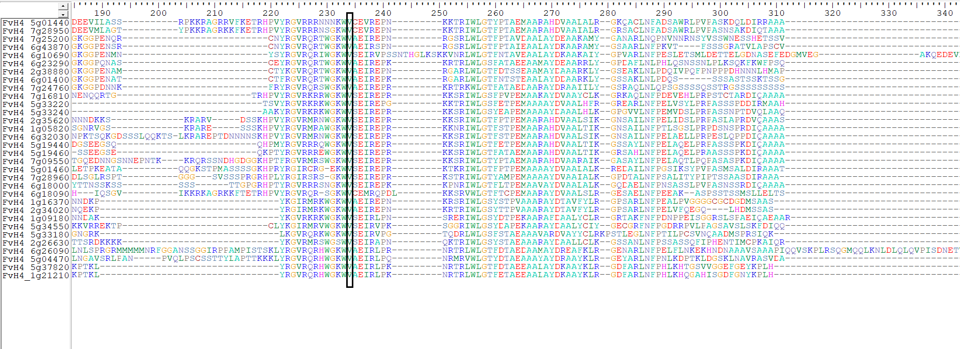
Fig. S1 Comparison of amino acid sequences of the AP2 domains in the FvDREB subfamily
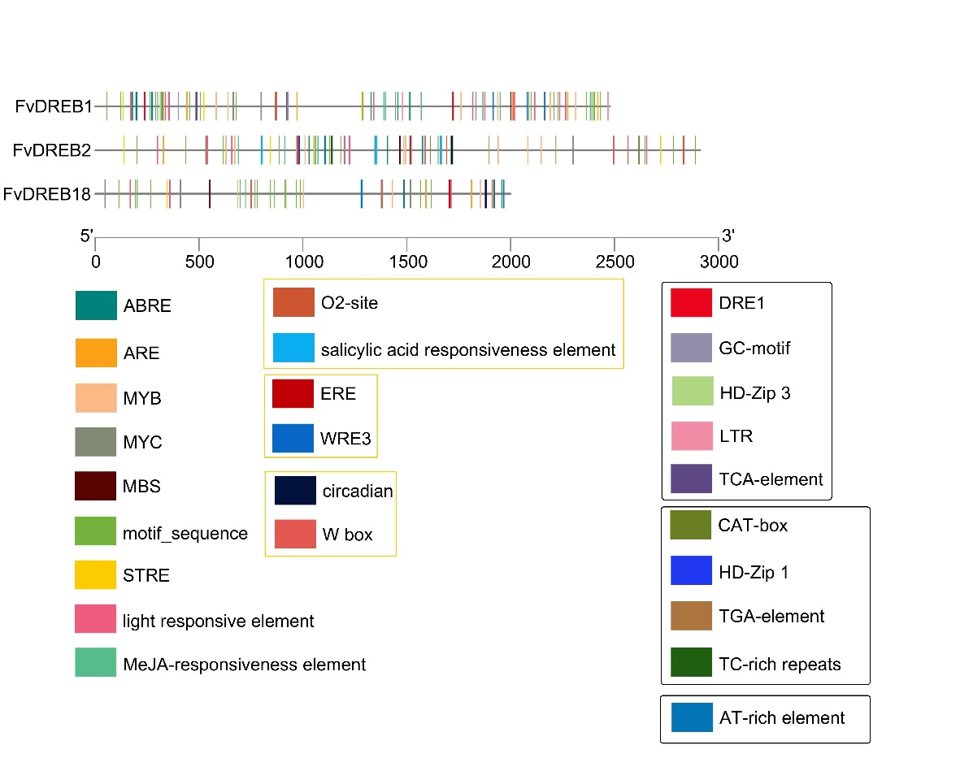
Fig S2. Characteristics of cis-regulatory elements in the promoter region of FvDREBs. All cis-regulatory elements were listed in supplementary information. Some basic cis-acting elements, such as TATA-box, GC-BOX and CAAT-box, and some cis-regulatory elements with unknown functions were not shown in this figure. The elements in the left column were found in the promoter region of the three FvDREB genes, in the middle column were found in the two of three genes, and in the right column were only found in one of the three gene.

