Supplementary Information

Supplementary Figures

A
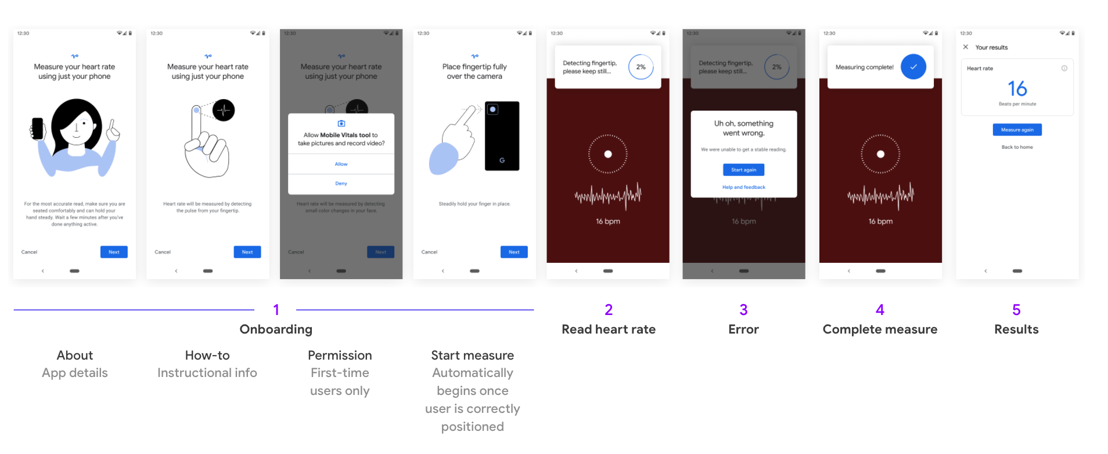
B
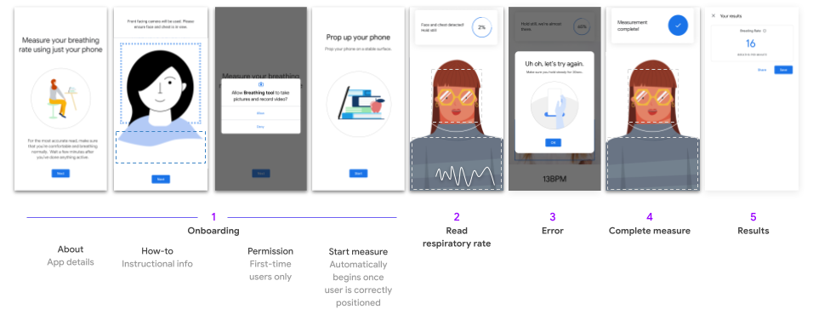
Supplementary Figure 1. Detailed user interface for both heart rate (HR) and respiratory rate (RR) measurements.
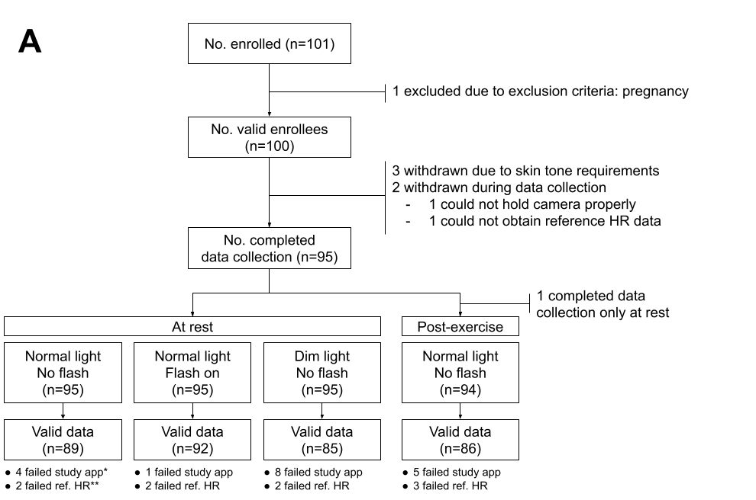
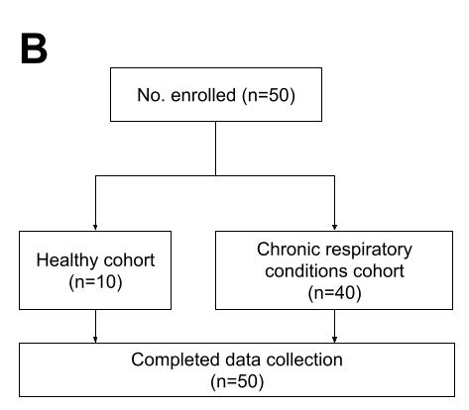
Supplementary Figure 2. Number of participants enrolled and data analyzed in (A) the heart rate (HR) study and (B) the respiratory rate (RR) study. *Failed study application data collection due to signal-to-noise ratio <0; **Failed reference HR collection.

A
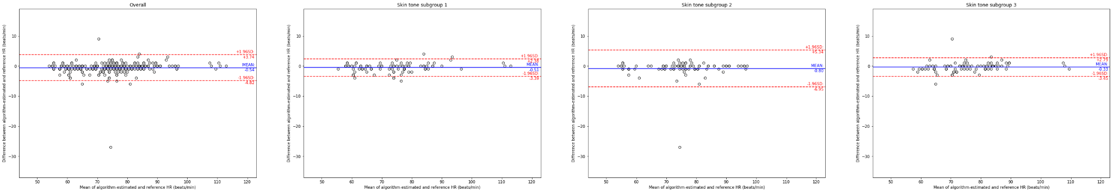
B
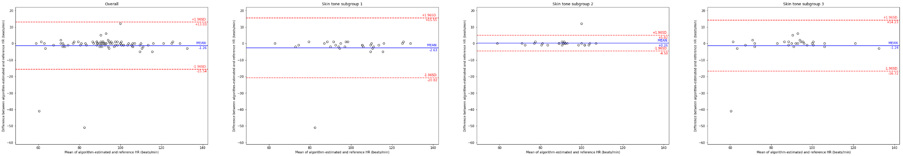
Supplementary Figure 3. Additional Bland-Altman plots for the heart rate (HR) study (see Figure 2), for participants (A) at rest and (B) post-exercise. Left to right: plots from the full study followed by subgroups based on skin type (see Figure 1). The reference HR was obtained from a pulse oximeter (see Methods). Dots represent individual participants; blue lines indicate the mean difference; red lines indicate the 95% limits of agreement (mean difference ± 1.96 standard deviations).

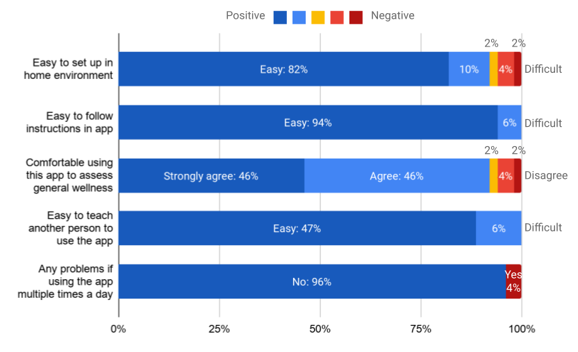
Supplementary Figure 4. Participants’ survey results after the respiratory rate (RR) study. The exact survey questions are provided in Supplementary Table 7.

Supplementary Tables

Supplementary Table 1A. Eligibility criteria of the heart rate (HR) study.
Inclusion criteria | - Age > 18 years  - Participant is able and willing to provide written informed consent (Attached document: GH-VV-002 [ICF Heart Rate Study])  - Reads and speaks English. (Spanish speaking participants may be enrolled based on IRB requirements and/or availability of bilingual clinical study staff)
Exclusion criteria | - Unwilling or unable to remove makeup or face covering for study participation  - Pregnancy - Women who are, or believe they might be, pregnant  - Inability to understand study procedures and/or the informed consent process  - Other medical complications that preclude completion of the study as determined by the principal investigator at each study site  - Significant tremor that is present while seated at time of study as determined by the study coordinator (upper chest or face)  - Ineligibility for physical activity based on interpretation of PAR-Q by the site’s principal investigator. Study participants who answer yes to one or more of the PAR-Q questions should be further assessed for eligibility by the site’s principal investigator.
Enrollment requirements | Age  - ≥25% between 20–39 years old  - ≥25% between 40–59 years old  - ≥25% greater than 60 years old  Skin Tones  Measured by Pantone Device; see Supplementary Table 2 for details  - ≥30% Very light, light, intermediate (minimum 10 participants from each group, maximum 40 participants in total)  - ≥20% Tan, brown (minimum 10 participants from each group, maximum 30 participants in total)  - ≥30% Dark (minimum 30 participants)

Supplementary Table 1B. Eligibility criteria of the respiratory rate (RR) study.
Inclusion criteria | - Age > 18 years  - Participant is able and willing to provide written informed consent  - Reads and speaks English. (Spanish speaking participants may be enrolled based on IRB requirements and/or availability of bilingual clinical study staff)
 | Healthy cohort (n=10) | - No respiratory symptoms at time of study and no history of chronic respiratory conditions.
 | Cohort of chronic respiratory conditions (n=40) | - COPD of moderate severity as defined by at least one of the following:  - hospitalized for exacerbation within 1 year  - received oral steroids for COPD within 3 months  - Current use of supplemental oxygen at home.  AND  - A Modified Medical Research Council (mMRC) breathlessness scale score of > 26  - Asthma that is not currently well-controlled, as determined by by one or more of the following;  - Emergency department visit and/or hospital admission for asthma within the preceding 3 months  - Use of oral corticosteroids for > 3 days for treatment of asthma within the preceding 3 months  - Use of a short acting beta agonist (SABA) for > 2 days during the preceding 7 days
Exclusion criteria | - Pregnancy - Women who are, or believe they might be, pregnant  - Inability to understand study procedures and/or the informed consent process  - Medical or other complications that preclude completion of the study as determined by the principal investigator at each study site  - Significant tremor that is present while seated at time of study as determined by the study coordinator (upper chest or face)
Enrollment requirements | Age  - > 20% between 20–39 years old  - > 20% between 40–59 years old  - > 40% greater than 60 years old  Race/Ethnicity  - > 20% self-identifying as of Hispanic/Latino ethnicity  - > 20% self-identifying as White  - > 20% self-identifying as African American/Black

Supplementary Table 2. Objective skin tone information was objectively measured by applying a Pantone RM200QC Spectro to each participant’s cheek and mapping the parameters to a Fitzpatrick skin type. The numerical parameters were in the CIELAB color space, and the L* and b* parameters were converted to an individual typology angle (°ITA) as defined by the function [arctan(L* - 50)/b*] x 180/3.14159.
°ITA | Skin Tone Classification | Mapped to Fitzpatrick Skin Type
°ITA > 55° | Very Light | 1
41° < °ITA ≤ 55° | Light | 2
28° < °ITA ≤ 41° | Intermediate | 3
10° < °ITA ≤ 28° | Tan | 4
-30° < °ITA ≤ 10° | Brown | 5
°ITA ≤ -30° | Dark | 6

Supplementary Table 3. Participant race and skin tone group stratified by signal-to-noise ratio (SNR) readings < 0 for the heart rate (HR) study.

 | No. of participants with SNR<0 | No. of participants with SNR≥0 | P value*
Age | 45.5 ± 16.4 | 41.2 ± 14.7 | 0.372
Sex*  Female  Male | 11 (15.4%)  3 (12.5%) | 60 (84.5%)  21 (87.5%) | >0.99
Race/ethnicity*  White, non-Hispanic  Black, non-Hispanic  Asian / pacific islander  Multiple races, non-Hispanic  Multiple races, Hispanic | 5 (20.0%)  8 (13.1%)  1 (14.3%)  0 (0.0%)  0 (0.0%) | 20 (80.0%)  53 (86.9%)  6 (85.7%)  1 (100%)  1 (100%) | 0.798
Measured skin tone**  1 (Fitzpatrick types 1-3)  2 (Fitzpatrick types 4-5)  3 (Fitzpatrick type 6) | 5 (16.1%)  4 (12.5%)  5 (15.6%) | 26 (83.9%)  28 (87.5%)  27 (84.4%) | 0.938
Fitzpatrick type  1 (Very light)  2 (Light)  3 (Intermediate)  4 (Tan)  5 (Brown)  6 (Dark) | 0 (0.0%)  1 (6.3%)  4 (28.6%)  2 (40.0%)  2 (7.4%)  5 (15.6%) | 1 (100%)  15 (93.8%)  10 (71.4%)  3 (60.0%)  25 (92.6%)  27 (84.4%) | 0.194

* P values were calculated by Fisher’s exact test comparing participants with SNR<0 and those with SNR≥0
** Fitzpatrick determination based on measurement with Pantone device and conversion to Fitzpatrick scale
Supplementary Table 4. Detailed results of the heart rate (HR) study.
Session | Number of participants | Number of data points | Reference HR  (beats/min) |  | MAE  (beats/min) | MAPE
 |  |  | Mean ± SD | Range | Mean ± SD | Mean ± SD | Median (IQR) | 95th percentile
Total population | 95 | 352 | 79.8 ± 14.6 | 54–134 | 1.32 ± 3.92 | 1.63 ± 4.27 | 1.14 (0.0–1.64) | 4.84
At rest, flash on, regular light | 95 | 89 | 75.6 ± 11.1 | 55–113 | 0.87 ± 1.06 | 1.16 ± 1.38 | 1.22 (0.0–1.47) | 3.97
At rest, flash off, regular light | 95 | 92 | 74.8 ± 11.0 | 54–111 | 1.23 ± 3.01 | 1.64 ± 3.60 | 1.20 (0.0–1.64) | 4.77
At rest, flash off, dim light | 95 | 85 | 75.6 ± 11.2 | 55–110 | 0.96 ± 1.26 | 1.33 ± 1.77 | 1.18 (0.0–1.67) | 5.19
Post-exercise | 94 | 86 | 93.9 ± 15.4 | 59–134 | 2.23 ± 7.05 | 2.39 ± 7.45 | 1.02 (0.0–1.75) | 5.42
Subgroup 1: very light, light, and intermediate skin tone | 31 | 119 | 81.0 ± 17.4 | 56–129 | 1.53 ± 4.73 | 1.77 ± 4.46 | 1.27 (0.0–1.83) | 4.84
At rest, flash on, regular light | 31 | 30 | 74.5 ± 11.8 | 58–113 | 1.03 ± 1.16 | 1.40 ± 1.56 | 1.28 (0.0–1.69) | 4.49
At rest, flash off, regular light | 31 | 31 | 74.0 ± 11.6 | 58–111 | 1.00 ± 1.15 | 1.36 ± 1.57 | 1.27 (0.0–1.64) | 4.59
At rest, flash off, dim light | 31 | 28 | 74.2 ± 12.3 | 56–110 | 1.04 ± 1.23 | 1.43 ± 1.72 | 1.23 (0.0–1.74) | 5.13
Post-exercise | 31 | 30 | 101.0 ± 15.9 | 63–129 | 3.03 ± 9.15 | 2.90 ± 8.46 | 1.09 (0.82–2.09) | 4.36
Subgroup 2: tan and brown skin tone | 32 | 113 | 78.8 ± 12.7 | 54–107 | 1.04 ± 2.87 | 1.32 ± 3.30 | 0.98 (0.0–1.37) | 4.86
At rest, flash on, regular light | 32 | 28 | 76 .0± 11.3 | 55–97 | 0.86 ± 1.15 | 1.14 ± 1.40 | 1.23 (0–1.43) | 2.32
At rest, flash off, regular light | 32 | 29 | 75.2 ± 11.4 | 54–96 | 1.59 ± 4.98 | 1.97 ± 5.68 | 0.0 (0.0–1.35) | 4.93
At rest, flash off, dim light | 32 | 29 | 75 .0± 11.3 | 55–96 | 0.86 ± 1.27 | 1.20 ± 1.78 | 0.0 (0.0–1.72) | 5.35
Post-exercise | 32 | 27 | 89.5 ± 11.3 | 59–107 | 0.85 ± 2.28 | 0.93 ± 2.43 | 0.0 (0.0–1.10) | 1.35
Subgroup 3: dark skin tone | 32 | 120 | 79.7 ± 13.3 | 58–134 | 1.37 ± 3.89 | 1.77 ± 4.87 | 1.15 (0.0–1.64) | 4.48
At rest, flash on, regular light | 32 | 31 | 76.2 ± 10.6 | 61–110 | 0.71 ± 0.86 | 0.95 ± 1.17 | 0.91 (0–1.49) | 3.24
At rest, flash off, regular light | 32 | 32 | 75.3 ± 10.4 | 58–108 | 1.12 ± 1.66 | 1.61 ± 2.50 | 1.22 (0–1.93) | 3.71
At rest, flash off, dim light | 32 | 28 | 77.5 ± 10.0 | 60–107 | 1.00 ± 1.31 | 1.35 ± 1.87 | 1.19 (0–1.41) | 3.99
Post-exercise | 31 | 29 | 90.6 ± 15.9 | 61–134 | 2.69 ± 7.51 | 3.22 ± 9.27 | 1.12 (0.0–2.17) | 6.27
Abbreviations: HR, heart rate; MAE, mean absolute error; MAPE, mean absolute percentage error; SD, standard deviation; IQR, interquartile ranges

Supplementary Table 5. Detailed results of the respiratory rate (RR) study.
Subgroups | N | Reference RR  (breaths/min) |  | MAE (breaths/min)
 |  | Mean ± SD | Range | Mean ± SD | Range | P value
Algorithm version A | 50 | 15.5 ± 3.6 | 8–22 | 0.84 ± 0.97 | 0–6 | <0.001
Healthy | 10 | 16.0 ± 3.7 | 10–20 | 0.60 ± 0.52 | 0–1 | 0.001
Chronic respiratory conditions | 40 | 15.4 ± 3.6 | 8–22 | 0.90 ± 1.05 | 0–6 | <0.001
Algorithm version B | 50 | 15.3 ± 3.7 | 8–26 | 0.78 ± 0.61 | 0–2 | <0.001
Healthy | 10 | 16.4 ± 3.7 | 12–22 | 0.70 ± 0.67 | 0–2 | <0.001
Chronic respiratory conditions | 40 | 15.1 ± 3.7 | 8–26 | 0.80 ± 0.60 | 0–2 | 0.001
Abbreviations: RR, respiratory rate; MAE, mean absolute error; SD, standard deviation

Supplementary Table 6. Subgroup analysis for algorithm version B of the respiratory rate (RR) study.
Subgroups | N | Reference RR  (breaths/min) |  | MAE (breaths/min)
 |  | Mean ± SD | Range | Mean ± SD | Range | P value
Age subgroups
<40 years old | 17 | 15.8 ± 4.4 | 10–26 | 0.79 ± 0.64 | 0–2 | <0.001
40–59 years old | 21 | 15.3 ± 3.1 | 10–22 | 0.79 ± 0.60 | 0–2 | <0.001
≥60 years old | 12 | 14.8 ± 3.8 | 8–22 | 0.75 ± 0.62 | 0–2 | <0.001
Race/ethnicity
White, non-Hispanic | 18 | 15.4 + 4.1 | 8–26 | 0.72 + 0.67 | 0–2 | <0.001
Black, non-Hispanic | 6 | 18.0 + 4.0 | 12–22 | 0.83 + 0.41 | 0–1 | <0.001
Hispanic/Latino ethnicity | 23 | 14.5 + 2.6 | 10–19 | 0.83 + 0.63 | 0–2 | <0.001
Other | 3 | 16.3 + 6.8 | 12–24 | 0.67+ 0.58 | 0–1 | 0.010

Supplementary Table 7. Participant experience survey on the respiratory rate (RR) measurement algorithm.

How easy do you believe it would be to find a place to prop the phone up at home? | ☐  Easy* | ☐  Somewhat Easy* | ☐  Neither easy nor difficult | ☐  Somewhat difficult | ☐  Difficult
How would you rate the experience of following instructions in this application? | ☐  Easy* | ☐  Somewhat Easy* | ☐  Neither easy nor difficult | ☐  Somewhat difficult | ☐  Difficult
How much do you agree with the following statement, I would feel comfortable using this application to assess my general wellness? | ☐  Strongly agree* | ☐  Agree* | ☐  Neither agree nor disagree | ☐  Disagree | ☐  Strongly disagree
How well do you feel you could teach another person to use this application? | ☐  Easy* | ☐  Somewhat Easy* | ☐  Neither easy nor difficult | ☐  Somewhat difficult | ☐  Difficult
If you needed to use this app several times per day do you think there would be any problems? | ☐  Yes | ☐  No*
(Optional) Do you have any other feedback you’d like to give on this application? | (Free description)
* These responses were considered a “positive” response, and excludes neutral responses: “neither easy nor difficult” and “neither agree nor disagree”.

