Supplementary Figures

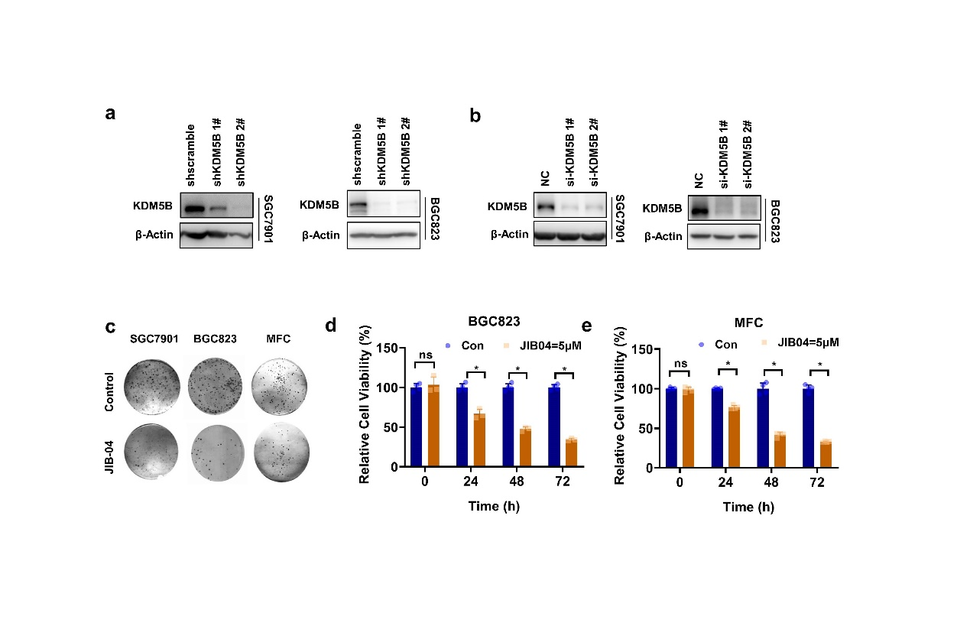
Figure. S1
KDM5B was upregulated to promote cell proliferation in gastric cancer a-b The knocking down of KDM5B by shRNA or siRNA in SGC7901 and BGC823 cells was verified by Western blotting. c Colony formation of SGC7901, BGC823 and MFC cells treated with JIB04 (1 μM). d, e Relative cell viability of BGC823 and MFC cells at 24h, 48h and 72h after treatment of JIB04 (5 μM) were determined by CCK8 assay (mean ± SD, n = 3, one-way ANOVA, *p<0.05).

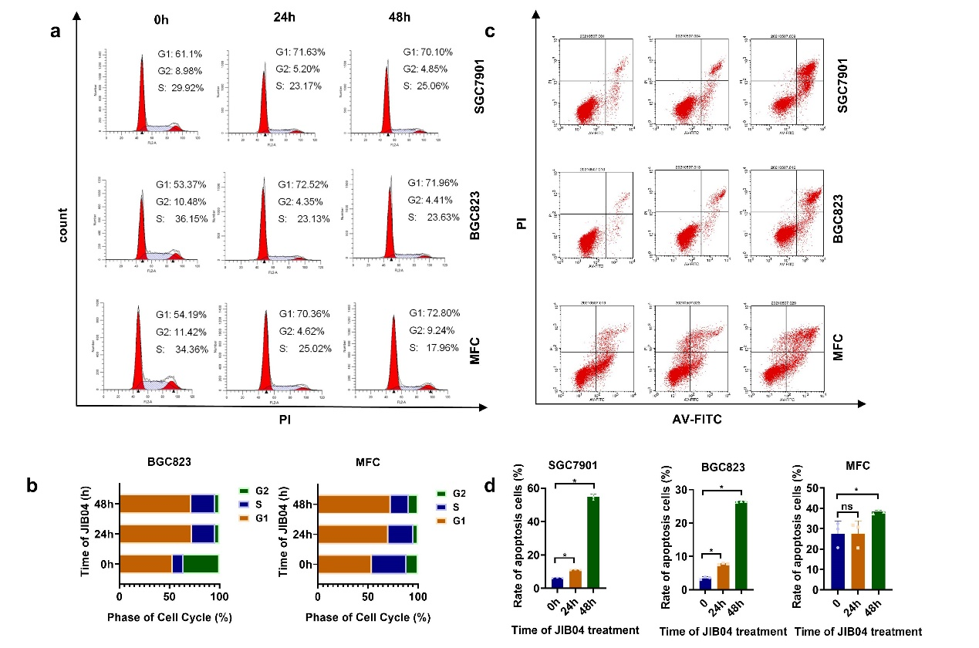
Figure. S2
KDM5B inhibition induced G1/S arrest and apoptosis
a, b Flow cytometry analysis of cell cycle in SGC7901, BGC823 and MFC cells before and after treatment of JIB04 at 24 and 48 hours. c, d Flow cytometry analysis of cell apoptosis in SGC7901 cells before and after treatment of JIB04 (5μM) at 24h and 48h hours.

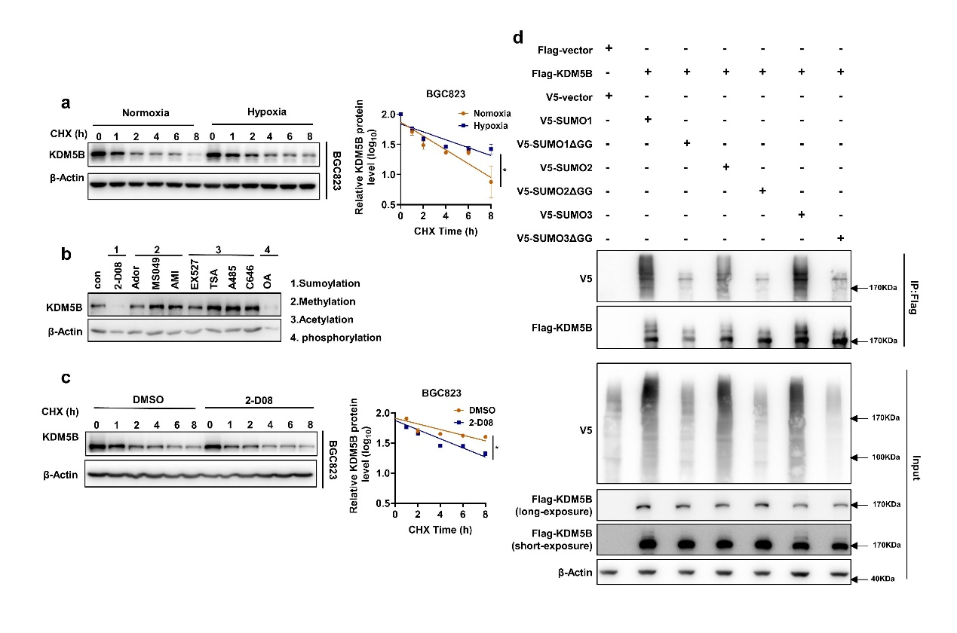
Figure. S4
Hypoxia induced SUMO3-dependent SUMOylation and subsequent stabilization of KDM5B
a The half-life of KDM5B protein in BGC823 cells under normoxia and hypoxia (1%O₂) was determined by CHX assay. The relative KDM5B protein expression was quantified by ImageJ (mean ± SD, n = 3, ANCOVA analysis, *p<0.05). b KDM5B expression in SGC7901 cells treated with various inhibitors as indicated，2-D08 (200μM), ADOX (20μM), MS049 (10μM), AMI-1 (10μM), EX527 (100nM), TSA (1μM), A485 (10nM), C646 (10μM), and okadaicacid (OA) (10nM) for 24h were determined by Western blotting. c The half-life of KDM5B protein in BGC823 cells under hypoxia (1%O₂) with 2-D08 (200μM) or DMSO treatment was determined by CHX assay. The relative KDM5B protein expression was quantified by ImageJ (mean ± SD, n = 3, ANCOVA analysis, *p<0.05). d HEK293T co-transfected with indicated plasmids for 48h under normoxia, and the SUMOylation assay with Flag antibody was performed followed by western blot analysis.

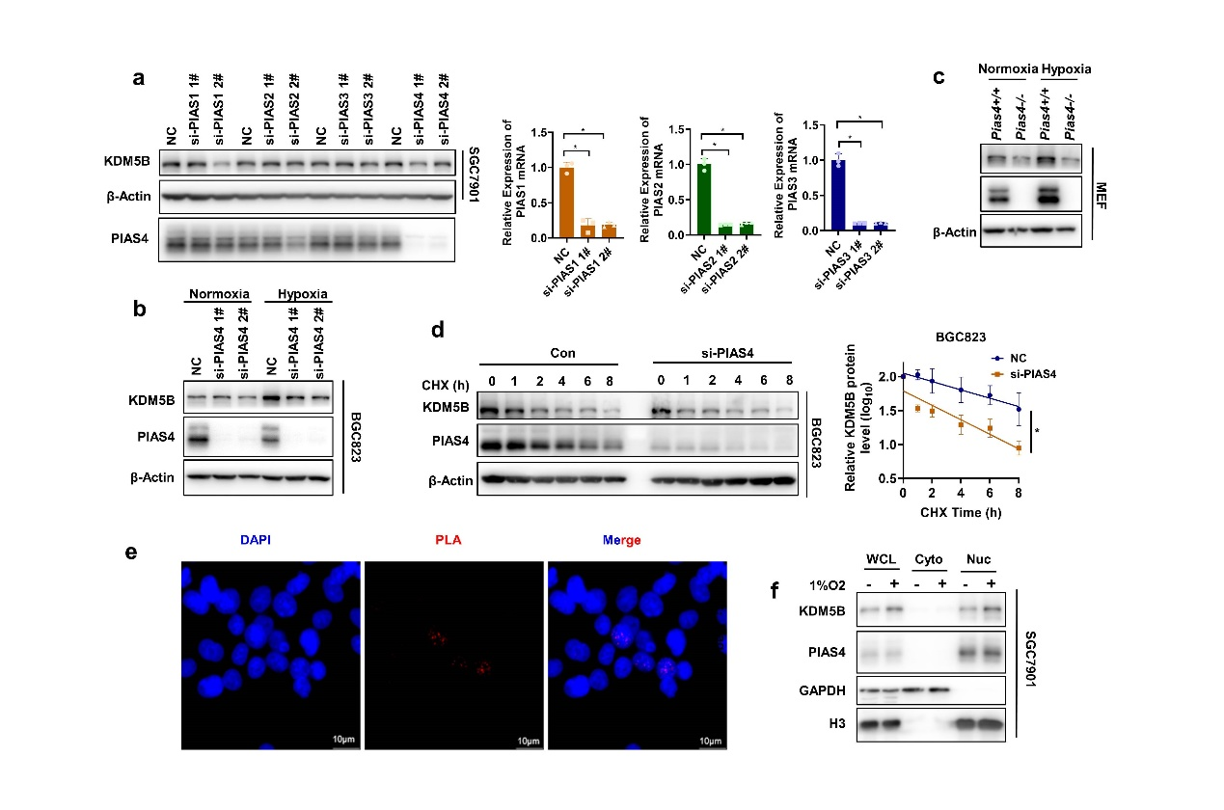
Figure. S5
PIAS4 was the SUMO E3 ligase for hypoxia-induced KDM5B SUMOylation.
a The protein expression of KDM5B was determined by Western blotting with or without the PIAS1/2/3/4 knocking down by siRNA with 1%O₂ treatment for 6h. b The protein expression of KDM5B in BGC823 under normoxia and 1%O₂ condition for 6h with or without PIAS4 knockdown by siRNA was analyzed by western blotting. c Western blotting analysis of the protein expression of KDM5B in Pias4+/+ and Pias4-/- MEF under normoxia and 1%O_{2.}for 6h. d BGC823 was transiently transfected with PIAS4 siRNA for 48h later with cycloheximide (CHX) and 1% O₂ treatment for the indicated times, and then the half-life of KDM5B was analyzed by western blotting. e PLA assay was performed withing Flag and PIAS4 antibody after 293T co-transfected with Flag-KDM5B and HA-PIAS4 for 48h. The red PLA spots in the nucleus indicated a positive PLA signal, suggesting interactions between the two proteins. f The nuclear and cytosol fractions were isolated using the Nuclear-Cytosol Extraction Kit (Thermo, USA), then the distribution of KDM5B and PIAS4 was analyzed by western blotting (H₃ and GAPDH were used as marker of nuclear and cytosol fraction separately).

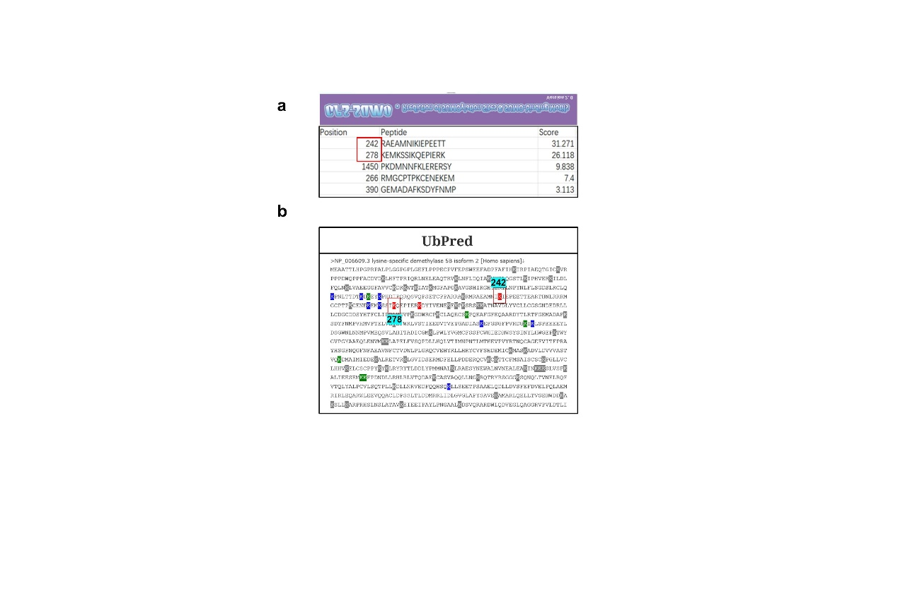
Figure. S6
PIAS4-mediated KDM5B SUMOylation prevents it from ubiquitination-dependent proteasomal degradation
a The SUMOylation modification sites of KDM5B were predicted by GPS-SUMO based on the SUMO modification consensus motif. K242 and K278 were the top 2 sites which were the most potential sites modified by SUMOylation. b The ubiquitination sites of KDM5B were predicted by UbPred. K242 and K278 were in the red highlight, means the strongest possibility be ubiquitinated at these 2 sites.

Supplementary Tables
Table. S1
Name | Sequence | supplier
siKDM5B-1# | GAGGGCAUUAUGAACGAAUTT  AUUCGUUCAUAAUGCCCUCTT | Gene Pharma Company (Shanghai, China)
siKDM5B-2# | GGAGACUAGUAAGCACUAUTT  AUAGUGCUUACUAGUCUCCTT | Gene Pharma Company (Shanghai, China)
siPIAS1-1# | GGAACUAAAGCAAAUGGUUTT  AACCAUUUGCUUUAGUUCCTT | Gene Pharma Company (Shanghai, China)
siPIAS1-2# | GCAGCCUGGUUUCUUCCAATT  UUGGAAGAAACCAGGCUGCTT | Gene Pharma Company (Shanghai, China)
siPIAS2-1# | CCCUGCGGUUCAGAUUAAATT  UUUAAUCUGAACCGCAGGGTT | Gene Pharma Company (Shanghai, China)
siPIAS2-2# | GCCUAUGAAAGUCUAAUAUTT  AUAUUAGACUUUCAUAGGCTT | Gene Pharma Company (Shanghai, China)
siPIAS3-1# | GCAAGUGCAGCAGAUUCUUTT  AAGAAUCUGCUGCACUUGCTT | Gene Pharma Company (Shanghai, China)
siPIAS3-2# | CCCUUUAUCUACAGAUGAATT  UUCAUCUGUAGAUAAAGGGTT | Gene Pharma Company (Shanghai, China)
siPIAS4-1# | GCUGAAGCCCACCGAAUUATT  UAAUUCGGUGGGCUUCAGCTT | Gene Pharma Company (Shanghai, China)
SiPIAS4-2# | GCUCUACGGAAAGUACUUATT  UAAGUACUUUCCGUAGAGCTT | Gene Pharma Company (Shanghai, China)
siRNA sequences used for knockingdown

Table. S2
Primer sequences used for clone

PIAS4 ΔRING-C337S | F:5'-CTCTGCACGGGAGGGCACCGAGAG-3'  R:5'-CTCTCGGTGCCCTCCCGTGCAGAG-3'
PIAS4 ΔRING-C342S | F:5'-GCAGGTGTGCGGAGGTCTCTGCACGG-3'  R:5'-CCGTGCAGAGACCTCCGCACACCTGC-3'
PIAS4 ΔRING-H344A | F:5’-TGCAGAGACCTCCGCAGCCCTGCAGTGCTTTG-3’  R:5'-CAAAGCACTGCAGGGCTGCGGAGGTCTCTGCA-3'
PIAS4 ΔRING-C347S | F:5'-ACACAGCATCAAAGGACTGCAGGGCTGCG-3'  R5’-CGCAGCCCTGCAGTCCTTTGATGCTGTGT-3’
PIAS4-W363A | F:5'-CACACGGGGCACATCGCGGTGGGCTTCTTCTC-3'  R:5'-GAGAAGAAGCCCACCGCGATGTGCCCCGTGTG-3'

Table. S3
Primer sequences used for qPCR

HUMAN-P21 | F:5’-CTGGAGACTCTCAGGGTCGAAA-3’  R:5’-GATTAGGGCTTCCTCTTGGAGAA-3’
HUMAN-ZBTB17 | F:5’-TGTAACCCCTCCCTCCAAGC-3’  R:5’-GTCTAGCACACAGCTCTGAACG-3’
HUMAN-CDC45 | F:5’-CTTGAAGTTCCCGCCTATGAAG-3’  R:5’-GCATGGTTTGCTCCACTATCTC-3’
HUMAN-TP53 | F:5’-CCTGGTCCTCTGACTGCTCT-3’  R:5’-GTGTAGGAGCTGCTGGTGCA-3’
HUAMN-ABL1 | F:5’-AGGAGCTCTCATGGGTGAACA-3’  R:5’-GTTCTCCCCTACCAGGCAGTT-3’
HUMAN-PLK1 | F:5’-AAAGAGATCCCGGAGGTCCTA-3’  R:5’-GGCTGCGGTGAATGGATATTTC-3’
HUMAN-CDC20 | F:5’-GCACAGTTCGCGTTCGAGA-3’  R:5’-CTGGATTTGCCAGGAGTTCGG-3’
HUMAN-KDM5B | F:5’-AATCAAACTGAGCCACCCCA-3’  R:5’-CAGTCCACCTCATCTCCTTCTG-3’
HUMAN-ACTINB | F:5’-ACTCTTCCAGCCTTCCTTCC-3’  R:5’-CGTCATACTCCTGCTTGCTG-3’
HUMAN-p21-chip-p1 | F:5’-AGTGTGGCCAAAGGATCTGA-3’  R:5’-ACTGAGATTTGCAGCAGACAC-3’
HUMAN-p21-chip-p2 | F:5’-GCCCATTAATATTATAGGTCTGGC-3’  R:5’-CAATGCTGGC CTCGAAG-3’
HUMAN-p21-chip-p3 | F:5’-GCCTCTCTTCAAACATTGTACAAG-3’  R:5’-TCTATGAGAGTCCTTGTGGGC-3’
HUMAN-p21-chip-p4 | F:5’-GGAGTCTCACTCTGTCACCCA-3’  R:5’-AATATGGTG AAACCCCGTC TC-3’
HUMAN-p21-chip-p5 | F:5’-AGACGGGGTTTCACCATATTG-3’  R:5’-GATTACAGGCATGCACCACC-3’
HUMAN-p21-chip-p6 | F:5’-ATGGTGGTGCATGCCTGTA-3’  R:5’-TCAGCTTTCAGAGGAATTCACC-3’
HUMAN-p21-chip-p7 | F:5’-TGAAGGTGAATTCCTCTGAAAGC-3’  R:5’-GACAAGAGTGCCCAGTCCAG-3’
HUMAN-p21-chip-p8 | F:5’-CTGGACTGGGCACTCTTGTC-3’  R:5’-GACAAAATAGCCACCAGCCTC-3’

