Third molar agenesis in modern humans with and without agenesis of other teeth
Maya Scheiwiller, Elias S. Oeschger, Nikolaos Gkantidis

Appendix Table 1. Distribution of the total number of missing teeth per individual in the agenesis sample, excluding third molars.
 | Missing teeth | Frequency | Percentage (%)
 | 1 | 117 | 38.6
 | 2 | 101 | 33.3
 | 3 | 24 | 7.9
 | 4 | 24 | 7.9
 | 5 | 10 | 3.3
 | 6 | 3 | 1
 | 7 | 6 | 2
 | 8 | 2 | 0.7
 | 9 | 4 | 1.3
 | 10 | 4 | 1.3
 | 11 | 1 | 0.3
 | 12 | 2 | 0.7
 | 13 | 1 | 0.3
 | 14 | 3 | 1
 | 20 | 1 | 0.3
Total | 799 | 303 | 100

Appendix Table 2. Most common patterns of tooth agenesis observed in the agenesis group including third molars.
Index | Frequency (%) | Missing teeth | Index | Frequency (%) | Missing teeth
Maxilla |  |  | Mandible
1 | 31/220 (14.1) | 12, 22 | 1 | 30/234 (12.8) | 35, 45
2 | 30/220 (13.6) | 18, 28 | 2 | 24/234 (10.3) | 35
3 | 17/220 (7.7) | 22 | 3 | 20/234 (8.5) | 45  or  35, 38, 45, 48
4 | 16/220 (7.3) | 12 | 4 | 16/234 (6.8) | 38, 48
5 | 12/220 (5.5) | 15, 18, 25, 28 | 5 | 13/234 (5.6) | 38, 45, 48
Overall | 106/220 (48.2) |  | Overall | 103/234 (44.0)
Whole dentition
1 | 22/303 (7.3) | 12, 22
2 | 16/303 (5.3) | 35 or 45
3 | 15/303 (5.0) | 22
4 | 14/303 (4.6) | 35, 45
5 | 12/303 (4.0) | 12
Overall | 79/303 (26.1)

Appendix Table 3. Most common patterns of third molar agenesis observed in control individuals.
Index | Frequency (%) | Missing teeth | Index | Frequency (%) | Missing teeth
Maxilla |  |  | Mandible
1 | 26/43 (60.5) | 18, 28 | 1 | 27/48 (56.3) | 38, 48
2 | 11/43 (25.6) | 18 | 2 | 12/48 (25) | 48
3 | 6/43 (14.0) | 28 | 3 | 9/48 (18.8) | 38
Overall | 43/43 (100) |  | Overall | 48/48 (100)
Whole dentition
1 | 17/62 (27.4) | 18, 28, 38, 48
2 | 9/62 (14.5) | 38, 48
3 | 6/62 (9.7) | 38
4 | 5/62 (8.1) | 28 or 18  or 18, 48
5 | 4/62 (6.5) | 18, 28 or  48
Overall | 50/62 (80.6)

Appendix Table 4. Most common patterns of third molar agenesis observed in the agenesis subjects.
Index | Frequency (%) | Missing teeth | Index | Frequency (%) | Missing teeth
Maxilla |  |  | Mandible
1 | 88/118 (74.6) | 18, 28 | 1 | 88/124 (71.0) | 38, 48
2 | 17/118 (14.4) | 28 | 2 | 20/124 (16.1) | 38
3 | 13/118 (11) | 18 | 3 | 16/124 (12.9) | 48
Overall | 118/118 (100) |  | Overall | 124/124 (100)
Whole dentition
1 | 59/154 (38.3) | 18, 28, 38, 48
2 | 19/154 (12.3) | 38, 48
3 | 16/154 (10.4) | 18, 28
4 | 13/154 (8.4) | 38
5 | 8/154 (5.2) | 28 or 18, 28, 48
Overall | 123/154 (79.9)

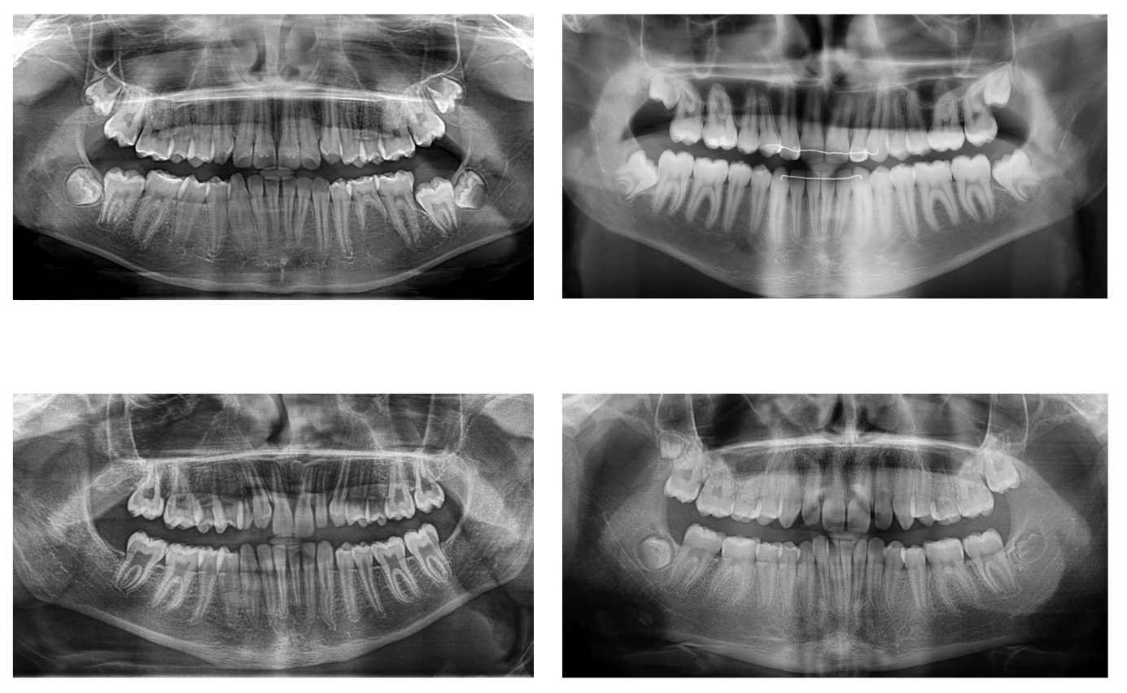
Appendix Figure 1. Four randomly selected panoramic radiographs from the tested sample.

