SupplementaryInformation for

Polarity- and molecular orbital-engineered host materials for stable and efficient blue thermally activated delayed fluorescence

Soo-Ghang Ihn,1* Daun Jeong,2 Eun Suk Kwon,1Sangmo Kim,1 Yeon Sook Chung,1 Myungsun Sim,1 Jun Chwae,1 Yasushi Koishikawa,1 Soon Ok Jeon,1Jong Soo Kim,1 Joonghyuk Kim,1 Sungho Nam,1 Hyeonho Choi,1Sunghan Kim1

*1Organic Materials Laboratory, Materials Research Center,Samsung Advanced Institute of Technology, Samsung Electronics Co., LTD, 130 Samsung-ro, Yeongtong-gu, Suwon-si, Gyeonggi-do, 16678, the Republic of Korea.*

*2Data and Information Technology Center, Samsung Electronics Co., LTD, 1 Samsungjeonja-ro, Hwaseong-si, Gyeonggi-do 18448, the Republic of Korea.*

Contents

**Supplementary Figure 1 S2**

**Supplementary Figure 2 S3**

**Supplementary Figure 3 S4**

**Supplementary Figure 4 S5**

**Supplementary Figure 5 S6**

**Supplementary Figure 6 S6**

**Supplementary Figure 7 S7**

**Supplementary Figure 8 S7**

**Supplementary Figure 9 S8**

**Supplementary Figure 10 S8**

**Supplementary Figure 11 S9**

**Supplementary Figure 12 S9**



**Supplementary Figure 1. Ground-state dipole moments *μ*GS of hosts calculated from various conformer structures, related Figure 2.** The representative value, corresponding to the minimum energy structure for each host, is marked with ablack solid line.

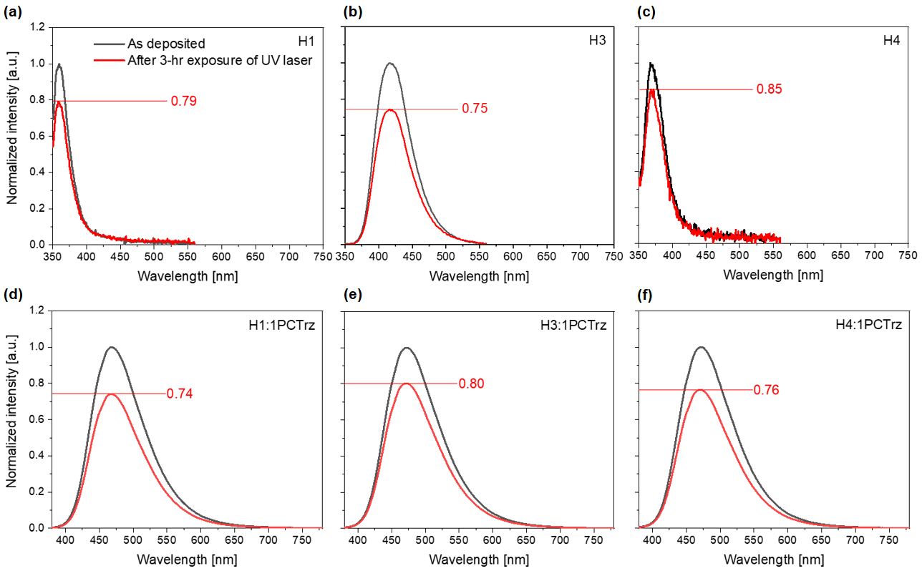

**Supplementary Figure 2. PL stability of various host films with and without 1PCTrz doping, related to Figure 6.**

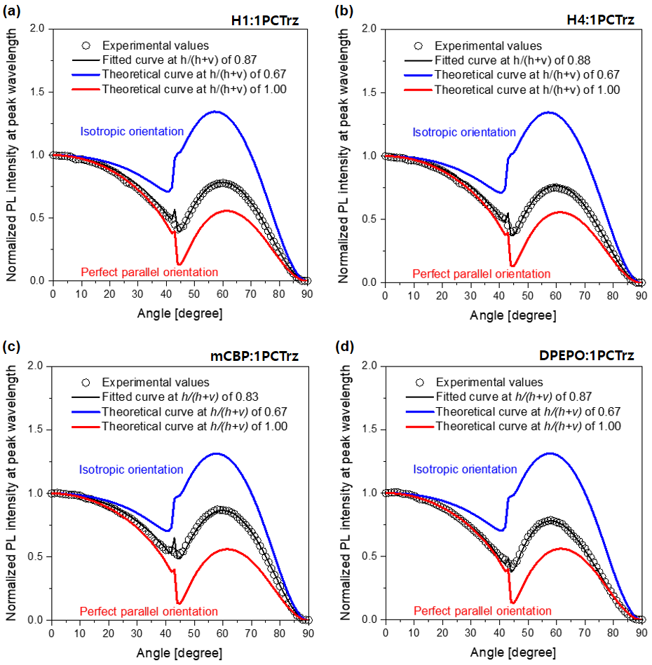

**Supplementary Figure 3. Analysis of the horizontal orientations of the transition dipolemoments, *h*/(*h* + *v*), related Figure 7.** Angle-dependent PL intensities at peak wavelengths. The black open squares represent the PL intensities from **a.** H1:1PCTrz, **b.** H4:1PCTrz, **c.** mCBP:1PCTrz, and **d.** DPEPO:1PCTrz films. Inspection of the solid curves for the films of the four 15% TADF emitter (1PCTrz)-doped hosts (H1, H4, mCBP, and DPEPO) reveal that the horizontal orientations of (*h*/(*h*+ *v*)) are 0.87, 0.88, 0.83, and 0.87, respectively. The blue and red lines correspond to theoretical curves constructed with *h*/(*h*+ *ν*) values of 0.67 (isotropic orientation) and 1.0 (perfect parallel orientation), respectively.



**Supplementary Figure 4. Synthetic route for H1, H2, H3, H4.**

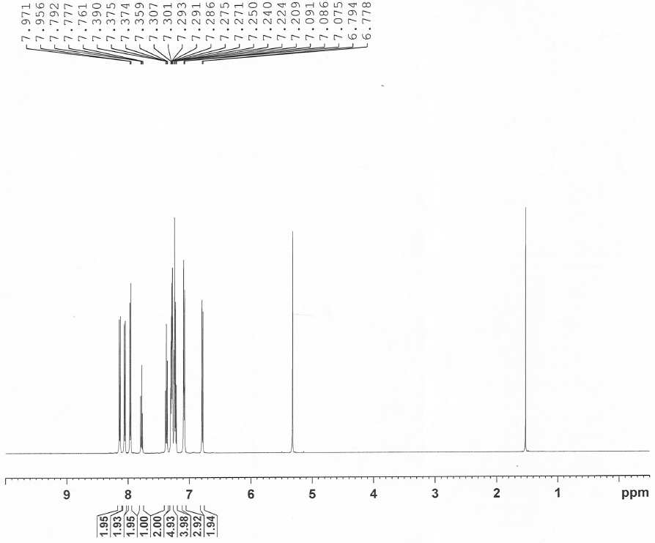

**Supplementary Figure 5. 1H NMR spectra of H1.**

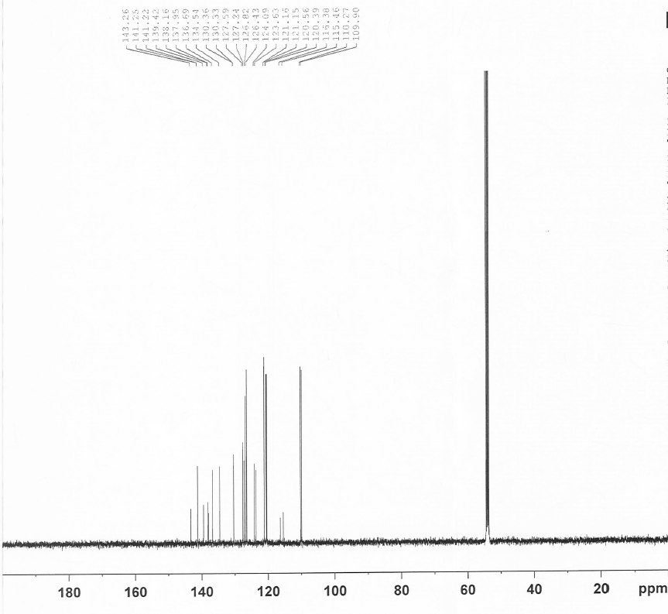

**Supplementary Figure 6. 13C NMR spectra of H1.**

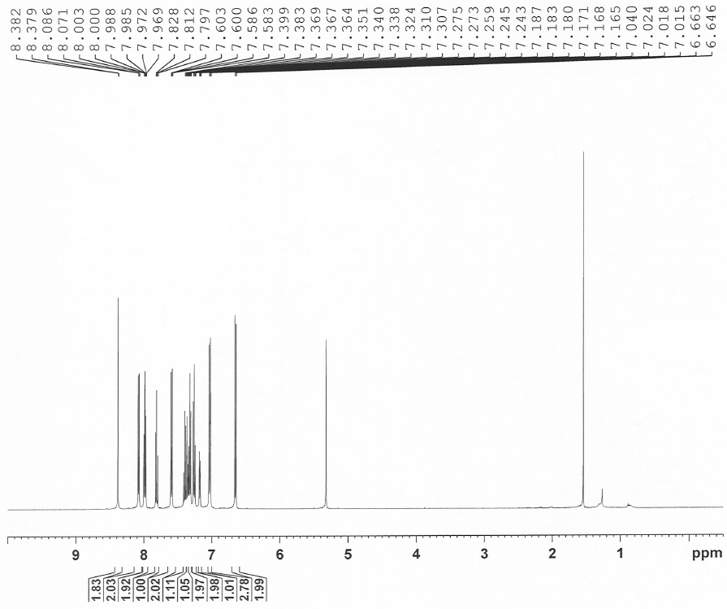

**Supplementary Figure 7. 1H NMR spectra of H2.**

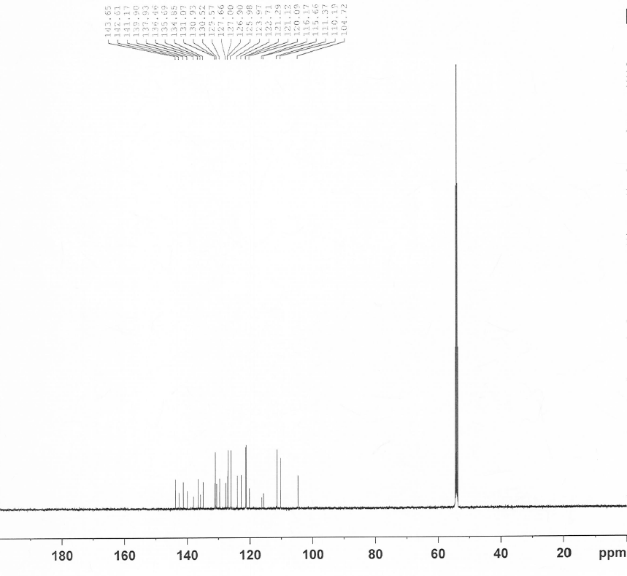

**Supplementary Figure 8. 13C NMR spectra of H2.**

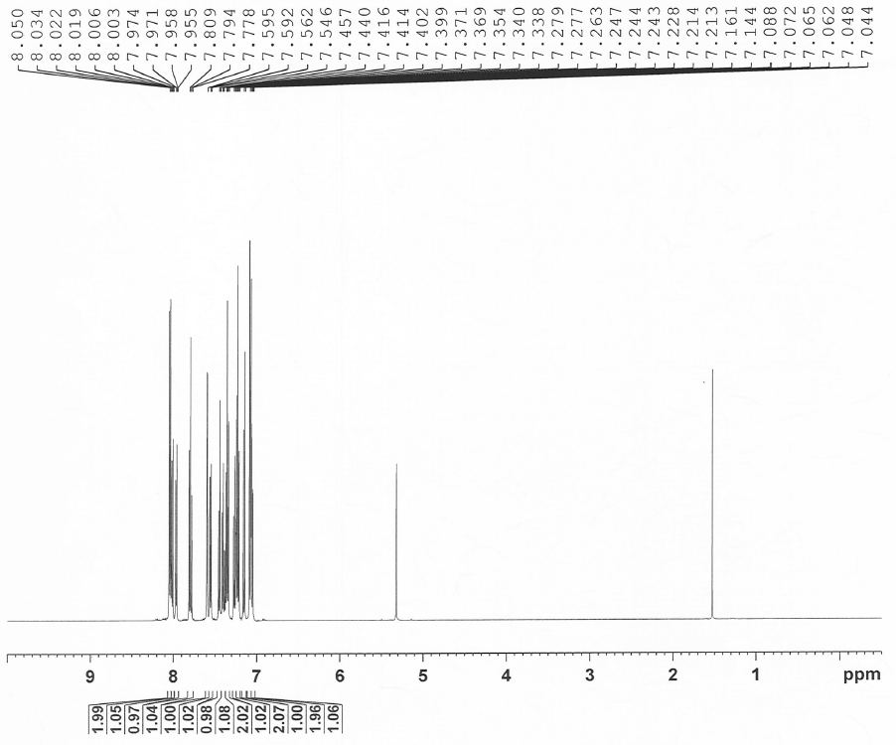

**Supplementary Figure 9. 1H NMR spectra of H3.**

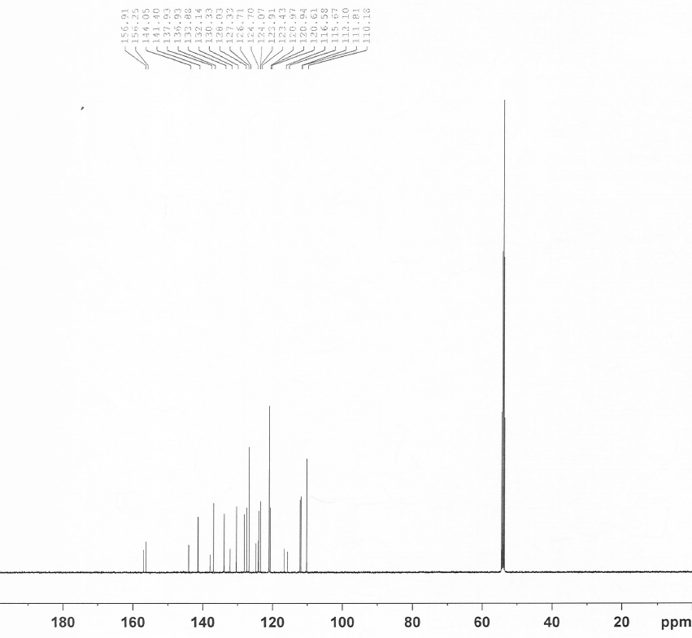

**Supplementary Figure 10. 13C NMR spectra of H3.**

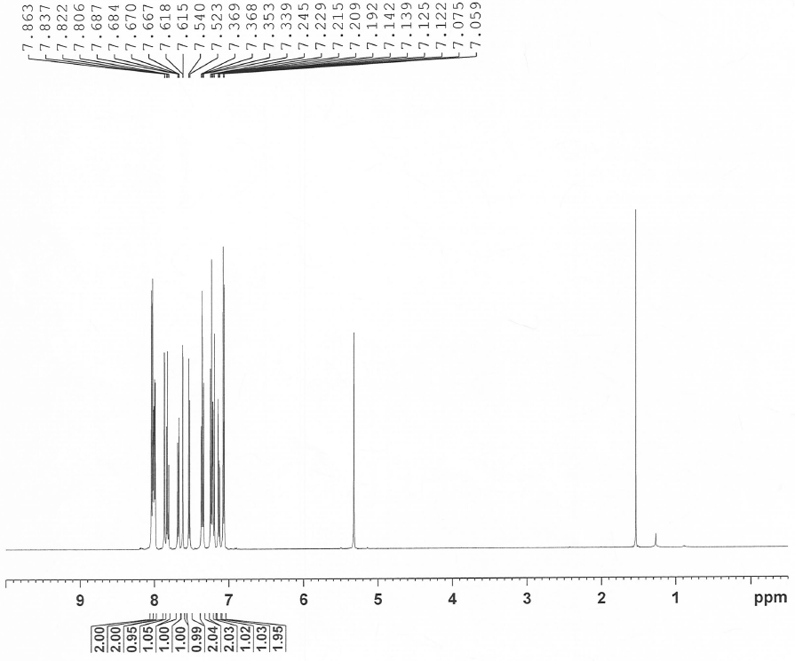

**Supplementary Figure 11.1H NMR spectra of H4.**

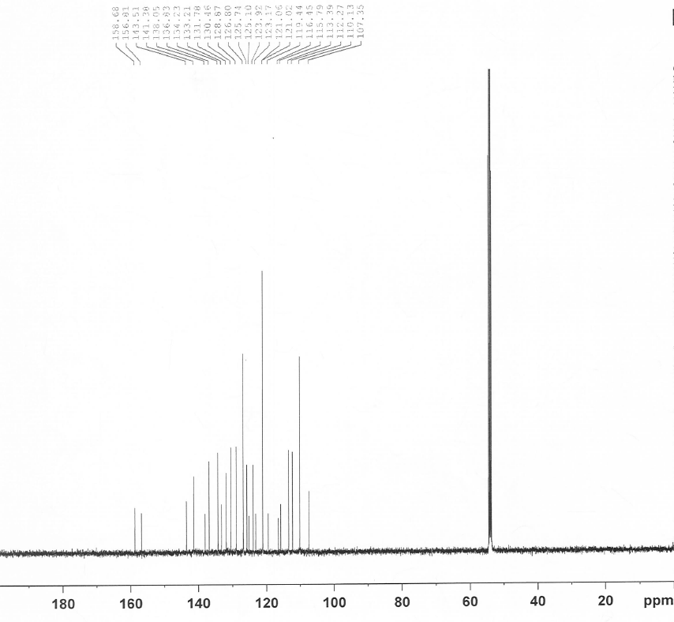

**Supplementary Figure 12. 13C NMR spectra of H4.**