Supplementary Material
Supplementary Figure 1. Ranked influencing factors for participating in research among PWUD stratified by rural communities in Kentucky, Ohio, and Oregon, April 2019-July 2019
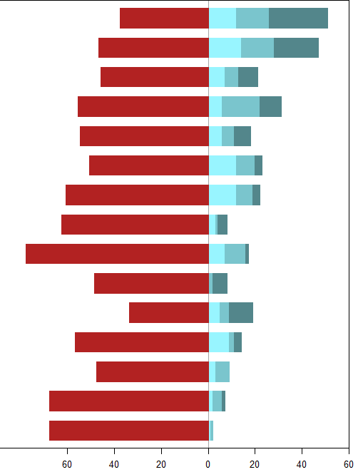
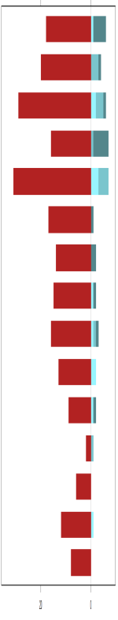
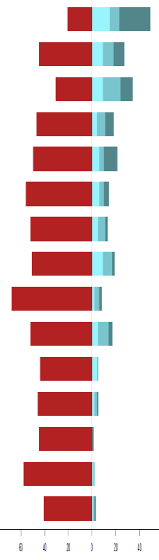
60 40 20 0 20 40
Count
60 40 20 0 20 40
Count
60 40 20 0 20 40
Count
 | Kentucky | Ohio | Oregon
How much money they will receive
Whether their information will be kept confidential
How much time is required
Privacy of the research office
What the research study involves (e.g., survey, drug testing for research)
How far they have to travel to participate (i.e., nearby vs. out of town)
Why their information is being collected and what it will be used for
How much the project will benefit them overall
Whether the staff doing the research is friendly and trustworthy
How often they have to come in for visits
How their friends, family, or partner feels about them participating
Whether they have childcare so that they can attend their appointments
Whether their appointment times will interfere with their work schedule
Whether they can skip questions of parts of the study that make them uncomfortable
Whether the research institution or university is respected

Supplementary Figure 2. Ranked motivators for joining a research study among PWUD stratified by rural communities in Kentucky, Ohio, and Oregon, April 2019-July 2019
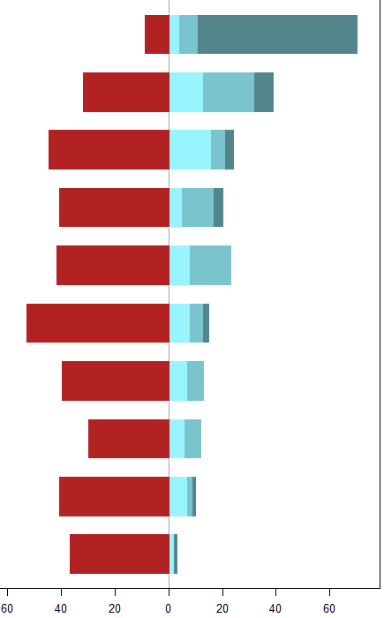
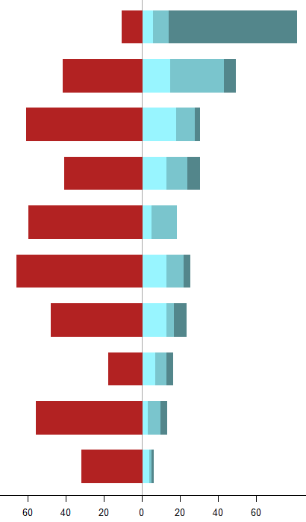
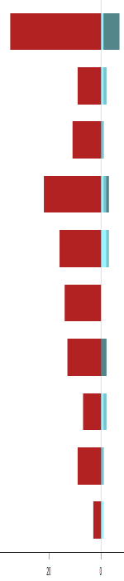
60 40 20 0 20 40 60
Count
60 40 20 0 20 40 60
Count
40 20 0 20 40
Count
 | Kentucky | Ohio | Oregon
Financial incentive (i.e., money or gift card given for participation
They would want to get free testing (for example, rapid tests for HIV & HCV) if it was offered as part of the study
They would want to be linked with resources and/or follow-up testing if it was offered as part of the study
They believe in the mission of the research and want to contribute
Their friends, family, or partner participates
They would want to try a new treatment if it was offered as part of the study
They want to tell their story
Their friends, family, or partner pressures them to participate so that they can share the financial incentive
They want to learn about the topic
They know someone on the research team and want to help them out

Supplementary Figure 3. Ranked barriers to returning to follow-up research appointments among PWUD stratified by rural communities in Kentucky, Ohio, and Oregon, April 2019-July 2019
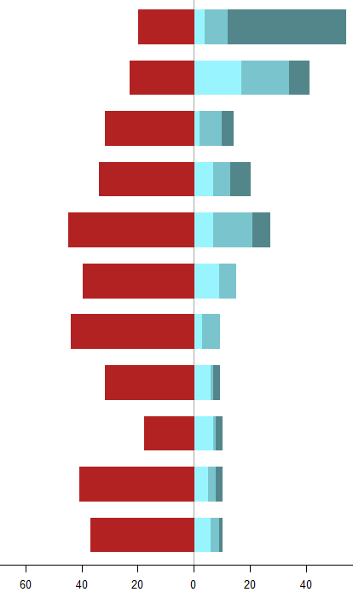
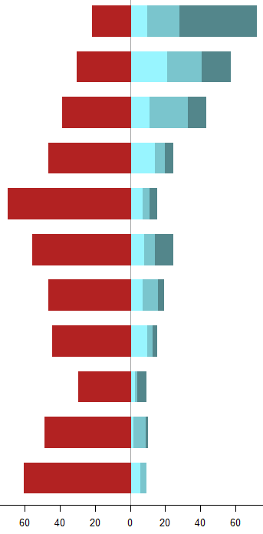
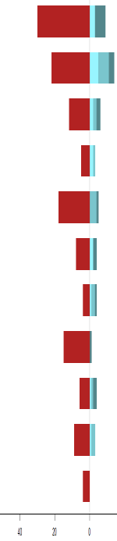
60 40 20 0 20 40 60
Count
60 40 20 0 20 40 60
Count
60 40 20 0 20
Count
 | Kentucky | Ohio | Oregon
Not being able to get in touch with participants because their contact information changed
They may have trouble getting transportation for their appointments
Not being able to get in touch with participants because they gave false contact information when they started the study
They may have concerns about confidentiality and privacy
They may have trouble being able to show up at a specific appointment time
They are in a drug treatment or recovery facility and are unable to be contacted by research staff
They may have trouble finding childcare so that they can go to their appointment
They may be afraid that the staff would judge them if they are still using drugs
Their friends, family, or partner may want them to stop participating
They may have trouble getting to their appointment because of their work schedule
They may have stopped using drugs and no longer think the study is relevant to them

