Effective degradation of cellulose by Microwave irradiation in alkaline solution
Lama Jabareen, Moorthy Maruthapandi, Arumugam Saravanan, Aharon Gedanken*
Department of Chemistry, Bar-Ilan Institute for Nanotechnology and Advanced Materials (BINA), Bar-Ilan University, Ramat-Gan 52900, Israel.
* Corresponding authors: gedanken@mail.biu.ac.il, Fax: +972-3-7384053; Tel: +972-3-5318315

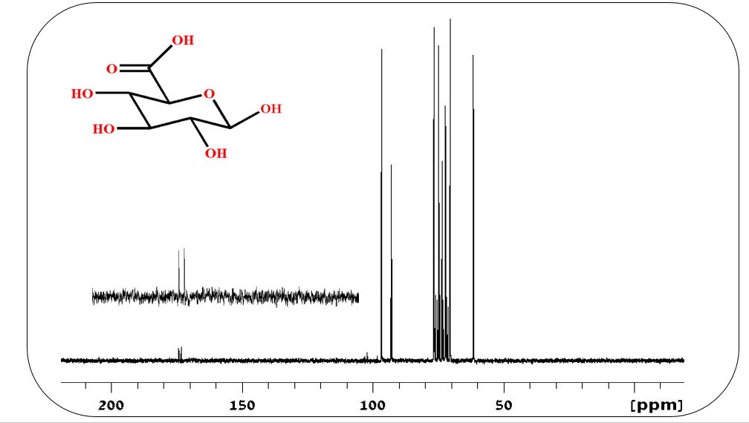
Figure S1. ¹³C NMR spectrum for the oxidized glucose.
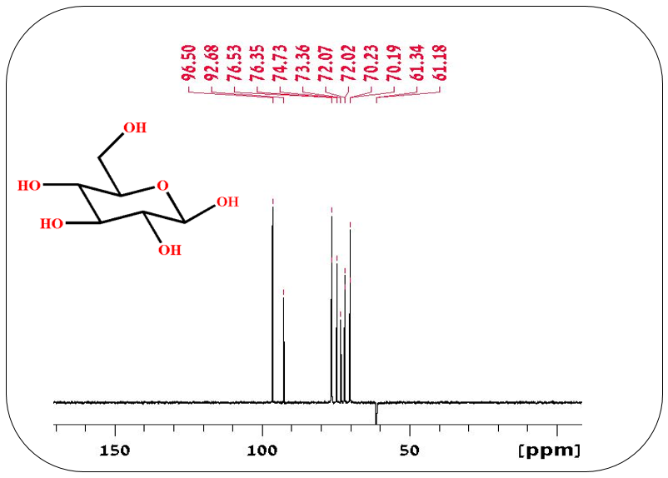

Figure S2. ¹³C NMR spectrum for the glucose.

The NMR peaks in figure S2 (61, 70, 72, 73, 74, 76 and 96 ppm) are represent the glucose carbons. Fig.S2 illustrates the ¹³C NMR spectrum of the glucose after the oxidation, the peaks in the spectrum belong to glucose carbons and glucuronic acid carbons, the peak at 173 ppm assigned for the carboxyl carbon of the glucuronic acid.

