Supplementary Material for

Combined toxicity and toxicity persistence of antidepressants citalopram and mirtazapine to zooplankton Daphnia magna
Yunfeng Ma^{1†}, Dong Xu^{2†}, Chenyang Li¹, Shu Wei¹, Ruixin Guo¹, Yang Li³, Jianqiu Chen^{1*}, Yanhua Liu^{1*}
1. School of Engineering, China Pharmaceutical University, Nanjing 211198, China.
2. School of the Environment, Nanjing University, Nanjing 210023, China.
3. Blood Transfusion Department, Wuhan University Zhongnan Hospital, Wuhan 430071, China.

Corresponding author:
* Jianqiu Chen & Yanhua Liu: School of Engineering, China Pharmaceutical University, Nanjing 211198, China. E-mail address: cjqer@cpu.edu.cn (J.Q. CHEN) & liuyanhua8.18@163.com (Y.H. LIU).
† Yunfeng Ma and Dong Xu contributed equally to this work.

Table S1. Physiochemical properties of the target compounds.
Compounds | Abbreviation | CAS-No. | Chemical structures
Citalopram | CTP | 59729-33-8 | 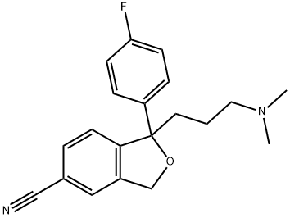
Mirtazapine | MTP | 85650-52-8 | 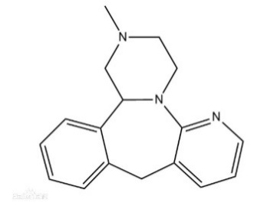

Table S2. The specific information of primers for two genes (α-Amylase ,Trypsin) used in qPCR
Genes | Origin | Amplicon size (bp) |  | Primer: forward/reverse  (5’-3’)
α-Amylase | XM_032924189 | 123 | F: AGAAGTCATCGATCTCGGCG  R: TTCAGTTGGTTACGACCCCG
Trypsin | XM_032922088.1 | 122 | F: TCCTGAACGGCAAATACC  R: CTGCGAGAAACCACCGAA
Actin | NCBI Accession: XM_032925012.1 | 137 | F: CCCCAAGGCTAATCGTGAGA  R: CACCGGAGTCGAGGACGATA

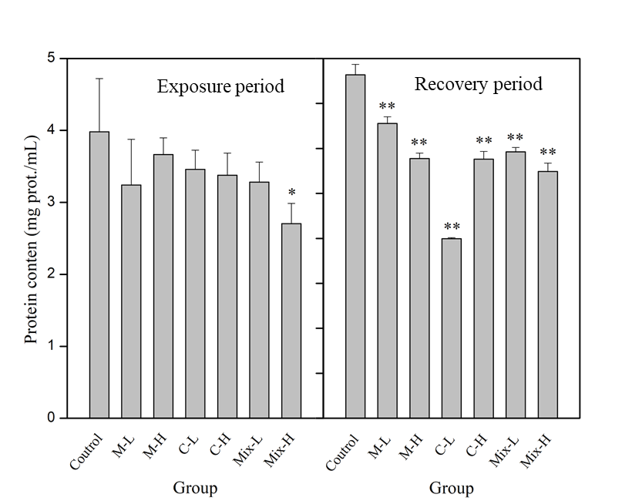
Fig. S1. Effect of CTP and MTP on protein content of D. magna.
*: statistical significance of the correction (p < 0.05); **: statistical significance of the correction (p < 0.01).

S1. Acute toxicity test on D. magna
In the experiment of acute toxicity test, D. magna neonates (≤ 24-h-old) were used to perform a static exposure for 24 h. Six neonates of D. magna were employed in each group, and five replicates were set. The exposure was performed in a 100 mL glass beaker containing 80 mL of exposure solution. Different concentrations of CTP (0, 1, 5, 20, 30, 40 and 50 mg/L) and MTP (0, 1, 5, 20, 50, 80 and 100 mg/L) were set with culture medium solution (80 mL). D. magna was kept in dark place and was not fed during the exposure period.
After 24 h exposure, the number of dead individuals in each replicate was counted. The acute toxicity data-lethal concentrations 50 (EC50) were calculated to evaluate the toxicity of these two substances. According to the acute toxicity test, the 24-h EC₅₀ values for CTP and MTP were 28.93 and 20.59 mg/L, respectively.

S2. Total protein (TP) quantitative assay kit instruction
Reagents | Control tube | Standard tube | Measuring tube
Double distilled water (mL) | 0.05
Protein standard (mL) |  | 0.05
Sample (mL) |  |  | 0.05
Coomassie brilliant blue solution (mL) | 3.0 | 3.0 | 3.0
Mixed well, standed for 10min. After setting zero by distilled water, the absorbance value of each tube was measured by spectrophotometer of 1 cm optical diameter at 595 nm.
1. The experimental sample was 10% tissue homogenate
2. 50 μL double distilled water was added to the control tube, 50 μL protein standard solution was added to the standard tube, and 50 μL tissue homogenate was added to the test tube
3. Added 3 mL coomassie brilliant blue solution into each tube, mixed well, standed for 10min, adjusted zero with double distilled water, and measured the OD value of each tube at 595 nm.

S3. Trypsin assay Kit instruction
Operation table
Reagents | Control tube | Determination tube
Reagent 1 (mL) | 1.5 | 1.5
preheated at 37 ℃ for 5min
Tissue homogenate (mL) |  | 0.015
Normal saline (mL) | 0.015
After mixing, poured the solution into a 0.5 cm light passing quartz cuvette, measured the absorbance OD value at 253 nm, and recorded the absorbance OD value (A1) at 30s. Then, putted the cuvette in the colorimetric tank for 20 min (37 ℃) and record the absorbance OD value (A2) at 20.5 min.
1. Prepared all reagents before starting assay procedure. 4% of tissue homogenate was used as testing sample for determination.
2. Added reagent 1: Added 1.5 mL reagent 1 into the control tube and determination tube. Preheated them at 37 ℃ for 5 min.
3. Added 15 μL of normal saline in control tube and added 15 μL tissue homogenate in determination tube.
4. After mixing, poured the solution into a 0.5 cm light passing quartz cuvette, measured the absorbance OD value at 253 nm, and recorded the absorbance OD value (A1) at 30s. Then, putted the cuvette in the colorimetric tank for 20 min (37 ℃) and record the absorbance OD value (A2) at 20.5 min.

S4. α-Amylase assay kit instruction
Operation table
Reagents | Determination tube | Control tube
Substrate buffer (mL) (preheated at 37 ℃ for 5 min) | 0.5 | 0.5
Tissue homogenate (mL) | 0.1
Mixed well at 37 ℃ for 7.5 minute
Iodine application solution（mL） | 0.5 | 0.5
Double distilled water (mL) | 3.0 | 3.1
Mixed them well. After setting zero by double distilled water, the absorbance value of each tube was measured by spectrophotometer of 1 cm optical diameter at 660 nm wavelength.
- Prepared all reagents before starting assay procedure. 4% of tissue homogenate was used as testing sample for determination.
- Added substrate buffer: Added 0.5 mL substrate buffer in control tube and determination tube. Preheated at 37 ℃ for 5min.
- Added 0.1 mL tissue homogenate in determination tube. Mixed well and reacted accurately at 37 ℃ for 7.5 minute.
- Added 0.5 mL of iodine application solution to the control tube and determination tube.
- 3 mL and 3.1 mL of double distilled water were added into the determination tube and the control tube, respectively. Mixed them well. After setting zero by double distilled water, the absorbance value of each tube was measured by spectrophotometer of 1 cm optical diameter at 660 nm wavelength.

