Supplementary A

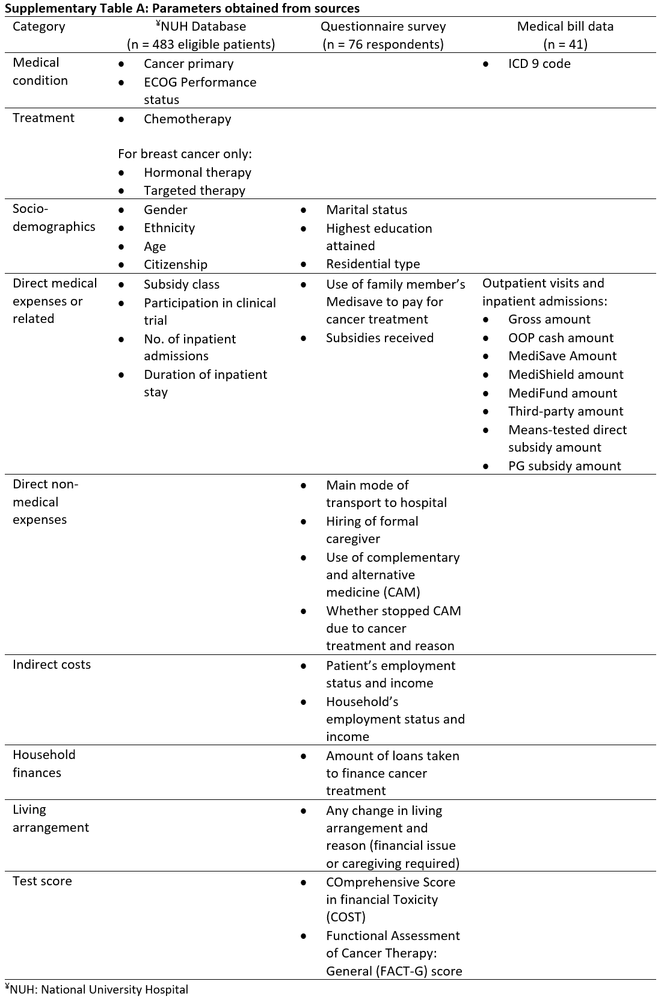
Supplementary Table A depicts the specific parameters obtained from the three sources in our study. From the hospital database, we obtained the name, contact details, and basic characteristics of the patients who fit the eligibility criteria. The basic characteristics include demographics, primary cancer, treatment received (including if they were treated on a clinical trial where costs would have been borne by the sponsor), indicators of direct medical expenses (such as whether the patient received further subsidy or assistance from family members Medisave accounts), and hospital admission. Admissions during the neo-adjuvant therapy or adjuvant therapy period(s) were recorded; elective admissions for surgery for breast cancer patients, as well as unrelated admissions relating to neither radiotherapy nor chemotherapy toxicities (e.g. a patient developed right-sided weakness and was diagnosed with a stroke one year after breast cancer treatment), were not included.

To sample an approximate equal number of patients with breast cancer and NPC, we contacted all eligible NPC patients and a subset of breast cancer patients whilst ensuring that patients belonging to the minority races are represented. During May 2019, we sent postal correspondence to 238 patients—145 (61%) and 93 (39%) had breast cancer and NPC, respectively—to invite them to participate in the study. The contents of the mail included an invitation letter, participant information sheet, and three sets of questionnaires consisting COST questionnaire, FACT-G questionnaire, and a specifically-designed questionnaire (see Appendices). All the materials contained Chinese and Malay translations; the COST and FACT-G questionnaires, including the translated versions, were licensed by FACIT. The specifically-designed questionnaire elicited additional information that, subject to statistical analyses, can reveal variables associated with financial toxicity and quality of life. The variables include socio-demographic characteristics, indicators of how direct medical expenses are financed, and indicators of indirect medical expenses. Respondents were asked to specify, for indirect cost of cancer treatment, the changes they and their household members had experienced in employment status and income, as well as living arrangement and household finances.

About a week after the letters were sent out, we called the recipients to seek their verbal consent for participation. We also asked if they preferred to self-complete the questionnaires and mail back to the study team using the return envelope, or to have the survey administered over the telephone. We received a total of 76 responses (32% response rate), of which 48 (63%) were self-completed questionnaires and 28 (37%) were surveys administered over the phone. The average duration of a phone survey was 27 minutes. There were 47 (62%) and 29 (38%) breast cancer and NPC patients respectively.

During the phone call, we also sought consent from patients to access their medical bill data from the hospital system for further analysis. Identification numbers of 41 consenting patients—of which 30 (73%) and 11 (27%) had breast cancer and NPC, respectively—were recorded and forwarded to the NUH Academic Informatics Office for data extraction. The medical bill data for all outpatient visits and inpatient admissions related to breast cancer and NPC diagnosis or treatment were obtained. The data has a breakdown of out-of-pocket expenses, amount from MediSave account, amount paid by MediShield, amount paid by Medifund, amount paid by third party (e.g. voluntary welfare organisation [VWO]), means-tested direct subsidy amount, and PG subsidy amount.

