Supplementary Figure S1. TRIM25 predicts recurrence and poor prognosis of patients with CRC treated with OXA-based chemotherapy.

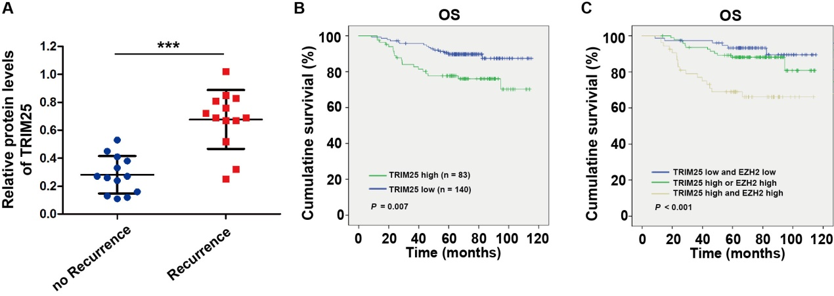
Supplementary Figure S2. Western blotting analysis of stem cell markers in TRIM25-knockdown /-overexpressing CRC cells.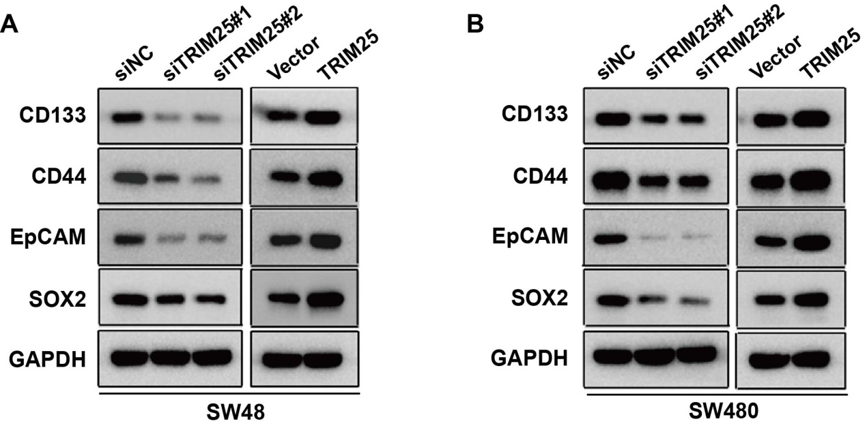

Supplementary Figure S3. TRIM25 regulates the ubiquitination of EZH2.

