Supplementary Figure S1. Overall survival for CRC patients (n = 223).

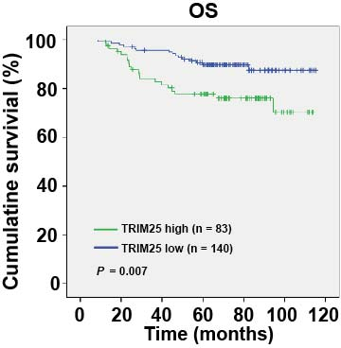

Supplementary Figure S2. Overall survival for CRC patients grouped according to TRIM25 and EZH2 expression (n = 223).

