Protocol for 6-OHDA unilateral lesioning in mice

Material list:
- Sterile saline (Fresenius Kabi AB 9 mg/ml, 20 x 10 ml, Vnr 141856)
- Carprofen (Non steroidal anti-inflammatory drug, Rimadyl Bovis Vet. 50 ml Vnr 01 49 20). Stock solution 50 mg/Kg. Used at a 1:10 dilution (5 mg/ml/Kg), to renew regularly.
- Marcain (Local anesthetics, Bupivacaine Hydrochloride). Stock solution 5 mg/ml, aspen M130091AE). Used at a 1:3 dilution, to renew regularly.
- Iodine (Jodopax vet). For asepsis.
- Isoflurane (Attane Vnr 17 05 79, 250 ml).
- L-Ascorbic acid (A92902, Sigma)
- NaCl (Sigma)
- 6-OHDA hydrochloride (H4381, Sigma).

- Stereotaxic frame
- Anesthetic system (isoflurane/air)
- Tabletop microscope
- Parafilm (used to put the drop of saline for withdrawing within the syringe).
- Aluminum foil (to protect the 6-OHDA solution from the light).
- Cotton sticks
- Eye gel (Bepanthen, Bayer, 2x5 g for nose)
- Syringes for IP/SC injections (Terumo Syringe Injection syringe 1ml 3d piece without needle SS + 01T1)
- Needles for IP/SC injections (Henke Sass Wolf, Fine-Ject 27Gx12” 0.4x12mm)
- Syringe for 6-OHDA injection (WPI, NanoFil 10uL syringe)
- Needle for 6-OHDA injection (WPI Nanofil, NF34BV, 34GA. Beveled needle)
- Suture thread (Ethicon Coated Vicryl rapide Plyglactin 910, 6-0 (0.7 Ph.Eur), 11 mm 3/8c, 45 cm, V32H)

Experiment preparation:

- Prepare a solution of 0.02% ascorbic acid / 0.9% NaCl. Make a consequent number of aliquots of 1 mL from this solution which can be stored at -80°C for many years. Once thawed, the aliquot should be used within the day and not be re-frozen.

- The 6-OHDA solution is made freshly the same day as the injections. To obtain a concentration of 1.85 mg/ml of 6-OHDA free-base, weight 2.2 mg of 6-hydroxydopamine-hydrochloride powder and add it to the ascorbic acid/NaCl 1 ml aliquot. It is important to keep the 6-OHDA solution away from the light to avoid oxidation.

- Carprofen solution: dilute the Carprofen stock solution 1:10 in sterile saline to obtain a concentration of 5 mg/mL/Kg.

- Marcain solution: dilute the Marcain stock solution 1:3 in sterile saline to obtain a concentration of 1.67 mg/mL/Kg.

- Syringe filling: The syringe is filled with first 1000 nL of saline, followed by 1000 nL of air and then the 6-OHDA solution. The amount of 6-OHDA solution withdrew in the syringe depends on the amount of animals injected within the day. Put aluminum around the syringe to protect the 6-OHDA solution from the light (oxidation) and avoid to direct lights towards the syringe.

Experimental protocol for 6-OHDA injection:

- Place the mouse in the isoflurane gas chamber; turn on the isoflurane at a rate of 4% (isoflurane/air).

- Once the mouse is deeply asleep and its respiration stable, decrease the rate to 2% isoflurane/air and switch the direction of the pump towards the mask on the stereotaxic apparatus.

- Weigh the mouse and immediately put the animal in the mask of the stereotaxic apparatus.

- Place the mouse in the stereotaxic apparatus and adjust the ear bars so the head of the mouse is well fixed.

- Put eye gel on the mouse’s eyes for protection and inject Carprofen subcutaneously (5 mg/mL/kg)

- Shave the head with a scissor or a trimmer. Decontaminate the skin with iodine and inject Marcain subcutaneously (1.7 mg/mL/Kg) at the place of the incision until you see a small bump.
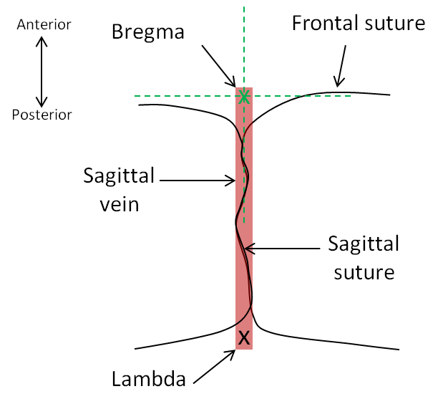
- 5 min after injecting the Marcain, incise the skin with the scalpel along the sagittal plan. Clean the skull’s surface until the bone sutures are clean and clearly visible.

- Look for the sagittal vein and define the midline. The sagittal vein is used as the zero in the medio-lateral (MD) plan. Zero the MD coordinate (X). Then, define your bregma (meeting point between the coronal sutures and the sagittal vein) and zero the antero-posterior (AP) coordinate (Y).

- Verify that the head is well positioned horizontally: Zero the dorso-ventral (DV) coordinates on the bregma (skull). Move the needle to the lambda and look at the Z coordinate. The acceptable error of the Z value is ± 0.07 mm between the bregma and the lambda.

- Go back to bregma and zero all the coordinates. Take your AP coordinate (MFB: -1.20 mm for AP) and ML coordinate (MFB: -1.10 mm). Mark the AP and ML coordinates on the skull and drill the hole.

- Clean the hole making sure there is no dura matter, pieces of bone left or clogged blood. Place the needle on the brain surface and zero the Z coordinate. Slowly lower the needle to -4.75 mm to reach the MFB.

- Inject 1 µL of the 6-OHDA solution at a rate of 100 nl.min⁻¹.

- Let the needle in place for 10 min before lifting it up slowly.

- Stich the skin of the head back and apply iodine.

- Inject subcutaneously 1 mL of sterile saline.

- Put the mouse in a “waking” cage on top of a heating pad until the mouse is fully awake (normal locomotion and exploratory behavior, food consumption). The mouse is then put back in its home cage.

- 20 to 24 hours after the first Carprofen injection, a second subcutaneously injection of Carprofen (5 mg/ml/Kg) is performed.

Post-operative care:

- Mice are weighted daily to keep track on potential weight loss.
- The 6-OHDA injected mice are injected daily with 1 ml of saline, subcutaneously, until sacrifice. The saline is warmed up before injecting (around 35-37°C) to avoid hypothermia.
- A petri dish is available in the cage, filled with 15% sucrose solution. A couple of food pellets is placed in the petri dish so they get softer and easier to eat.
- Hydrating caloric gel can be placed within the cage if needed.
- Sun flower seeds can also be placed in the cage.
- Cages are changed to clean cages at least once a week.

