Targeted Phototherapy by Niobium Carbide for Mammalian Tumor Models Similar to Human Being
Zhao Liu¹, Yuhang Tian¹, Shan Jiang¹, Haitao Shang¹, Kexin Chen², Haoyan Tan¹, Lei Zhang¹, Chongshen Guo³, Hui Jing¹*, Wen Cheng¹*

1 Department of Ultrasound, Harbin Medical University Cancer Hospital, 150 Haping Road, Nangang District, Harbin, 150081, China
2 Department of Pathology, Harbin Medical University Cancer Hospital, 150 Haping Road, Harbin, 150081, China
3 School of Chemistry and Chemical Engineering, Harbin Institute of Technology, Harbin 150000, China.

Corresponding authors
Email: hrbchengwen@163.com
Email: jinghui@hrbmu.edu.cn

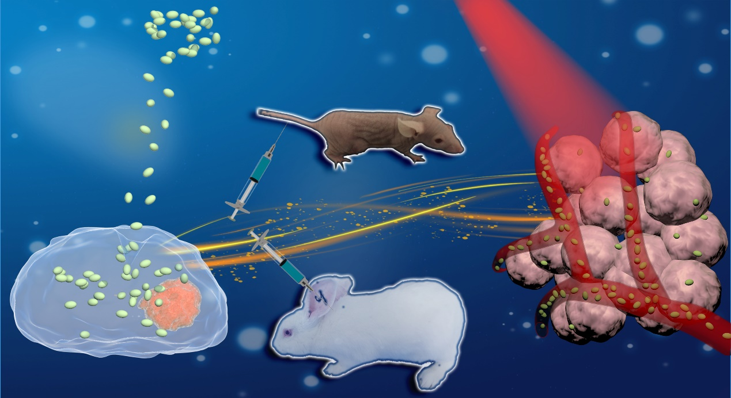
Macrophage loaded Niobium Carbide can achieve the synergistic photothermal and photodynamic therapy on solid tumor in mice and rabbits in vivo

