ADDITIONAL FILES
Conceptualization of a cognitively enriched walking program for older adults: a co-design study with experts and end users
Marent & Vangilbergen et al. (2021)

Additional File 1. Delphi Round 1 – Questions
Additional File 2. Delphi Round 2 – Questions
Additional File 3. Delphi Round 3 – Questions
Additional File 4. Description of the (groups of) cognitive tasks presented in the survey.
Additional File 5. Proposed tasks that were found unsuitable by the experts (due to feasibility reasons) to implement in a real-life walking program.
Additional File 6. Matrix 1 – Walking un-related tasks ª
Additional File 7. Matrix 2 – Walking-related tasks ª
Additional File 8. Matrix 3 – Walking as cognitive challenging task ª
Additional File 9. Flow chart of end users in the survey.

Additional File 1. Delphi Round 1 – Questions

Type of cognitive functions to be trained
- Which specific types of cognitive functions should be targeted in order to optimally boost neuroplasticity in healthy older adults (65+) during a 30 min walking program? (e.g. reaction speed, logical reasoning, coordination, memory…)
- Could you briefly indicate why exactly these should be targeted?

Characteristics tasks
- In order to improve cognitive function, how often should a certain task be performed to stimulate that aspect of cognitive function?
- During a 30-min walk:
- During the week:
- Should the program focus on only specific cognitive functions or should the provided tasks target several cognitive functions at once? Please briefly indicate why as well.

Examples
- Please give at least 3 concrete examples of cognitive tasks that could be performed during an organised group walk of 30 minutes and that, in your opinion, are useful to boost neuroplasticity and fun.
- Example 1:
- Example 2:
- Example 3:
- Additional example/info:
- Additional example/info:
- In addition, explain why these potential tasks are preferable to you.

Additional File 2. Delphi Round 2 – Questions

Type of cognitive functions to be trained
The answer options of the questions below are based on answers given by experts in round 1.
Important: If you do not want to answer, you believe this is not your field of expertise or you do not agree with the given answer options, please select "Other" and specify your reason (e.g. “no expertise”, “I have doubts about this program”, “I think another answer is more suitable, namely____”).

- In your opinion, which specific types of cognitive functions should be targeted to optimally boost neuroplasticity in healthy older adults (65+) during a 30 min walking program? You can choose multiple answers, with a maximum of three.
- Executive functioning & Higher-order thinking
- Attention
- Memory & Learning
- Processing speed
- Visuospatial functions
- Auditory functions
- Language
- Other (please specify or use "/")

- If in question 1 you answered "Memory", could you specify which memory systems should be targeted? Multiple answers are possible. [You can leave this question blank if you did not choose "Memory&Learning" in question 1]
- Working memory (= short-term memory): verbal/phonological loop
- Working memory (= short-term memory): visuospatial
- Long-term memory (= prospective memory): explicit/declarative, episodic memory (= relational memory)
- Long-term memory (= prospective memory): explicit/declarative, semantic memory
- Long-term memory (= prospective memory): implicit, procedural memory
- Other (please specify)

- If in question 1 you answered "Executive functions", could you specify which type of executive functions should be targeted? Multiple answers are possible. [You can leave this question blank if you did not choose "Executive Functions" in question 1]
- Cognitive Inhibition/Inhibitory control: ability to stay focused despite distraction + inhibit pre-potent but inappropriate responses
- Working Memory: ability to hold and manipulate information, priorities dual task and plan actions
- Cognitive flexibility: ability to adjust and change attention, set-shifting as well as task switching
- (Logical) Reasoning
- Problem Solving
- Decision Making
- Planning
- Other (please specify)

- If not already done in round 1, could you provide us with specific fun and feasible examples of a task that target the cognitive function(s) you answered in question 1? Please note that these tasks should be performed during a 30 min walk.
- Executive functioning & Higher-order thinking:
- Attention:
- Memory & Learning:
- Processing speed:
- Visuospatial functions:
- Auditory functions:
- Language:
- Other (please specify cognitive function as well):

Bonus (optional): do you have something to add to your previous answers? Remarks, explanations...?

- In your opinion, what is the importance of the following reasons in the selection of the types of cognitive functions to target in a walking program?
 | Not important | Slightly important | Moderately important | Important | Very important
Focus on those types will be optimal in terms of real-life relevance. | □ | □ | □ | □ | □
Focus on those types that will produce the greatest physiological change. | □ | □ | □ | □ | □
Focus on those types that will be optimal in terms of transfer of skill. | □ | □ | □ | □ | □

Bonus (optional): do you have something to add to your previous answers? Remarks, explanations...?

Characteristics tasks
- In your opinion, at least how much time during the 30-min walk (minimum amount) should be allocated to the cognitive activities in order to improve cognitive function? Choose one.
- 0-5 min
- 5-10 min
- 10-15 min
- 15-20 min
- 20-25 min
- 25-30 min
- I would not walk and simultaneously perform cognitive activities.

- In your opinion, at least how often per week (minimum amount) should they follow the cognitively enriched walking program (30 min walk) in order to improve cognitive function? Choose one.
- 1
- 2
- 3
- 4
- 5
- 6
- 7 (every day of the week)
- I would not walk and simultaneously perform cognitive activities.

Bonus (optional): do you have something to add to your previous answers? Remarks, explanations...?
Additional File 3. Delphi Round 3 – Questions

The final statements below are based on answers given by experts in round 1 and 2. You are asked to indicate - for the last time - your level of agreement on these statements.
Important:
- Please do not hesitate to share a view that differs from the summary feedback. There is a possibility to express remarks at the bottom of the page.
- If you do not want to answer or you believe this is not your field of expertise, please select "Other" and specify your reason (e.g. “no expertise”) or use "/".

- Please indicate the degree to which you agree/disagree with the following statements:
  - “The PA+CA program should primarily target executive functioning and higher-order thinking, as well as memory and learning."
Strongly disagree | Disagree | Neither agree nor disagree | Agree | Strongly agree | Other
□ | □ | □ | □ | □ | □ namely...

  - “With regard to executive functioning and higher-order thinking, the program should mostly focus on working memory, cognitive inhibition/inhibitory control, cognitive flexibility and planning.”
Strongly disagree | Disagree | Neither agree nor disagree | Agree | Strongly agree | Other
□ | □ | □ | □ | □ | □ namely...

  - “With regard to memory and learning, the program should mostly focus on the visuospatial and verbal/phonological loop of the working memory.”
Strongly disagree | Disagree | Neither agree nor disagree | Agree | Strongly agree | Other
□ | □ | □ | □ | □ | □ namely...

  - "The most important reason in selecting the targeted cognitive functions for the PA+CA-program is their real-life relevance.”
Strongly disagree | Disagree | Neither agree nor disagree | Agree | Strongly agree | Other
□ | □ | □ | □ | □ | □ namely...

  - "During the 30-min walk, minimum 15-20 minutes should be allocated to cognitive activities in order to improve cognitive function."
Strongly disagree | Disagree | Neither agree nor disagree | Agree | Strongly agree | Other
□ | □ | □ | □ | □ | □ namely...

  - "During the week, the PA+CA program should be organized at least 2-3 times in order to improve cognitive function."
Strongly disagree | Disagree | Neither agree nor disagree | Agree | Strongly agree | Other
□ | □ | □ | □ | □ | □ namely...

Bonus (optional): do you have something to add to your previous answers? Remarks, explanations...?

We have collected and categorized all the different examples of cognitive tasks that were given by the experts in rounds 1 and 2. Below you will find three major categories (the three matrices), subdivided in several subcategories (columns) with specific examples of tasks, sorted according to complexity (along y-axis). Please have a thorough look at these three matrices and answer the questions below them.

Matrix 1
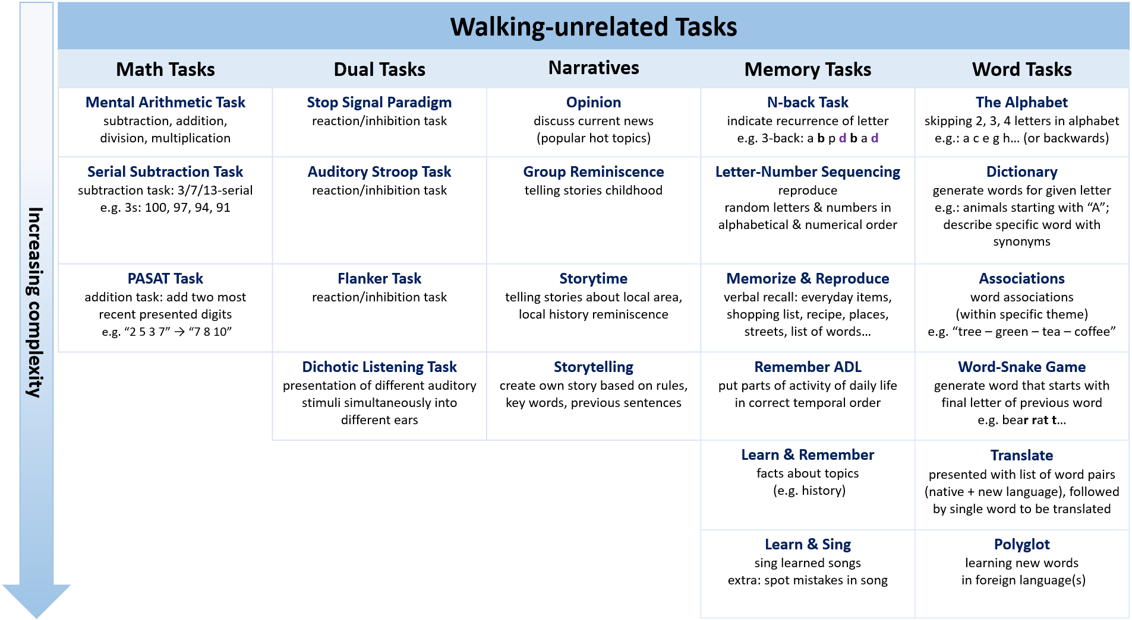

The following tasks were categorized as “Waking-unrelated Tasks”. This means they are essentially unrelated to walking; walking is not a necessary condition. In other words, you do not have to walk to take on these tasks. Nevertheless, as we aim to establish a PA+CA-program, we plan to perform/integrate these tasks during our walks.

Math Tasks
- Mental Arithmetic Task: provide arithmetical operations to train mental calculation abilities.
- Serial Subtraction Task: ask to subtract x (e.g. 3; 7; 13) from y (e.g. 100) and keep going (serial 3s: 100, 97, 94…).
- PASAT Task (Paced Auditory Serial Addition): presenting series of single digit numbers where the two most recent digits must be summed (e.g. present “2, 5, 3, 7” → “7 (= 5+2), 8 (5+3), 10 (=7+3)”).

Dual Tasks
- Stop Signal Paradigm: present series of “Go” signals, instruct to respond quickly; however, also present “Stop” signals to which participants are instructed to inhibit their response.
- Auditory Stroop Task: respond as quickly as possible to some perceptual feature of word (e.g., speaker gender, voice pitch, stimulus location) while ignoring semantic information.
- Flanker Task: ask directional response to central target stimulus, while ignoring non-target stimuli presented in its immediate proximity.
- Dichotic Listening Task: listen to different acoustic events presented to each ear simultaneously.

Narratives
- Opinion: discuss the current news (popular hot topic)
- Group Reminiscence: let them tell stories about their childhood; their life as a 45-year-old.
- Storytime: let them tell stories about the local area (local history reminiscence)
- Storytelling:
  - Create a story with the group: each person says new sentence following the previous one
  - Story needs to be developed according to rules and key words

Memory Tasks
- N-back Task: reading list of letters, ask to indicate when letter is same as N letters ago (e.g. 3-back: a b p d b a d)
- Letter-Number Sequencing: sequence random order of numbers & letters, say numbers in ascending order and then letters in alphabetical order.
- Memorize & Reproduce: memorize list of items and reproduce them as good as possible
- Remember ADL: sort sketches of an activity of daily living, provided on sheet of papers, in correct temporal order
- Learn & Remember: learn specific facts about topics such as history and try to remember them
- Learn & Sing: sing learned songs while walking (extra: spot lyrical/rhythmic mistakes in played songs)

Word Tasks
- The Alphabet: going (backwards) through the alphabet, skipping e.g. 1 letter each time
- Dictionary:
  - Verbal fluency, generate words (within a category such as animals) from given initial letter (e.g. a,f,s,c,l).
  - Describe things as elaborated as possible or use different words for the same things
- Associations:
  - Word associations game (“blue – sky – airplane – pollution – protests”)
  - Find words within a specific theme/category (e.g., fruits and vegetables)
- Word-Snake Game: generate words that start with final letter of previous word (e.g., bear – rat – t…)
- Translate: auditory presented list of word pairs (native and new language), followed by a single word that has to be translated.
- Polyglot: learn new words in a foreign language

In your opinion, are all tasks presented in the matrix above suited as effective cognitive activities? Performing them during an organised group walk of 30 minutes should eventually help the older adults at maintaining and improving their cognitive capabilities.
- I do not wish to answer
- Yes, all presented tasks are suited as effective cognitive activities
- No (please specify which task(s) are not suited):

In your opinion, are all tasks presented in the matrix above suited as feasible cognitive activities according to you? Older adults (healthy, 65+ years old) should be able to do them during an outdoor walk in group, under the supervision of a coach.
- I do not wish to answer
- Yes, all presented tasks are suited as feasible cognitive activities
- No (please specify which task(s) are not suited):

Do you agree with our overall classification of the tasks as “Walking-unrelated Tasks”? This means they are essentially unrelated to walking; walking is not a necessary condition. In other words, you do not have to walk to take on these tasks. Nevertheless, as we aim to establish a PA+CA-program, we plan to perform/integrate these tasks during our walks.
  - I do not wish to answer
  - Yes, all presented tasks are accurately classified as “Walking-unrelated Tasks”
  - No (please specify which task(s) are wrongly classified):

Do you agree with our classification of the tasks within the subcategories “Math Tasks – Dual Tasks – Narratives – Memory Tasks – Word Tasks”?
  - I do not wish to answer
  - Yes, all presented tasks are accurately classified within each subcategory
  - No (please specify which task(s) are wrongly classified):

The tasks are ranked within each subcategory (column) according to their complexity level (see arrow on the left). This is based on our estimation of how cognitive challenging each task is at baseline level and on how much differentiation and variation is possible within each task (suitability to scale it up). Do you agree on how all tasks are ranked according to complexity (within each subcategory)? Please note that each task can be differentiated and can have increasing complexity levels, but consider for now a basic level.
  - I do not wish to answer
  - Yes, all presented tasks are accurately ranked according to complexity
  - No (please specify which task(s) are wrongly ranked):

Bonus (optional): Some of the experts suggested a few tasks that we would value your thoughts and opinion on. How would you implement the following tasks in a real-life walking program? In other words, which adaptations could be made to incorporate these tasks in a walking and outdoor environment?
- Auditory Stroop Task:
- Flanker Task:
- Dichotic Listening Task:

Bonus (optional): do you have something to add to your previous answers? Remarks, explanations...?

Matrix 2
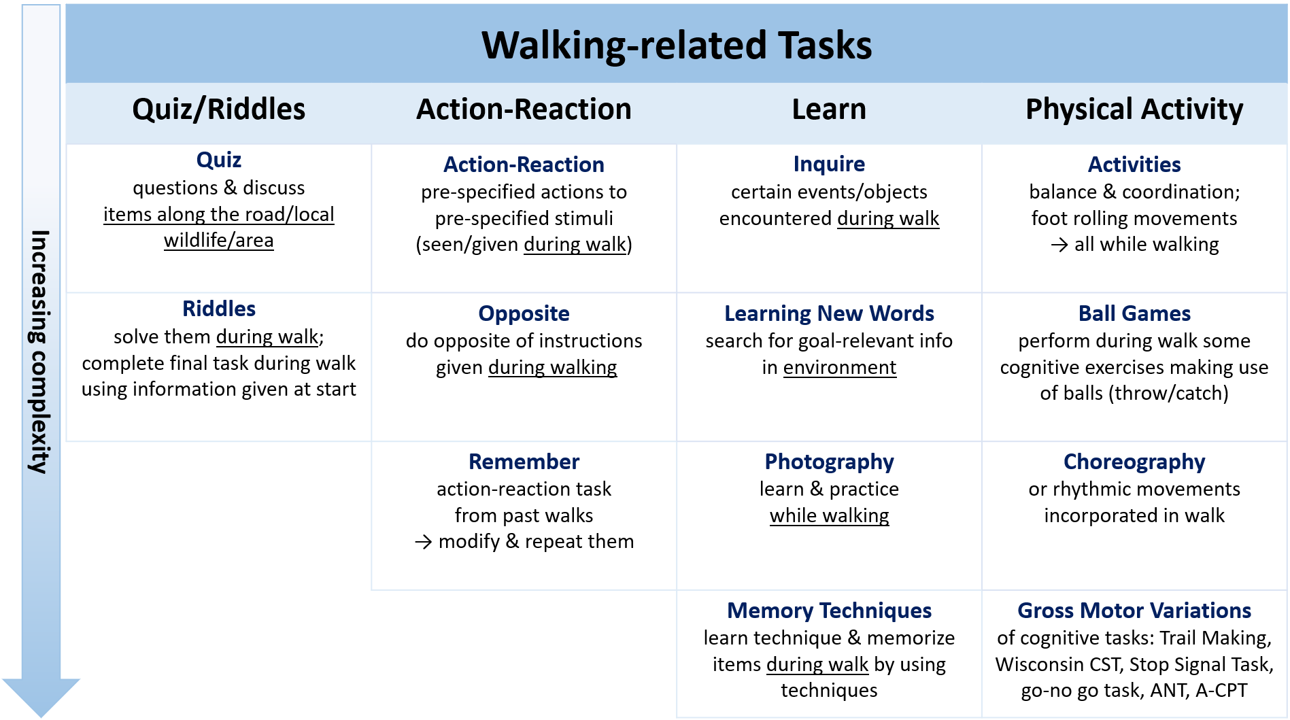

The following tasks were categorized as “Walking-related Tasks”. This means they are related to walking, namely you do have to walk to take on these tasks. The walking even becomes a fundamental part of the tasks – a necessary condition – and is of added value. Therefore, leaving out the walking part is possible, but will fundamentally change the original, specific intent of the tasks.

Quiz/Riddles
- Quiz:
  - Hold a quiz on local wildlife/area, neighbourhood (let them discuss to find correct answer)
  - Every 5 minutes 1-2 questions about items along the road
- Riddles:
  - Present several riddles they need to solve during walking (problem-thinking).
  - Completing a final task using information given at the start of the walk

Action-Reaction
- Action-Reaction: pre-specified reactions on pre-specified stimuli (cues, signs)
- Opposite: do opposite of instruction (inhibit initial reaction)
- Remember: ask to remember an action-reaction task of the past walks, modify & repeat them

Learn
- Inquire: inform participants about objects/events encountered during the walk
- Learning New Words: search for goal-relevant information in environment to learn new words
- Photography: learn the technique of making photographs and practice during the walk
- Memory Techniques: learn and practice memory techniques (e.g. mnemonics, Loci)

Physical Activity
- Activities:
  - Do some balance & coordination exercises
  - Focus on foot rolling movements while naming items in area
- Ball Games: throw balls to each other (specific order, work with different colours, different rules)
- Choreography: learn a choreography while walking, do rhythmic movements during walk
- Gross Motor Variations of specific cognitive tasks:
  - Trail Making: draw lines to connect circled numbers in a numerical sequence/to connect circled numbers and letters in an alternating numeric and alphabetic sequence (as quick and accurate as possible)
  - Wisconsin Card Sorting Task: sort cards according to different rules (colour, form…)
  - Go-no go Task: One of four shapes (circle, square, triangle, or diamond) is randomly designated as a “nontarget” for each participant. Participants are instructed to respond as fast and as accurately as possible anytime a target shape appears (i.e., go trial) but to withhold their response whenever the nontarget shape appears (i.e., no-go trial).
  - Stop Signal Task: present series of “Go” stimuli, instruct to respond quickly; however, also present “stop” signals to which participants are instructed to inhibit their response.
  - Attention Network Task: determine as fast and accurately as possible direction of a central arrow (target) located in middle of horizontal line projected either at top or at bottom of screen.
  - Auditory Continuous Performance Task: presented with a repetitive, boring task; must maintain focus over a period of time in order to respond to targets or inhibit response to foils

In your opinion, are all tasks presented in the matrix above suited as effective cognitive activities? Performing them during an organised group walk of 30 minutes should eventually help the older adults at maintaining and improving their cognitive capabilities.
- I do not wish to answer
- Yes, all presented tasks are suited as effective cognitive activities
- No (please specify which task(s) are not suited):

In your opinion, are all tasks presented in the matrix above suited as feasible cognitive activities according to you? Older adults (healthy, 65+ years old) should be able to do them during an outdoor walk in group, under the supervision of a coach.
- I do not wish to answer
- Yes, all presented tasks are suited as feasible cognitive activities
- No (please specify which task(s) are not suited):

Do you agree with our overall classification of the tasks as “Walking-related Tasks”? This means they are related to walking, namely you do have to walk to take on these tasks. The walking even becomes a fundamental part of the tasks – a necessary condition – and is of added value. Therefore, leaving out the walking part is possible, but will fundamentally change the original, specific intent of the tasks.
  - I do not wish to answer
  - Yes, all presented tasks are accurately classified as “Walking-related Tasks”
  - No (please specify which task(s) are wrongly classified):

Do you agree with our classification of the tasks within the subcategories “Quiz/Riddles – Action-Reaction – Learn – Physical Activity”?
  - I do not wish to answer
  - Yes, all presented tasks are accurately classified within each subcategory
  - No (please specify which task(s) are wrongly classified):

The tasks are ranked within each subcategory (column) according to their complexity level (see arrow on the left). This is based on our estimation of how cognitive challenging each task is at baseline level and on how much differentiation and variation is possible within each task (suitability to scale it up). Do you agree on how all tasks are ranked according to complexity (within each subcategory)? Please note that each task can be differentiated and can have increasing complexity levels, but consider for now a basic level.
  - I do not wish to answer
  - Yes, all presented tasks are accurately ranked according to complexity
  - No (please specify which task(s) are wrongly ranked):

Bonus (optional): Some of the experts suggested a few tasks that we would value your thoughts and opinion on. How would you implement the following tasks in a real-life walking program? In other words, which adaptations could be made to incorporate these tasks in a walking and outdoor environment? It was suggested to make gross motor variations of it, but how would you explicitly do this?
- Wisconsin Card Sorting Task:
- Attention Network Task:
- Auditory Continuous Performance Task:

Bonus (optional): do you have something to add to your previous answers? Remarks, explanations...?

Matrix 3
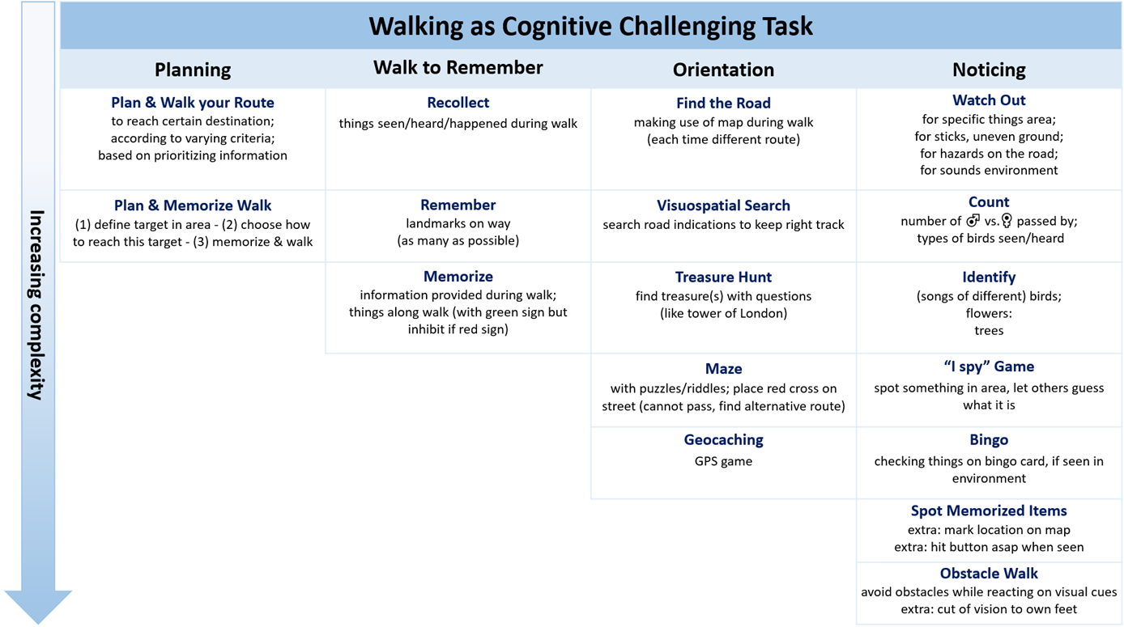

The following tasks were categorized as “Walking as Cognitive Challenging Task”. This means that the walk itself becomes the cognitive challenge. Walking is no longer a fundamental part of the task, it becomes the task. Walking and the task are inextricably linked. It is essential to walk in order to take on the tasks.

Planning
- Plan your Route:
  - To reach a certain destination
  - According to varying criteria
  - Based on prioritizing information
- Plan & Memorize Walk: (1) define a specific target in town - (2) choose how you will reach this target, use a map to plan your route - (3) memorize your route - (4) walk towards the target

Walk to Remember
- Recollect: at end of walk things that happened or things they saw/heard during walk
- Remember: as many landmarks as possible on the way
- Memorize:
  - Information provided during walk
  - Things along the walk that have a green sign, but inhibit when it has a red sign

Orientation
- Find the Road: by making use of a map during walk (each walk must have different route)
- Visuospatial Search: search for road indications to keep the right track
- Treasure Hunt: find treasure(s) along way by answering questions/riddles (e.g. tower of London)
- Maze:
  - Make the walk a maze by giving them puzzles/riddles that need to be solved in order to find the correct way out
  - Place red crosses on streets they cannot pass, resulting in searching for alternative routes
- Geocaching: find specific locations by using GPS coordinates
Noticing
- Watch Out:
  - for specific things in the area
  - for sticks, uneven ground
  - for hazards on the road
  - for specific sounds in the environment
- Count:
  - the number of males/females passed on the walk
  - the types of birds seen/heard during the walk
  - tones/tapping produced by the coach/others participants
- Identify:
  - The song of different birds
  - Specific flowers
  - Trees
- “I Spy” Game: spot something in area, let others guess what it is by describing it (e.g., “it’s green”)
- Bingo: checking things off on a bingo card, if seen in environment. All found? BINGO!
- Spot Memorized Items: Memorize beforehand a list of items you need to spot during the walk. Keep track on how many items you saw and try to indicate on a map where you have seen it.
- Obstacle Walk:
  - Walk in a trail with obstacles, do not step on obstacles while reacting on visual cues (e.g. the trainer shows numbers)
  - Walk in a trail with obstacles, focus on foot rolling movements and react on visual or auditory cues
  - Cut of the vision to the own feet by using sight screens while avoiding obstacles

In your opinion, are all tasks presented in the matrix above suited as effective cognitive activities? Performing them during an organised group walk of 30 minutes should eventually help the older adults at maintaining and improving their cognitive capabilities.
- I do not wish to answer
- Yes, all presented tasks are suited as effective cognitive activities
- No (please specify which task(s) are not suited):

In your opinion, are all tasks presented in the matrix above suited as feasible cognitive activities according to you? Older adults (healthy, 65+ years old) should be able to do them during an outdoor walk in group, under the supervision of a coach.
- I do not wish to answer
- Yes, all presented tasks are suited as feasible cognitive activities
- No (please specify which task(s) are not suited):

Do you agree with our overall classification of the tasks as “Walking as Cognitive Challenging Task”? This means that the walk itself becomes the cognitive challenge. Walking is no longer a fundamental part of the task, it becomes the task. Walking and the task are inextricably linked. It is essential to walk in order to take on the tasks.
  - I do not wish to answer
  - Yes, all presented tasks are accurately classified as “Walking as Cognitive Challenging Task”
  - No (please specify which task(s) are wrongly classified):

Do you agree with our classification of the tasks within the subcategories “Planning – Walk to Remember – Orientation – Noticing”?
  - I do not wish to answer
  - Yes, all presented tasks are accurately classified within each subcategory
  - No (please specify which task(s) are wrongly classified):

The tasks are ranked within each subcategory (column) according to their complexity level (see arrow on the left). This is based on our estimation of how cognitive challenging each task is at baseline level and on how much differentiation and variation is possible within each task (suitability to scale it up). Do you agree on how all tasks are ranked according to complexity (within each subcategory)? Please note that each task can be differentiated and can have increasing complexity levels, but consider for now a basic level.
  - I do not wish to answer
  - Yes, all presented tasks are ranked accurately according to complexity
  - No (please specify which task(s) are wrongly ranked):

Bonus (optional): do you have something to add to your previous answers? Remarks, explanations...?

Additional File 4. Description of the (groups of) cognitive tasks presented in the survey.

- Facts and titbits: Walkers tell each other a fact or titbit about something they know (e.g. nature, history, buildings, a funny anecdote) and try to remember what the others tell. Afterwards, everyone is allowed to pose one quiz question about the fact that he or she told.
- Quest with environmental clues: A quest in which participants can find the right route by searching for clues in their environment (e.g. follow the arrows). Clues can also be given at the start of the walk (e.g. a photo of something on the route), walkers then have to find the place where the photo was taken.
- Awareness: Walkers try to become aware and make others aware of certain things. For instance, themselves (e.g. their own movements, breathing), their surroundings (e.g. remarkable noises, objects, obstacles). Walkers are encouraged to count remarkable things and to try to remember these things at the end of the walk.
- Spotted: Walkers try to spot certain objects (e.g. a bird, a mushroom, a church). They can try to find it as fast as possible or as many as possible, they can call ‘bingo’ when all objects from a pre-arranged list are found, they can try to take a picture of every spotted item or they can use a road map to indicate where the item was spotted.
- Opinions: Walkers share their opinion about an imposed theme (e.g. hot topics in the news or historical events).
- Notice and remember symbols: Walkers search for pre-applied symbols on the walk and try to remember which symbol was found on which object.
- Quiz: Walkers answer quiz questions about things they walked past, local fauna and flora, buildings and monuments, local history, …
- Plan the route: Walkers plan the walking route themselves and draw it on a road map. They can try to remember the planned route or use the map while walking. Rules can be agreed upon to make it more challenging (e.g. the route must pass past a bakery or certain roads cannot be used).
- Quest: A quest in which the walkers solve problems, riddles and quiz questions in order to gain information about the route they have to walk.
- Hidden word: One walker describes a word (e.g. object, place, event, well-known person) while the other walkers try to guess the word.
- Words starting with a particular letter: Walkers call words in a pre-arranged theme (e.g. animals, vegetables, cities) that start with a predetermined letter.
- Problem solving: Walkers try to solve riddles and other problems.
- Word associations: Walkers make a chain of word associations by calling the first word that comes to mind (e.g. blue – air – plane – pollution).
- Remember the route: Walkers try to remember the route while they are walking. Afterwards, they try to draw the route on a map.
- I spy: Walkers play the well-known game ‘I spy with my little eye’.
- A new language: Walkers learn a few words or sentences in a foreign language.
- Buzz it: Walkers come up with an answer to a question as quickly as possible. These questions require inventiveness rather than knowledge (e.g. What do you give as a birth gift? Where should you definitely not put your finger in?).
- Story telling: Walkers create a story by adding a sentence to the sentence of the previous person. Rules can be agreed upon to make it more challenging (e.g. certain words or rhyme schemes must be used).
- Geocaching: Walkers use the geocaching-app to play the well-known game ‘geocaching’.
- Serial subtraction task: Walkers perform the serial subtraction task, in which they count down from 100 in steps of 3, 7 or 13.
- Memory techniques: Walkers learn how to use certain memory techniques (e.g. Loci-method).
- Music: Walkers learn a song and sing it, try to sing along with the played music, try to continue singing in the wright rhythm when the music stops or try to guess the title and artist of a played song.
- Obstacle walk: Participants walk a parkours with obstacles.
- Order of daily activities: All walkers receive a part of an activity (e.g. repair a bicycle tire, maintain a vegetable garden from sowing to harvesting). They try to put all parts in the right order by discussing and portraying the activity.
- Mental arithmetic: Walkers solve mental arithmetic tasks (e.g. addition tasks, subtraction tasks, multiplication tasks, division tasks or the PASAT task).
- The alphabet: Walkers recite the alphabet in different ways (e.g. by starting with a letter other than the a, by skipping one or two letters each time, by saying it backwards, or by alternating the letters with numbers).
- Choreography: Walkers invent special ways to walk and cast them into some kind of choreography (e.g. take five big steps, then five small steps on your toes, jump backwards with both feet together, clap in your hands and start all over).
- Immediate recall: Walkers perform an immediate recall test with a list of numbers, letters or words. The items can be recalled in a random order, in the same order, backwards or in a logical (e.g. alphabetical) order.
- N-back: Walkers perform an N-back task (react if a stimulus matches with the stimulus n trials before) with a list of numbers, letters or words.
- List learning: Walkers perform a list learning task in which they memorize relevant information (e.g. phone numbers, shopping lists, addresses) for a longer period of time.
- Stimulus-response: Walkers perform certain stimulus-response tasks (e.g. jump when you hear a bird, clap in your hands when you see a yellow car). Walkers can agree upon more than one stimulus-response task, they can add stop signals (e.g. clap in your hands when you see a yellow car, except when it has a foreign number plate) or they can play the well-known game ‘Simon says’.
- Ball-games: Walkers throw soft balls at each other. They can agree upon rules about to whom they have to throw which ball or how a certain ball has to be thrown.

Additional File 5. Proposed tasks that were found unsuitable by the experts (due to feasibility reasons) to implement in a real-life walking program.

Wisconsin Card Sorting Task | “sort cards according to different rules (color, form…)”
Flanker Task | “ask directional response to central target stimulus, while ignoring non-target stimuli presented in its immediate proximity”
Attention Network Task | “determine as fast and accurately as possible direction of a central arrow (target) located in middle of horizontal line projected either at top or at bottom of screen”
Auditory Continuous Performance Task | “presented with a repetitive, boring task; must maintain focus over a period of time in order to respond to targets or inhibit response to foils”

Additional File 6. Matrix 1 – Walking un-related tasks ª

Math Tasks | Inhibition Tasks | Narratives | Memory Tasks | Word Tasks
Serial Subtraction Task  subtraction task: 3/7/13-serial  e.g. 3s: 100, 97, 94, 91 | Stop Signal Paradigm  reaction/inhibition task | Group Reminiscence  telling stories childhood | Letter-Number Sequencing  reproduce random letters & numbers in alphabetical & numerical order | The Alphabet  skipping 2, 3, 4 letters in alphabet  e.g.: a c e g h… (or backwards)
Mental Arithmetic Task  subtraction, addition,  division, multiplication | Stroop Task  reaction/inhibition task | Opinion  discuss current news  (popular hot topics) | N-back Task  indicate recurrence of letter  e.g. 3-back: a b p d b a d | Dictionary  generate words for given letter  e.g.: animals starting with “A”; describe specific word with synonyms
PASAT Task  addition task: add two most recent presented digits  e.g. “2 5 3 7” → “7 8 10” | Dichotic Listening Task  presentation of different auditory stimuli simultaneously into different ears | Storytime  telling stories about local area, local history reminiscence | Remember ADL  put parts of activity of daily life  in correct temporal order | Associations  word associations  (within specific theme)  e.g. “tree – green – tea – coffee”
 |  | Storytelling  create own story based on rules, key words, previous sentences | Learn & Remember  facts about topics  (e.g. history) | Word-Snake Game  generate word that starts with final letter of previous word  e.g. bear rat t…
 |  |  | Learn & Sing  sing learned songs  extra: spot mistakes in song | Translate  presented with list of word pairs (native + new language), followed by single word to be translated
 |  |  | Memorize & Reproduce  verbal recall: everyday items, shopping list, recipe, places, streets, list of words… | Polyglot  learning new words in foreign language(s)
Notes. The tasks are ranked within each subcategory (column) according to their complexity level; PASAT = Paced Auditory Serial Addition Test.
ª This means they are essentially unrelated to walking; walking is not a necessary condition. In other words, you do not have to walk to take on these tasks. Nevertheless, as we aim to establish a PA+CA-program, we plan to perform/integrate these tasks during our walks.

Additional File 7. Matrix 2 – Walking-related tasks ª

Quiz/Riddles | Action-Reaction | Learn | Physical Activity
Quiz  questions & discuss  items along the road/local wildlife/area | Action-Reaction  pre-specified actions to  pre-specified stimuli  (seen/given during walk) | Inquire  certain events/objects encountered during walk | Activities  balance & coordination;  foot rolling movements  → all while walking
Riddles  solve them during walk;  complete final task during walk using information given at start | Opposite  do opposite of instructions  given during walking | Learning New Words  search for goal-relevant info  in environment | Choreography  or rhythmic movements incorporated in walk
 | Remember  action-reaction task  from past walks  → modify & repeat them | Photography  learn & practice  while walking | Ball Games  perform during walk some cognitive exercises making use of balls (throw/catch)
 |  | Memory Techniques  learn technique & memorize items during walk by using techniques | Gross Motor Variations  of cognitive tasks: Trail Making, Stop Signal Task, go-no go task
Note. The tasks are ranked within each subcategory (column) according to their complexity level.
ª This means they are related to walking, namely you do have to walk to take on these tasks. The walking even becomes a fundamental part of the tasks – a necessary condition – and is of added value. Therefore, leaving out the walking part is possible, but will fundamentally change the original, specific intent of the tasks.

Additional File 8. Matrix 3 – Walking as cognitive challenging task ª

Planning | Walk to Remember | Orientation | Noticing
Plan & Walk your Route  to reach certain destination;  according to varying criteria;  based on prioritizing information | Recollect  things seen/heard/happened during walk | Find the Road  making use of map during walk  (each time different route) | Watch Out  for specific things area;  for sticks, uneven ground;  for hazards on the road;  for sounds environment
Plan & Memorize Walk  (1) define target in area - (2) choose how to reach this target - (3) memorize & walk | Remember  landmarks on way  (as many as possible) | Visuospatial Search  search road indications to keep right track | Count  number of ♂ vs.♀ passed by;  types of birds seen/heard
 | Memorize  information provided during walk;  things along walk (with green sign but inhibit if red sign) | Treasure Hunt  find treasure(s) with questions  (like tower of London) | Identify  (songs of different) birds;  flowers:  trees
 |  | Maze  with puzzles/riddles; place red cross on street (cannot pass, find alternative route) | “I spy” Game  spot something in area, let others guess what it is
 |  | Geocaching  GPS game | Bingo  checking things on bingo card, if seen in environment
Spot Memorized Items
extra: mark location on map
extra: hit button asap when seen
Obstacle Walk
avoid obstacles while reacting on visual cues
extra: cut of vision to own feet
Note. The tasks are ranked within each subcategory (column) according to their complexity level.
ª This means that the walk itself becomes the cognitive challenge. Walking is no longer a fundamental part of the task, it becomes the task. Walking and the task are inextricably linked. It is essential to walk in order to take on the tasks.

Additional File 9. Flow chart of end users in the survey.

