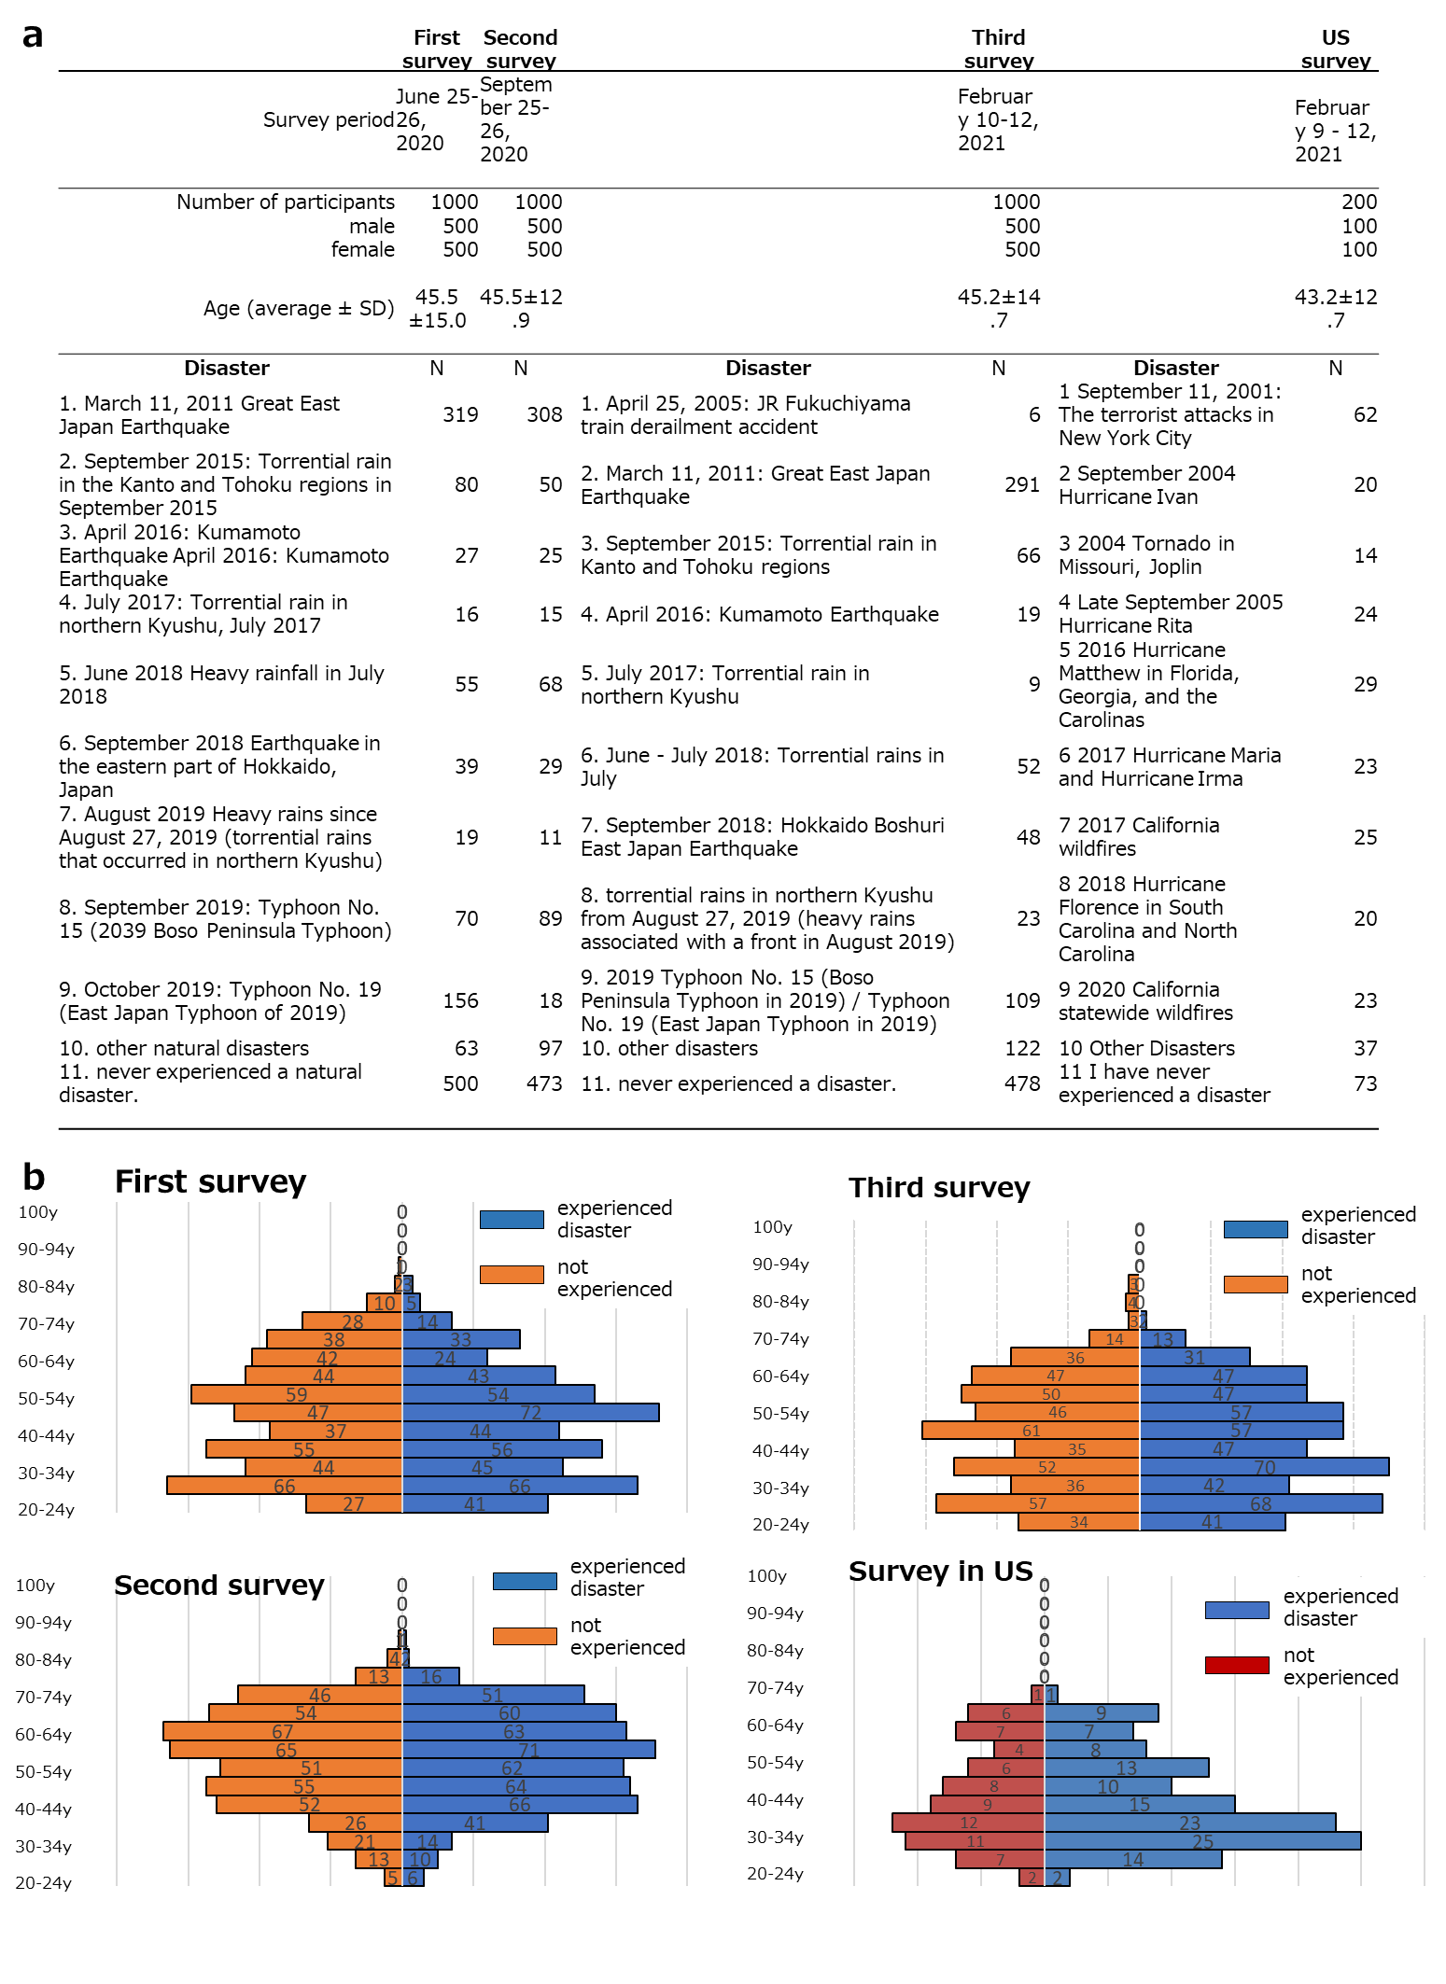

**Supplementary Figure 1: Profile of study participants.**

Supplemental Figure 1a: Number of participants in the first, second, and third surveys in Japan and the previously experienced disasters questioned in each session. Figure 1b: Number of survey participants and past disasters in the United States.

Supplemental Figure 1b: Experienced and non-experienced disaster participants in the first, second, and third rounds of the Japan and U.S. surveys, shown by age group.

Translated with www.DeepL.com/Translator (free version)

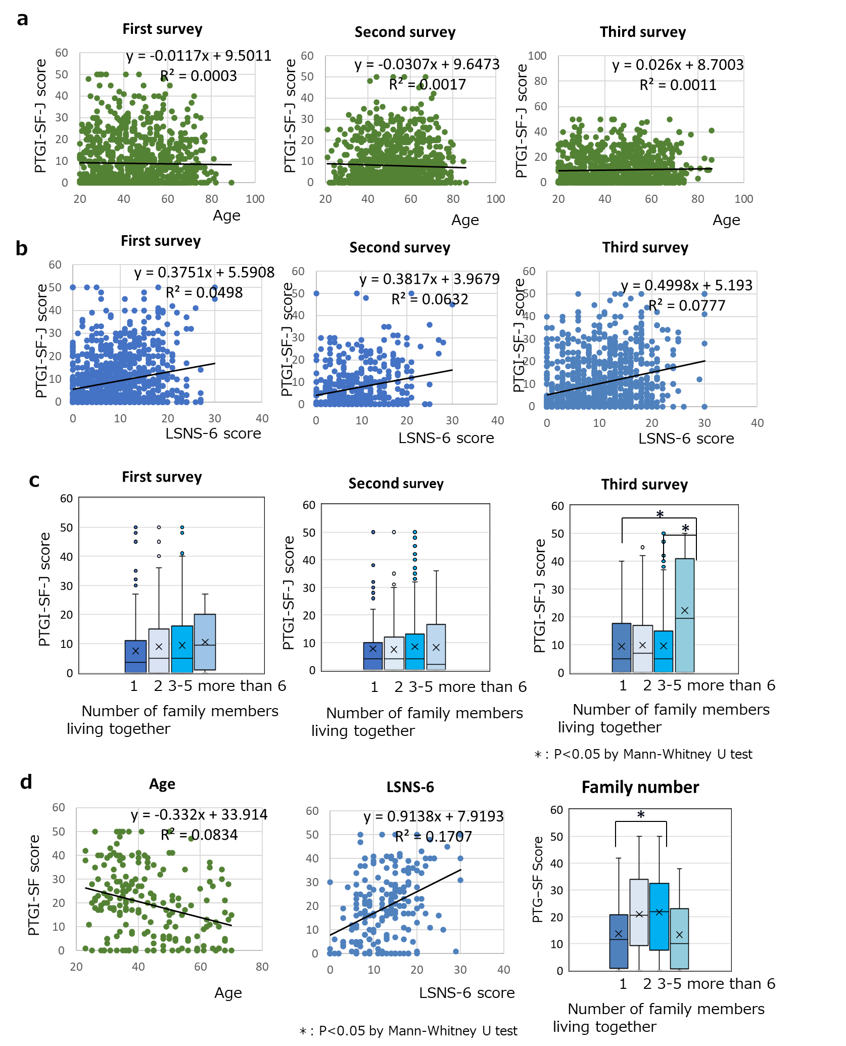

**Supplemental Figure 2: Factors associated with resilience.**

**Supplemental Figure 2a:** Relationship between the age of survey participants and resilience scores in the first, second, and third surveys in Japan.

**Supplemental Figure 2b:** Relationship between the Human Connectedness Scale (LSNS-6 score) and resilience scores in the first, second, and third surveys in Japan.

**Supplementary Figure 2c:** Relationship between the number of family members living together and resilience scores in the first, second, and third surveys in Japan.

**Supplemental Figure 2d:** Relationship between age, human connection scale, and number of family members living together and resilience score in the US survey.

Supplemental Figure 1b: Experienced and non-experienced disaster participants in the first, second, and third rounds of the Japan and U.S. surveys, shown by age group.

Translated with www.DeepL.com/Translator (free version)