Table 1. Characterization of the chemical constituents in XBW by UHPLC-Q-TOF-MS.
No. | Chemical name | Pubchem CID | Cas No. | Formula | 2D structure | Molecular Weight (Da) | ESI+（m/z） | ESI-（m/z） | Fragmentations  (m/z) | RT (min) | Chinese Medicine | Ref.
1 | Adenosine | 60961 | 58-61-7. | C₁₀H₁₃N₅O₄ | 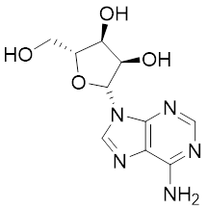 | 267.0967 | 【M+H】+：268.1047 | 【M-H】-：266.1047 | 136.0609,【M+H-C5H8O4】+ | 0.80 | CCP | Shen et al. 2019
2 | Karakolidine | 101306844 | 41655-13-4 | C₂₂H₃₅NO₅ | 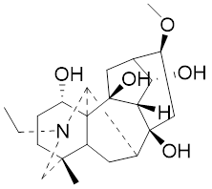 | 393.2515 | 【M+H】+：394.2594 | - | 376.2474, 【M+H-H2O】⁺；  317.1795，  【M+H-H2O-C3H9N】+ | 1.58 | Fuzi | Zhang et al. 2019
3 | Mesaconine | 101671037 | 6792-09-2 | C₂₄H₃₉NO₉ | 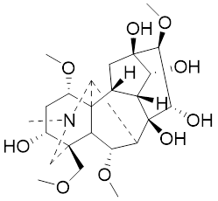 | 485.2625 | 【M+H】+：486.2716 |  | 468.2616  【M+H-H2O】+;  454.2431  【M+H-H2O-CH2】+;  424.2740  【M+H-H2O-CH2-CH2O】+ | 1.80 | Fuzi | Zhang et al. 2019
4 | Isotalatizidine | 11452543 | 7633-68-3 | C₂₃H₃₇NO₅ | 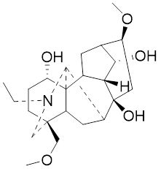 | 408.2730 | 【M+H】+：408.2730 |  | 390.2634，【M+H-H2O】+；  378.2625，  【M+H-CH2O】+；  360.2511，  【M+H-H2O-CH2O】+ | 1.91 | Fuzi | Zhang et al. 2019
5 | Aconine | 417761 | 509-20-6 | C₂₅H₄₁NO₉ | 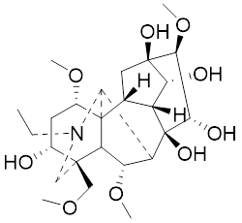 | 499.2781 | 【M+H】+：500.2869 |  | 468.2616  【M+H-H2O-CH2】+;  454.2780  【M+H-H2O-C2H4】+;  438.2846  【M+H-H2O-CH2-CH2O】+;  408.2730  【M+H-H2O-CH2-CH2O-C2HO】+;  378.2625  【M+H-H2O-CH2-CH2O-CH2O】+; | 1.97 | Fuzi | Zhang et al. 2019
6 | Songorine | 139291804 | 509-24-0 | C₂₂H₃₁NO₃ | 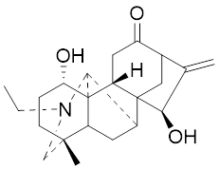 | 357.2304 | 【M+H】+：358.2383 |  | 340.2252  【M+H-H2O】+;  330.2276  【M+H-C2H4】+; | 2.04 | Fuzi | Zhang et al. 2019
7 | Scopolamin | 3000322 | 51-34-3 | C₁₇H₂₁NO₄ | 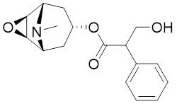 | 303.1471 | 【M+H】+：304.1531 |  | 156.1013  【M+H-C9H8O2】+;  138.0900  【M+H-C9H8O2-H2O】+; | 2.13 | Datura metel L. | Cirlini et al. 2018
8 | Hypaconine | 101671038 | 63238-68-6 | C₂₄H₃₉NO₈ | 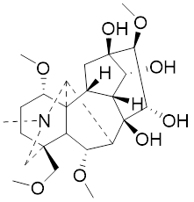 | 469.2676 | 【M+H】+：470.2740 |  | 438.2520  【M+H-CH3OH】+; | 2.23 | Fuzi | Zhang et al. 2019
9 | Fuziline | 131675180 | 80665-72-1 | C₂₄H₃₉NO₇ | 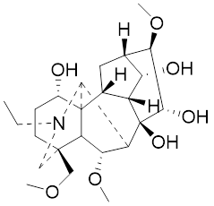 | 453.2726 | 【M+H】+：454.2824 | 【M+HCOO】-：498.2682 | 436.2692  【M+H-H2O】+ | 2.26 | Fuzi | Zhang et al. 2019
10 | Neoline | 12313185 | 466-26-2 | C₂₄H₃₉NO₆ | 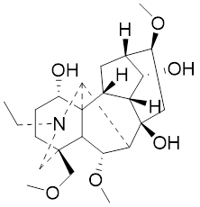 | 437.2777 | 【M+H】+：438.2846 |  | 420.2758  【M+H-H2O】+;  388.2489  【M+H-H2O-CH3OH】+ | 2.41 | Fuzi | Zhang et al. 2019
11 | 10-Hydroxyneoline | 138114026 | 132362-42-6 | C₂₄H₃₉NO₇ | 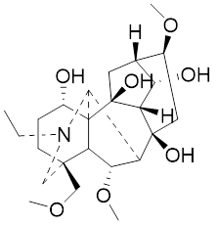 | 453.2726 | 【M+H】+：454.2824 |  | 438.2468  【M+H-H2O】+;  406.2579  【M+H-H2O-CH3OH】+ | 2.52 | Fuzi | Takayama et al. 1990
12 | 3-Deoxyaconine | 132580133 | 5877-69-0 | C₂₅H₄₁NO₈ | 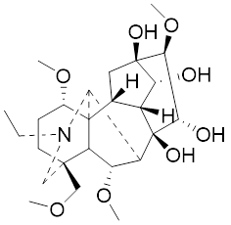 | 483.2832 | 【M+H】+：484.2882 |  | 452.2610  【M+H-C2H4】+ | 2.59 | Fuzi | Wang et al. 2014
13 | Atropine | 174174 | 51-55-8 | C₁₇H₂₃NO₃ | 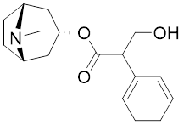 | 289.1678 | 【M+H】+：290.1751 |  | 260.1735  【M+H-CH2O】+ | 2.66 | Datura metel L. | Boermans et al. 2006
14 | Talatisamine | 159891 | 20501-56-8 | C₂₄H₃₉NO₅ | 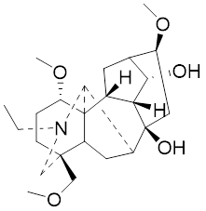 | 421.2828 | 【M+H】+：422.2917 |  | 390.2634  【M+H-CH3OH】+;  372.2533  【M+H-CH3OH-H2O】+; | 2.74 | Fuzi | Zhang et al. 2019
15 | 14-Acetyltalatizamine | 156166 | 71239-55-9 | C₂₆H₄₁NO₆ | 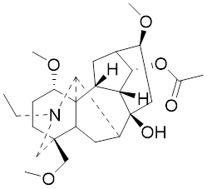 | 463.2934 | 【M+H】+：464.3026 |  | 432.2732  【M+H-CH3OH】+; | 3.64 | Fuzi | Zhang et al. 2019
16 | 14-Benzoyl-10-hydroxymesaconine | 70692815 |  | C₃₁H₄₃NO₁₁ | 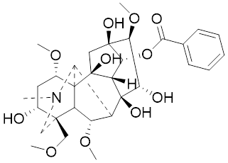 | 605.2836 | 【M+H】+：606.2900 |  | 588.2823  【M+H-H2O】+；  556.2526  【M+H-H2O-CH3OH】+； | 3.79 | Fuzi | Wu et al. 2012
17 | Ginsenoside M6A | 90478300 | 93376-72-8 | C₄₈H₈₂O₁₉ | 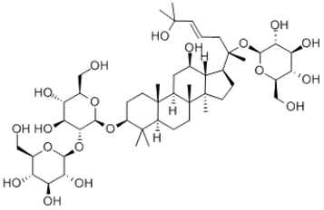 | 952.5450 |  | 【M-H】-：951.5444；  【M+HCOO】-：1007.5488 | 799.4877【M-H-glu】-;  637.4298  【M-H-glu-glu】-;  475.3797  【M-H-glu-glu-glu】-; | 4.47 | Panax ginseng C.A.Mey. | Li et al. 2019
18 | Notoginsenoside R1 | 441934 | 80418-24-2 | C₄₇H₈₀O₁₈ | 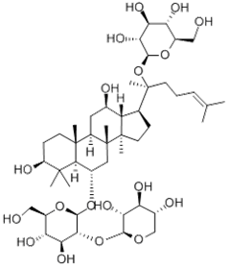 | 932.5345 | 【M+Na】+：955.5221 | 【M-H】-：931.5304；  【M+HCOO】-：977.5429 | 799.4877  【M-H-xyl】-;;  637.4356  【M-H-xyl-glu】-;  475.3797  【M-H-xyl-glu-glu】 | 4.65 | Panax notoginseng | Chen et al. 2018
19 | Benzoylmesaconine | 24832659 | 63238-67-5 | C₃₁H₄₃NO₁₀ | 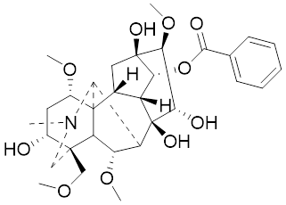 | 589.2887 | 【M+H】+：590.2991 |  | 558.2717  【M+H-CH3OH】+;  540.2599  【M+H-CH3OH-H2O】+;  526.2453  【M+H-CH3OH-CH3OH】+;  508.2315  【M+H-CH3OH-CH3OH-H2O】+; | 4.86 | Fuzi | Zhang et al. 2019
20 | Ginsenoside Rg1 | 441923 | 22427-39-0 | C₄₂H₇₂O₁₄ | 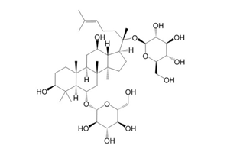 | 800.4922 | 【M+Na】+：823.4822 | 【M-H】-：799.4847；  【M+HCOO】-：845.5045 | 637.4375  【M-H-glu】-;  475.3797  【M-H-glu-glu】- | 5.03a | Panax ginseng C.A.Mey. | Chen et al. 2018
21 | Ginsenoside Re | 441921 | 52286-59-6 | C₄₈H₈₂O₁₈ | 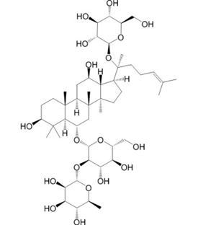 | 946.5501 | 【M+Na】+：969.5352 | 【M-H】-：945.5521；  【M+HCOO】-：991.5571 | 799.4847  【M-H-Rha】-;  637.4375  【M-H- Rha -glu】-; | 5.03b | Panax ginseng C.A.Mey. | Chen et al. 2015a
22 | Arenobufagin | 12305198 | 464-74-4 | C₂₄H₃₂O₆ | 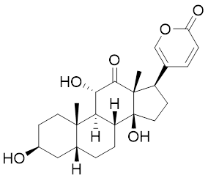 | 416.2199 | 【M+H】+：417.2274 |  | 399.2154  【M+H-H2O】+；  371.2236  【M+H-H2O-H2O】+； | 5.26 | Chansu | Wei et al. 2020
23 | Benzoylaconine | 20055771 | 466-24-0 | C₃₂H₄₅NO₁₀ | 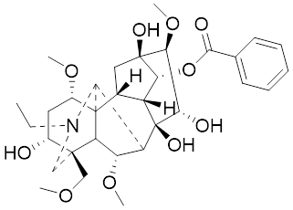 | 603.3043 | 【M+H】+：604.3115 |  | 586.3038  【M+H-H2O】+；  572.2827  【M+H-CH3OH】+；  554.2757  【M+H-CH3OH-H2O】+；  522.2489  【M+H-CH3OH-H2O-CH3OH】+； | 5.39 | Fuzi | Zhang et al. 2019
24 | Benzoylhypaconine | 78358526 | 63238-66-4 | C₃₁H₄₃NO₉ | 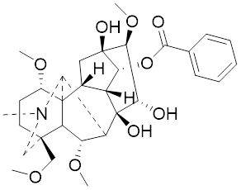 | 573.2938 | 【M+H】+：574.3012 | 【M+HCOO】-：618.2905 | 542.2737  【M+H-CH3OH】+；  510.2493  【M+H-CH3OH -CH3OH】+； | 5.74 | Fuzi | Zhang et al. 2019
25 | Ginsenoside Ra3 | 73157064 | 90985-77-6 | C₅₉H₁₀₀O₂₇ | 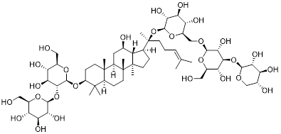 | 1240.6451 |  | 【M-2H】/2-：619.3145 | 1107.6091  【M-H-xyl】-;  945.5458  【M-H-xyl-glu】-;  783.4946  【M-H-xyl-glu-glu】-; | 6.59 | Panax ginseng C.A.Mey. | Chen et al. 2015b
26 | Ginsenoside F3 | 46887678 | 62025-50-7 | C₄₁H₇₀O₁₃ | 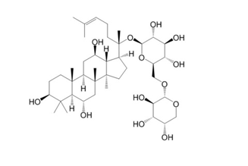 | 770.4816 |  | 【M-H】-：769.4797；  【M+HCOO】-：815.4846 | 637.4350  【M-H-glu】-;  475.3797  【M-H-glu-glu】-; | 7.00 | Panax ginseng C.A.Mey. | Du et al. 2018
27 | Ginsenoside Rb1 | 9898279 | 41753-43-9 | C₅₄H₉₂O₂₃ | 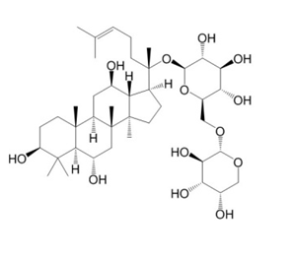 | 1108.6029 | 【M+Na】+：1139.5986 | 【M-H】-：1107.6023；  【M+HCOO】-：1153.6107 | 945.5458  【M-H-glu】-;  783.4946【M-H-glu-glu】-;  621.4415  【M-H-glu-glu-glu】-; | 7.07 | Panax ginseng C.A.Mey. | Chen et al. 2015a
28 | Ginsenoside Rb2 | 432450 | 11021-13-9 | C₅₃H₉₀O₂₂ | 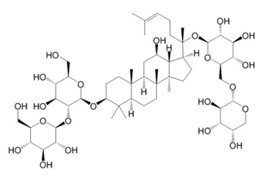 | 1078.5924 |  | 【M-H】-：1077.5958；  【M+HCOO】-：1123.6008 | 945.5458  【M-H-Ara】-;  783.4946【M-H-Ara-glu】-; | 7.27 | Panax ginseng C.A.Mey. | Chen et al. 2015a
29 | Ginsenoside Ro | 11815492 | 34367-04-9 | C₄₈H₇₆O₁₉ | 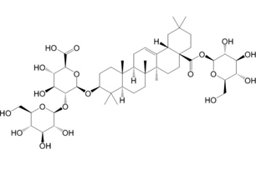 | 956.4981 |  | 【M-H】-：955.4960 | 793.4425  【M-H-glu】-; | 7.34 | Panax ginseng C.A.Mey. | Du et al. 2018
30 | Ginsenoside Rb3 | 12912363 | 68406-26-8 | C53H90O22 | 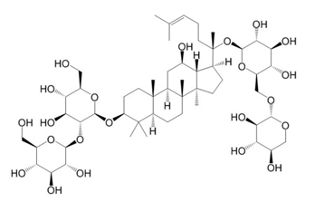 | 1078.5924 |  | 【M-H】-：1077.5958；  【M+HCOO】-：1123.6008 | 945.5458  【M-H-xyl】-;  783.4946【M-H-xyl-glu】-; | 7.48a | Panax ginseng C.A.Mey. | Chen et al. 2015b
31 | Ginsenoside Rc | 12855889 | 11021-14-0 | C₅₃H₉₀O₂₂ | 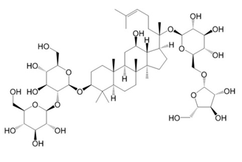 | 1078.5924 |  | 【M-H】-：1077.5958；  【M+HCOO】-：1123.6008 | 945.5458  【M-H- Xylofuranose】-;  783.4946【M-H- Xylofuranose -glu】-; | 7.48b | Panax ginseng C.A.Mey. | Chen et al. 2018
32 | Ginsenoside b1 | 71587485 | 132929-86-3 | C₅₆H₉₄O₂₄ | 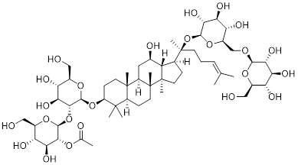 | 1150.6135 |  | 【M-H】-：1149.6147；  【M+HCOO】-：1195.6218 | 1107.6023  【M-H- Ac】-;  1089.5950  【M-H- Ac-H2O】-;  1077.5891  【M-H- Ac-CH2O】-;  945.5458  【M-H- Ac-Glu】-; | 7.70 | Panax ginseng C.A.Mey.
33 | Ginsenoside Rd | 24721561 | 52705-93-8 | C₄₈H₈₂O₁₈ | 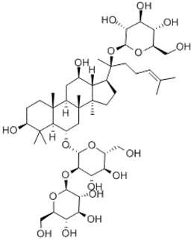 | 946.5501 |  | 【M-H】-：945.5458；  【M+HCOO】-：991.5571 | 783.4946【M-H-glu】-;  621.4415  【M-H-glu-glu】-; | 8.00 | Panax ginseng C.A.Mey. | Chen et al. 2018
34 | Gypenoside XVII | 44584555 | 80321-69-3 | C₄₈H₈₂O₁₈ | 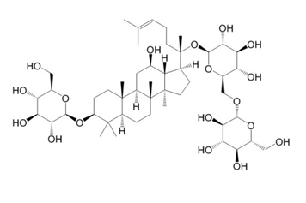 | 946.5501 |  | 【M-H】-：945.5458；  【M+HCOO】-：945.5458 | 783.4946【M-H-glu】-;  621.4415  【M-H-glu-glu】-; | 8.36 | Panax ginseng C.A.Mey. | Xu et al. 2017
35 | Acetyl ginsenoside Rd | 73818238 | 102805-32-3 | C₅₀H₈₄O₁₉ | 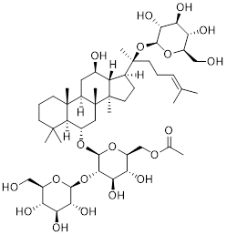 | 988.5607 |  | 【M-H】-：987.5566；  【M+HCOO】-：1033.5660 | 945.5458  【M-H-Ac】-;  927.5345  【M-H-Ac-H2O】-;  783.4946【M-H-Ac-glu】-; | 8.72 | Panax ginseng C.A.Mey. | Yao et al. 2021
36 | Ginsenoside Rg2 | 21599924 | 52286-74-5 | C₄₂H₇₂O₁₃ | 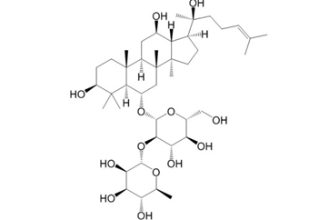 | 784.4973 |  | 【M-H】-：783.4946；  【M+HCOO】-：829.4975 | 621.4363  【M-H-glu】-;  459.3836  【M-H-glu-glu】-; | 9.39 | Panax ginseng C.A.Mey. | Chen et al. 2018
37 | Ginsenoside Rg3 | 9918693 | 14197-60-5 | C₄₂H₇₂O₁₃ | 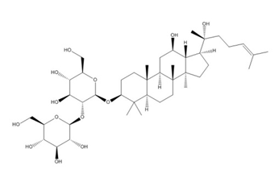 | 784.4973 |  | 【M-H】-：783.4946；  【M+HCOO】-：829.4975 | 621.4363  【M-H-glu】-;  459.3836  【M-H-glu-glu】-; | 9.43 | Panax ginseng C.A.Mey. | Chen et al. 2018

