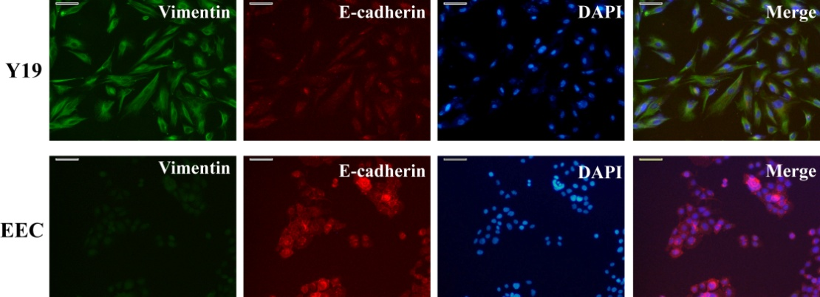
sFig1. Identification of mesenchymal cells. Immunofluorescent analysis of Vimentin(Green) and E-cadherin (Red) in Y19 and EEC respectively. DAPI staining was included to visualize the cell nucleus (Blue), Scale bar=100 μm.

sTable 1. The information for control group (Uterine Leiomyoma)
No. | Age | Pathological diagnosis
1 | 46 | Uterine Leiomyoma；
2 | 39 | Uterine Leiomyoma；
3 | 47 | Uterine Leiomyoma；
4 | 48 | Uterine Leiomyoma；
5 | 47 | Uterine Leiomyoma；
6 | 39 | Uterine Leiomyoma；
7 | 41 | Uterine Leiomyoma；
8 | 41 | Uterine Leiomyoma；
9 | 48 | Uterine Leiomyoma；
10 | 48 | Uterine Leiomyoma；
11 | 43 | Uterine Leiomyoma；
12 | 48 | Uterine Leiomyoma；
13 | 47 | Uterine Leiomyoma；
14 | 49 | Uterine Leiomyoma；
15 | 47 | Uterine Leiomyoma；
16 | 43 | Uterine Leiomyoma；
17 | 45 | Uterine Leiomyoma；

sTable 2. The information for adenomyosis patient group
No. | Age | Pathological diagnosis
1 | 43 | Adenomyoma
2 | 49 | Adenomyoma
3 | 49 | Adenomyosis
4 | 41 | Adenomyosis
5 | 42 | Adenomyosis
6 | 45 | Adenomyosis
7 | 50 | Adenomyoma
8 | 43 | Adenomyoma
9 | 41 | Adenomyosis
10 | 47 | Adenomyosis
11 | 51 | Adenomyosis
12 | 48 | Adenomyosis
13 | 39 | Adenomyosis
14 | 43 | Adenomyoma
15 | 41 | Adenomyosis
16 | 44 | Adenomyosis

