Supplementary Information

Knowledge, socio-cognitive perceptions and the practice of hand hygiene and social distancing during the COVID-19 pandemic: A cross-sectional study of UK university students
Christine Barrett, Kei Long Cheung

Table S1: Frequency of hand hygiene behaviour activities
How often do you practise the following activities? | N | Rarely/never  n (%) | Mostly  n (%) | Always  n (%)
Wash hands after using the toilet | 293 | 4 (1.4) | 48 (16.4) | 241 (82.3)
Wash hands before eating or handling food | 293 | 25(8.5) | 146 (49.8) | 122 (41.6)
Wash hands after contact with animals or pets (blank if no contact) | 229 | 71 (24.2) | 66 (22.5) | 92 (31.4)
Wash hands after handling money or public equipment | 293 | 62 (21.2) | 98 (33.4) | 133 (45.4)
Wash hands after coughing or sneezing | 292 | 59 (20.1) | 125 (42.7) | 108 (36.9)
Wash hands before touching face, eyes, nose, mouth | 293 | 129 (44.0) | 109 (37.2) | 55 (18.8)
If sneeze or cough, then sneeze of cough into tissue or sleeve | 293 | 33 (11.3) | 94 (32.1) | 166 (56.7)
Put tissues in the bin immediately after use | 293 | 18 (6.1) | 101 (34.5) | 174 (59.4)
Hand hygiene behaviour score - mean (SD)/ median (IQR) ª | 293 | 1.78 (± 0.69)/ 1.75 (1.0)
Abbreviations: SD, standard deviation; IQR, interquartile range
ª Hand hygiene behaviour score was normally distributed by visual inspection of histogram but was significantly different from a normal distribution by the Kolmogorov-Smirnov test (p = 0.035). Both mean and median measure of central tendency are shown.

Table S2: Frequency of social distancing behaviour activities
How often do you practise the following activities? | N | Rarely/mostly  n (%) | Mostly  n (%) | Always  n (%)
Staying at home when sick or have a cold | 279 | 2 (0.7) | 26 (9.3) | 251 (90.0)
Isolating at home if have high temperature or new, continuous cough until symptoms stop or at least 7 days | 280 | 3 (1.1) | 13 (4.6) | 264 (94.3)
Isolating at home for 14 days if someone in household develops high temperature or new, continuous cough | 280 | 3 (1.1) | 23 (7.8) | 255 (91.1)
Shopping only for basic necessities, as infrequently as possible | 280 | 4 (1.4) | 80 (28.6) | 196 (70.0)
Restricting to one form of outside exercise a day alone or with members of your household | 281 | 7 (2.5) | 62 (22.1) | 212 (75.4)
Not meeting in groups | 281 | 3 (1.1) | 12 (4.3) | 266 (94.7)
Staying at home except for essential shopping, exercise, medical need or work where you cannot work from home | 280 | 3 (1.1) | 34 (12.1) | 243 (86.8)
If outside the house, staying at least 2 m away from others not in household | 281 | 4 (1.4) | 61 (21.7) | 216 (76.9)
Social distancing behaviour score median (IQR) ª | 281 | 2.75 (0.5)
Abbreviations: SD, standard deviation; IQR, interquartile range
ª Social distancing behaviour score was not normally distributed by visual inspection of histogram and was significantly different from a normal distribution by the Kolmogorov-Smirnov test (p < 0.001), indicating median should be used. Mean (SD): 2.69 (0.44).

Table S3: Risk perception: probability, susceptibility and severity
Risk Perception – n (%) | 1 | 2 |  | 3 | 4 | 5 | 6 | 7 | 8 | 9
 | Extremely unlikely Extremely likely
Probability | 12  (4.1) | 47  (16.0) |  | 53  (18.1) | 42  (14.3) | 44  (15.0) | 48  (16.4) | 31  (10.6) | 10  (3.4) | 6  (2.0)
 | Not at all susceptible Very susceptible
Susceptibility | 10  (3.4) | 47  (16.0) |  | 56  (19.1) | 44  (15.0) | 52  (17.7) | 31  (10.6) | 33  (11.3) | 14  (4.8) | 6  (2.0)
 | Not severe Very severe
Severity | 25  (8.5) | 54  (18.4) |  | 59  (20.1) | 39  (13.3) | 30  (10.2) | 35  (11.9) | 29  (9.9) | 18  (6.1) | 4  (1.4)
Overall risk perception score – mean (SD)/median (IQR) ª |  |  | 4.31 (±1.55)/ 4.33 (2.0)
ª Risk perception score was approximately normally distributed by visual inspection of histogram but was significantly different from a normal distribution by the Kolmogorov-Smirnov test (p = 0.001). Both mean and median measure of central tendency are shown.

Figure S1: Participant responses for knowledge of COVID-19 risk groups and symptoms
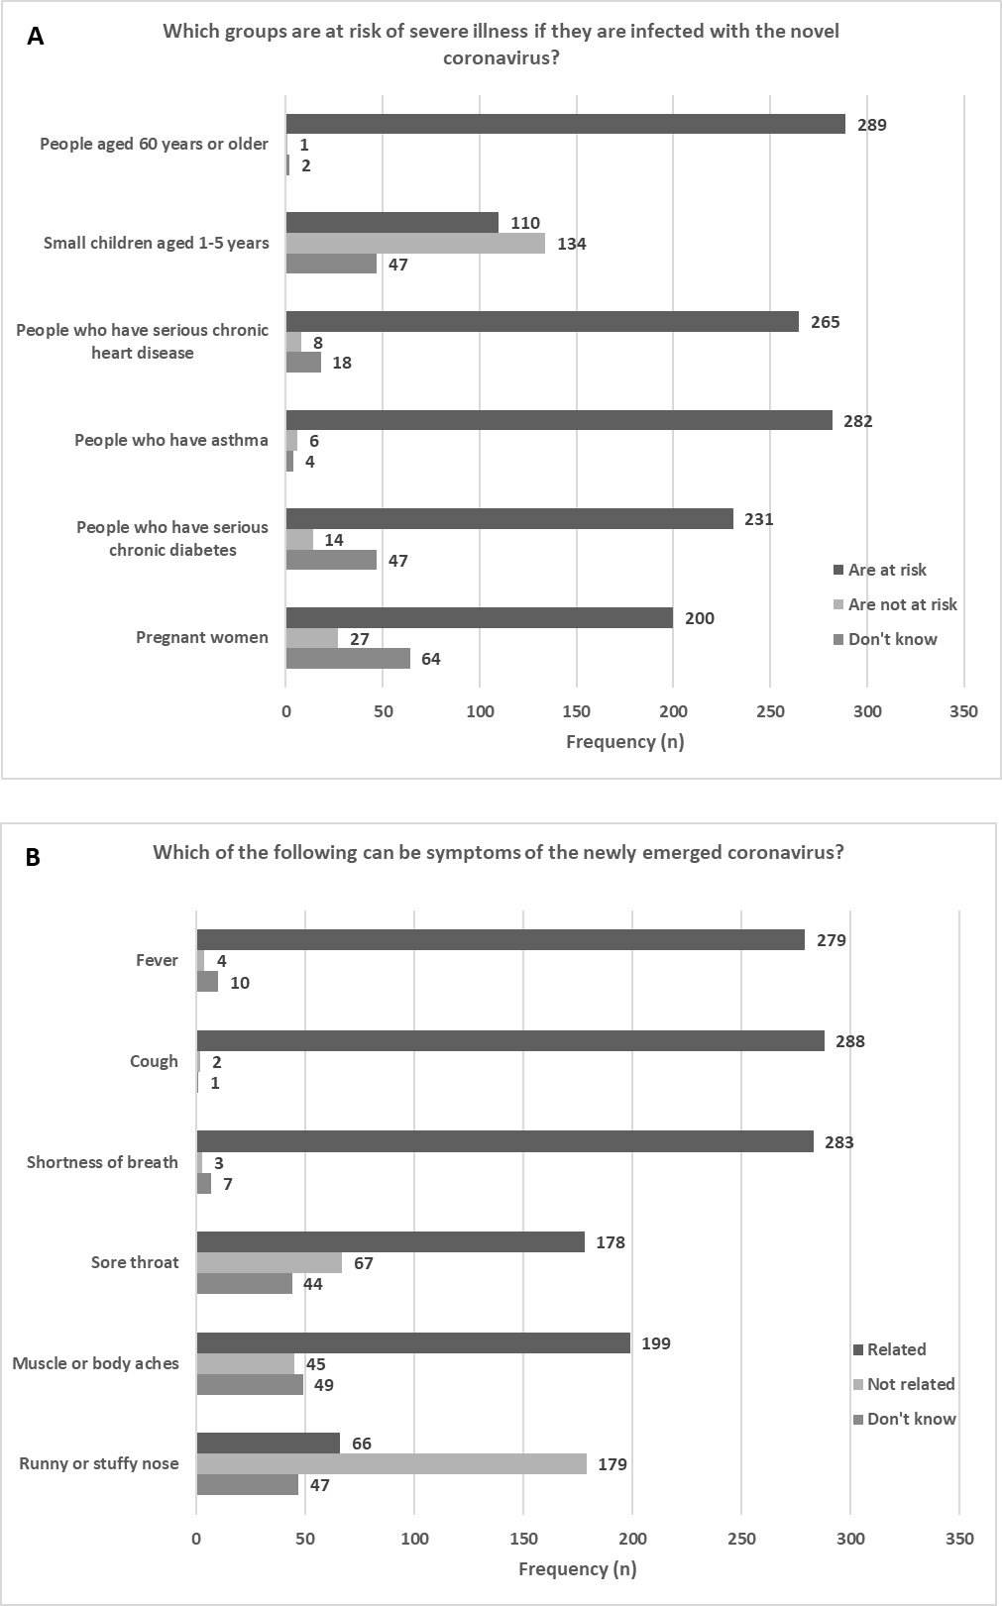

Table S4: Attitudes, self-efficacy, time factors and habit in hand hygiene behaviour
Domain and belief | N | Strongly agree  n(%) | Agree  n (%) | Neutral  n (%) | Disagree  n (%) | Strongly disagree  n (%)
Attitude (Advantages)
I believe that regular handwashing with soap and water will help prevent me from becoming infected with coronavirus | 293 | 134  (45.7) | 135  (46.1) | 17  (5.8) | 7  (2.4) | 0  (0)
I like the feeling of washing my hands | 293 | 60  (20.5) | 111 (37.9) | 91 (31.1) | 25 (8.5) | 6  (2.0)
I believe that regular handwashing with soap and water will help prevent vulnerable people from becoming infected with coronavirus | 293 | 114  (38.9) | 139  (47.4) | 26  (8.9) | 12  (4.1) | 2  (0.7)
I believe that believe that covering my mouth and nose with a tissue or sleeve when I cough or sneeze will help prevent others from becoming infected with coronavirus | 293 | 161  (54.9) | 107  (36.5) | 19  (6.5) | 6  (2.0) | 0  (0)
(Attitude) Disadvantages
I think that regular handwashing with soap and water is too much effort | 293 | 9  (3.1) | 20  (6.8) | 27  (9.2) | 104  (35.5) | 133  (45.4)
I think that washing my hands can hurt them | 293 | 16  (5.5) | 63  (21.5) | 50  (17.1) | 79  (27.0) | 85  (29.0)
I think that covering my mouth and nose with a tissue or sleeve when I cough or sneeze, is too much effort | 292 | 3  (1.0) | 11  (3.8) | 14  (4.8) | 70  (23.9) | 194  (66.2)
Time factor
Even if I am busy, I manage to wash my hands with soap after the toilet | 293 | 194  (66.2) | 69  (23.5) | 21  (7.2) | 8  (2.7) | 1  (0.3)
It takes too much time to wash my hands with soap each time I prepare food | 293 | 6  (2.0) | 27  (9.2) | 48  (16.4) | 96  (32.8) | 116  (39.6)
Hand-washing with soap and water for 20 seconds is quick and very easy to do | 293 | 138  (47.1) | 103  (35.2) | 29  (9.9) | 20  (6.8) | 3  (1.0)
Habit/automaticity
I sometimes start washing my hands without even realizing I’m doing it | 291 | 107  (36.5) | 83  (28.3) | 32  (10.9) | 44  (15.0) | 25  (8.5)
I feel strange when I don’t wash my hands with soap after the toilet | 292 | 165  (56.3) | 61  (20.8) | 35  (11.9) | 25  (8.5) | 6  (2.0)
Washing my hands with soap before I eat a meal is something I do automatically | 293 | 67  (22.9) | 71  (24.2) | 55  (18.8) | 73  (24.9) | 27  (9.2)
If I feel I am going to cough or sneeze, I have a tissue or my sleeve ready to cover my mouth and nose without even realizing I’m doing it | 293 | 98  (33.4) | 101  (34.5) | 39  (13.3) | 45  (15.4) | 10  (3.4)
Self-Efficacy – Hand hygiene
I am confident that I can practise handwashing correctly when at home | 293 | 195  (66.6) | 78  (26.6) | 16  (5.5) | 3  (1.0) | 1  (0.3)
I am confident that I can practise handwashing correctly when away from home | 293 | 157  (53.6) | 88  (30.0) | 22  (7.5) | 25  (8.5) | 1  (0.3)
I am confident that I can practise good cough etiquette | 293 | 184  (62.8) | 87  (29.7) | 19  (6.5) | 3  (1.0) | 0

Table S5: Attitudes, social support, self-efficacy, and trust in social distancing behaviour
Domain and belief | N | Strongly agree  n (%) | Agree  n (%) | Neutral  n (%) | Disagree  n (%) | Strongly disagree  n (%)
Advantages
I believe social distancing will help protect me from getting the novel coronavirus | 293 | 174  (59.4) | 101  (34.8) | 12  (4.1) | 4  (1.4) | 1  (0.3)
I believe social distancing will help protect the vulnerable from getting coronavirus | 293 | 201  (68.6) | 79  (27.0) | 10  (3.4) | 2  (0.7) | 1  (0.3)
I believe that social distancing will protect the NHS from having too many cases of COVID-19 in hospital at once | 292 | 198  (67.8) | 83  (28.4) | 6  (2.1) | 3  (1.0) | 2  (0.7)
Disadvantages
I think I miss meeting up with family and friends | 291 | 173  (59.5) | 69  (23.7) | 28  (9.6) | 14  (4.8) | 7  (2.4)
I think I (or someone close to me) will lose my job | 293 | 72  (24.6) | 101  (34.5) | 59  (20.1) | 47  (16.0) | 14  (4.8)
I think I will get too bored during the time of social distancing | 292 | 64  (21.9) | 82  (28.1) | 52  (17.8) | 68  (23.3) | 26  (8.9)
Social Support
My family and friends avoid crowded areas | 291 | 165  (56.7) | 105  (35.8) | 15  (5.2) | 5  (1.7) | 1  (0.3)
My family and friends avoid social contacts | 290 | 154  (53.1) | 106  (36.6) | 21  (7.2) | 7  (2.4) | 2  (0.7)
My friends encourage me to meet with them, against government guidelines | 293 | 12  (4.1) | 24  (8.2) | 11  (3.8) | 78  (26.6) | 168  (57.3)
Trust
I think the authorities should restrict personal liberty rights to combat the novel coronavirus | 292 | 47  (16.1) | 85  (29.1) | 94  (32.3) | 47  (16.1) | 19  (6.5)
I think the decisions that have been made to reduce the spread of the novel coronavirus are fair | 293 | 118  (40.3) | 118  (40.3) | 30  (10.2) | 20  (6.8) | 7  (2.4)
I think the authorities should relax the restrictions even if there are still many new cases of COVID-19 emerging | 293 | 8  (2.7) | 26  (8.9) | 26  (8.9) | 68  (23.2) | 165  (56.3)
Self-efficacy
I am confident that I can practise social distancing from family and friends who do not live in my household | 293 | 177  (60.4) | 90  (30.7) | 17  (5.8) | 6  (2.0) | 3  (1.0)
I am confident that I can practise social distancing when I am outside for essential activities | 292 | 139  (47.6) | 106  (36.3) | 27  (9.2) | 17  (5.8) | 3  (1.0)
I am confident that I can practise social distancing when I am outside for exercise | 293 | 166  (56.7) | 100  (34.1) | 16  (5.5) | 10  (3.4) | 1  (0.3)

Table S6: Correlation Matrix for general and hand hygiene related variables
 | (1) | (2) | (3) | (4) | (5) | (6) | (7) | (8) | (9) | (10) | (11) | (12) | (13) | (14) | (15) | (16) | (17) | (18)
Age (1) | 1.00
Gender (Male/Female) (2) | -0.09 | 1.00
Ethnicity (White/Minorities) (3) | 0.05 | -0.06 | 1.00
Student Status (UK/International) (4) | 0.11 | 0.03 | -.14* | 1.00
Health Course (5) | 0.04 | -0.11 | -.12* | -0.07 | 1.00
Infection exposure (6) | 0.06 | 0.02 | 0.00 | -0.07 | -.02 | 1.00
Disease knowledge (7) | 0.08 | -0.09 | 0.06 | -0.03 | 0.00 | -0.01 | 1.00
Risk perception (8) | .14* | -0.11 | 0.08 | -0.08 | 0.05 | .24** | 0.03 | 1.00
Self-efficacy- infection avoidance (9) | -.14* | 0.04 | -0.03 | 0.08 | -.01 | -.19** | -0.02 | -.42** | 1.00
Hand hygiene knowledge (10) | 0.02 | -0.01 | .17** | -0.10 | -.08 | -0.03 | -0.03 | 0.02 | 0.01 | 1.00
Hand Hygiene Compliance (11) | 0.03 | -0.10 | 0.01 | 0.03 | 0.00 | -0.01 | 0.07 | .15** | -0.06 | -.01 | 1.00
Hand hygiene behaviour (12) | 0.01 | -.23** | -0.08 | -0.07 | 0.04 | 0.11 | 0.10 | .20** | -0.08 | -.07 | .26** | 1.00
Attitude hand hygiene (13) | -0.03 | -0.10 | -0.06 | 0.01 | -.01 | -0.01 | 0.06 | -0.05 | 0.12* | 0.10 | .13* | .26** | 1.00
Advantages hand hygiene (14) | -0.05 | -0.09 | -0.07 | -0.06 | 0.01 | -0.04 | 0.01 | 0.03 | 0.04 | 0.06 | .12* | .29** | .69** | 1.00
Disadvantages (reversed) (15) | -0.01 | -0.06 | -0.04 | 0.04 | -.02 | 0.03 | 0.06 | -0.07 | 0.13* | 0.03 | 0.11 | .19** | .84** | .23** | 1.00
Time factors hand hygiene (16) | -0.01 | -.15** | 0.05 | -.15* | 0.03 | 0.06 | 0.12* | 0.01 | 0.03 | 0.02 | .30** | .49** | .51** | .34** | .45** | 1.00
Habit hand hygiene score (17) | -0.01 | -.20** | -0.04 | -0.09 | 0.00 | 0.06 | 0.08 | 0.10 | 0.00 | -.04 | .22** | .58** | .37** | .35** | .28** | .60** | 1.00
Self-efficacy hand hygiene score (18) | 0.00 | -.17** | 0.00 | -.13* | 0.11 | 0.10 | 0.06 | 0.07 | -0.06 | 0.00 | .23** | .38** | .47** | .38** | .36** | .54** | .47** | 1.00
Bold: * p <0.05 (significant, 2-tailed); ** p <0.01 (significant, 2-tailed)

Table S7: Correlation Matrix for general and social distancing related variables
 | (1) | (2) | (3) | (4) | (5) | (6) | (7) | (8) | (9) | (10) | (11) | (12) | (13) | (14) | (15) | (16) | (17)
Age (1) | 1.00
Gender (Male/Female) (2) | -0.09 | 1.00
Ethnicity (White/Minorities) (3) | 0.07 | -0.07 | 1.00
Student Status (UK/International) (4) | 0.11 | 0.04 | -.14* | 1.00
Health Course (5) | 0.03 | -0.11 | -.13* | -0.07 | 1.00
Infection exposure (6) | 0.06 | 0.03 | 0.02 | -0.08 | -.03 | 1.00
Disease knowledge (7) | 0.12* | -0.09 | 0.05 | -0.03 | 0.02 | -0.01 | 1.00
Risk perception (8) | 0.12* | -0.11 | 0.08 | -0.08 | 0.05 | 0.26** | 0.06 | 1.00
Self-efficacy- infection avoidance (9) | -.14* | 0.04 | -0.04 | 0.07 | -.01 | -.20** | -0.03 | -.42** | 1.00
Social distancing knowledge (10) | 0.05 | -.15* | 0.12 | -0.05 | -.06 | -0.04 | 0.09 | 0.05 | -0.02 | 1.00
Social Distancing compliance (11) | -0.01 | -0.02 | -0.11 | -0.03 | 0.02 | 0.01 | -0.07 | 0.09 | 0.02 | -0.11 | 1.00
Social distancing behaviour (12) | 0.03 | -.13* | -.124 | -0.03 | 0.02 | 0.01 | 0.06 | 0.07 | 0.12* | 0.11 | 0.27** | 1.00
Advantages social distancing (13) | -0.01 | -0.02 | -0.10 | 0.07 | -.02 | -0.06 | 0.06 | 0.03 | 0.15* | 0.17** | 0.17** | 0.26** | 1.00
Disadvantages (reversed) (14) | 0.11 | 0.15* | -0.01 | 0.16** | 0.01 | -.16** | -.13* | -0.02 | -0.02 | 0.05 | 0.06 | 0.02 | -0.01 | 1.00
Social support social distancing (15) | -0.06 | -.13* | 0.05 | -0.05 | 0.04 | 0.01 | .120* | 0.03 | 0.09 | 0.17** | 0.10 | 0.28** | 0.28** | 0.01 | 1.00
Trust social distancing score (16) | 0.05 | -0.09 | 0.14* | -0.09 | 0.05 | 0.06 | 0.09 | 0.12* | 0.09 | 0.21** | 0.18** | 0.28** | 0.29** | 0.04 | 0.27** | 1.00
Self-efficacy social distancing (17) | -0.02 | -0.02 | -0.09 | -0.09 | 0.08 | 0.03 | -0.03 | 0.04 | 0.06 | 0.14* | 0.18** | 0.43** | 0.37** | -.02 | 0.39** | 0.26** | 1.00
Bold: * p <0.05 (significant, 2-tailed); ** p <0.01 (significant, 2-tailed)

