Supplementary Information
Supplementary Figures and Tables
Supplementary Table 1 Levels of metals in HydroZitLa measured by inductively couple plasma-optical emission spectrometer (ICP-OES).
Metals | Concentration (ppm, mg/L)
Thallium (Tl) | 0
Arsenic (AS) | UD
Selenium (Se) | 0.0043 ± 0.0103
Molybdenum (Mo) | 0.0113 ± 0.0050
Zinc (Zn) | 2.0897 ± 0.0523
Antimony (Sb) | UD
Lead (Pb) | 0.0004 ± 0.0006
Cadmium (Cd) | 0
Cobalt (Co) | UD
Nickel (Ni) | UD
Iron (Fe) | 0.1587 ± 0.0011
Manganese (Mn) | 0.0803 ± 0.0010
Chromium (Cr) | UD
Magnesium (Mg) | 14.0420 ± 0.0511
Vanadium (V) | UD
Beryllium (Be) | 0
Calcium (Ca) | 0.8627 ± 0.0240
Copper (Cu) | UD
Titanium (Ti) | 0.0353 ± 0.0004
Strontium (Sr) | 0.0080 ± 0.0001
Lithium (Li) | 0
UD: undetectable, Data presented as mean ± SD.

Supplementary Figure 1 Inhibitory activity of various concentrations of citric acid on COM aggregation. Citric acid at concentrations of 0.5 mM and thereafter higher concentrations significantly inhibited aggregation of COM crystals.
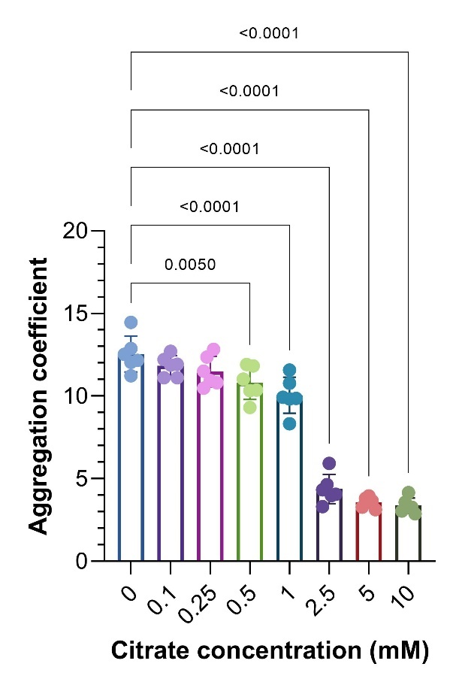
Supplementary Figure 2 Representative H&E micrographs of all four groups of rat renal sections. Magnification: x100.
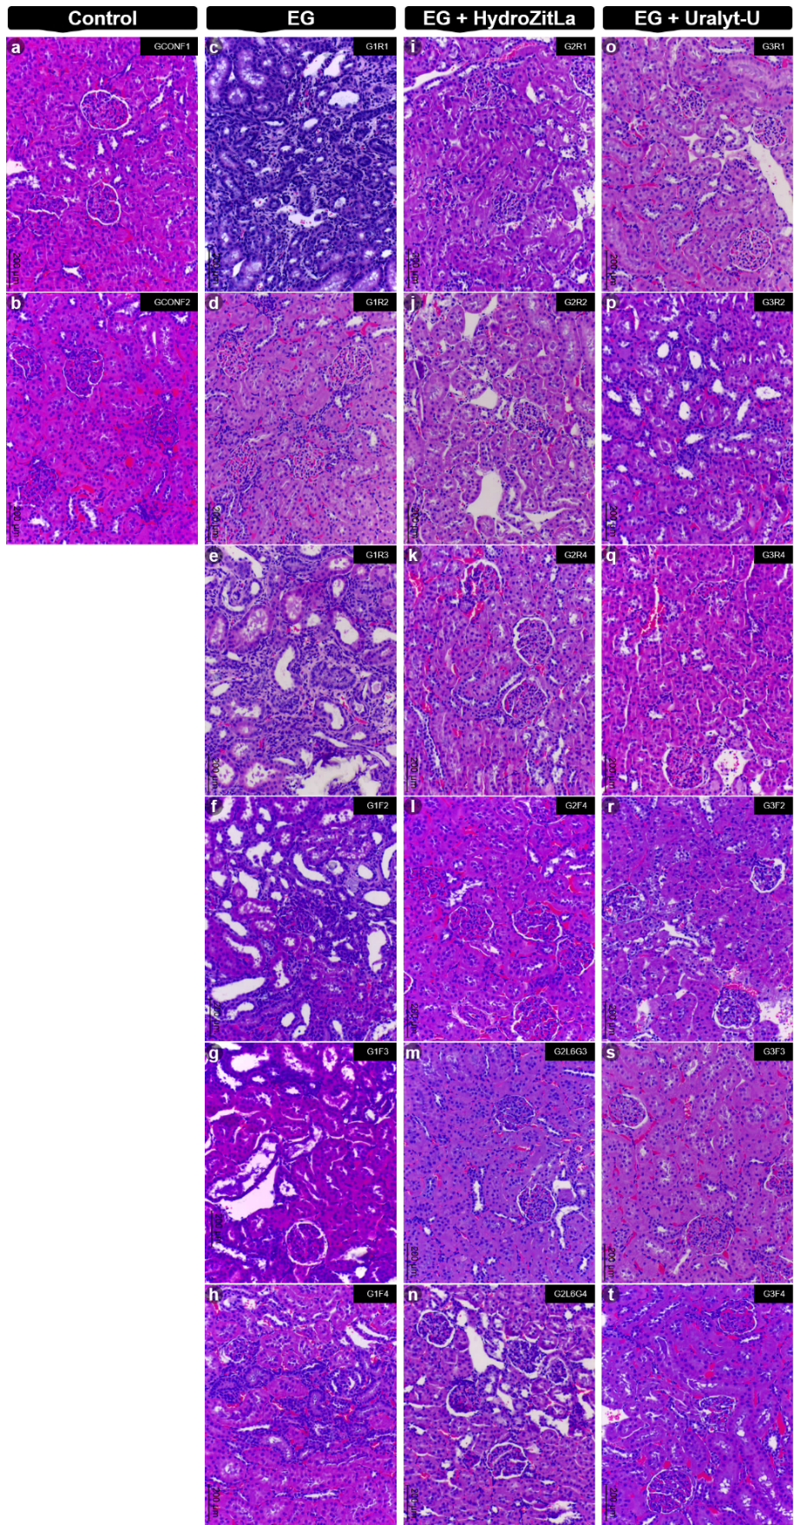
Supplementary Figure 3 Polarized micrographs of all four groups of rat renal sections. Magnification: x100.
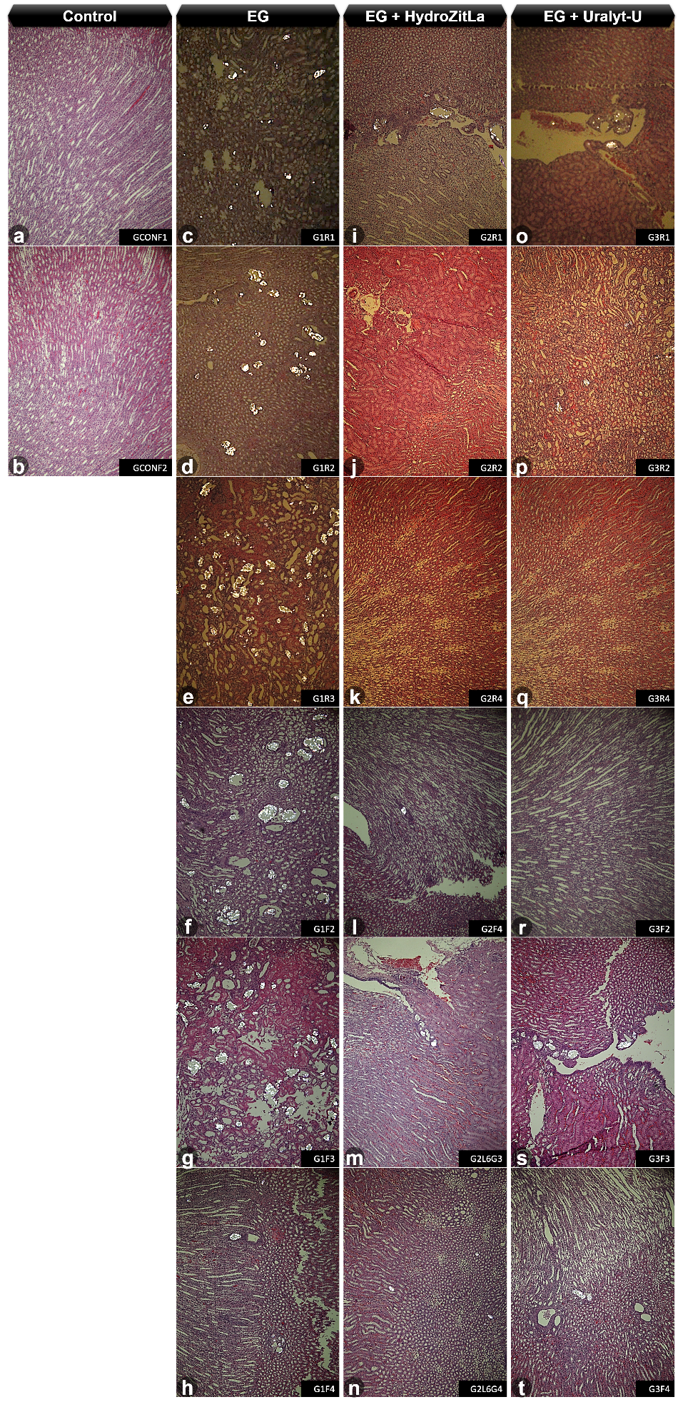

Supplementary Figure 4 Yasue staining micrographs of all four groups of rat renal sections. Magnification: x100.
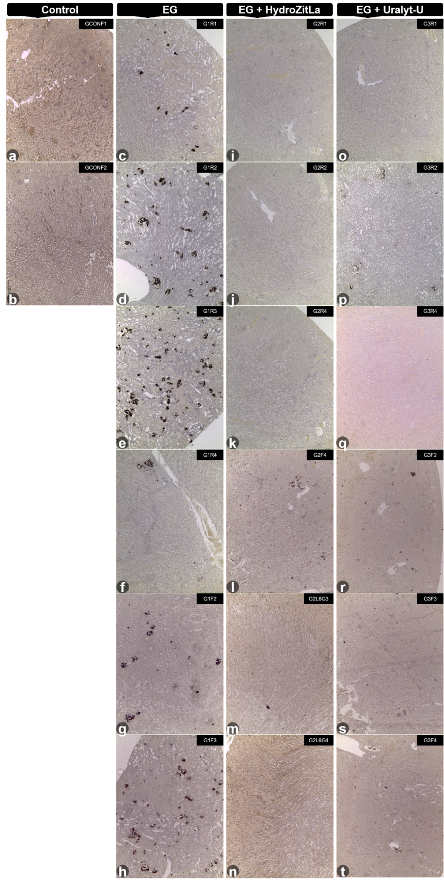

Supplementary Figure 5 Representative micrographs of 4-HNE expression in the renal sections of all four groups of rats. Magnification: x400.
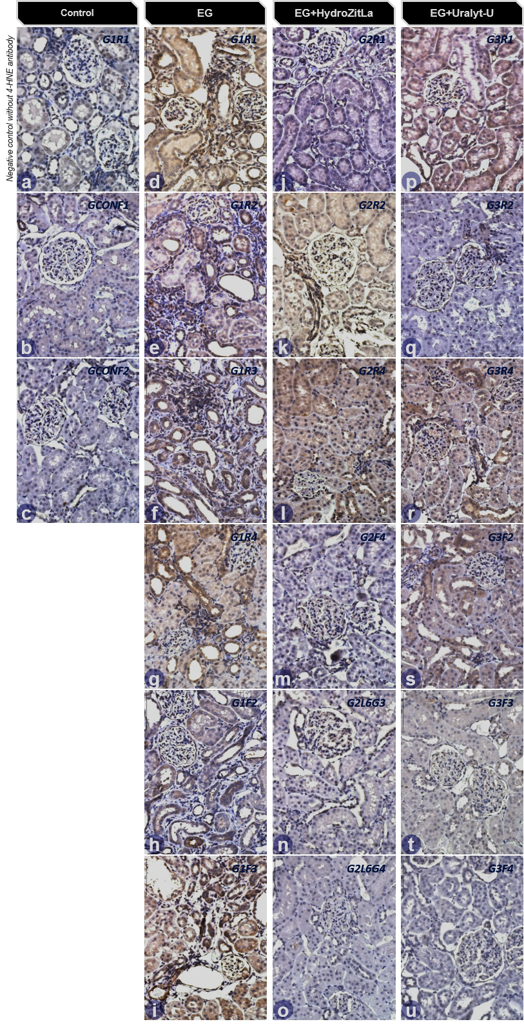

Supplementary Figure 6 Representative micrographs of cleaved Caspase-3 expression in renal sections. Intrarenal expression of cleaved Caspase-3 in EG, EG + HydroZitLa, EG + Uralyt-U, and control rats were relatively comparable. Magnification: x400.

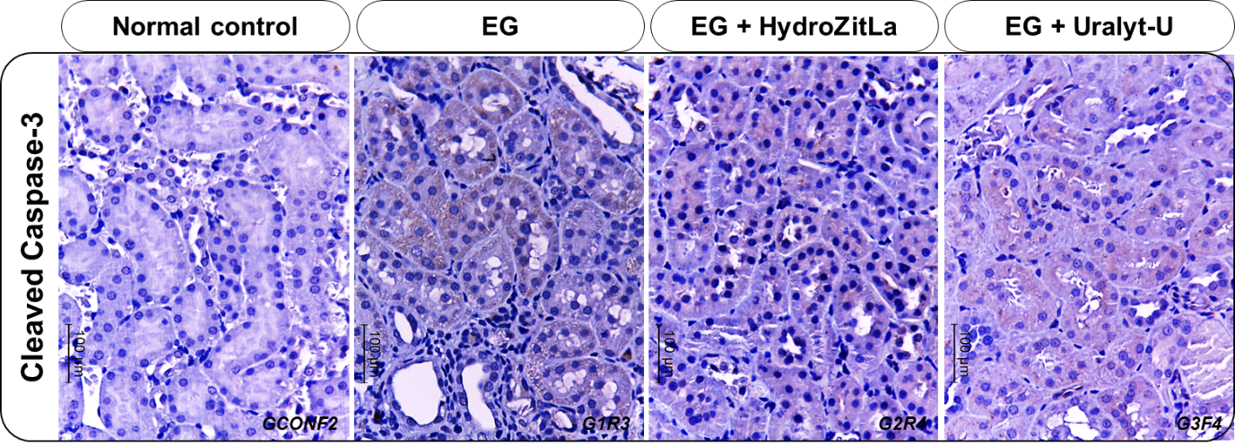

Supplementary Figure 7 The effect of HydroZitLa (varied concentrations from 1 to 100% v/v) on C. elegans survival. At the extremely high doses (90 and 100% v/v), HydroZitLa (HZL) was evidently toxic to the C. elegans. HydroZitLa supplementation at 30% v/v delivered the most lifespan extending effect in tested nematodes.
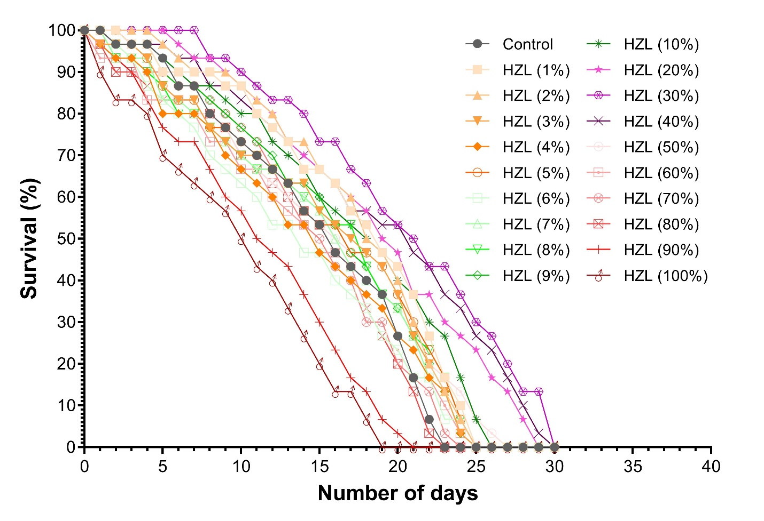

Supplementary Figure 8 A: Total antioxidant capacity (TAC, measured by ABTS method) of HydroZitLa was 1.87 ± 7.96 mg vitamin C equivalent antioxidant capacity/pouch, but TAC in Uralyt-U drug was undetectable (UD). B: Total phenolic content (TPC) and total flavonoid content (TFC) of HydroZitLa were 19.99 ± 0.83 mg gallic acid equivalent/100 g, and 4.59 ± 0.31 mg catechin equivalent/100 g, respectively.


