Supplementary Information
for
Discovery of Next-Generation Tropomyosin Receptor Kinase (TRK) Inhibitors for Combatting Resistance Associated with Protein Mutation

Lin-Sheng Zhuo^{1,†}, Ming-Shu Wang^{1,†}, Feng-Xu Wu^{2,†}, Hong-Chuang Xu^{1,†}, Yi Gong¹, Zhi-Cheng Yu¹, Yan-Guang Tian¹, Chao Pang¹, Ge-Fei Hao¹, Wei Huang^{1,}*, and Guang-Fu Yang^{1,}*

- Key Laboratory of Pesticide & Chemical Biology of Ministry of Education, International Joint Research Center for Intelligent Biosensor Technology and Health, College of Chemistry, Central China Normal University, Wuhan 430079, P.R. China
- Hubei Key Laboratory of Wudang Local Chinese Medicine Research, School of Pharmaceutical Sciences, Hubei University of Medicine, Hubei, 442000, P. R. of China

* Corresponding authors. E-mail address: weihuangwuhan@126.com (W. Huang), gfyang@mail.ccnu.edu.cn (G. Yang).
† L.Z., M.W., F.W. and H.X. contributed equally to this work

Contents
1 Fig. S1 S2
2 Preparation of Key Intermediate Compounds S3
3 Preparation of All Target Compounds S7
4 Copies of NMR Data for all Target Compounds S17
5 Copies of HPLC of Representative Compounds S43

Fig. S1
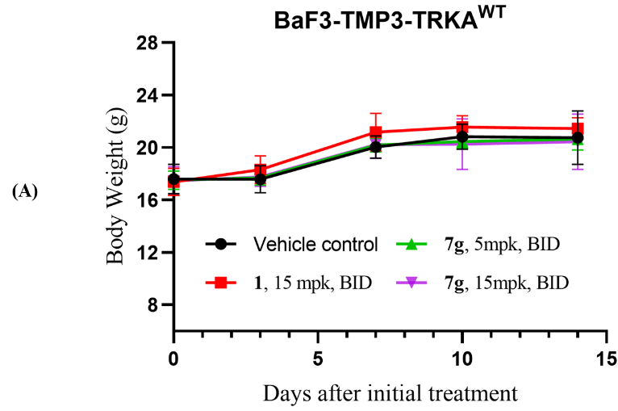

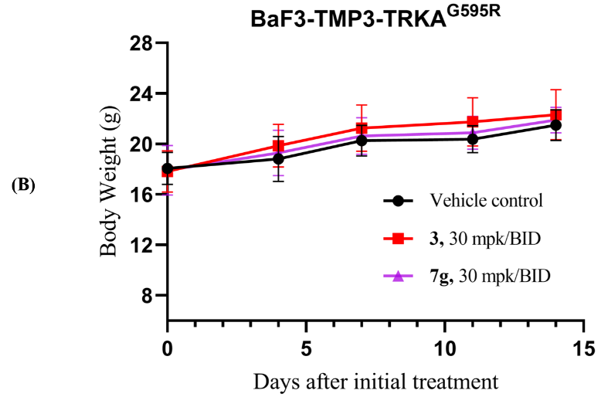

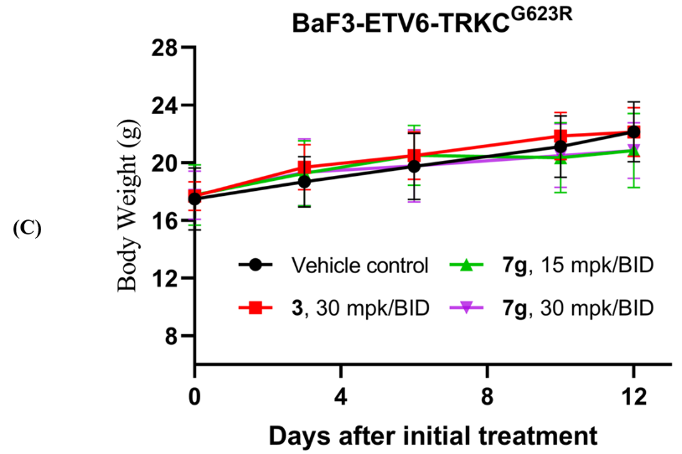
Fig. S1: Body weight of mice during treatment with 1 (Larotrectinib), 3 (Selitrectinib) and 7g in the Ba/F3-TMP3-TRKA^{WT} fusion (A), Ba/F3-TMP3-TRKA^{G595R} fusion (B), and Ba/F3-ETV6-TRKC^{G623R} fusion (C) xenograft model.

Preparation of Key Intermediate Compounds
(R)-5-(2-(2,5-difluorophenyl)pyrrolidin-1-yl)pyrazolo[1,5-a]pyrimidine (9)
A mixture of (R)-2-(2,5-difluorophenyl)pyrrolidine hydrochloride 8 (6.0 g, 27.3 mmol), 5-chloropyrazolo[1,5-a]pyrimidine (27.3 mmol), DIPEA (55 mmol) in anhydrous n-butanol (20 mL) was heated at 140 °C for overnight. The reaction mixture was concentrated for further purification by column chromatography on silica gel (heptane/acetone = 5:1) to afford the intermediate 9 (7.22, 88%) as a pale-yellow solid. ¹H NMR (600 MHz, CDCl₃) δ 8.29 – 8.14 (m, 1H), 7.91 – 7.80 (m, 1H), 7.10 – 7.02 (m, 1H), 6.96 – 6.87 (m, 1H), 6.77 – 6.69 (m, 1H), 6.21 – 6.07 (m, 1H), 6.03 – 5.80 (m, 1H), 5.42 – 5.15 (m, 1H), 4.05 – 3.90 (m, 1H), 3.83 – 3.66 (m, 1H), 2.53 – 2.40 (m, 1H), 2.11 – 1.94 (m, 3H).

(R)-5-(2-(2,5-difluorophenyl)pyrrolidin-1-yl)-3-iodopyrazolo[1,5-a]pyrimidine (10)
A solution of 9 (7.0 g, 23.3 mmol) and N-iodosuccinimide (34.95 mmol) in acetonitrile (150 mL) was stirred at room temperature for 1h. The reaction mixture was concentrated under reduced pressure, and diluted with ethyl acetate (300 mL), wash with sodium hydroxide aqueous solution (2 mol/L) and brine (2×50mL), dried over Na₂SO₄, filtered, and concentrated. The residue was purified by chromatography (heptane/acetone = 5:1) to yield 10 (9.44g, 95%) as a pale-yellow solid. ¹H NMR (600 MHz, CDCl₃) δ 8.27 – 8.01 (m, 1H), 7.90 – 7.74 (m, 1H), 7.11 – 7.00 (m, 1H), 6.98 – 6.86 (m, 1H), 6.84 – 6.72 (m, 1H), 5.99 – 5.71 (m, 1H), 5.33 – 5.01 (m, 1H), 4.17 – 3.55 (m, 2H), 2.50 (s, 1H), 2.22 – 1.91 (m, 3H).

(R)-N-(1-(2,5-difluorophenyl)ethyl)pyrazolo[1,5-a]pyrimidin-5-amine (13)
The compounds 13 were prepared from (R)-1-(2,5-difluorophenyl)ethan-1-amine hydrochloride 12 and 5-chloropyrazolo[1,5-a]pyrimidine by following a similar procedure as described for 9. ¹H NMR (600 MHz, CDCl₃) δ 8.22 (d, J = 7.6 Hz, 1H), 7.85 – 7.82 (m, 1H), 7.09 – 7.04 (m, 1H), 7.03 – 6.98 (m, 1H), 6.93 – 6.85 (m, 1H), 6.12 – 6.05 (m, 1H), 5.99 (d, J = 7.6 Hz, 1H), 5.42 – 5.29 (m, 1H), 5.22 – 5.12 (m, 1H), 1.58 (d, J = 7.2 Hz, 3H).

(R)-N-(1-(2,5-difluorophenyl)ethyl)-3-iodopyrazolo[1,5-a]pyrimidin-5-amine (14)
The compounds 14 were prepared from 13 by following a similar procedure as described for 10. ¹H NMR (400 MHz, CDCl₃) δ 8.16 (d, J = 7.6 Hz, 1H), 7.81 (s, 1H), 7.19 – 7.08 (m, 1H), 7.06 – 6.97 (m, 1H), 6.95 – 6.86 (m, 1H), 6.00 (d, J = 7.6 Hz, 1H), 5.58 – 5.40 (m, 1H), 5.38 – 5.21 (m, 1H), 1.62 (d, J = 6.9 Hz, 3H).

(R)-N-(1-(5-fluoro-2-((4-methoxybenzyl)oxy)phenyl)ethyl)pyrazolo[1,5-a]pyrimidin-5-amine (17)
The compounds 17 were prepared from (R)-1-(5-fluoro-2-((4-methoxybenzyl)oxy)phenyl)ethan-1-amine hydrochloride 16 and 5-chloropyrazolo[1,5-a]pyrimidine by following a similar procedure as described for 9. ¹H NMR (600 MHz, CDCl₃) δ 8.14 (d, J = 7.6 Hz, 1H), 7.83 (s, 1H), 7.42 – 7.31 (m, 2H), 7.08 – 7.00 (m, 1H), 6.97 – 6.81 (m, 4H), 6.07 (s, 1H), 5.79 (d, J = 7.6 Hz, 1H), 5.58 (d, J = 6.9 Hz, 1H), 5.37 (br, 1H), 5.06 (q, J = 11.0 Hz, 2H), 3.83 (s, 3H), 1.53 (d, J = 6.9 Hz, 3H).

(R)-4-fluoro-2-(1-(pyrazolo[1,5-a]pyrimidin-5-ylamino)ethyl)phenol (18)
A solution of 17 (5.0 g, 12.7 mmol) and TFA (44.45 mmol) in DCM (50 mL) was stirred at rt for 4 h. The mixture was dropwise added to ice water, and then extracted with EA. The organic layer was separated, washed with saturated brine (2×50mL), dried over Na₂SO₄, filtered, and concentrated. The residue was purified by chromatography (heptane/acetone = 4:1) to yield 18 (2.9 g, 85%) as a white solid. ¹H NMR (400 MHz, DMSO-d₆) δ 9.67 (s, 1H), 8.48 (d, J = 7.5 Hz, 1H), 7.78 (d, J = 8.1 Hz, 1H), 7.76 (d, J = 2.2 Hz, 1H), 7.03 (dd, J = 9.8, 3.1 Hz, 1H), 6.91 – 6.84 (m, 1H), 6.83 – 6.77 (m, 1H), 6.35 (d, J = 7.6 Hz, 1H), 5.94 (d, J = 2.2 Hz, 1H), 5.44 – 5.32 (m, 1H), 1.41 (d, J = 6.8 Hz, 3H).

(R)-N-(1-(5-fluoro-2-(fluoromethoxy)phenyl)ethyl)-3-iodopyrazolo[1,5-a]pyrimidin-5-amine (19a)
A mixture of 18 (3.0 g, 11.0 mmol), fluoroiodomethane (22.0 mmol), and Cs₂CO₃ (33.0 mmol) in DMF (50 mL) was heated at 100 °C for overnight. The reaction was allowed to cool and then diluted with ethyl acetate (300 mL), wash with saturated brine (2×50mL), dried over Na₂SO₄, filtered, and concentrated. The residue was used directly in next step without further purification. A solution of this residue (11.0 mmol) and N-iodosuccinimide (16.5 mmol) in acetonitrile (150 mL) was stirred at room temperature for 1h. The reaction mixture was concentrated under reduced pressure, and diluted with ethyl acetate (300 mL), wash with sodium hydroxide aqueous solution (2 mol/L) and brine (2×50mL), dried over Na₂SO₄, filtered, and concentrated. The residue was purified by chromatography (heptane/acetone = 6:1) to yield 19a (4.2g, 90%) as a yellow solid. ¹H NMR (600 MHz, CDCl₃) δ 8.17 (d, J = 7.5 Hz, 1H), 7.82 (s, 1H), 7.17 – 7.06 (m, 2H), 6.98 – 6.89 (m, 1H), 6.00 (d, J = 7.5 Hz, 1H), 5.85 (d, J = 54.1 Hz, 2H), 5.48 (br, 1H), 1.57 (d, J = 6.7 Hz, 3H).

(R)-N-(1-(5-fluoro-2-(2-fluoroethoxy)phenyl)ethyl)-3-iodopyrazolo[1,5-a]pyrimidin-5-amine (19b)
The compounds 19b were prepared from 18 and 1-fluoro-2-iodoethane by following a similar procedure as described for 19a. ¹H NMR (600 MHz, CDCl₃) δ 8.12 (d, J = 7.5 Hz, 1H), 7.81 (s, 1H), 7.18 – 7.09 (m, 1H), 6.98 – 6.88 (m, 1H), 6.85 – 6.80 (m, 1H), 6.08 – 5.90 (m, 2H), 5.54 – 5.26 (m, 1H), 4.96 – 4.73 (m, 2H), 4.41 – 4.19 (m, 2H), 1.60 (d, J = 6.8 Hz, 3H).

(R)-N-(1-(5-fluoro-2-(3-fluoropropoxy)phenyl)ethyl)-3-iodopyrazolo[1,5-a]pyrimidin-5-amine (19c)
The compounds 19c were prepared from 18 and 1-fluoro-3-iodopropane by following a similar procedure as described for 19a. ¹H NMR (600 MHz, CDCl₃) δ 8.13 (d, J = 7.5 Hz, 1H), 7.81 (s, 1H), 7.14 – 7.05 (m, 1H), 6.94 – 6.88 (m, 1H), 6.87 – 6.80 (m, 1H), 5.96 (d, J = 7.6 Hz, 1H), 5.90 – 5.79 (m, 1H), 5.54 – 5.23 (m, 1H), 4.83 – 4.62 (m, 2H), 4.25 – 4.13 (m, 2H), 2.36 – 2.16 (m, 2H), 1.57 (d, J = 6.8 Hz, 3H).

(R)-N-(1-(2-(2,2-difluoroethoxy)-5-fluorophenyl)ethyl)-3-iodopyrazolo[1,5-a]pyrimidin-5-amine (19d)
The compounds 19d were prepared from 18 and 1,1-difluoro-2-iodoethane by following a similar procedure as described for 19a. ¹H NMR (600 MHz, CDCl₃) δ 8.14 (d, J = 7.6 Hz, 1H), 7.81 (s, 1H), 7.17 – 7.08 (m, 1H), 6.96 – 6.87 (m, 1H), 6.85 – 6.76 (m, 1H), 6.20 (tt, J = 54.8, 3.8 Hz, 1H), 5.98 (d, J = 7.6 Hz, 1H), 5.79 – 5.59 (m, 1H), 5.50 – 5.29 (m, 1H), 4.40 – 4.15 (m, 2H), 1.58 (d, J = 6.8 Hz, 3H).

(R)-N-(1-(5-fluoro-2-(2,2,2-trifluoroethoxy)phenyl)ethyl)-3-iodopyrazolo[1,5-a]pyrimidin-5-amine (19e)
The compounds 19d were prepared from 18 and 1,1,1-trifluoro-2-iodoethane by following a similar procedure as described for 19a. ¹H NMR (600 MHz, CDCl₃) δ 8.13 (d, J = 7.6 Hz, 1H), 7.82 (s, 1H), 7.16 – 7.07 (m, 1H), 6.92 – 6.84 (m, 1H), 6.81 – 6.72 (m, 1H), 5.95 (d, J = 7.6 Hz, 1H), 5.80 – 5.61 (m, 1H), 5.53 – 5.27 (m, 1H), 5.01 – 4.84 (m, 2H), 1.55 (d, J = 6.8 Hz, 3H).

Preparation of All Target Compounds
(R)-1-(5-(2-(2,5-difluorophenyl)pyrrolidin-1-yl)pyrazolo[1,5-a]pyrimidin-3-yl)imidazolidin-2-one (5a). A mixture of 10 (200 mg, 0.52 mmol), imidazolidin-2-one (1.56 mmol), Cu(I) iodide (0.1 mmol), (1R,2R)-N,N'-Dimethyl-1,2-cyclohexanediamine (0.1 mmol), and K₃PO₄ (4 mmol) were added to a sealed tube. The tube was degassed and charged with nitrogen (three cycles). DMF (10.0 mL) were added by syringe at room temperature. The mixture was heated to 110 °C for overnight under an atmosphere of nitrogen. The reaction was allowed to cool and then diluted with ethyl acetate (200 mL), wash with saturated brine (2×50mL), dried over Na₂SO₄, filtered, and concentrated. The residue was purified by chromatography (DCM/MeOH = 200:1 to 50:1) to yield 5a (151 mg, 81%) as a yellow solid. m.p. 115.5−116.9 °C. ¹H NMR (600 MHz, DMSO-d₆) δ 8.61 – 8.35 (m, 1H), 7.96 (s, 1H), 7.34 – 7.16 (m, 1H), 7.15 – 7.03 (m, 1H), 7.02 – 6.89 (m, 1H), 6.65 – 6.53 (m, 1H), 6.51 – 6.34 (m, 1H), 5.39 – 5.23 (m, 1H), 4.01 – 3.87 (m, 2H), 3.72 – 3.49 (m, 2H), 3.31 – 3.11 (m, 2H), 2.47 – 2.34 (m, 1H), 2.10 – 1.95 (m, 2H), 1.91 – 1.76 (m, 1H). ¹³C NMR (150 MHz, DMSO-d₆) δ 160.02 (d, J_{C-F} = 164.0 Hz), 159.47, 157.89, 155.90 (d, J_{C-F} = 239.9 Hz), 152.18, 138.31, 136.16 (d, J_{C-F} = 12.4 Hz), 133.80, 116.87, 114.85, 114.08 (d, J_{C-F} = 25.2 Hz), 107.33 (d, J_{C-F} = 36.9 Hz), 98.42, 56.00, 48.16, 45.18, 38.17, 33.47, 23.92. HR-MS (EI) m/z calcd for C₁₉H₁₈F₂N₆O, 384.3908; found 385.3901 [M+H]⁺. HPLC purity: 99.24%, t_{R} = 11.16 min.

(R)-5-(2-(2,5-difluorophenyl)pyrrolidin-1-yl)-3-(furan-3-yl)pyrazolo[1,5-a]pyrimidine (5b). A mixture of 10 (200 mg, 0.52 mmol), 2-(furan-3-yl)-4,4,5,5-tetramethyl-1,3,2-dioxaborolane (0.68 mmol), tetrakis(triphenylphosphine)palladium (Pd(PPh₃)₄, 0.0026 mmol) and K₂CO₃ (1.56 mmol) were added to a sealed tube. The tube was degassed and charged with nitrogen (three cycles). DMF (10 mL) and water (2 mL) were added by syringe at room temperature. The mixture was heated to 110 °C for overnight under an atmosphere of nitrogen. The reaction was allowed to cool and then diluted with ethyl acetate (200 mL), wash with saturated brine (2×50mL), dried over Na₂SO₄, filtered, and concentrated. The residue was purified by chromatography (heptane/acetone = 4:1) to yield 5b (120 mg, 65%) as a white solid. m.p. 142.3−143.7 °C. ¹H NMR (600 MHz, DMSO-d₆) δ 8.75 – 8.62 (m, 1H), 7.93 (s, 1H), 7.88 – 7.79 (m, 1H), 7.61 – 7.48 (m, 1H), 7.36 – 7.23 (m, 1H), 7.14 – 7.05 (m, 1H), 7.04 – 6.88 (m, 1H), 6.70 – 6.61 (m, 1H), 6.60 – 6.48 (m, 1H), 5.55 – 5.40 (m, 1H), 4.08 – 3.96 (m, 1H), 3.70 – 3.55 (m, 1H), 2.49 – 2.37 (m, 1H), 2.13 – 1.97 (m, 2H), 1.92 – 1.81 (m, 1H). ¹³C NMR (100 MHz, DMSO-d₆) δ 158.26 (d, J_{C-F} = 240.1 Hz), 155.52 (d, J_{C-F} = 238.7 Hz), 153.07, 150.10, 142.65 (d, J_{C-F} = 9.6 Hz), 141.68, 136.57, 135.81, 117.24, 113.65, 108.38, 97.98, 97.35, 55.65, 47.79, 33.15, 23.07. HR-MS (EI) m/z calcd for C₂₀H₁₆F₂N₄O, 366.3718; found 367.3712 [M+H]⁺. HPLC purity: 98.09%, t_{R} = 11.40 min.

The compounds 5c-m were prepared from the key intermediate 10 and corresponding boronic acid pinacol ester by following a similar procedure as described for 5b.
(R)-4-(5-(2-(2,5-difluorophenyl)pyrrolidin-1-yl)pyrazolo[1,5-a]pyrimidin-3-yl)isoxazole (5c). Yield: 54%, yellow solid. m.p. 137.3−139.1 °C. ¹H NMR (600 MHz, DMSO-d₆) δ 8.15 – 7.89 (m, 2H), 7.83 (s, 1H), 7.75 (s, 1H), 7.38 – 7.25 (m, 1H), 7.19 – 7.06 (m, 1H), 7.04 – 6.93 (m, 1H), 6.82 – 6.64 (m, 1H), 5.41 – 5.26 (m, 1H), 4.10 – 3.94 (m, 1H), 3.68 – 3.52 (m, 1H), 2.46 – 2.39 (m, 1H), 2.13 – 1.93 (m, 2H), 1.93 – 1.82 (m, 1H). ¹³C NMR (100 MHz, DMSO-d₆) δ 158.25 (d, J_{C-F} = 239.2 Hz), 155.55 (d, J_{C-F} = 238.2 Hz), 153.29, 144.05, 140.95, 135.86, 116.86, 114.65, 113.73, 113.49, 100.62, 98.17, 55.69, 47.80, 33.18, 23.04. HR-MS (EI) m/z calcd for C₁₉H₁₅F₂N₅O, 367.1245; found 368.1629 [M+ H]⁺.

(R)-5-(2-(2,5-difluorophenyl)pyrrolidin-1-yl)-3-(1H-pyrazol-4-yl)pyrazolo[1,5-a]pyrimidine (5d). Yield: 67%, yellow solid. m.p. 193.3−194.8 °C. ¹H NMR (600 MHz, DMSO-d₆) δ 12.68 (br, 1H), 8.69 – 8.58 (m, 1H), 8.11 (s, 1H), 7.64 (s, 2H), 7.34 – 7.25 (m, 1H), 7.16 – 6.94 (m, 2H), 6.58 – 6.47 (m, 1H), 5.55 – 5.44 (m, 1H), 4.07 – 3.97 (m, 1H), 3.69 – 3.57 (m, 1H), 2.47 – 2.41 (m, 1H), 2.10 – 1.81 (m, 3H). ¹³C NMR (100 MHz, DMSO-d₆) δ 159.39 (d, J_{C-F} = 237.0 Hz), 156.66 (d, J_{C-F} = 237.0 Hz), 152.76, 143.11, 141.21, 137.05, 135.68, 134.66, 134.54, 116.60, 114.74, 113.66 (d, J_{C-F} = 25.0 Hz), 112.42, 98.12, 97.77, 55.49, 47.75, 33.12, 22.51. HR-MS (EI) m/z calcd for C₁₉H₁₆F₂N₆, 366.1405; found 367.1471 [M+ H]⁺. HPLC purity: 97.81%, t_{R} = 6.07 min.

(R)-5-(2-(2,5-difluorophenyl)pyrrolidin-1-yl)-3-phenylpyrazolo[1,5-a]pyrimidine (5e). Yield: 65%, white solid. m.p. 137.1−138.6 °C. ¹H NMR (600 MHz, DMSO-d₆) δ 8.70 (d, J = 7.2 Hz, 1 H), 8.34 (m, 1H), 8.05 – 8.00 (m, 1H), 7.78 (d, J = 7.2 Hz, 1H), 7.73 – 7.60 (m, 2H), 7.24 – 7.14 (m, 2H), 7.11 – 6.96 (m, 2H), 6.57 d, J = 7.2 Hz, 1H), 5.50 – 5.38 (m, 1H), 4.07 – 3.94 (m, 1H), 3.71 – 3.58 (m, 1H), 2.47 – 2.40 (m, 1H), 2.16 – 2.00 (m, 2H), 1.92 – 1.81 (m, 1H). ¹³C NMR (100 MHz, DMSO-d₆) δ 159.92 (d, J_{C-F} = 236.0 Hz), 157.28 (d, J_{C-F} = 236.0 Hz), 153.54, 144.46, 142.41, 136.50, 133.55(d, J_{C-F} = 3.0, 3.0 Hz), 129.80, 128.59, 127.78, 117.03, 115.68, 115.42, 113.93, 104.37, 98.53, 56.29, 48.31, 33.56, 23.72. HR-MS (EI) m/z calcd for C₂₂H₁₈F₂N₄, 376.1502; found 377.1586 [M+H]⁺.

(R)-5-(2-(2,5-difluorophenyl)pyrrolidin-1-yl)-3-(6-methylpyridin-3-yl)pyrazolo[1,5-a]pyrimidine (5f). Yield: 58%, yellow solid. m.p. 153.5−154.6 °C. ¹H NMR (600 MHz, DMSO-d₆) δ 8.76 (d, J = 7.8 Hz, 1H), 8.49 (s, 1H), 8.19 (d, J = 5.2 Hz, 1H), 7.59 (s, 1H), 7.45 (d, J = 5.2 Hz, 1H), 7.39 – 7.32 (m, 1H), 7.12 – 7.05 (m, 1H), 7.04 – 6.96 (m, 1H), 6.64 (d, J = 7.8 Hz, 1H), 5.59 – 5.47 (m, 1H), 4.08 – 3.99 (m, 1H), 3.70 – 3.60 (m, 1H), 2.49 – 2.42 (m, 1H), 2.38 (s, 3H), 2.12 – 2.03 (m, 2H), 1.92 – 1.83 (m, 1H). ¹³C NMR (100 MHz, DMSO-d₆) δ 158.22 (d, J_{C-F} = 239.8 Hz), 157.45, 155.59 (d, J_{C-F} = 239.4 Hz), 153.64, 148.44, 145.14, 142.60, 140.53, 136.20, 132.83, 117.29, 116.90, 115.75, 114.64, 113.53 (d, J_{C-F} = 24.4 Hz), 101.55, 98.51, 55.87, 47.85, 32.92, 24.02, 23.12. HR-MS (EI) m/z calcd for C₂₂H₁₉F₂N₅, 391.1609; found 392.1679 [M+ H]⁺.

(R)-5-(2-(2,5-difluorophenyl)pyrrolidin-1-yl)-3-(1-methyl-1H-pyrazol-4-yl)pyrazolo[1,5-a]pyrimidine (5g). Yield: 61%, yellow solid. m.p. 148.7−150.2 °C. ¹H NMR (600 MHz, DMSO-d₆) δ 8.71 – 8.56 (m, 1H), 8.08 (s, 1H), 7.55 (s, 2H), 7.35 (s, 1H), 7.18 – 6.92 (m, 3H), 6.57 – 6.47 (m, 1H), 5.53 – 5.42 (m, 1H), 4.08 – 3.92 (m, 1H), 3.80 (s, 3H), 3.68 – 3.56 (m, 1H), 2.47 – 2.41 (m, 1H), 2.13 – 1.80 (m, 3H). ¹³C NMR (100 MHz, DMSO-d₆) δ 159.43 (d, J_{C-F} = 237.0 Hz), 156.68 (d, J_{C-F} = 238.0 Hz), 152.74, 143.11, 140.97, 135.71, 134.98, 133.42, 125.49, 116.68, 114.62, 113.79 (d, J_{C-F} = 5.0 Hz), 113.49, 55.62, 47.75, 38.32, 33.09, 23.22. HR-MS (EI) m/z calcd for C₂₀H₁₈F₂N₆, 380.1561; found 381.1633 [M+ H]⁺. HPLC purity: 99.17%, t_{R} = 13.16 min.

(R)-5-(2-(2,5-difluorophenyl)pyrrolidin-1-yl)-3-(5-methyl-1H-pyrazol-4-yl)pyrazolo[1,5-a]pyrimidine (5h). Yield: 53%, yellow solid. m.p. 163.7−165.1 °C. ¹H NMR (400 MHz, DMSO-d₆) δ 12.38 (br, 1H), 8.76 – 8.62 (m, 1H), 8.06 – 7.95 (m, 1H), 7.37 – 7.25 (m, 1H), 7.20 – 7.03 (m, 1H), 7.02 – 6.89 (m, 1H), 6.66 – 6.44 (m, 1H), 5.55 – 5.39 (m, 1H), 4.07 – 3.96 (m, 1H), 3.71 – 3.57 (m, 1H), 2.48 – 2.39 (m, 1H), 2.23 (s, 3H), 2.10 – 2.00 (m, 2H), 1.93 – 1.83 (m, 1H). ¹³C NMR (100 MHz, DMSO-d₆) δ 158.22 (d, J_{C-F} = 240.5 Hz), 155.51 (d, J_{C-F} = 239.9 Hz), 152.72, 143.43, 141.43, 135.72, 116.95, 114.70, 113.56 (d, J_{C-F} = 25.0 Hz), 109.80, 98.63, 97.83, 55.50, 47.73, 33.08, 22.84, 18.82. HR-MS (EI) m/z calcd for C₂₀H₁₈F₂N₆, 380.1561; found 381.1642 [M+ H]⁺. HPLC purity: 98.79%, t_{R} = 16.30 min.

(R)-5-(2-(2,5-difluorophenyl)pyrrolidin-1-yl)-3-(1,5-dimethyl-1H-pyrazol-4-yl)pyrazolo[1,5-a]pyrimidine (5i). Yield: 51%, white solid. m.p. 151.3−152.7 °C. ¹H NMR (400 MHz, DMSO-d₆) δ 8.78 – 8.59 (m, 1H), 8.01 (s, 1H), 7.44 – 7.25 (m, 2H), 7.20 – 7.09 (m, 1H), 7.02 – 6.96 (m, 1H), 6.66 – 6.48 (m, 1H), 5.53 – 5.37 (m, 1H), 4.08 – 3.96 (m, 1H), 3.74 (s, 3H), 3.66 – 3.58 (m, 1H), 2.47 – 2.37 (m, 1H), 2.22 (s, 3H), 2.12 – 1.84 (m, 3H). ¹³C NMR (100 MHz, DMSO-d₆) δ 159.36 (d, J_{C-F} = 238.0 Hz), 156.67 (d, J_{C-F} = 236.0 Hz), 152.70, 143.53, 141.57, 135.73, 133.45, 117.05, 114.57, 113.70 (d, J_{C-F} = 17.0 Hz), 110.71, 98.48, 97.86, 55.53, 47.70, 36.00, 33.20, 22.81, 10.16. HR-MS (EI) m/z calcd for C₂₁H₂₀F₂N₆, 394.1718; found 394.1721 [M]⁺. HPLC purity: 99.65%, t_{R} = 17.47 min.

(R)-5-(2-(2,5-difluorophenyl)pyrrolidin-1-yl)-3-(1,3-dimethyl-1H-pyrazol-4-yl)pyrazolo[1,5-a]pyrimidine (5j). Yield: 58%, white solid. m.p. 172.5−173.9 °C. ¹H NMR (600 MHz, DMSO-d₆) δ 8.72 – 8.62 (m, 1H), 7.99 (s, 1H), 7.42 – 7.29 (m, 2H), 7.15 – 7.06 (m, 1H), 7.04 – 6.95 (m, 1H), 6.59 – 6.49 (m, 1H), 5.49 – 5.38 (m, 1H), 4.05 – 3.96 (m, 1H), 3.70 (s, 3H), 3.65 – 3.56 (m, 1H), 2.46 – 2.39 (m, 1H), 2.18 (s, 3H), 2.10 – 1.79 (m, 3H). ¹³C NMR (100 MHz, DMSO-d₆) δ 159.43 (d, J_{C-F} = 239.0 Hz), 156.67 (d, J_{C-F} = 237.0 Hz), 152.67, 143.29, 140.81, 135.69, 133.20, 127.42, 116.76, 114.79, 113.82 (dd, J_{C-F} = 5.0, 4.0 Hz), 110.96, 98.24, 97.93, 55.62, 47.74, 37.99, 33.08, 23.10, 13.39. HR-MS (EI) m/z calcd for C₂₁H₂₀F₂N₆, 394.1718; found 394.1736 [M]⁺.

(R)-2-(4-(5-(2-(2,5-difluorophenyl)pyrrolidin-1-yl)pyrazolo[1,5-a]pyrimidin-3-yl)-1H-pyrazol-1-yl)ethan-1-ol (5k). Yield: 75%, white solid. m.p. 168.4−170.1 °C. ¹H NMR (600 MHz, DMSO-d₆) δ 8.70 – 8.57 (m, 1H), 8.07 (s, 1H), 7.60 (s, 1H), 7.54 (s, 1H), 7.38 – 7.25 (m, 1H), 7.15 – 6.89 (m, 2H), 6.57 – 6.43 (m, 1H), 5.55 – 5.39 (m, 1H), 4.97 – 4.81 (m, 1H), 4.20 – 3.91 (m, 3H), 3.79 – 3.54 (m, 3H), 2.44 – 2.35 (m, 1H), 2.11 – 1.75 (m, 3H). ¹³C NMR (100 MHz, DMSO-d₆) δ 159.43 (d, J_{C-F} = 237.0 Hz), 156.64 (d, J_{C-F} = 236.0 Hz), 152.75, 143.08, 141.00, 135.72, 135.07, 133.71, 125.19, 116.98, 114.53, 113.69 (d, J_{C-F} = 26.0 Hz), 113.10, 97.91, 97.77, 60.21, 55.54, 53.97, 47.74, 33.07, 23.23. HR-MS (EI) m/z calcd for C₂₁H₂₀F₂N₆O, 410.1667; found 410.1647 [M]⁺. HPLC purity: 94.08%, t_{R} = 10.34 min.

(R)-5-(2-(2,5-difluorophenyl)pyrrolidin-1-yl)-3-(1-(2-methoxyethyl)-1H-pyrazol-4-yl)pyrazolo[1,5-a]pyrimidine (5l). Yield: 71%, yellow solid. m.p. 157.4−158.7 °C. ¹H NMR (600 MHz, DMSO-d₆) δ 8.69 – 8.54 (m, 1H), 8.06 (s, 1H), 7.65 – 7.48 (m, 2H), 7.34 – 7.22 (m, 1H), 7.12 – 7.02 (m, 1H), 7.00 – 6.89 (m, 1H), 6.56 – 6.42 (m, 1H), 5.55 – 5.38 (m, 1H), 4.23 – 4.08 (m, 2H), 4.05 – 3.90 (m, 1H), 3.74 – 3.49 (m, 3H), 3.20 (s, 3H), 2.43 – 2.36 (m, 1H), 2.08 – 1.95 (m, 2H), 1.88 – 1.77 (m, 1H). ¹³C NMR (100 MHz, DMSO-d₆) δ 158.28 (d, J_{C-F} = 239.9 Hz), 155.52 (d, J_{C-F} = 240.0 Hz), 152.89, 143.25, 141.13, 135.71, 135.33, 134.53 (d, J_{C-F} = 11.7 Hz), 125.35, 116.79, 114.69, 113.60 (d, J_{C-F} = 25.1 Hz), 113.28, 97.78, 70.66, 57.96, 55.66, 51.12, 47.79, 33.23, 22.92. HR-MS (EI) m/z calcd for C₂₂H₂₂F₂N₆O, 424.4558; found 424.4641 [M+H]⁺. HPLC purity: 98.73%, t_{R} = 12.27 min.

(R)-3-(1-cyclopropyl-1H-pyrazol-4-yl)-5-(2-(2,5-difluorophenyl)pyrrolidin-1-yl)pyrazolo[1,5-a]pyrimidine (5m). Yield: 69%, yellow solid. m.p. 180.9−182.3 °C. ¹H NMR (600 MHz, DMSO-d₆) δ 8.67 – 8.58 (m, 1H), 8.07 (s, 1H), 7.59 (s, 1H), 7.53 (s, 1H), 7.35 – 7.29 (m, 1H), 7.14 – 7.05 (m, 1H), 7.00 – 6.91 (m, 1H), 6.55 – 6.45 (m, 1H), 5.55 – 5.47 (m, 1H), 4.75 – 4.65 (m, 1H), 4.05 – 3.95 (m, 1H), 3.63 – 3.54 (m, 2H), 2.45 – 2.30 (m, 3H), 2.08 – 1.74 (m, 4H). ¹³C NMR (100 MHz, DMSO-d₆) δ 159.41 (d, J_{C-F} = 237.0 Hz), 156.64 (d, J_{C-F} = 238.0 Hz), 152.79, 143.10, 141.07, 135.73, 135.04, 133.24, 124.65, 116.99, 114.70, 113.68 (d, J_{C-F} = 25.0 Hz), 113.28, 97.81, 97.70, 55.55, 47.73, 33.05, 32.25, 23.09, 6.19. HR-MS (EI) m/z calcd for C₂₂H₂₀F₂N₆, 406.1718; found 406.1700 [M]⁺. HPLC purity: 99.49%, t_{R} = 18.05 min.

The compounds 6a-e were prepared from the key intermediate 14 and corresponding boronic acid pinacol ester by following a similar procedure as described for 5b.
(R)-3-(1-cyclopropyl-1H-pyrazol-4-yl)-N-(1-(2,5-difluorophenyl)ethyl)pyrazolo[1,5-a]pyrimidin-5-amine (6a). Yield: 55%, yellow solid. m.p. 212.2−113.8 °C. ¹H NMR (600 MHz, DMSO-d6) δ 8.48 (d, J = 7.2 Hz, 1H), 8.11 (d, J = 6.6 Hz, 1H), 8.04 (s , 1H), 7.86 (s, 1H), 7.70 (s, 1H), 7.36 – 7.15 (m, 2H), 7.14 – 7.06 (m, 1H), 6.34 (d, J = 7.2 Hz, 1H), 5.52 – 5.31 (m, 1H), 3.66 (p, J = 6.0 Hz, 1H), 1.51 (d, J = 7.2 Hz, 3H), 1.09 – 0.94 (m, 4H). ¹³C NMR (101 MHz, DMSO) δ 159.58 (d, J_{C-F} = 237.0 Hz), 156.92 (d, J_{C-F} = 236.0 Hz), 153.98, 143.16, 140.68, 135.36, 135.15, 134.74 (dd, J_{C-F} = 8.0, 6.0 Hz), 124.79, 116.95 (dd, J_{C-F} = 9.0, 10.0 Hz), 114.84 (dd, J_{C-F} = 8.0, 9.0 Hz), 113.24, 113.00 (dd, J_{C-F} = 3.0, 3.0 Hz), 99.68, 98.14, 44.03, 32.30, 21.63, 6.16, 6.10. HR-MS (EI) m/z calcd for C₂₀H₁₈F₂N₆, 380.4028; found 380.4133 [M+ H]⁺. HPLC purity: 98.23%, t_{R} = 14.31 min.

(R)-N-(1-(2,5-difluorophenyl)ethyl)-3-(1H-pyrazol-4-yl)pyrazolo[1,5-a]pyrimidin-5-amine (6b). Yield: 58%, yellow solid. m.p. 235.1−236.6 °C. ¹H NMR (600 MHz, DMSO-d₆) δ 12.86 (s, 1 H), 8.61 (d, J = 7.6 Hz, 1H), 8.25 – 8.17 (m, 2H), 7.98 (br, 2H), 7.44 – 7.30 (m, 2H), 7.27 – 7.18 (m, 1H), 6.47 (d, J = 7.6 Hz, 1H), 5.61 – 5.51 (m, 1H), 1.64 (d, J = 6.6 Hz, 3H). ¹³C NMR (100 MHz, DMSO-d₆) δ 159.56 (d, J_{C-F} = 238.0 Hz), 156.93 (d, J_{C-F} = 238.0 Hz), 153.93, 143.14, 140.83, 135.34, 134.57 (dd, J_{C-F} = 6.0, 6.0 Hz), 123.07, 116.82 (dd, J_{C-F} = 9.0, 8.0 Hz), 114.85 (dd, J_{C-F} = 8.0, 9.0 Hz), 113.39 (dd, J_{C-F} = 5.0, 5.0 Hz), 112.42, 99.63, 98.56, 43.86, 21.57. HR-MS (EI) m/z calcd for C₁₇H₁₄F₂N₆, 340.1248; found 341.1320 [M+ H]⁺. HPLC purity: 99.18%, t_{R} = 10.02 min.

(R)-N-(1-(2,5-difluorophenyl)ethyl)-3-(1-methyl-1H-pyrazol-4-yl)pyrazolo[1,5-a]pyrimidin-5-amine (6c). Yield: 61%, yellow solid. m.p. 230.7−232.3 °C. ¹H NMR (600 MHz, DMSO-d₆) δ 8.47 (d, J = 7.2 Hz, 1H), 8.11 (d, J = 6.6 Hz, 1H), 8.03 (s, 1H), 7.80 (s, 1H), 7.70 (s, 1H), 7.37 – 7.27 (m, 1H), 7.24 – 7.19 (m, 1H), 7.11 – 7.06 (m, 1H), 6.34 (d, J = 7.2 Hz, 1H), 5.45 – 5.32 (m, 1H), 3.84 (s, 3H), 1.51 (d, J = 7.2 Hz, 3H). ¹³C NMR (100 MHz, DMSO-d₆) δ 159.57 (d, J_{C-F} = 237.0 Hz), 157.00 (d, J_{C-F} = 237.0 Hz), 153.95, 143.15, 140.58, 135.33, 135.07, 134.66 (dd, J_{C-F} = 6.0, 7.0 Hz), 125.68, 116.91 (dd, J_{C-F} = 9.0, 9.0 Hz), 114.83 (dd, J_{C-F} = 9.0, 9.0 Hz), 113.47, 113.19 (dd, J_{C-F} = 5.0, 5.0 Hz), 99.65, 98.24, 44.20, 38.34, 21.57. HR-MS (EI) m/z calcd for C₁₈H₁₆F₂N₆, 354.1405; found 355.1475 [M+ H]⁺.

(R)-2-(4-(5-((1-(2,5-difluorophenyl)ethyl)amino)pyrazolo[1,5-a]pyrimidin-3-yl)-1H-pyrazol-1-yl)ethan-1-ol (6d). Yield: 63%, yellow solid. m.p. 228.1−229.5 °C. ¹H NMR (600 MHz, DMSO-d₆) δ 8.47 (d, J = 7.2 Hz, 1H), 8.10 (d, J = 6.6 Hz, 1H), 8.04 (s, 1H), 7.86 (s, 1H), 7.73 (s, 1H), 7.35 – 7.14 (m, 2H), 7.12 – 7.03 (m, 1H), 6.33 (d, J = 7.2 Hz, 1H), 5.52 – 5.32 (m, 1H), 4.92 (t, J = 6.0 Hz, 1H), 4.12 (t, J = 6.0 Hz, 2H), 3.75 (dt, J = 6.0 Hz, 2H), 1.50 (d, J = 7.2 Hz, 3H). ¹³C NMR (100 MHz, DMSO-d₆) δ 159.57 (d, J_{C-F} = 238.0 Hz), 156.97 (d, J_{C-F} = 238.0 Hz), 153.93, 143.13, 140.65, 135.35, 135.18, 134.69 (dd, J_{C-F} = 7.0, 7.0 Hz), 125.48, 116.95 (dd, J_{C-F} = 8.0, 8.0 Hz), 114.85 (dd, J_{C-F} = 9.0, 9.0 Hz), 113.40 (dd, J_{C-F} = 4.0, 5.0 Hz), 113.06, 99.64, 98.35, 60.20, 54.02, 44.06, 21.59. HR-MS (EI) m/z calcd for C₁₉H₁₈F₂N₆O, 384.1511; found 385.1583 [M+ H]⁺. HPLC purity: 99.57%, t_{R} = 9.67 min.

(R)-N-(1-(2,5-difluorophenyl)ethyl)-3-(1-(2-methoxyethyl)-1H-pyrazol-4-yl)pyrazolo[1,5-a]pyrimidin-5-amine (6e). Yield: 75%, yellow solid. m.p. 218.1−219.7 °C. ¹H NMR (600 MHz, DMSO-d₆) δ 8.61 (d, J = 7.6 Hz, 1H), 8.24 (d, J = 6.6 Hz, 1H), 8.19 (s, 1H), 8.00 (s, 1H), 7.89 (s, 1H), 7.45 – 7.32 (m, 2H), 7.26 – 7.18 (m, 1H), 6.48 (d, J = 7.6 Hz, 1H), 5.63 – 5.44 (m, 1H), 4.38 (t, J = 5.4 Hz, 2H), 3.84 (t, J = 5.4 Hz, 2H), 3.51 (s, 3H), 1.64 (d, J = 6.6 Hz, 3H). ¹³C NMR (100 MHz, DMSO-d₆) δ 159.55 (d, J_{C-F} = 237.0 Hz), 156.95 (d, J_{C-F} = 237.0 Hz), 153.96, 143.14, 140.65, 135.36, 135.29, 134.64 (dd, J_{C-F} = 7.0, 7.0 Hz), 125.44, 116.95 (dd, J_{C-F} = 8.0, 8.0 Hz), 114.86 (dd, J_{C-F} = 8.0, 9.0 Hz), 113.44 (dd, J_{C-F} = 5.0, 5.0 Hz), 113.22, 99.65, 98.24, 70.63, 57.94, 51.12, 44.05, 21.57. HR-MS (EI) m/z calcd for C₂₀H₂₀F₂N₆O, 398.1667; found 399.1741 [M+ H]⁺. HPLC purity: 99.57%, t_{R} = 13.51 min.

The compounds 7a-h were prepared from the key intermediate 19a-e and corresponding boronic acid pinacol ester by following a similar procedure as described for 5b.
(R)-N-(1-(5-fluoro-2-(fluoromethoxy)phenyl)ethyl)-3-(1H-pyrazol-4-yl)pyrazolo[1,5-a]pyrimidin-5-amine (7a). Yield: 56%, yellow solid. m.p. 130.8−132.6 °C. ¹H NMR (400 MHz, DMSO-d₆) δ 12.68 (s, 1H), 8.46 (d, J = 7.6 Hz, 1H), 8.10 – 7.99 (m, 2H), 7.86 (br, 1H), 7.79 (br, 1H), 7.25 – 7.20 (dd, J = 9.2, 4.4 Hz, 1H), 7.16 (dd, J = 9.5, 3.2 Hz, 1H), 7.07 (td, J = 8.0, 3.2 Hz, 1H), 6.33 (d, J = 7.6 Hz, 1H), 6.00 (d, J_{H-F} = 54.2 Hz, 2H), 5.57 – 5.46 (m, 1H), 1.45 (d, J = 6.9 Hz, 3H). ¹³C NMR (150 MHz, DMSO-d₆) δ 158.64 (d, J_{C-F} = 238.9 Hz), 154.40, 149.91, 143.74, 141.18, 137.81, 135.71, 123.81, 116.71 (d, J_{C-F} = 8.6 Hz), 114.43 (d, J_{C-F} = 23.0 Hz), 112.95 (d, J_{C-F} = 24.9 Hz), 112.93, 101.74 (d, J_{C-F} = 216.1 Hz), 100.17, 98.87, 44.73, 22.00. HR-MS (EI) m/z calcd for C₁₈H₁₆F₂N₆O, 370.1354; found 371.1426 [M+ H]⁺.

(R)-N-(1-(5-fluoro-2-(2-fluoroethoxy)phenyl)ethyl)-3-(1H-pyrazol-4-yl)pyrazolo[1,5-a]pyrimidin-5-amine (7b). Yield: 68%, yellow solid. m.p. 141.4−143.1 °C. ¹H NMR (400 MHz, DMSO-d₆) δ 12.68 (s, 1H), 8.48 (d, J = 7.6 Hz, 1H), 8.07 (s, 1H), 8.02 (d, J = 7.0 Hz, 1H), 7.86 (br, 2H), 7.13 – 7.04 (m, 2H), 7.00 (td, J = 8.6, 3.0 Hz, 1H), 6.36 (d, J = 7.6 Hz, 1H), 5.64 – 5.50 (m, 1H), 4.88 (dt, J_{H-F} = 47.6, 3.8 Hz, 2H), 4.42 (dt, J_{H-F} = 29.2, 3.8 Hz, 2H), 1.46 (d, J = 7.0 Hz, 3H). ¹³C NMR (150 MHz, DMSO-d₆) δ 157.22 (d, J_{C-F} = 236.3 Hz), 154.96, 151.89, 144.69, 140.76, 136.42, 135.81, 113.83, 113.67, 112.49 (d, J_{C-F} = 23.7 Hz), 102.33, 100.64, 82.69 (d, J_{C-F} = 167.2 Hz), 68.53 (d, J_{C-F} = 19.1 Hz), 44.71, 21.84. HR-MS (EI) m/z calcd for C₁₉H₁₈F₂N₆O, 384.1511; found 385.1549 [M+ H]⁺. HPLC purity: 96.34%, t_{R} = 12.28 min.

(R)-N-(1-(5-fluoro-2-(3-fluoropropoxy)phenyl)ethyl)-3-(1H-pyrazol-4-yl)pyrazolo[1,5-a]pyrimidin-5-amine (7c). Yield: 72%, yellow solid. m.p. 165.5−166.3 °C. ¹H NMR (400 MHz, DMSO-d₆) δ 12.70 (s, 1H), 8.46 (d, J = 7.6 Hz, 1H), 8.06 (s, 1H), 7.98 (d, J = 7.0 Hz, 1H), 7.86 (br, 2H), 7.09 (dd, J = 9.5, 3.1 Hz, 1H), 7.03 (dd, J = 9.0, 4.6 Hz, 1H), 6.97 (td, J = 8.5, 3.1 Hz, 1H), 6.35 (d, J = 7.6 Hz, 1H), 5.62 – 5.48 (m, 1H), 4.68 (dtd, J = 47.2, 6.0, 2.3 Hz, 2H), 4.32 – 4.12 (m, 2H), 2.24 (dp, J = 24.6, 6.0 Hz, 2H), 1.44 (d, J = 7.0 Hz, 3H). ¹³C NMR (100 MHz, DMSO-d₆) δ 156.58 (d, J_{C-F} = 235.5 Hz), 153.96, 151.65, 143.36, 140.68, 135.78 (d, J_{C-F} = 6.0 Hz), 135.17, 113.18 (d, J_{C-F} = 22.7 Hz), 112.61, 112.51, 111.93 (d, J_{C-F} = 24.1 Hz), 99.70, 98.34, 81.02 (d, J_{C-F} = 162.0 Hz), 64.20 (d, J_{C-F} = 5.9 Hz), 44.22, 30.00 (d, J_{C-F} = 19.4 Hz), 21.30. HR-MS (EI) m/z calcd for C₂₀H₂₀F₂N₆O, 398.1667; found 399.1718 [M+ H]⁺. HPLC purity: 99.13%, t_{R} = 11.94 min.

(R)-N-(1-(2-(2,2-difluoroethoxy)-5-fluorophenyl)ethyl)-3-(1H-pyrazol-4-yl)pyrazolo[1,5-a]pyrimidin-5-amine (7d). Yield: 74%, yellow solid. m.p. 122.6−124.1 °C. ¹H NMR (400 MHz, DMSO-d₆) δ 12.71 (s, 1H), 8.49 (d, J = 7.4 Hz, 1H), 8.08 (s, 1H), 8.04 (d, J = 6.8 Hz, 1H), 7.85 (br, 2H), 7.17 – 7.08 (m, 2H), 7.02 (td, J = 8.5, 3.1 Hz, 1H), 6.52 (tt, J = 54.5, 3.2 Hz, 1H), 6.37 (d, J = 7.4 Hz, 1H), 5.60 – 5.48 (m, 1H), 4.59 – 4.43 (m, 2H), 1.47 (d, J = 6.8 Hz, 3H). ¹³C NMR (100 MHz, DMSO-d₆) δ 157.10 (d, J_{C-F} = 236.6 Hz), 153.93, 150.80, 143.32, 140.64, 136.25 (d, J_{C-F} = 6.2 Hz), 135.19, 115.34 (t, J_{C-F} = 239.1 Hz), 113.39 (d, J_{C-F} = 9.5 Hz), 113.24 (d, J_{C-F} = 5.6 Hz), 112.50, 112.08 (d, J_{C-F} = 23.6 Hz), 99.67, 98.40, 67.14 (t, J_{C-F} = 26.7 Hz), 44.43, 21.27. HR-MS (EI) m/z calcd for C₁₉H₁₇F₃N₆O, 402.1416; found 403.1461 [M+ H]⁺. HPLC purity: 98.97%, t_{R} = 10.63 min.

(R)-N-(1-(5-fluoro-2-(2,2,2-trifluoroethoxy)phenyl)ethyl)-3-(1H-pyrazol-4-yl)pyrazolo[1,5-a]pyrimidin-5-amine (7e). Yield: 66%, yellow solid. m.p. 121.0−122.3 °C. ¹H NMR (400 MHz, DMSO-d₆) δ 12.67 (s, 1H), 8.46 (d, J = 7.6 Hz, 1H), 8.11 – 7.96 (m, 2H), 7.80 (br, 2H), 7.19 – 6.98 (m, 3H), 6.34 (d, J = 7.6 Hz, 1H), 5.56 – 5.40 (m, 1H), 5.00 – 4.80 (m, 2H), 1.43 (d, J = 6.9 Hz, 3H). ¹³C NMR (150 MHz, DMSO-d₆) δ 157.84 (d, J_{C-F} = 237.6 Hz), 154.35, 150.50, 143.73, 141.09, 136.77, 135.67, 124.43 (q, J_{C-F} = 277.8 Hz), 113.96, 113.84, 112.97, 112.57 (d, J_{C-F} = 24.0 Hz), 100.15, 98.87, 65.74 (q, J_{C-F} = 34.1 Hz), 44.81, 21.63. HR-MS (EI) m/z calcd for C₁₉H₁₆F₄N₆O, 420.1322; found 421.1385 [M+ H]⁺. HPLC purity: 97.67%, t_{R} = 12.58 min.

(R)-N-(1-(2-(2,2-difluoroethoxy)-5-fluorophenyl)ethyl)-3-(1-methyl-1H-pyrazol-4-yl)pyrazolo[1,5-a]pyrimidin-5-amine (7f). Yield: 69%, yellow solid. m.p. 175.1−176.2 °C. ¹H NMR (400 MHz, DMSO-d₆) δ 8.49 (d, J = 7.6 Hz, 1H), 8.14 – 7.96 (m, 2H), 7.75 (br, 2H), 7.23 – 7.09 (m, 2H), 7.08 – 6.99 (m, 1H), 6.71 – 6.29 (m, 2H), 5.66 – 5.41 (m, 1H), 4.49 (t, J = 14.3 Hz, 2H), 3.85 (s, 3H), 1.48 (d, J = 6.9 Hz, 3H). ¹³C NMR (100 MHz, DMSO-d₆) δ 157.13 (d, J_{C-F} = 236.6 Hz), 154.03, 150.91, 143.29, 140.58, 136.21 (d, J_{C-F} = 6.6 Hz), 135.24, 125.47, 114.20 (t, J_{C-F} = 239.1 Hz), 113.76 (d, J_{C-F} = 8.2 Hz), 113.59, 113.38 (d, J_{C-F} = 22.9 Hz), 112.20 (d, J_{C-F} = 23.8 Hz), 99.77, 98.09, 67.40 (t, J_{C-F} = 26.5 Hz), 44.65, 38.36, 21.26. HR-MS (EI) m/z calcd for C₂₀H₁₉F₃N₆O, 416.1572; found 417.1633 [M+ H]⁺. HPLC purity: 99.54%, t_{R} = 12.95 min.

(R)-2-(4-(5-((1-(2-(2,2-difluoroethoxy)-5-fluorophenyl)ethyl)amino)pyrazolo[1,5-a]pyrimidin-3-yl)-1H-pyrazol-1-yl)ethan-1-ol (7g). Yield: 75%, yellow solid. m.p. 150.7−152.3 °C. ¹H NMR (400 MHz, DMSO-d₆) δ 8.47 (d, J = 7.6 Hz, 1H), 8.04 (s, 1H), 7.98 (d, J = 6.9 Hz, 1H), 7.78 (s, 1H), 7.75 (s, 1H), 7.18 – 7.07 (m, 2H), 7.06 – 6.98 (m, 1H), 6.51 (tt, J = 54.5, 3.2 Hz, 1H), 6.36 (d, J = 7.6 Hz, 1H), 5.56 – 5.43 (m, 1H), 4.94 (t, J = 5.2 Hz, 1H), 4.58 – 4.37 (m, 2H), 4.11 (t, J = 5.6 Hz, 2H), 3.73 (q, J = 5.6 Hz, 2H), 1.45 (d, J = 6.9 Hz, 3H). ¹³C NMR (100 MHz, DMSO-d₆) δ 157.10 (d, J_{C-F} = 236.7 Hz), 154.01, 150.89, 143.31, 140.63, 136.08, 135.44, 135.22, 125.38, 114.21 (t, J_{C-F} = 239.1 Hz), 113.67 (d, J_{C-F} = 8.6 Hz), 113.39 (d, J_{C-F} = 23.0 Hz), 113.15, 112.21 (d, J_{C-F} = 23.7 Hz), 99.76, 98.19, 67.33 (t, J_{C-F} = 26.8 Hz), 60.25, 53.93, 44.67, 21.21. HR-MS (EI) m/z calcd for C₂₁H₂₁F₃N₆O₂, 446.1678; found 447.1746 [M+ H]⁺. HPLC purity: 99.83%, t_{R} = 10.29 min.

(R)-3-(1-cyclopropyl-1H-pyrazol-4-yl)-N-(1-(2-(2,2-difluoroethoxy)-5-fluorophenyl)ethyl)pyrazolo[1,5-a]pyrimidin-5-amine (7h). Yield: 61%, yellow solid. m.p. 154.7−156.5 °C. ¹H NMR (400 MHz, DMSO-d₆) δ 8.48 (d, J = 7.6 Hz, 1H), 8.04 (s, 1H), 8.00 (d, J = 6.8 Hz, 1H), 7.81 (s, 1H), 7.73 (s, 1H), 7.25 – 7.15 (m, 1H), 7.13 – 7.08 (m, 1H), 7.07 – 6.99 (m, 1H), 6.51 (tt, J = 54.5, 3.2 Hz, 1H), 6.38 (d, J = 7.6 Hz, 1H), 5.56 – 5.39 (m, 1H), 4.48 (t, J = 14.5 Hz, 2H), 3.74 – 3.60 (m, 1H), 1.47 (d, J = 6.8 Hz, 3H), 1.11 – 0.92 (m, 4H). ¹³C NMR (100 MHz, DMSO-d₆) δ 157.11 (d, J_{C-F} = 236.8 Hz), 154.06, 150.88, 143.36, 140.69, 136.10 (d, J_{C-F} = 5.6 Hz), 135.34, 135.22, 124.70, 114.17 (t, J_{C-F} = 239.1 Hz), 113.77 (d, J_{C-F} = 7.7 Hz), 113.38 (d, J_{C-F} = 22.5 Hz), 113.37, 112.17 (d, J_{C-F} = 22.7 Hz), 99.79, 98.00, 67.38 (t, J_{C-F} = 25.8 Hz), 44.72, 32.29, 21.19, 6.19, 6.11. HR-MS (EI) m/z calcd for C₂₂H₂₁F₃N₆O, 442.1729; found 443.1811 [M+ H]⁺. HPLC purity: 99.54%, t_{R} = 18.11 min.

Copies of NMR Data for all Target Compounds

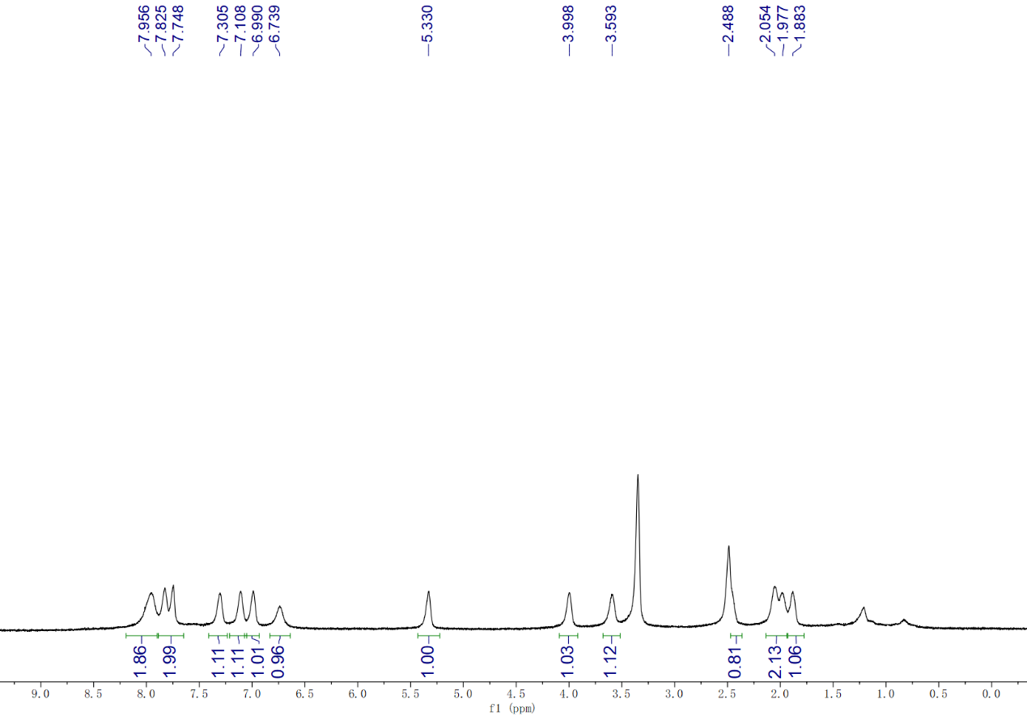

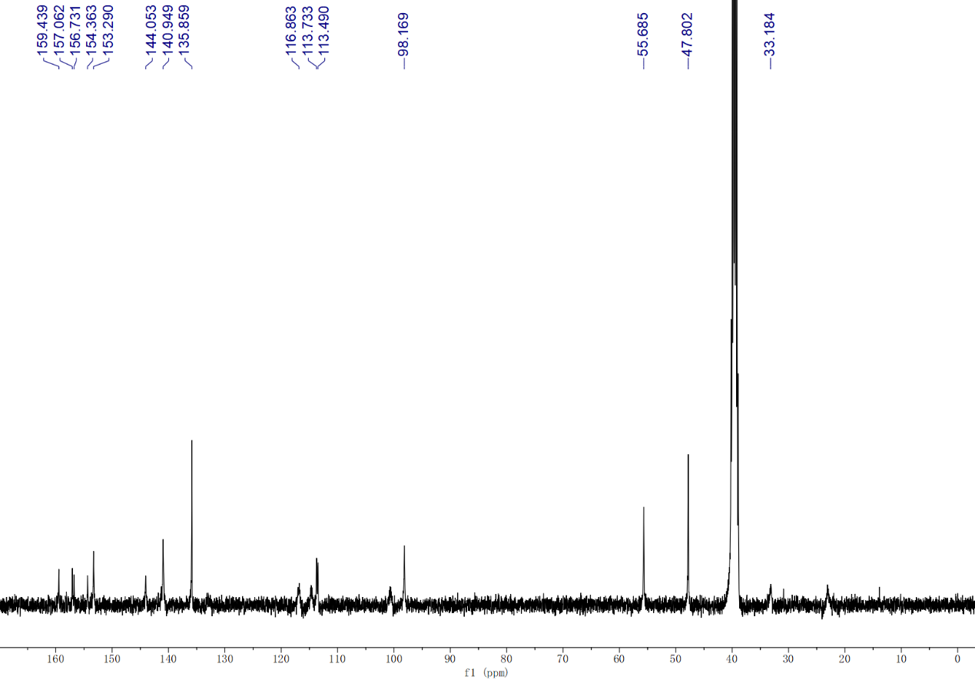

Copies of HPLC of Representative Compounds
4.1 HPLC trace of compound 5a:
HPLC Purity: 99.24%; Retention Time: 11.155 min; Instrument: Agilent 1200 with DAD detector; Mobile phase A: H2O (30%); Mobile phase B: MeOH (70%); Column Temp: 30°C; Wavelength: 254 nm.
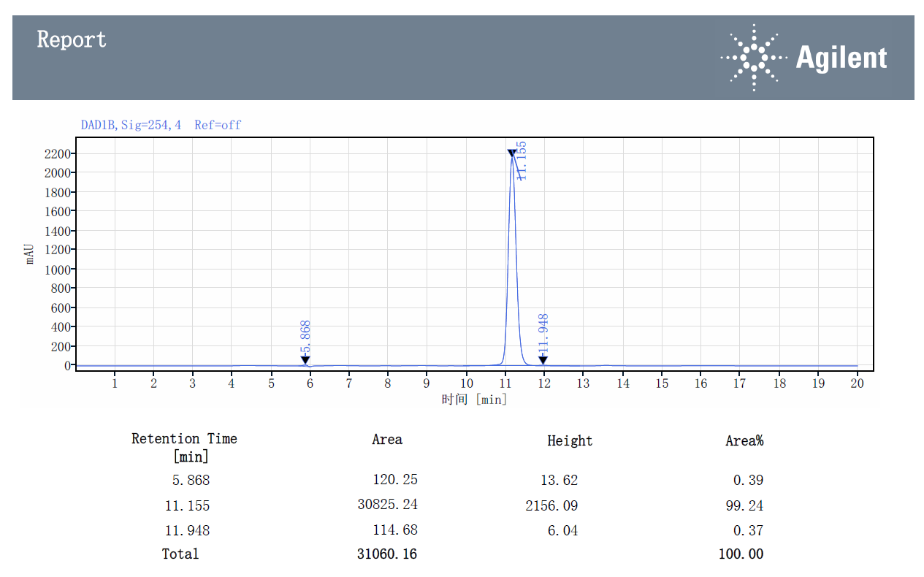
4.2 HPLC trace of compound 5b:
HPLC Purity: 98.09%; Retention Time: 11.403 min; Instrument: Agilent 1200 with DAD detector; Mobile phase A: H2O (30%); Mobile phase B: MeOH (70%); Column Temp: 30°C; Wavelength: 254 nm.
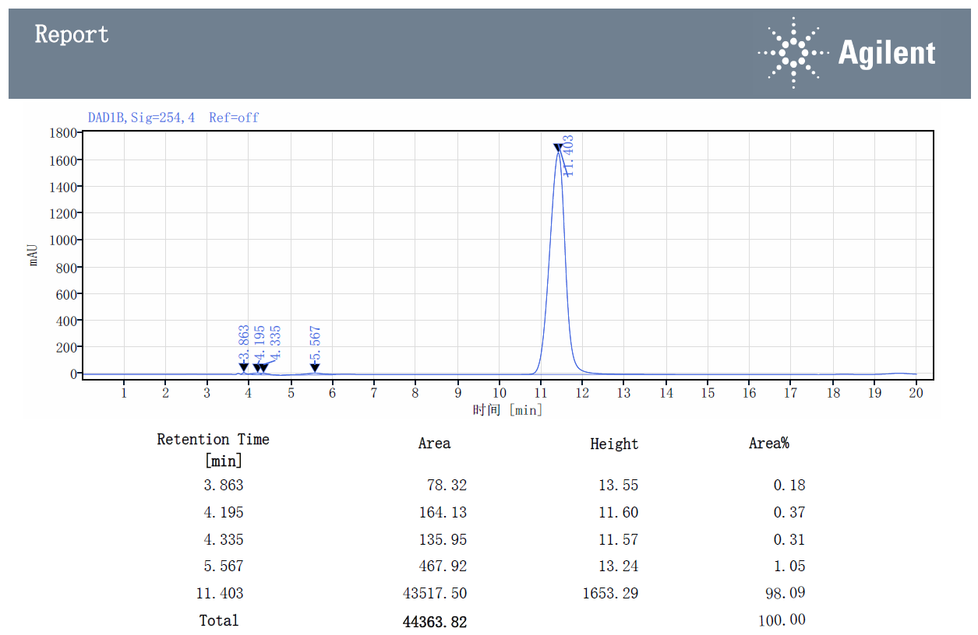
4.3 HPLC trace of compound 5d:
HPLC Purity: 97.81%; Retention Time: 6.065 min; Instrument: Agilent 1200 with DAD detector; Mobile phase A: H2O (25%); Mobile phase B: MeOH (75%); Column Temp: 30°C; Wavelength: 254 nm.
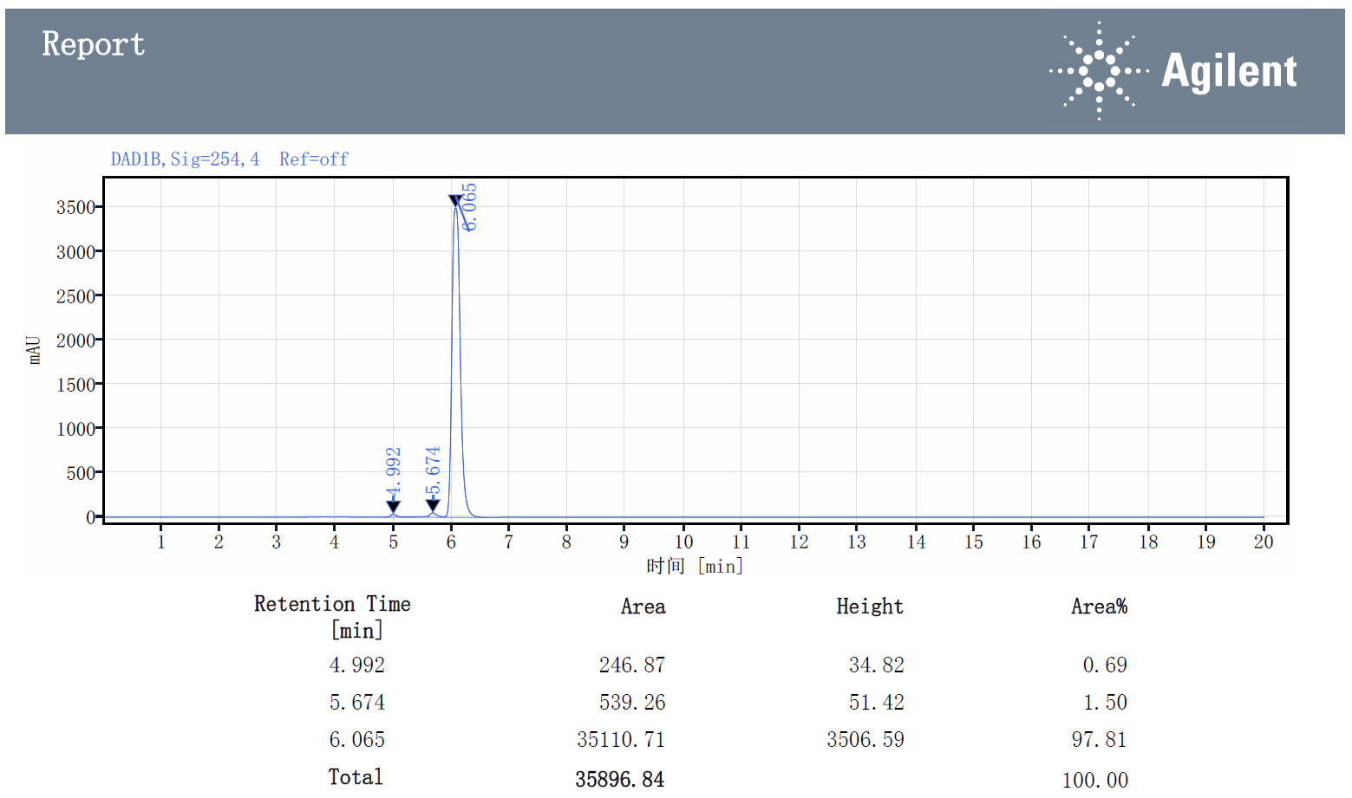

4.4 HPLC trace of compound 5g:
HPLC Purity: 99.17%; Retention Time: 13.161 min; Instrument: Agilent 1200 with DAD detector; Mobile phase A: H2O (30%); Mobile phase B: MeOH (70%); Column Temp: 30°C; Wavelength: 254 nm.
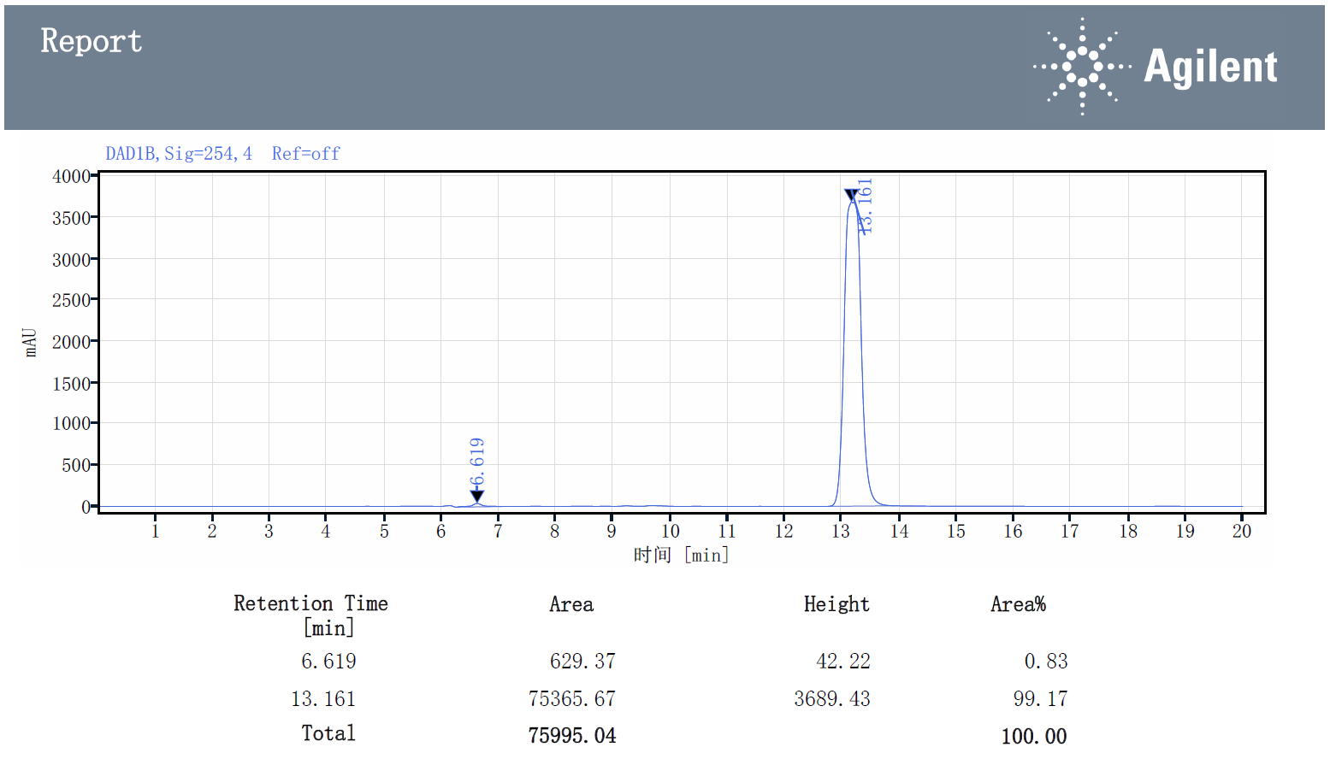

4.5 HPLC trace of compound 5h:
HPLC Purity: 98.79%; Retention Time: 16.301 min; Instrument: Agilent 1200 with DAD detector; Mobile phase A: H2O (30%); Mobile phase B: MeOH (70%); Column Temp: 30°C; Wavelength: 254 nm.
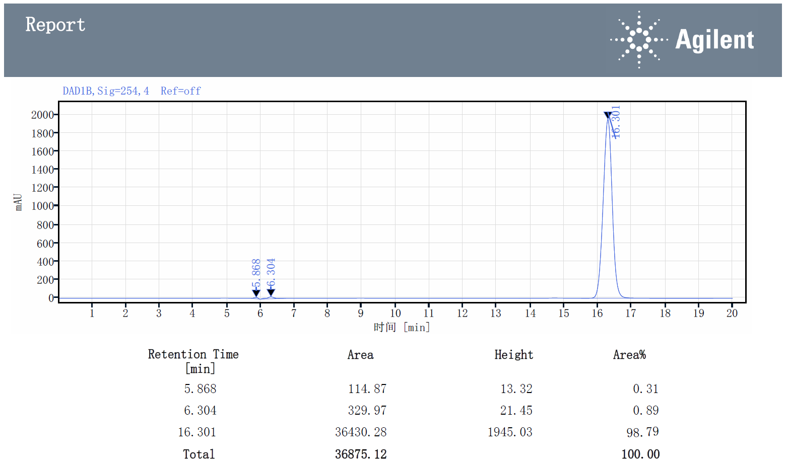

4.6 HPLC trace of compound 5i:
HPLC Purity: 99.65%; Retention Time: 17.474 min; Instrument: Agilent 1200 with DAD detector; Mobile phase A: H2O (30%); Mobile phase B: MeOH (70%); Column Temp: 30°C; Wavelength: 254 nm.
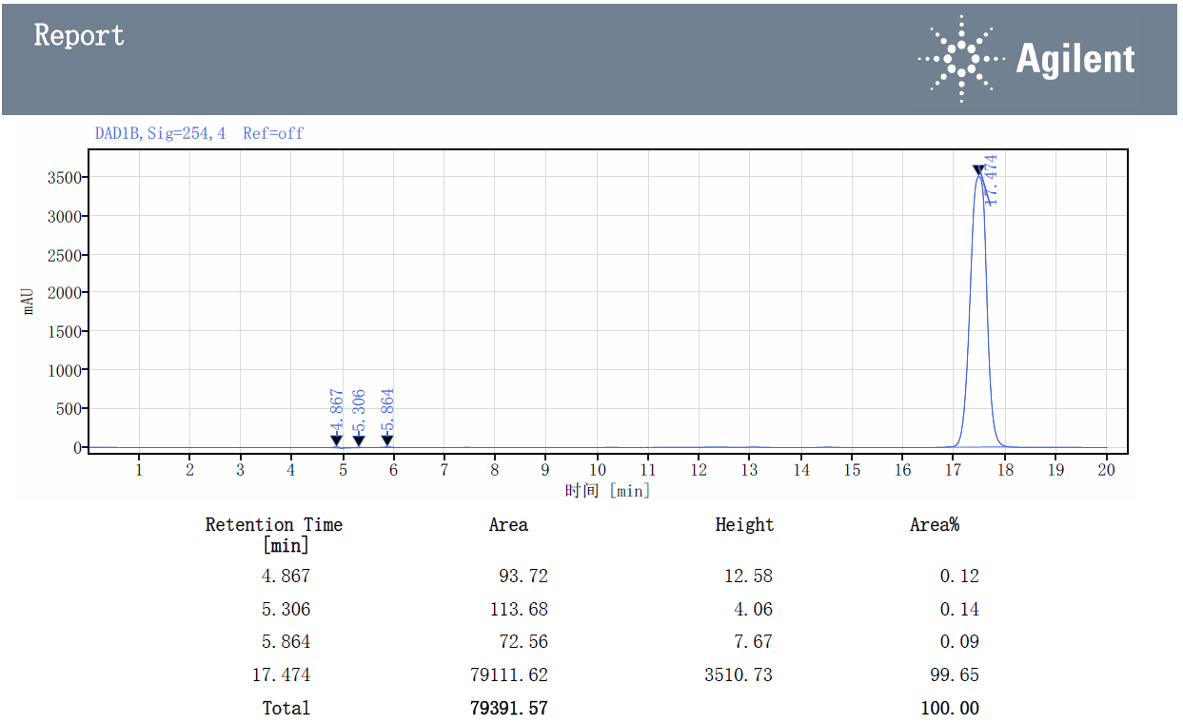
4.7 HPLC trace of compound 5k:
HPLC Purity: 94.08%; Retention Time: 10.339 min; Instrument: Agilent 1200 with DAD detector; Mobile phase A: H2O (30%); Mobile phase B: MeOH (70%); Column Temp: 30°C; Wavelength: 254 nm.
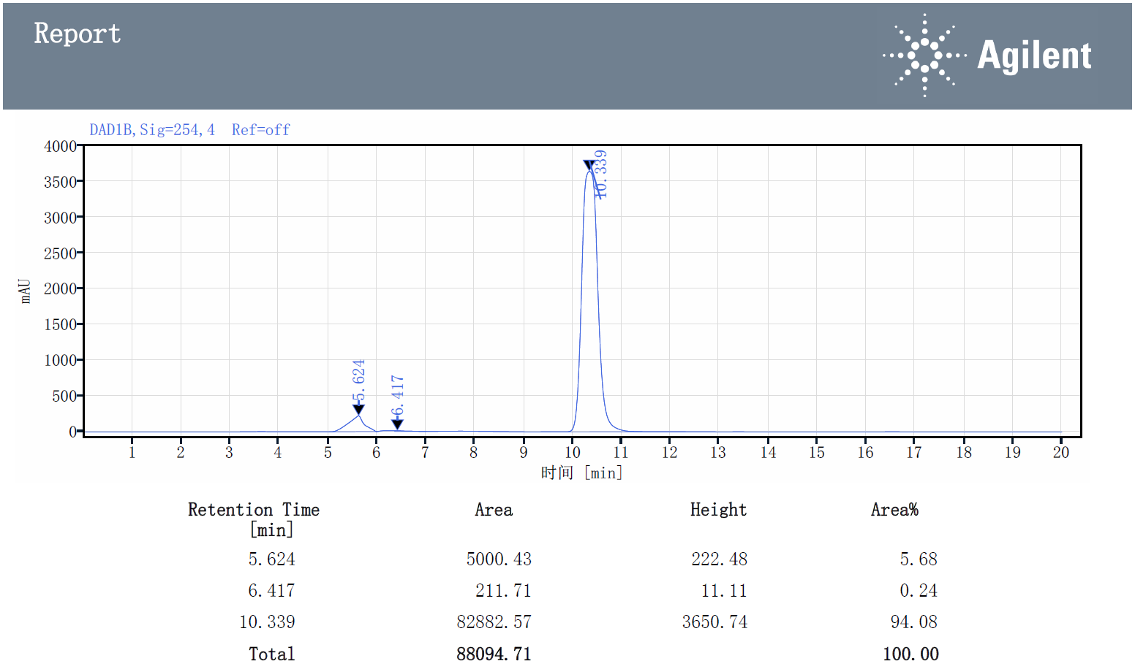

4.8 HPLC trace of compound 5l:
HPLC Purity: 98.73 %; Retention Time: 12.267 min; Instrument: Agilent 1200 with DAD detector; Mobile phase A: H2O (30%); Mobile phase B: MeOH (70%); Column Temp: 30°C; Wavelength: 254 nm.
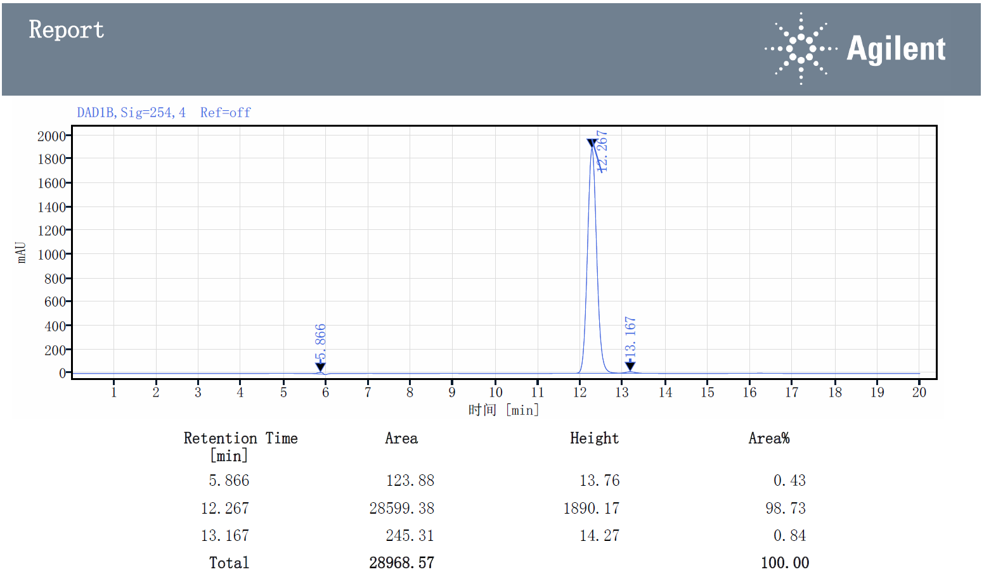

4.9 HPLC trace of compound 5m:
HPLC Purity: 99.49 %; Retention Time: 18.048 min; Instrument: Agilent 1200 with DAD detector; Mobile phase A: H2O (30%); Mobile phase B: MeOH (70%); Column Temp: 30°C; Wavelength: 254 nm.
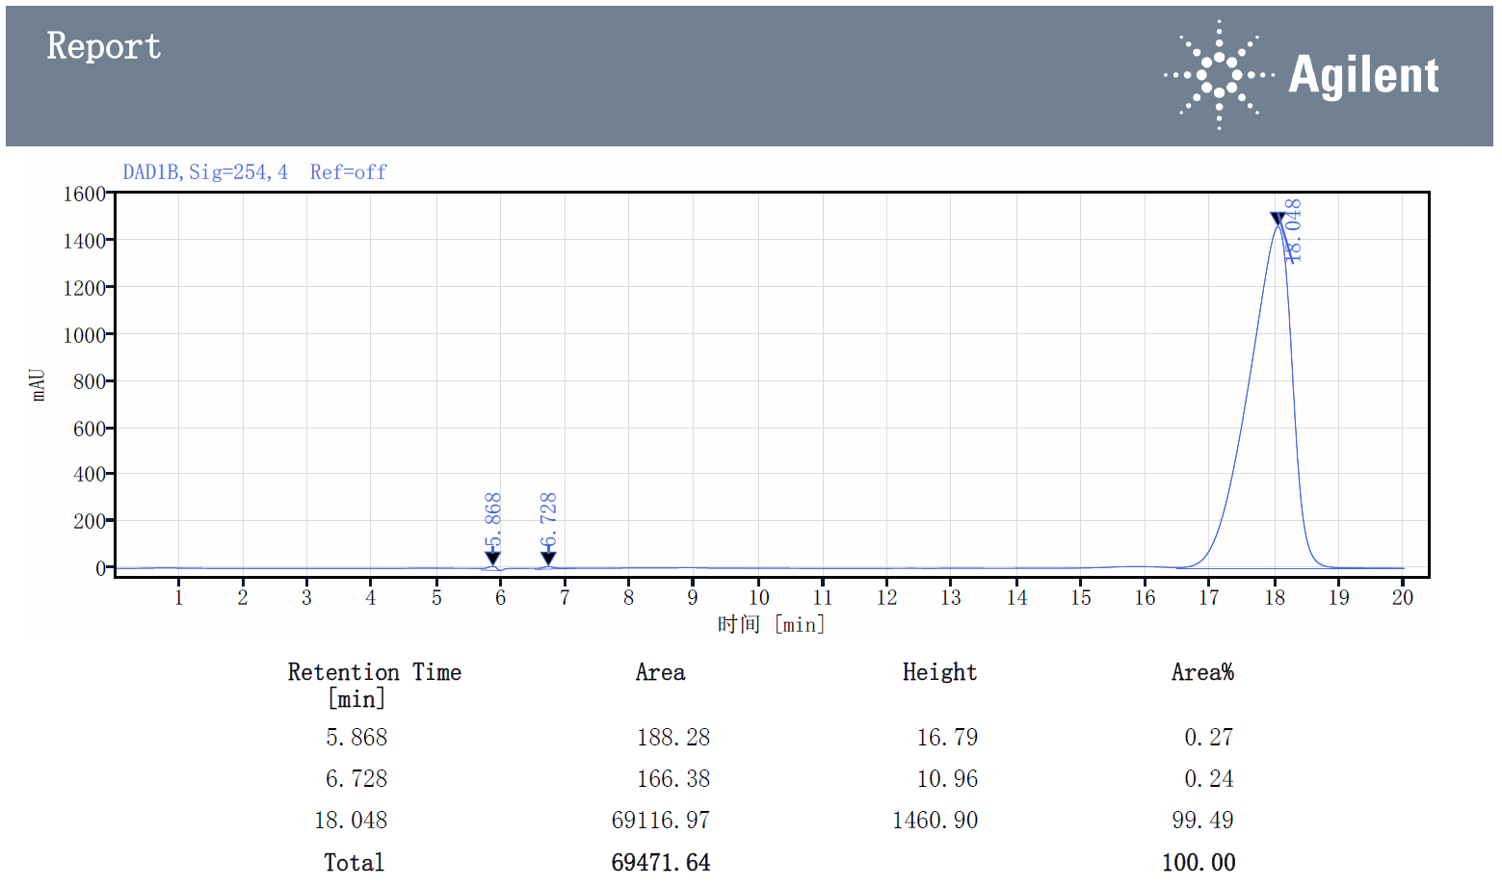

4.10 HPLC trace of compound 6a:
HPLC Purity: 98.23 %; Retention Time: 14.311 min; Instrument: Agilent 1200 with DAD detector; Mobile phase A: H2O (30%); Mobile phase B: MeOH (70%); Column Temp: 30°C; Wavelength: 254 nm.
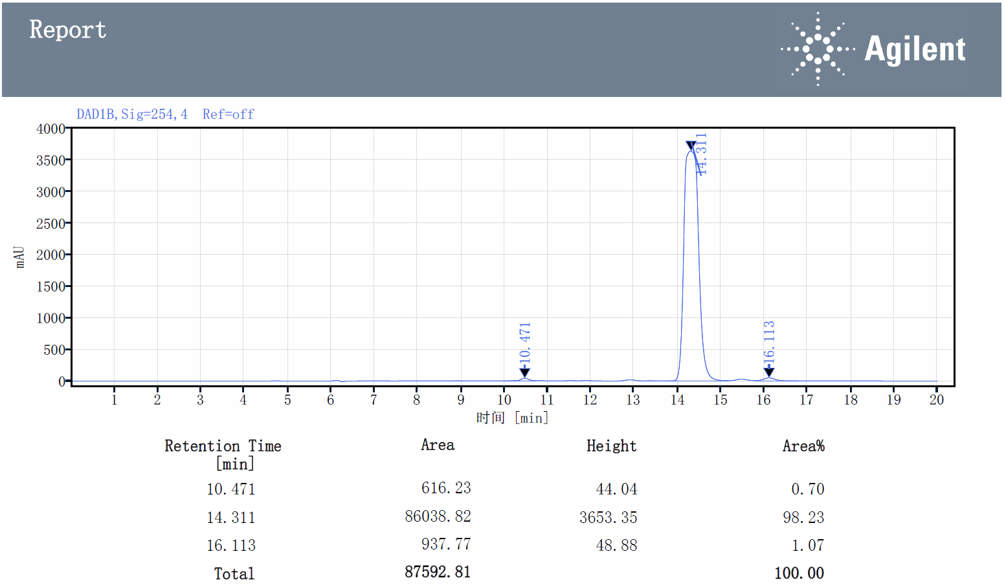

4.11 HPLC trace of compound 6b:
HPLC Purity: 99.18 %; Retention Time: 10.016 min; Instrument: Agilent 1200 with DAD detector; Mobile phase A: H2O (30%); Mobile phase B: MeOH (70%); Column Temp: 30°C; Wavelength: 254 nm.
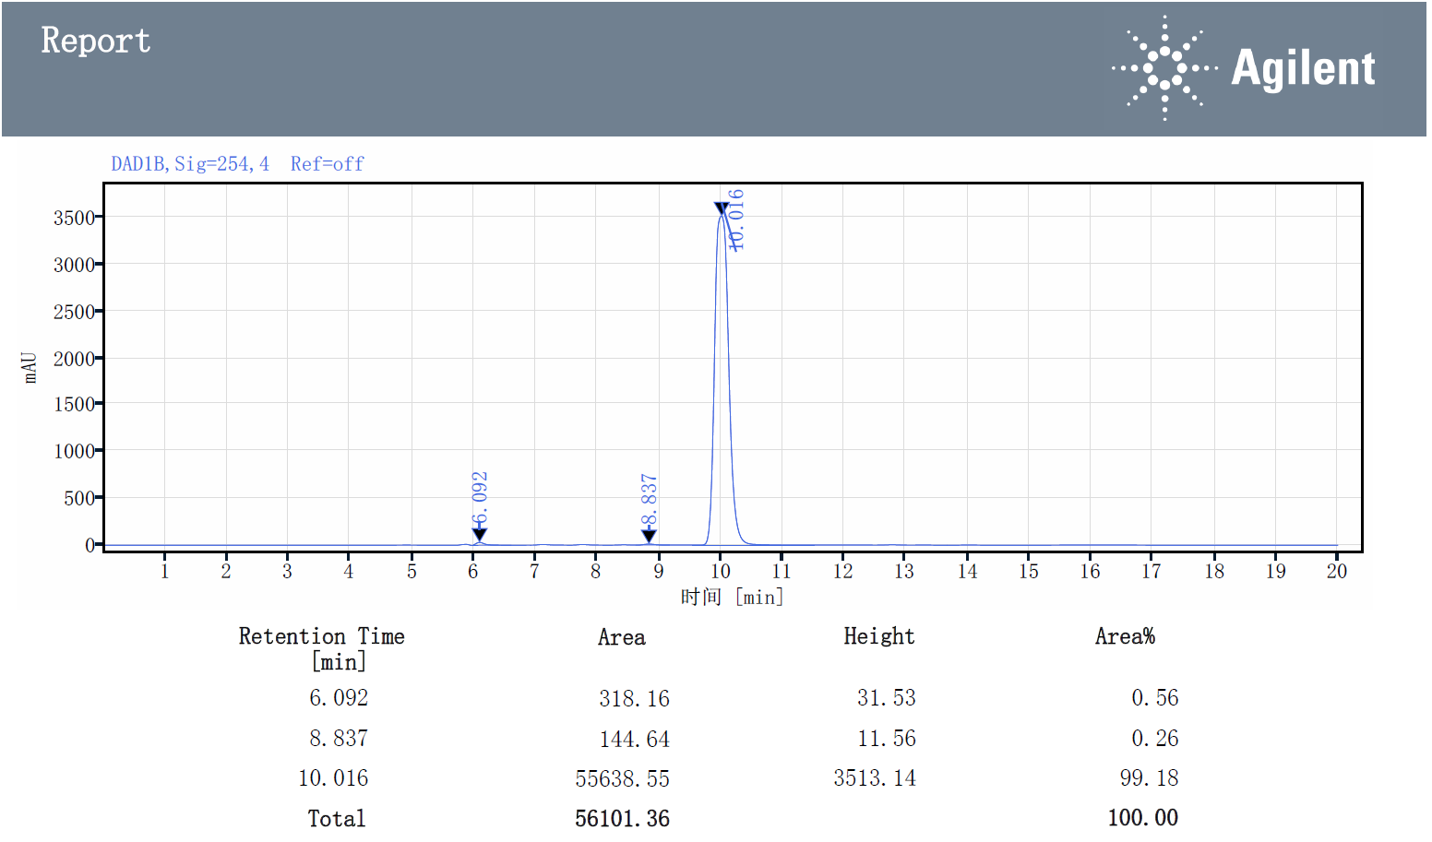

4.12 HPLC trace of compound 6d:
HPLC Purity: 99.57 %; Retention Time: 9.664 min; Instrument: Agilent 1200 with DAD detector; Mobile phase A: H2O (30%); Mobile phase B: MeOH (70%); Column Temp: 30°C; Wavelength: 254 nm.
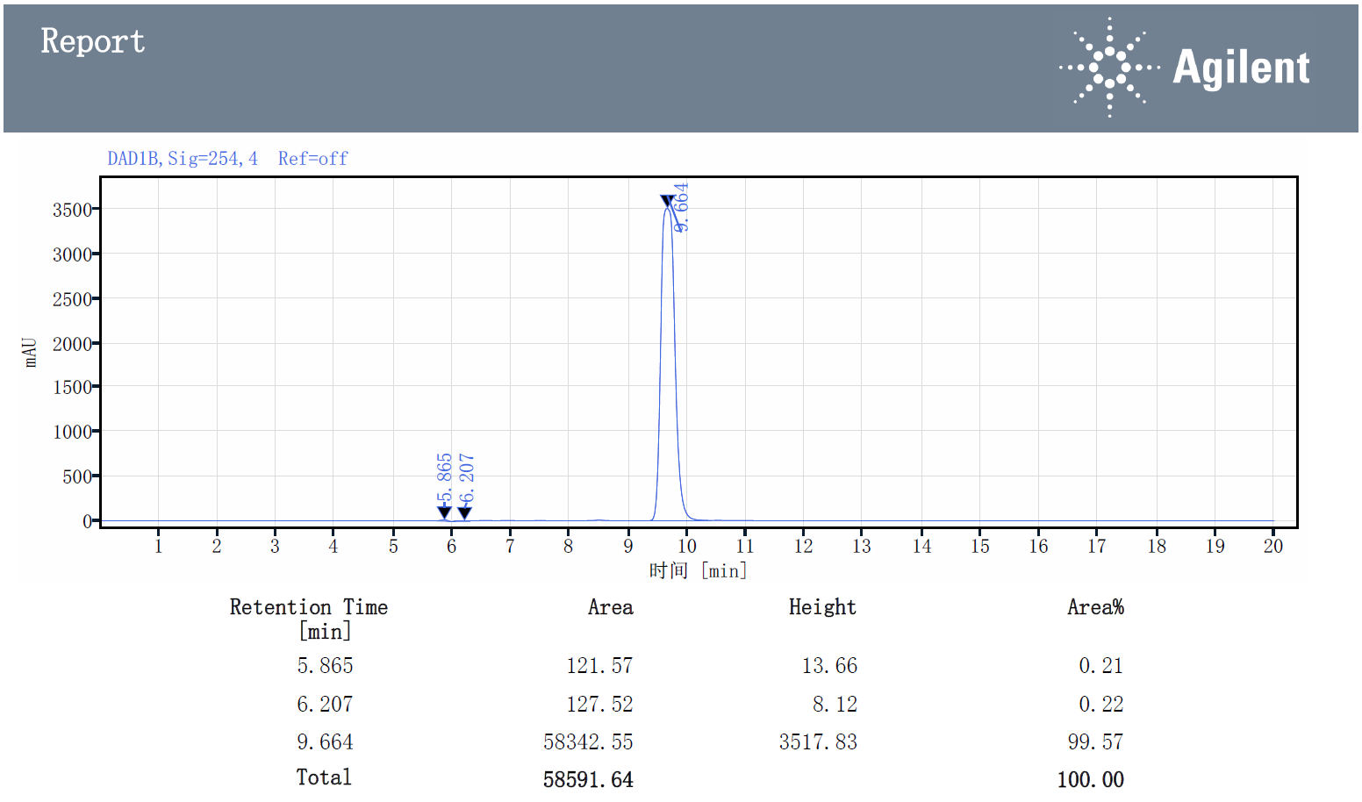

4.13 HPLC trace of compound 6e:
HPLC Purity: 99.57 %; Retention Time: 13.513 min; Instrument: Agilent 1200 with DAD detector; Mobile phase A: H2O (30%); Mobile phase B: MeOH (70%); Column Temp: 30°C; Wavelength: 254 nm.
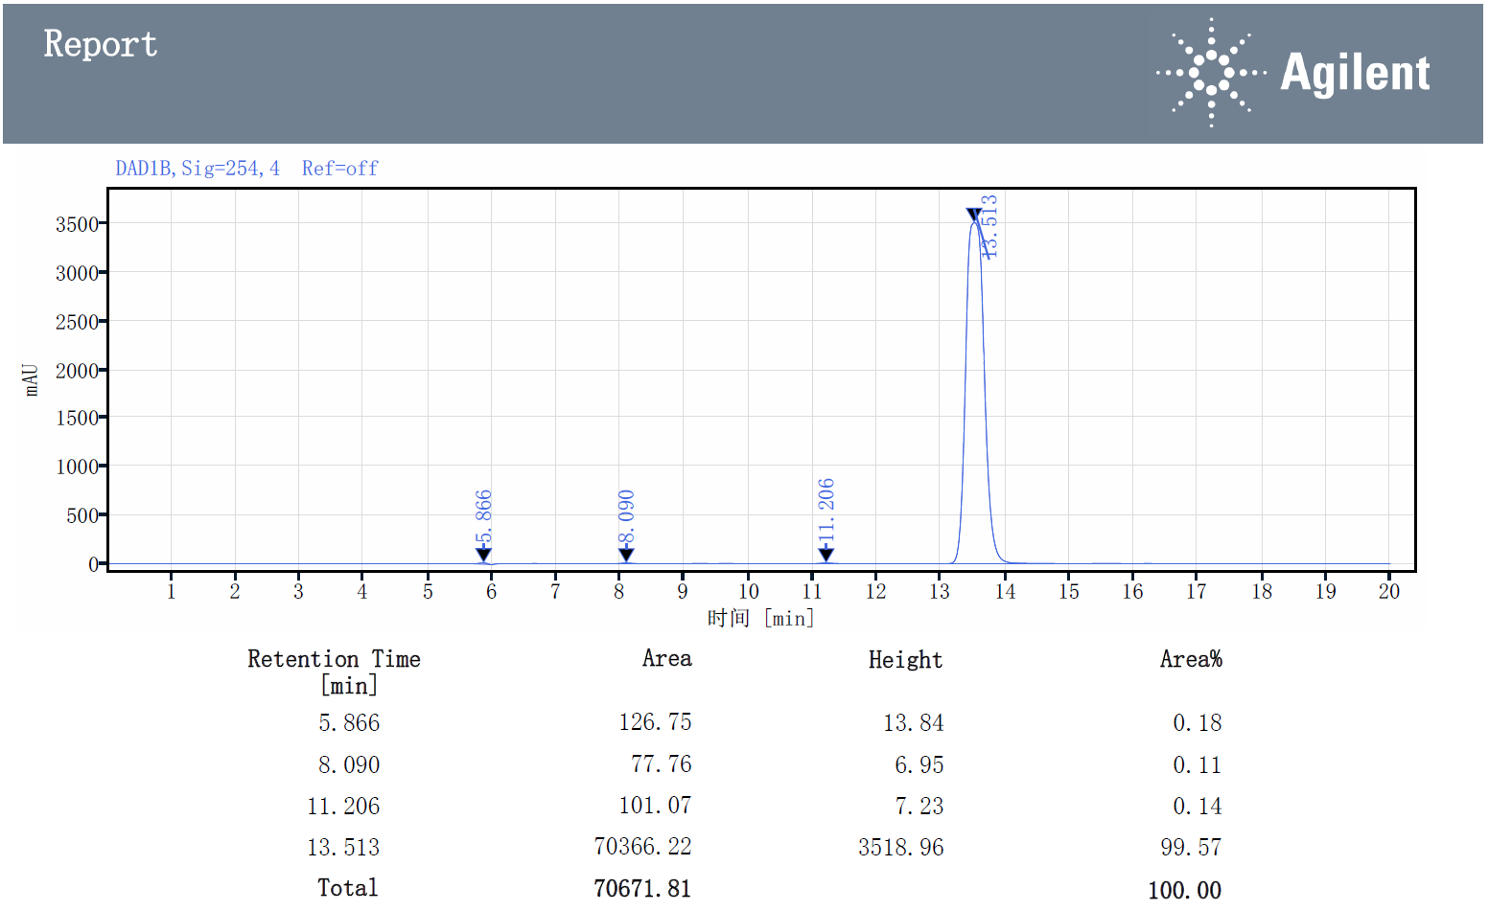

4.14 HPLC trace of compound 7b:
HPLC Purity: 96.34 %; Retention Time: 12.282 min; Instrument: Agilent 1200 with DAD detector; Mobile phase A: H2O (30%); Mobile phase B: MeOH (70%); Column Temp: 30°C; Wavelength: 254 nm.
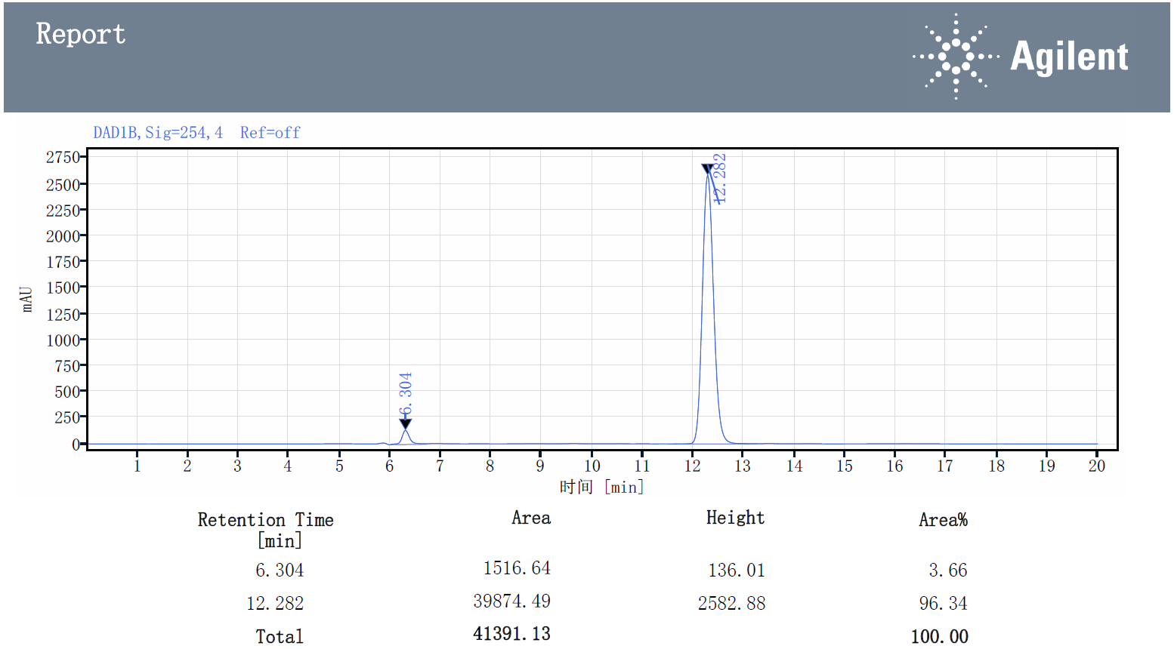

4.15 HPLC trace of compound 7c:
HPLC Purity: 99.13 %; Retention Time: 11.943 min; Instrument: Agilent 1200 with DAD detector; Mobile phase A: H2O (30%); Mobile phase B: MeOH (70%); Column Temp: 30°C; Wavelength: 254 nm.
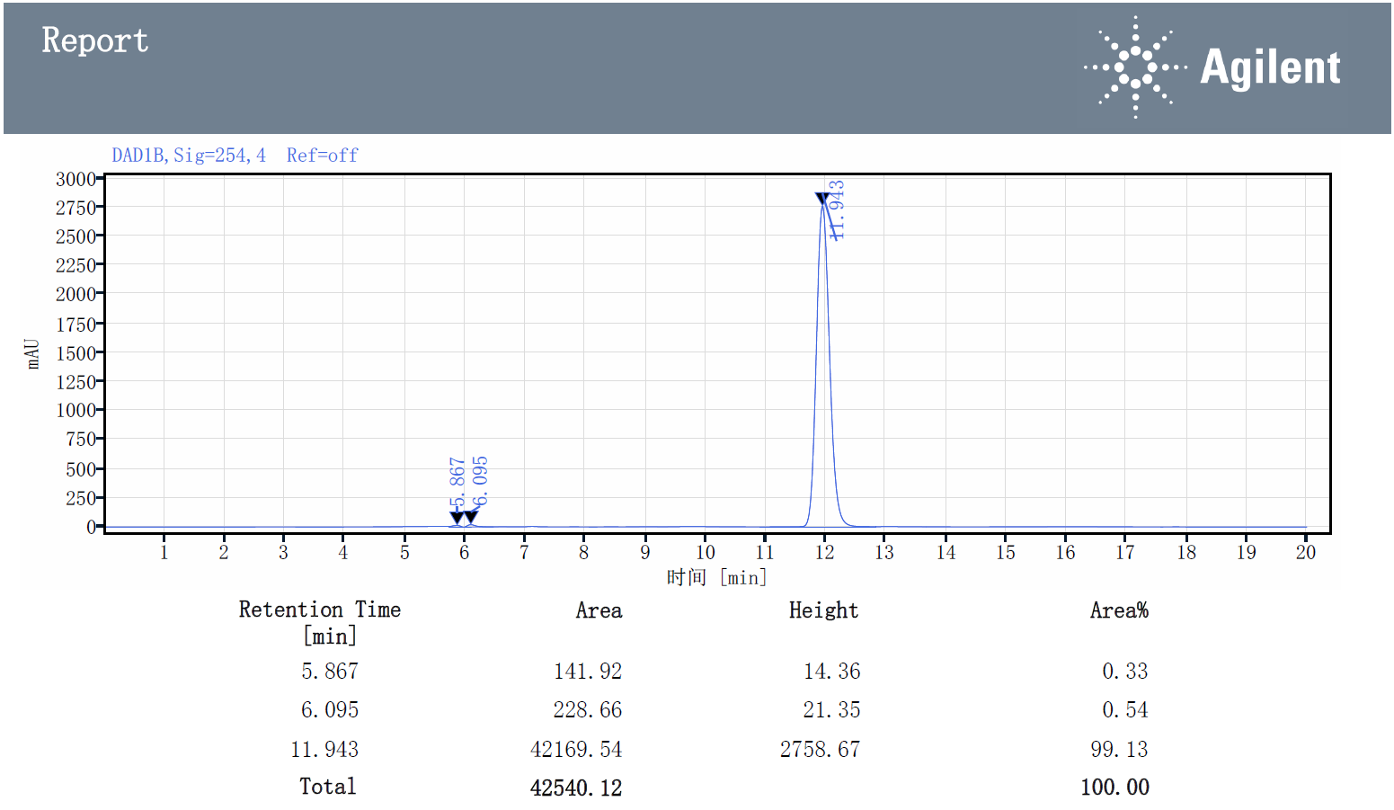

4.16 HPLC trace of compound 7d:
HPLC Purity: 98.97 %; Retention Time: 10.628 min; Instrument: Agilent 1200 with DAD detector; Mobile phase A: H2O (30%); Mobile phase B: MeOH (70%); Column Temp: 30°C; Wavelength: 254 nm.
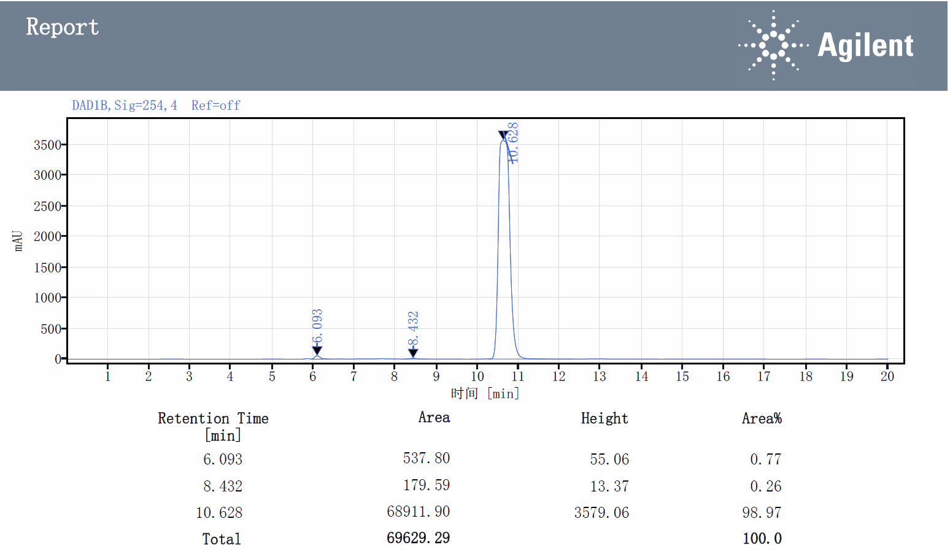

4.17 HPLC trace of compound 7e:
HPLC Purity: 97.67 %; Retention Time: 12.575 min; Instrument: Agilent 1200 with DAD detector; Mobile phase A: H2O (30%); Mobile phase B: MeOH (70%); Column Temp: 30°C; Wavelength: 254 nm.
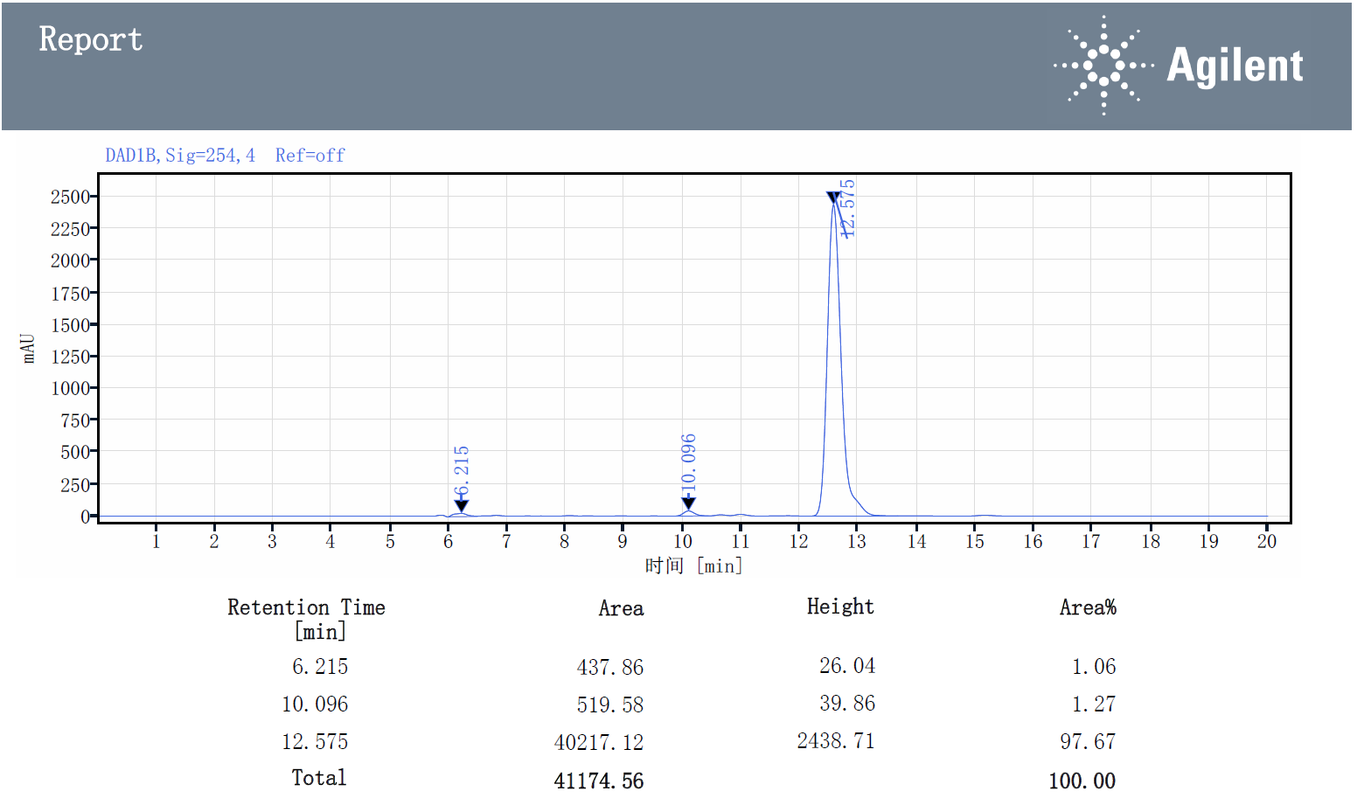

4.18 HPLC trace of compound 7f:
HPLC Purity: 99.54 %; Retention Time: 12.954 min; Instrument: Agilent 1200 with DAD detector; Mobile phase A: H2O (30%); Mobile phase B: MeOH (70%); Column Temp: 30°C; Wavelength: 254 nm.
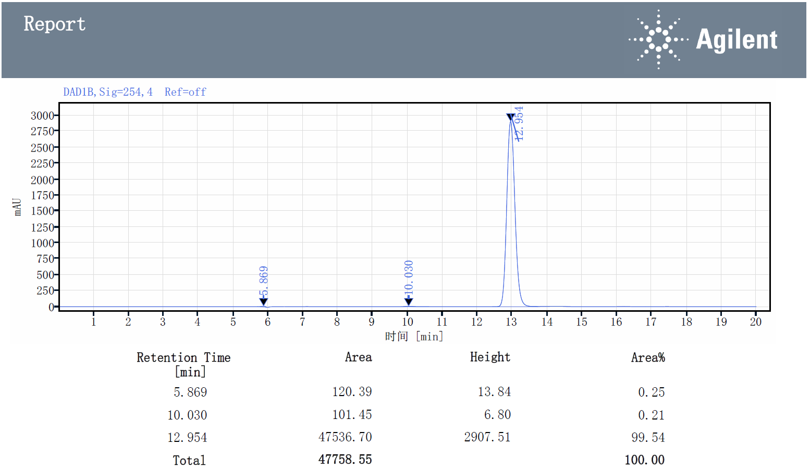

4.19 HPLC trace of compound 7g:
HPLC Purity: 99.83 %; Retention Time: 10.285 min; Instrument: Agilent 1200 with DAD detector; Mobile phase A: H2O (30%); Mobile phase B: MeOH (70%); Column Temp: 30°C; Wavelength: 254 nm.
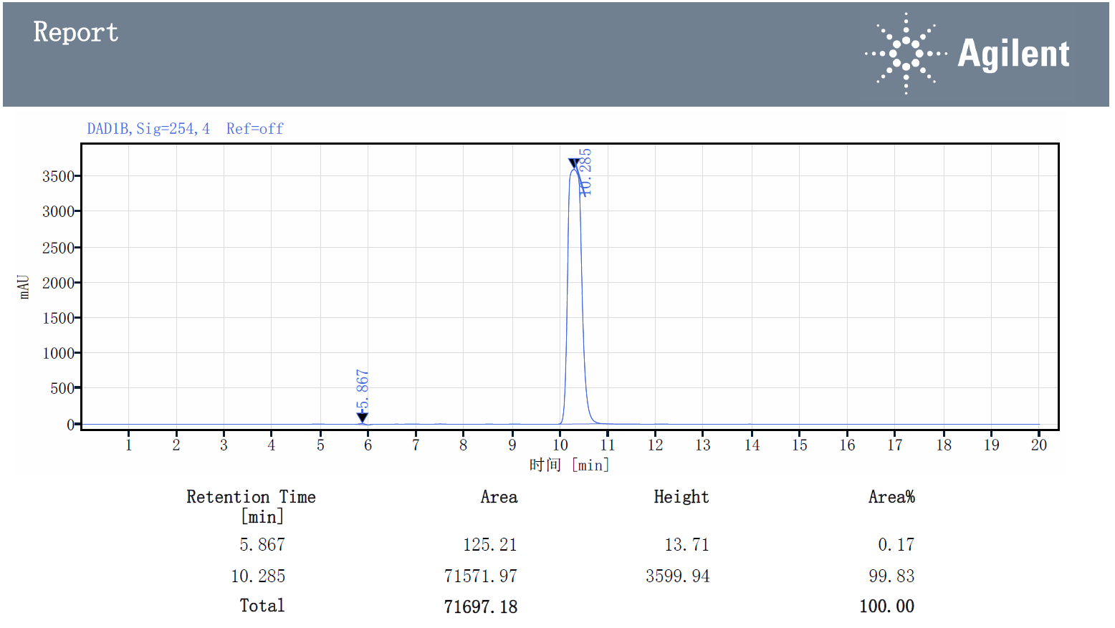

4.20 HPLC trace of compound 7h:
HPLC Purity: 99.54 %; Retention Time: 18.114 min; Instrument: Agilent 1200 with DAD detector; Mobile phase A: H2O (30%); Mobile phase B: MeOH (70%); Column Temp: 30°C; Wavelength: 254 nm.
