- Lean body mass
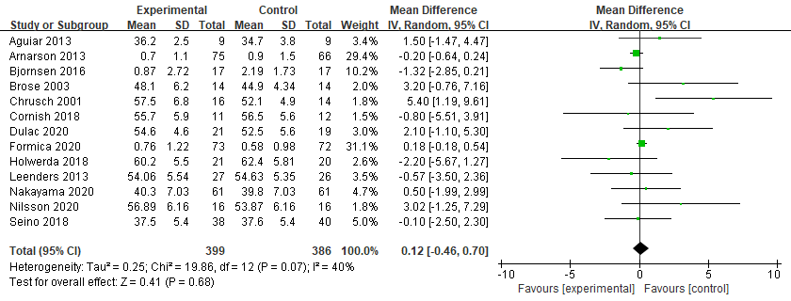

- Appendicular skeletal muscle mass
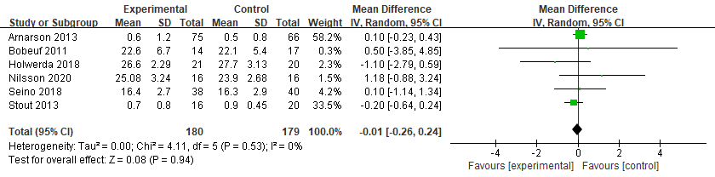
- Hand grip strength
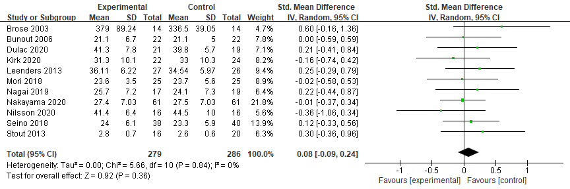
- Knee extension strength
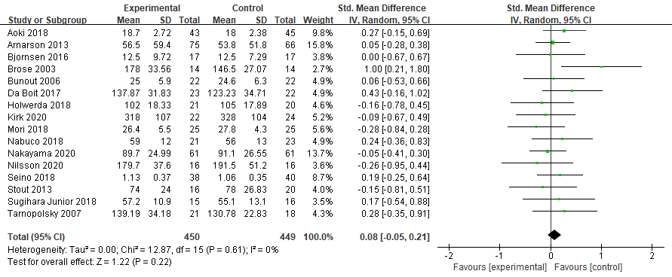

- Chair stand test
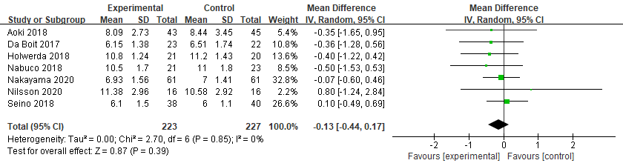
- Timed up and go
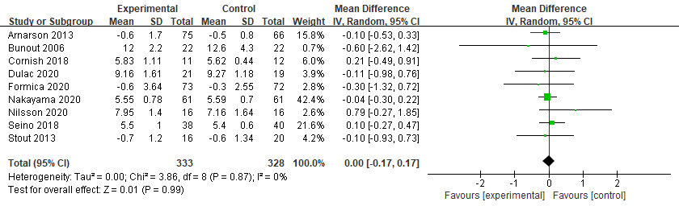
Figure 3 Effect of resistance training and nutritional intervention on muscle mass, strength, and physical functional performance

