Additional file 3: Search strategies

Screening search

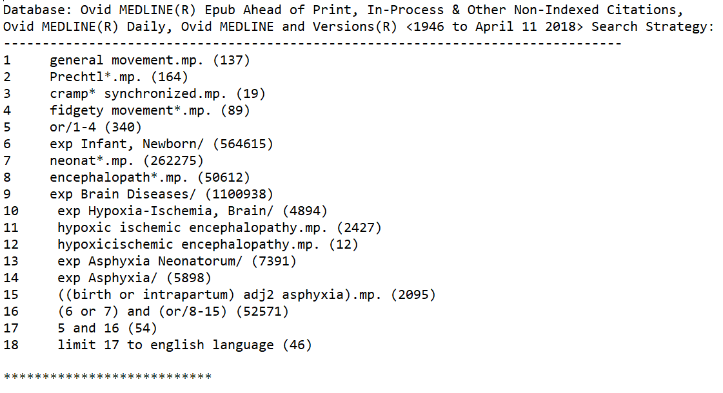
Dates of Ovid Medline screening search: conducted from 1946 to April 11th, 2018.

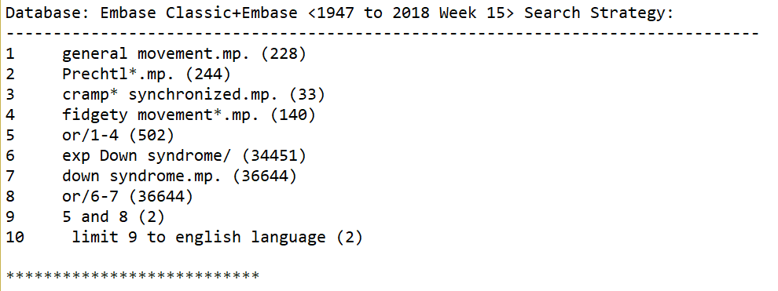
Dates of Embase screening search: conducted from 1947 to April 11th, 2018.

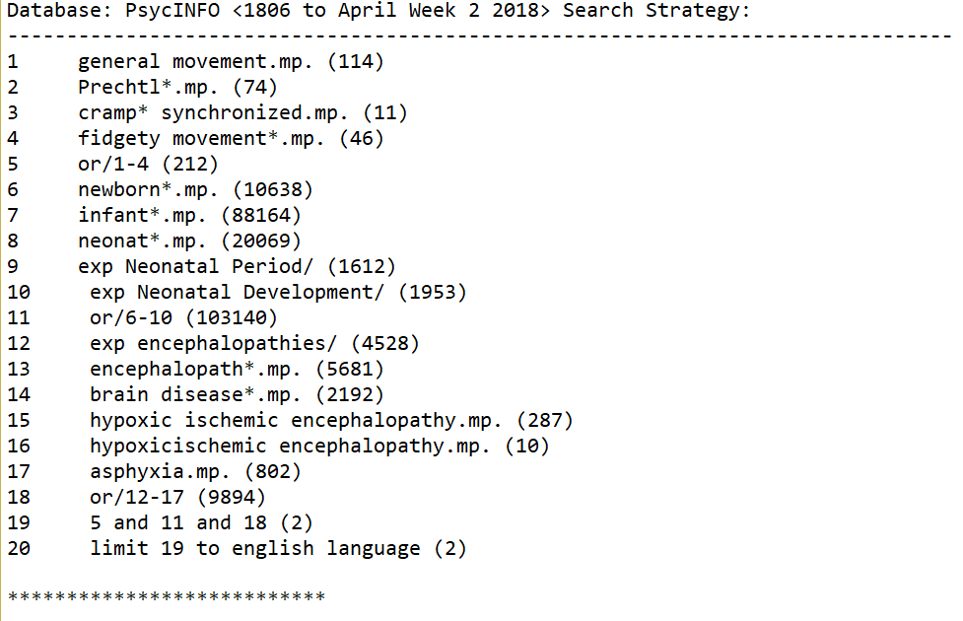
Dates of PsychINFO screening search: conducted from 1806 to April 11th, 2018.
Date of searches: First screening searches in Ovid Medline, Embase and PsychINFO, conducted on April 11th, 2018

Second search
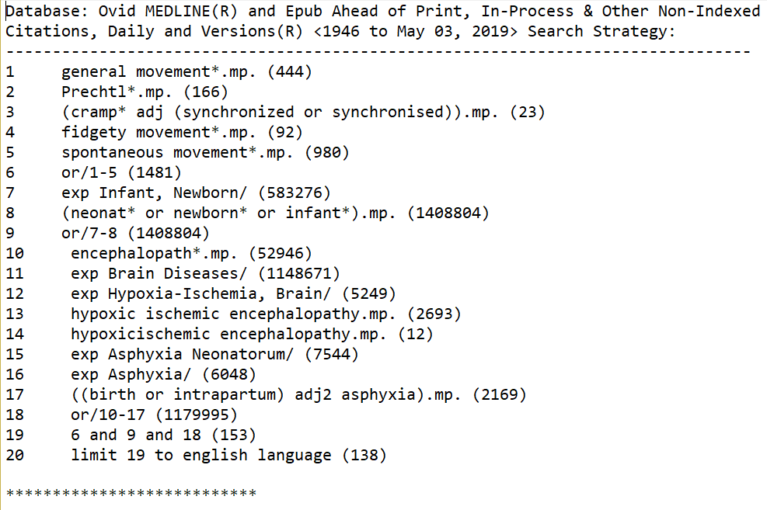
Dates of Ovid Medline second search conducted on May 3rd, 2019: for time period from 1946 to May 3rd 2019.
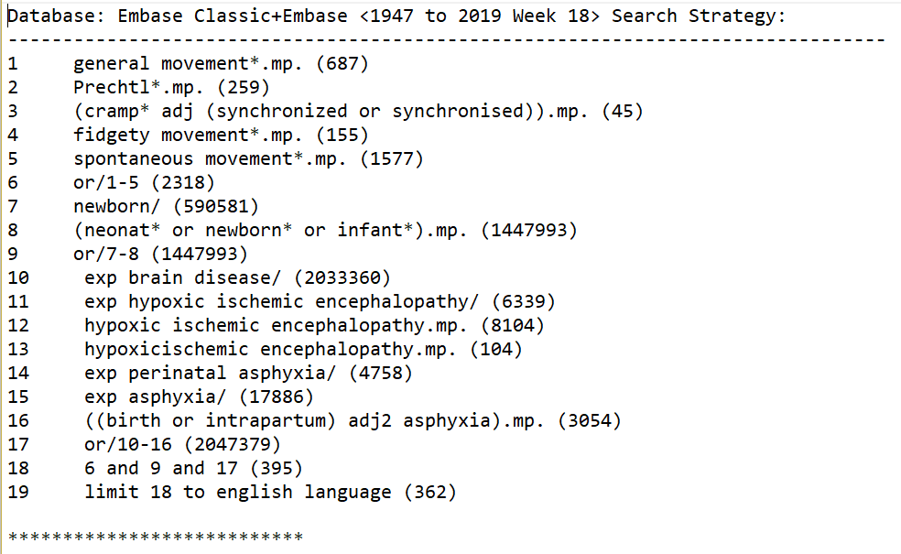
Dates of Embase second search conducted on May 3rd, 2019: for time period from 1946 to May 3rd 2019.
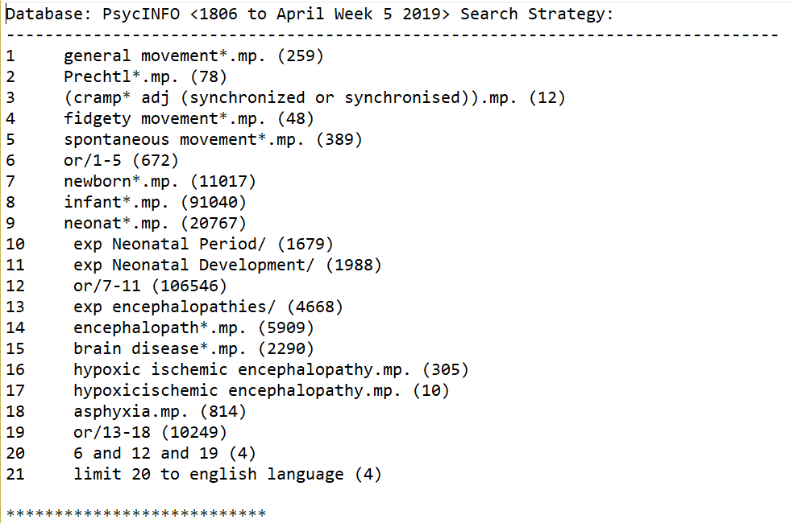
Dates of PsycINFO second search conducted on April 30th, 2019: for time period from 1806 to April 30th, 2019.

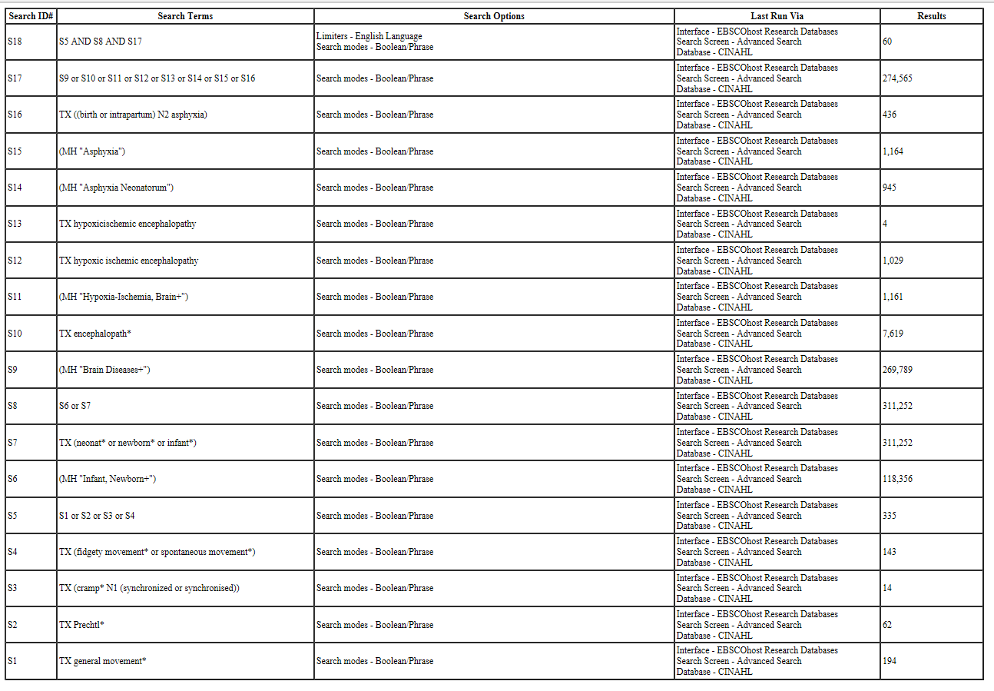
Dates of CINAHL second search conducted on May 11th, 2019: for time period from inception to May 11th, 2019.
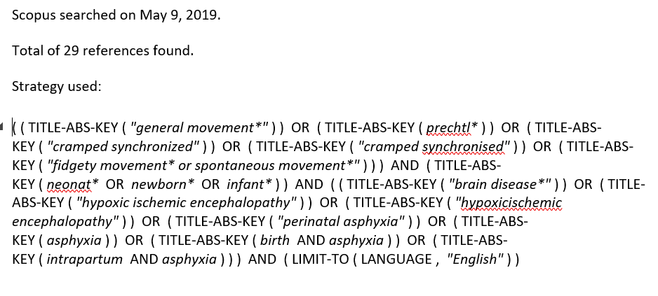
Dates of Scopus second search conducted on May 9th, 2019: for time period from 1946 to May 9th, 2019.

Third search
Search conducted on Ovid MEDLINE(R), Ovid MEDLINE(R) Daily and Epub Ahead of Print, In-Process & Other Non-Indexed Citations
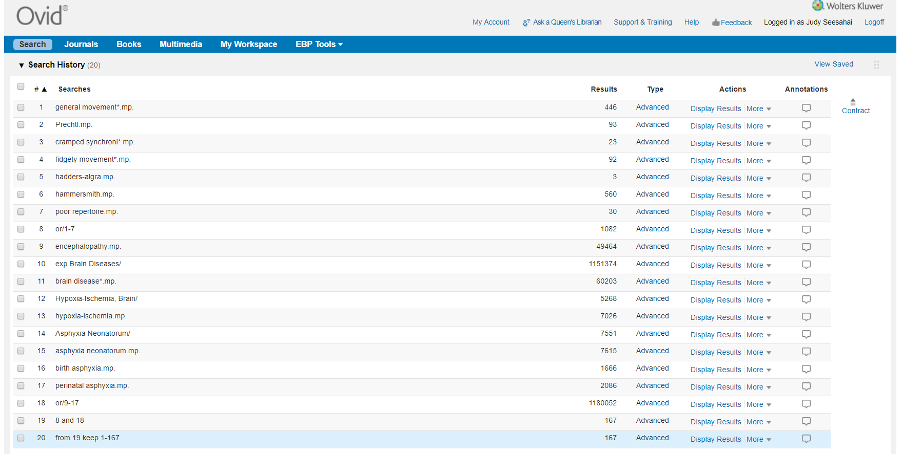
Dates of search: Third search conducted in Ovid Medline: from 1946 to May 9th, 2019.

Fourth and final search
Database: Ovid MEDLINE(R) and Epub Ahead of Print, In-Process & Other Non-Indexed Citations, Daily and Versions(R) <1946 to March 26, 2020>
Search Strategy:
--------------------------------------------------------------------------------
1 general movement*.mp. (476)
2 Prechtl*.mp. (170)
3 (cramp* adj (synchronized or synchronised)).mp. (24)
4 fidgety movement*.mp. (99)
5 spontaneous movement*.mp. (1025)
6 or/1-5 (1553)
7 exp Infant, Newborn/ (600543)
8 (neonat* or newborn* or infant*).mp. (1455661)
9 or/7-8 (1455661)
10 encephalopath*.mp. (55880)
11 exp Brain Diseases/ (1197704)
12 exp Hypoxia-Ischemia, Brain/ (5557)
13 hypoxic ischemic encephalopathy.mp. (2980)
14 hypoxicischemic encephalopathy.mp. (12)
15 exp Asphyxia Neonatorum/ (7650)
16 exp Asphyxia/ (6174)
17 ((birth or intrapartum) adj2 asphyxia).mp. (2265)
18 or/10-17 (1230874)
19 6 and 9 and 18 (159)
20 limit 19 to english language (144)
***************************​

Database: Embase Classic+Embase <1947 to 2020 Week 13>Search Strategy:
--------------------------------------------------------------------------------
1 general movement*.mp. (741)
2 Prechtl*.mp. (272)
3 (cramp* adj (synchronized or synchronised)).mp. (48)
4 fidgety movement*.mp. (167)
5 spontaneous movement*.mp. (1639)
6 or/1-5 (2432)
7 newborn/ (612117)
8 (neonat* or newborn* or infant*).mp. (1507899)
9 or/7-8 (1507899)
10 exp brain disease/ (2153053)
11 exp hypoxic ischemic encephalopathy/ (7167)
12 hypoxic ischemic encephalopathy.mp. (8991)
13 hypoxicischemic encephalopathy.mp. (105)
14 exp perinatal asphyxia/ (5041)
15 exp asphyxia/ (18545)
16 ((birth or intrapartum) adj2 asphyxia).mp. (3201)
17 or/10-16 (2167550)
18 6 and 9 and 17 (425)
19 limit 18 to english language (391)
***************************​

Database: APA PsycInfo <1806 to March Week 4 2020> Search Strategy:
--------------------------------------------------------------------------------
1 general movement*.mp. (268)
2 Prechtl*.mp. (78)
3 (cramp* adj (synchronized or synchronised)).mp. (14)
4 fidgety movement*.mp. (51)
5 spontaneous movement*.mp. (398)
6 or/1-5 (689)
7 newborn*.mp. (11352)
8 infant*.mp. (117547)
9 neonat*.mp. (21844)
10 exp Neonatal Period/ (1725)
11 exp Neonatal Development/ (2025)
12 or/7-11 (130975)
13 exp encephalopathies/ (4816)
14 encephalopath*.mp. (6144)
15 brain disease*.mp. (6718)
16 hypoxic ischemic encephalopathy.mp. (326)
17 hypoxicischemic encephalopathy.mp. (10)
18 asphyxia.mp. (1015)
19 or/13-18 (14573)
20 6 and 12 and 19 (9)
21 limit 20 to english language (9)
***************************​
Scopus Strategy. Searched on March 30, 2020. 31 references found.

( ( TITLE-ABS-KEY ( "general movement*" ) ) OR ( TITLE-ABS-KEY ( prechtl* ) ) OR ( TITLE-ABS-KEY ( "cramped synchronized" ) ) OR ( TITLE-ABS-KEY ( "cramped synchronised" ) ) OR ( TITLE-ABS-KEY ( "fidgety movement* or spontaneous movement*" ) ) ) AND ( TITLE-ABS-KEY ( neonat* OR newborn* OR infant* ) ) AND ( ( TITLE-ABS-KEY ( "brain disease*" ) ) OR ( TITLE-ABS-KEY ( "hypoxic ischemic encephalopathy" ) ) OR ( TITLE-ABS-KEY ( "hypoxicischemic encephalopathy" ) ) OR ( TITLE-ABS-KEY ( "perinatal asphyxia" ) ) OR ( TITLE-ABS-KEY ( asphyxia ) ) OR ( TITLE-ABS-KEY ( birth AND asphyxia ) ) OR ( TITLE-ABS-KEY ( intrapartum AND asphyxia ) ) ) AND ( LIMIT-TO ( LANGUAGE , "English”

Dates of searches: Conducted on March 26-30th, 2020
Time period: Each database inception to March 30th, 2020.

