Supplementary information
Title: Salvianolic acid B specifically binds mortalin to attenuate the migration and invasion of hepatocellular carcinoma cells by inhibiting RECK/STAT3 signaling pathway
Author list: Mengying Teng, Kailin Jiao, Chunyan Hu, Maoxuan Wu, Jing Zhen, Qian Zhou, Keke Yang, Yuan Li and Zhong Li
Inventory:
1. supplementary tables, page 2-4
2. supplementary figures and their legends, pages 5-6

1. Supplementary tables
1.1. Table S1. Primers used in this study.
Names |  | Primers
MMP2 | F:CCCACTGCGGTTTTCTCGAAT  R:CAAAGGGGTATCCATCGCCAT
MMP9 | F:TGTACCGCTATGGTTACACTCG  R:GGCAGGGACAGTTGCTTCT
β-actin | F:TCAGGTCATCACTATCGGCACT  R:AAAGAAAGGGTGTAAAACGCA
1.2. Table S2. Antibodies used in this study.
Names | Web Link | Source | Used
p-STAT3 | https://www.cellsignal.com/products/primary-antibodies/phospho-stat3-tyr705-d3a7-xp-rabbit-mab/9145?_=1473248676908 | Cell Signaling Technology | 1: 1000
Ac-STAT3 | https://www.cst-c.com.cn/products/primary-antibodies/acetyl-stat3-lys685-antibody/2523?site-search-type=Products | Cell Signaling Technology | 1: 1000
E-cadherin | https://www.cellsignal.com/products/primary-antibodies/e-cadherin-24e10-rabbit-mab/3195?N=4294956287&Ntt=24E10&fromPage=plp | Cell Signaling Technology | 1: 1000
N-cadherin | https://www.cellsignal.com/products/primary-antibodies/n-cadherin-d4r1h-xp-rabbit-mab/13116?site-search-type=Products&N=4294956287&Ntt=n-cadherin&fromPage=plp | Cell Signaling Technology | 1: 1000
Vimentin | https://www.cellsignal.com/products/primary-antibodies/vimentin-d21h3-xp-rabbit-mab/5741?N=4294956287&Ntt=vimentin&fromPage=plp | Cell Signaling Technology | 1: 1000
MMP2 | https://www.cst-c.com.cn/products/primary-antibodies/mmp-2-d4m2n-rabbit-mab/40994?site-search-type=Products&N=4294956287&Ntt=mmp2&fromPage=plp | Cell Signaling Technology | 1: 1000
MMP9 | https://www.cst-c.com.cn/products/primary-antibodies/mmp-9-d6o3h-xp-rabbit-mab/13667?site-search-type=Products&N=4294956287&Ntt=mmp9&fromPage=plp | Cell Signaling Technology | 1: 1000
RECK | https://www.cst-c.com.cn/products/primary-antibodies/reck-d8c7-rabbit-mab/3433?site-search-type=Products&N=4294956287&Ntt=reck&fromPage=plp&_requestid=64915 | Cell Signaling Technology | 1: 1000
Mortalin | https://www.cst-c.com.cn/products/primary-antibodies/grp75-d13h4-xp-rabbit-mab/3593?site-search-type=Products&N=4294956287&Ntt=mortalin&fromPage=plp | Cell Signaling Technology | 1: 1000
Flag | http://www.affbiotech.cn/goods-6269-T0003-Flag-Tag+Antibody.html | Affinity | 1:1000
Ubiquitin | https://www.ptgcn.com/products/ubiquitin-Antibody-10201-2-AP.htm | Proteintech Group | 1: 1000
β-Actin | http://www.beyotime.com/product/AA128.htm | Beyotime | 1:1000
GAPDH | http://www.beyotime.com/product/AG019.htm | Beyotime | 1:1000
1.3. Table S3. siRNAs used in this study.
Names | Web Link | Source | Used
RECK-  siRNA | https://datasheets.scbt.com/sc-39718.pdf | Santa Cruz Biotechnology | 50 nM
Mortalin-  siRNA | https://datasheets.scbt.com/sc-35520.pdf | Santa Cruz Biotechnology | 50 nM
STAT3-  siRNA | https://datasheets.scbt.com/sc-29493.pdf | Santa Cruz Biotechnology | 50 nM
NC-  siRNA | http://datasheets.scbt.com/sc-37007.pdf | Santa Cruz Biotechnology | 50 nM

2. Supplementary Figures and their legends
2.1. Figure S1
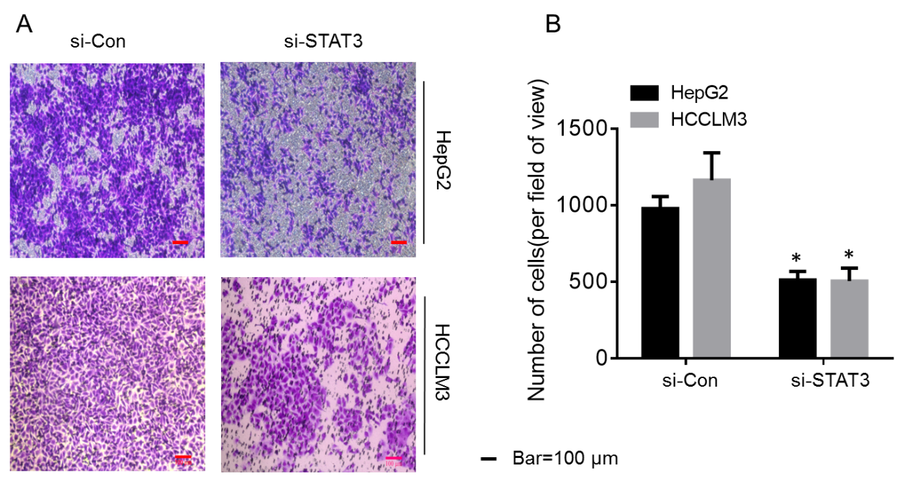
2.1. Figure S1. Effect of STAT3 in migration of hepatocellular carcinoma cells. HepG2 and HCCLM3 cells were subjected to the migration assays with different STAT3 levels, and migrated cells were counted with Stat Monitor in photoshop (mean ± SD, n=3). *P < 0.05, statistically significant difference vs. untreated cells (A and B). Bars = 100 μm.

2.2. Figure S2
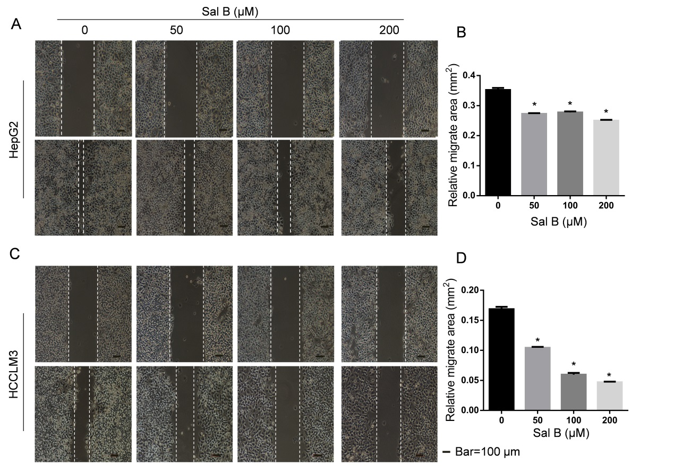
2.2. Figure S2. Sal B inhibited the scratch healing process of hepatocellular carcinoma cells. (A and B) HepG2 cells were exposed to 0.0, 50.0, 100.0, or 200.0 μM Sal B for 48 h, Wound healing assay analyses were performed, relative levels of cell migration areas were determined by Image J. Bars=100μm. (C and D) HCCLM3 cells were exposed to 0.0, 50.0, 100.0, or 200.0 μM Sal B for 24 h, Wound healing assay analyses were performed, relative levels of cell migration areas were determined by Image J. Bars=100μm.

