Supplementary data
Supplementary Table List of patients with methicillin-susceptible Staphylococcus aureus (MSSA) bacteremia who received continuous teicoplanin treatment
No. | Ages-range/Sex | Underlying  disease | Pitt bacteremia score ≥4 | Infection source | Infection source control | Teicoplanin  MIC (mg/L) | Teicoplanin treatment days | Hospitalization  course (days) | Favorable  outcome
1. | 81-90/ M | CAD, CKD (3) | Yes | Primary bacteremia | NA | 0.25 | 10 | 10 | No
2 | 81-90/ M | CAD, DM, ESRD | No | Bone and joint infection | Yes | 1.0 | 21 | 32 | Yes
3. | 91-100/ M | CHF, HTN, CKD (3) | Yes | Primary bacteremia | NA | 1.0 | 14 | 30 | Yes
4. | 61-70/ M | Malignancy, COPD | No | Catheter-related Infection | Yes | 1.0 | 7 | 24 | Yes
5. | 71-80/ F | Malignancy, HTN, CKD (3) | No | Primary bacteremia | NA | 1.5 | 5 | 7 | Yes
6 | 51-60/ M | Cirrhosis | No | Primary bacteremia | NA | 1.0 | 12 | 27 | Yes
7. | 61-70/ M | DM, HTN, CHF, CKD (3) | Yes | Catheter-related infection | No | 1.0 | 25 | 30 | Yes
CAD: coronary artery disease; DM: type 2 diabetes mellitus; CKD (stage): chronic kidney disease; ESRD: end-stage renal disease; HTN: hypertension; COPD: chronic obstructive pulmonary disease; NA: not applicable
Supplementary Figure Duration (in days) to switching to ß-lactam treatment (N=21) for methicillin-susceptible Staphylococcus aureus (MSSA) bacteremia in the initial teicoplanin treatment group.
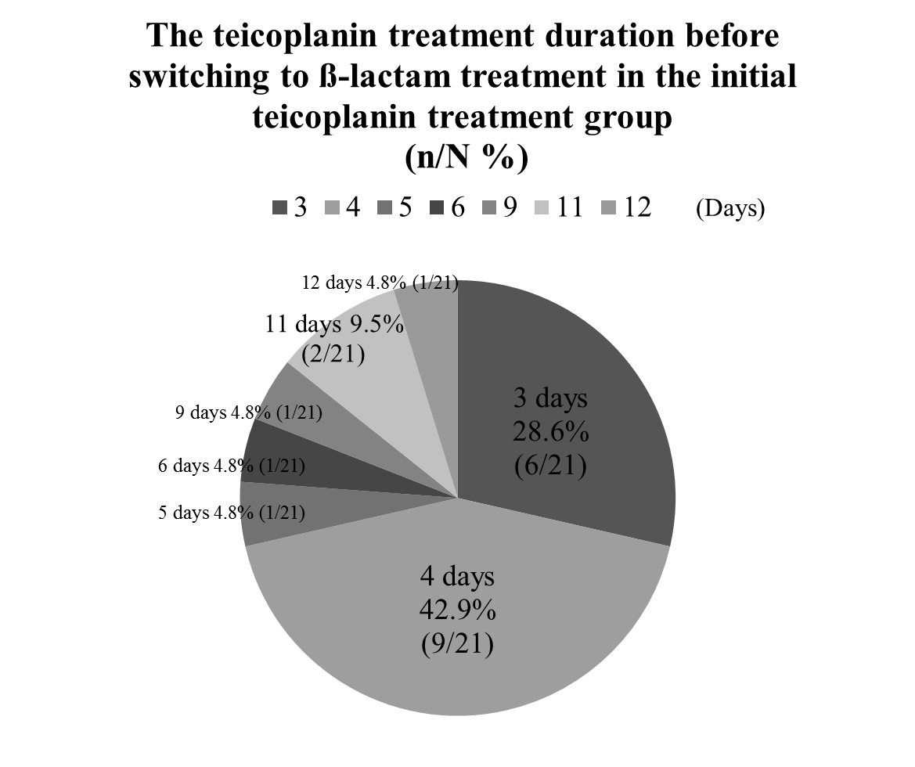
A total of 21 patients in the initial teicoplanin treatment group switched to β-lactam treatment for methicillin-susceptible Staphylococcus aureus (MSSA) bacteremia, including 17 patients switching to oxacillin, 2 patients switching to cefepime, 1 patient switching to meropenem plus vancomycin, and 1 patient switching to ceftriaxone. Among them, 71.5% (15/21) of patients switched to β-lactam treatment within 4 days after teicoplanin treatment.

